ORDRAHelp

**Table of contents**

Introduction 20

Controls 20

Introduction 20

General Controls used 20

Conclusion 21

Help Functionality 21

Introduction 21

Help Functionality 21

Contact details for additional help 22

Conclusion 22

System Procedure Implementation 22

Introduction 22

Hardware and Software Requirements 22

Estimated hardware and software requirements 22

Hardware Requirements 22

Minimum Hardware Requirements: Web Application and Desktop Application 22

Recommended Hardware Requirements: Web Application and Desktop Application 23

Minimum Hardware Requirements: Mobile Application 23

Recommended Hardware Requirements: Mobile Application 24

Software Requirements 24

Web Application and Desktop Application Requirements 24

Mobile Application Requirements 24

System Implementation Procedure 25

System 25

Mobile 25

Conclusion 25

User Functionality Web Application 25

Introduction 25

Subsystems 25

Login 25

Register 25

Login 26

Logout 27

Reset Password 27

Employee 30

Employment Management Screen 30

Create Employee 30

Update Employee 32

Search Employee 34

Delete Employee 37

Manager 38

Manager Profile Management Screen 38

Create Manager Profile 39

Update Manager Profile 40

Search Manager Profile 42

Delete Manger Profile 43

Container 46

Container Management Screen 46

Create Container 47

Update Container 47

Search Container 48

Delete Container 49

Product Category 50

Product Management Screen 50

Add Product Category 51

Update Product Category 52

Search Product Category 53

Remove Product Category 54

Supplier 55

Supplier Management Screen 55

Add Supplier 56

Update Supplier 56

Search Supplier 57

Delete Supplier 58

Product 59

Product Management Screen 59

Add Product 60

Update Product 62

Search Product 69

Remove Product 75

Stock Management Screen 81

Do Stock Take 82

Complete Stock Take 83

Search Stock Take 85

Generate Low Stock Notification 87

Add VAT 88

Update VAT 89

Customer 89

Customer Management Screen 89

Create Customer 90

Update Customer 91

Search Customer 92

Delete Customer 93

Sales 94

Sale Management Screen 94

Make Sales 95

Search Sales 97

Make Payment 98

Card Machine Help 98

Customer Order 99

Customer Order Management Screen 99

Place Order 100

Collect Order 102

Search Order 104

Cancel Order 107

View Fulfilled Order for Notification 110

Supplier Order 113

Supplier Order Management Screen 113

Place Supplier Order 114

Search Supplier Order 116

Cancel Supplier Order 119

Receive Stock 122

Creditor 124

Creditor Management Screen 124

Create Creditor 125

Update Creditor 125

Search Creditor 126

Remove Creditor 127

Creditor Payment 128

Creditor Management Screen 128

Add Payment 129

Search Payment 130

Province 131

GPS Management Screen 131

Add Province 132

Search Province 132

Update Province 134

Remove Province 135

Area 136

GPS Management Screen 136

Add Area 137

Search Area 138

Update Area 140

Remove Area 141

Location 142

GPS Management Screen 142

Create Location 143

Search Location 144

Update Location 146

Donation Recipient 147

Donation Management Screen 147

Create Donation Recipient 148

Update Donation Recipient 149

Search Donation Recipient 150

Remove Donation Recipient 151

Donations 152

Donation Management Screen 152

Create Donation 153

Update Donation 156

Search Donation 157

Reporting 161

Reporting Management Screen 161

Generate Creditors (Suppliers) Report 162

Generate Sales Report 164

Generate Customer Order Report 165

Generate Supplier Report 166

Generate Product Report 167

Generate User Report 168

Home Screen 169

Administration 170

Dashboard 170

User Type Access Management 171

Conclusion 172

User Functionality Desktop Application 173

Introduction 173

Subsystems 173

Login 173

Register 173

Login 174

Logout 175

Reset Password 175

Employee 177

Employee Management Screen 177

Create Employee 178

Update Employee 179

Search Employee 182

Delete Employee 184

Customer 186

Customer Management Screen 186

Create Customer 186

Update Customer 187

Search Customer 188

Delete Customer 189

Product 190

Product Management Screen 190

Add Product 191

Update Product 193

Search Product 199

Remove Product 206

Stock Management Screen 212

Do Stock Take 212

Complete Stock Take 214

Search Stock Take 215

Generate low Stock Notification 217

Add VAT 218

Update VAT 219

Sales 220

Sale Management Screen 220

Make Sales 220

Search Sales 222

Make Payment 223

Card Machine Help 224

Customer Order 224

Customer Order Management Screen 224

Place Order 225

Collect Order 227

Search Order 230

Cancel Order 233

View Fulfilled Order for Notification 236

Home Screen 239

Conclusion 240

Possible Confirmation and Error Messages 240

Introduction 240

Error and Confirmation Messages: Web Application 241

Confirmation and Alert Messages: Subsystems 241

Login 241

Successful Registration Alert Message 241

Mail Sent Alert Message 241

Verified Successful Alert Message 242

Update Successful Alert Message 242

Employee 242

Addition Confirm Message 242

Successful Alert Message 243

Update Confirmation Message 243

Update Successful Alert Message 244

Cancel Confirmation Message 244

Deletion Confirm Message 244

Delete Successful Alert Message 245

Manager 245

Addition Confirm Message 245

Successful Alert Message 246

Update Successful Alert Message 246

Deletion Confirm Message 246

Delete Successful Alert Message 247

Container 247

Addition Confirm Message 247

Successful Alert Message 248

Update Confirmation Message 248

Update Successful Alert Message 249

Cancel Confirmation Message 249

Deletion Confirm Message 249

Delete Successful Alert Message 250

Product Category 250

Addition Confirm Message 250

Successful Alert Message 251

Update Confirmation Message 251

Update Successful Alert Message 252

Cancel Confirmation Message 252

Deletion Confirm Message 252

Delete Successful Alert Message 253

Supplier 253

Addition Confirm Message 253

Successful Alert Message 254

Update Confirmation Message 254

Update Successful Alert Message 255

Delete Successful Alert Message 255

Product 255

Addition Confirm Message 255

Successful Alert Message 256

Add Product To Container Alert Message 256

Product Removed From Container Alert Message 257

Update Confirmation Message 257

Update Successful Alert Message 257

Movement Alert Message 258

Price Added Alert Message 258

Saved Stock Form Alert Message 259

Stock Take Completed Alert Message 259

Add To Backlog Alert Message 259

Add VAT Successful Alert Message 260

Update VAT Successful Alert Message 260

Delete Successful Alert Message 260

Customer 261

Addition Confirm Message 261

Successful Alert Message 261

Update Confirmation Message 262

Update Successful Alert Message 262

Cancel Confirmation Message 263

Deletion Confirm Message 263

Delete Successful Alert Message 263

Sales 264

Sale Incomplete Alert Message 264

Sale Completed Alert Message 264

Low Stock Alert Message 265

Sale Cancelled Alert Message 265

Customer Order 265

Order Successful Alert Message 265

Cancel Confirmation Message 266

Cancelled Alert Message 266

Email Confirmation Message 267

Email Alert Message 267

Collection Confirmation Message 267

Payment Successful Alert Message 268

Supplier Order 268

Order Confirm Message 268

Successful Alert Message 269

Cancel Order Confirmation Message 269

Cancel Order Successful Alert Message 269

Order Details Saved Successful Alert Message 270

Back Order Confirm Message 270

Back Order Successful Alert Message 271

Creditor 271

Addition Confirm Message 271

Successful Alert Message 271

Update Confirmation Message 272

Update Successful Alert Message 272

Cancel Confirmation Message 273

Deletion Confirm Message 273

Delete Successful Alert Message 274

Creditor Payment 274

Addition Confirm Message 274

Successful Alert Message 275

Payment Greater Alert Message 275

Payment Not Added Alert Message 276

Province 276

Addition Confirm Message 276

Successful Alert Message 276

Update Confirmation Message 277

Update Successful Alert Message 277

Cancel Confirmation Message 278

Deletion Confirm Message 278

Delete Successful Alert Message 279

Area 279

Addition Confirm Message 279

Successful Alert Message 279

Update Confirmation Message 280

Update Successful Alert Message 280

Deletion Confirm Message 281

Delete Successful Alert Message 281

Location 281

Addition Confirm Message 281

Successful Alert Message 282

Update Confirmation Message 282

Update Successful Alert Message 283

Donation Recipient 283

Addition Confirm Message 283

Successful Alert Message 284

Update Confirmation Message 284

Update Successful Alert Message 285

Cancel Confirmation Message 285

Deletion Confirm Message 285

Delete Successful Alert Message 286

Donations 286

Addition Confirm Message 286

Successful Alert Message 287

Update Confirmation Message 287

Update Successful Alert Message 288

Cancel Confirmation Message 288

Reporting 288

Administration 288

Access Changes Saved Alert Message 288

Error Messages 289

Validation Error Message: Subsystems 289

Login 289

Employee 289

Manager 290

Container 291

Product Category 291

Supplier 292

Product 293

Customer 293

Sales 294

Customer Order 294

Supplier Order 295

Creditor 296

Creditor Payment 296

Province 296

Area 297

Location 298

Donation Recipient 298

Donations 299

Reporting 299

Administration 300

Error and Confirmation Messages: Desktop Application 300

Confirmation and Alert Messages: Subsystem 300

Login 300

Successful Registration Alert Message 300

Mail Sent Alert Message 300

Verified Successful Alert Message 301

Update Successful Alert Message 301

Employee 302

Addition Confirm Message 302

Successful Alert Message 302

Update Confirmation Message 302

Update Successful Alert Message 303

Cancel Confirmation Message 303

Deletion Confirm Message 304

Delete Successful Alert Message 304

Customer 305

Addition Confirm Message 305

Successful Alert Message 305

Update Confirmation Message 305

Update Successful Alert Message 306

Cancel Confirmation Message 306

Deletion Confirm Message 307

Delete Successful Alert Message 307

Product 308

Addition Confirm Message 308

Successful Alert Message 308

Add Product To Container Alert Message 308

Product Removed From Container Alert Message 309

Update Confirmation Message 309

Update Successful Alert Message 310

Movement Alert Message 310

Price Added Alert Message 310

Saved Stock Form Alert Message 311

Stock Take Completed Alert Message 311

Add To Backlog Alert Message 311

Add VAT Successful Alert Message 312

Update VAT Successful Alert Message 312

Delete Successful Alert Message 313

Sales 313

Sale Incomplete Alert Message 313

Sale Completed Alert Message 313

Low Stock Alert Message 314

Sale Cancelled Alert Message 314

Customer Order 315

Order Successful Alert Message 315

Cancel Confirmation Message 315

Cancelled Alert Message 315

Email Confirmation Message 316

Email Alert Message 316

Collection Confirmation Message 317

Payment Successful Alert Message 317

Error Messages 317

Validation Error Message: Subsystems 317

Login 318

Employee 318

Customer 318

Product 319

Sales 320

Customer Order 320

Conclusion 321

Glossary 322

Introduction 322

Glossary 322

Conclusion 323

Conclusion 323

**Introduction**

The User Manual contains the controls which are used in the system, the help functionality, system procedure implementation, installation procedure, user functionality for the web and desktop application as well as the possible confirmation and error messages and the glossary.

*Created with the Personal Edition of HelpNDoc:* [*Full-featured EPub generator*](https://www.helpndoc.com/create-epub-ebooks)

**Controls**

*Created with the Personal Edition of HelpNDoc:* [*Free EPub and documentation generator*](https://www.helpndoc.com)

**Introduction**

This section contains the controls of the system which are listed and described here for the user manual.

*Created with the Personal Edition of HelpNDoc:* [*Easily create Help documents*](https://www.helpndoc.com/feature-tour)

**General Controls used**

|  |  |
| --- | --- |
| Control | Description |
| Navbar | The navbar is a scrollable list that is displayed on the left-hand side of the screen. This allows for quick and easy navigation between the screens. |
| Toolbar | The toolbar contains frequently used commands such as the logout button. |
| Input fields | The input fields can be used to enter specific details, if required. |
| Select boxes | The select boxes contains a list of details stored in the database. They provide more than one option which the user can select the desired record to enter. |

*Created with the Personal Edition of HelpNDoc:* [*Produce online help for Qt applications*](https://www.helpndoc.com/feature-tour/create-help-files-for-the-qt-help-framework)

**Conclusion**

The controls of the system were listed and described here for the user manual.

*Created with the Personal Edition of HelpNDoc:* [*Free help authoring environment*](https://www.helpndoc.com/help-authoring-tool)

**Help Functionality**

*Created with the Personal Edition of HelpNDoc:* [*Free EBook and documentation generator*](https://www.helpndoc.com)

**Introduction**

This section contains the help functionality of the system which is described here for the user manual.

*Created with the Personal Edition of HelpNDoc:* [*Easy EBook and documentation generator*](https://www.helpndoc.com)

**Help Functionality**

This provides help on where to find a specific functionality, what the controls are as well as what function they execute. This help function can be accessed on any screen. It will redirect to the help screen where the user can search a topic, or the user manual can he read to understand the system and its functionalities.

* **Navigation Process:** Clicking on the following icon on any screen.



* **Complete Layout:**

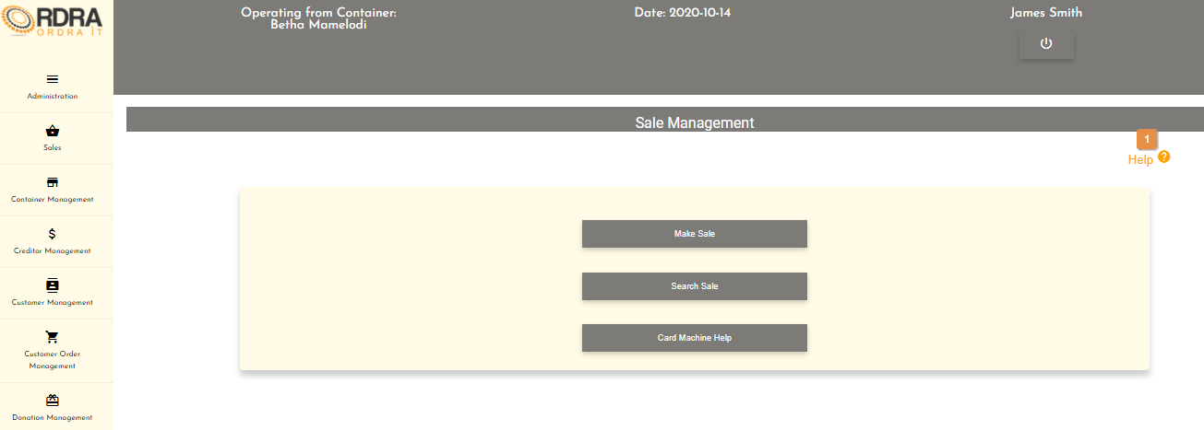

* **Detailed description of the controls:**

|  |  |  |
| --- | --- | --- |
| * Reference | Control | Functionality Description |
| 1 | Help Button | Re-directs you to the Help screen which is where the user can access the user manual and hep is provided. |

*Created with the Personal Edition of HelpNDoc:* [*Generate EPub eBooks with ease*](https://www.helpndoc.com/create-epub-ebooks)

**Contact details for additional help**

For any further assistance, the Maverick Solutions team can be contacted. The team can be contacted for any additionally help that the user manual does not cover as well as if any system errors occur.

|  |  |  |
| --- | --- | --- |
| Full Name | Contact Details | Email Address |
| Ashley Gwangwadza | 0643729539 | [u16206186@tuks.co.za](mailto:u16206186@tuks.co.za) |
| Thobeka Mthethwa | 0717500838 | [u17237948@tuks.co.za](mailto:u17237948@tuks.co.za) |
| Naazim Gani | 0747778786 | [u17107459@tuks.co.za](mailto:u17107459@tuks.co.za) |
| Jessica Mon | 0783914050 | [u17011133@tuks.co.za](mailto:u17011133@tuks.co.za) |
| Zander Potgieter | 0618385867 | [u18214496@tuks.co.za](mailto:u18214496@tuks.co.za) |

*Created with the Personal Edition of HelpNDoc:* [*Create help files for the Qt Help Framework*](https://www.helpndoc.com/feature-tour/create-help-files-for-the-qt-help-framework)

**Conclusion**

The help functionality of the system was described here for the user manual.

*Created with the Personal Edition of HelpNDoc:* [*Easily create Web Help sites*](https://www.helpndoc.com/feature-tour)

**System Procedure Implementation**

*Created with the Personal Edition of HelpNDoc:* [*Benefits of a Help Authoring Tool*](https://www.helpauthoringsoftware.com)

**Introduction**

This section contains the system procedure implementation that is described here for the user manual.

*Created with the Personal Edition of HelpNDoc:* [*Create help files for the Qt Help Framework*](https://www.helpndoc.com/feature-tour/create-help-files-for-the-qt-help-framework)

**Hardware and Software Requirements**

*Created with the Personal Edition of HelpNDoc:* [*Free EPub producer*](https://www.helpndoc.com/create-epub-ebooks)

**Estimated hardware and software requirements**

*Created with the Personal Edition of HelpNDoc:* [*Produce online help for Qt applications*](https://www.helpndoc.com/feature-tour/create-help-files-for-the-qt-help-framework)

**Hardware Requirements**

*Created with the Personal Edition of HelpNDoc:* [*Easily create EPub books*](https://www.helpndoc.com/feature-tour)

Minimum Hardware Requirements: Web Application and Desktop Application

|  |  |  |
| --- | --- | --- |
| Hardware Device | Client Side | Server Side |
| Input Device | * Mouse * Keyboard * Card machine | * Mouse * Keyboard |
| Output Devices | * Monitor with VGA, a resolution of 800 x 600 * Printer | * Monitor with VGA, a resolution of 800 x 600 * Printer |
| Storage | * 14GB available hard drive space | * 20GB available hard drive space or higher |
| CPU (Processor) | * 1.6 gigahertz (GHz) or x32 bit dual core processor | * 1.9 gigahertz (GHz) or faster 64-bit dual core processor |
| RAM | * 4GB RAM | * 8GB RAM or more |
| Hard Disk | * SSD | * SSD |
| GPU | * Onboard Microsoft Direct X 9.0 | * Onboard Microsoft Direct X 9.0 |
| Networking Hardware | * 10/100 Network Interface Card (NIC) | * 10/100/1000 Network Interface Card (NIC) |
| Internet Connection | * 2 Mbps  - 4 Mbps (Upload and Download) | * 10 Mbps - 50 Mbps  (Upload and Download) |

*Created with the Personal Edition of HelpNDoc:* [*Easily create CHM Help documents*](https://www.helpndoc.com/feature-tour)

Recommended Hardware Requirements: Web Application and Desktop Application

|  |  |  |
| --- | --- | --- |
| Hardware Device | Client Side | Server Side |
| Input Device | * Mouse * Keyboard * Yoco Card machine | * Mouse * Keyboard |
| Output Devices | * Monitor with HDMI, Super VGA, a resolution of 1024 x 768 monitor * Printer | * Monitor with HDMI, Super VGA, a resolution of 1024 x 768 monitor * Printer |
| Storage | * 14GB available hard drive space | * 20GB available hard drive space or higher |
| CPU (Processor) | * 1.6 gigahertz (GHz) or x64 bit dual core processor with SSE2 instruction set | * 1.9 gigahertz (GHz) or faster 64-bit dual core with SSE2 instruction set |
| RAM | * 2GB RAM | * 4GB RAM or more |
| GPU | * Onboard Microsoft Direct X 9.0 | * Onboard Microsoft Direct X 9.0 or better |
| Networking Hardware | * 10/100 Network Interface Card (NIC) | * 10/100/1000 Network Interface Card (NIC) |
| Internet Connection | * 2 Mbps  - 4 Mbps (Upload and Download) | * 30 Mbps - 50 Mbps  (Upload and Download) |

*Created with the Personal Edition of HelpNDoc:* [*Free help authoring environment*](https://www.helpndoc.com/help-authoring-tool)

Minimum Hardware Requirements: Mobile Application

|  |  |
| --- | --- |
| Hardware Device | Client Side |
| Internal Storage | * At least 30Mb of free space |
| RAM | * 1GB |
| CPU | * 1.5 GHz dual core |
| Networking | * 3G or HSDPA |
| Internet Connection | * Wi-Fi minimum: 2 Mbps * Mobile Data: Depends on the connectivity   (The Application requires Internet Connection) |

*Created with the Personal Edition of HelpNDoc:* [*Easily create EBooks*](https://www.helpndoc.com/feature-tour)

Recommended Hardware Requirements: Mobile Application

|  |  |
| --- | --- |
| Hardware Device | Client Side |
| Internal Storage | * At least 80Mb of free space |
| RAM | * 3GB |
| CPU | * Quad Core 1.4 GHz or better |
| Networking | * HSDPA+ or 4G LTE |
| Internet Connection | * Wi-Fi minimum: 2 Mbps * Mobile Data: Depends on the connectivity   (The Application requires Internet Connection) |

*Created with the Personal Edition of HelpNDoc:* [*Qt Help documentation made easy*](https://www.helpndoc.com/feature-tour/create-help-files-for-the-qt-help-framework)

**Software Requirements**

*Created with the Personal Edition of HelpNDoc:* [*Free EPub and documentation generator*](https://www.helpndoc.com)

**Web Application and Desktop Application Requirements**

|  |  |  |
| --- | --- | --- |
| Software | Client Side | Server Side |
| Operating System | * Microsoft Windows, Linux, Apple Mac OS or Ubuntu(All Distributions that have browser support) | * Windows Server 2012 or later. |
| Browser | * Internet Explorer 11 or later, Google chrome or Firefox | * N/A |
| Email Provider | * Default OS Email Client | * N/A |
| Database management system | * N/A | * SQL Server 2012 or later |
| Web Server | * N/A | * Apache Web Server or Microsoft IIS |
| Export view | * Microsoft Excel 2010 or later, Microsoft Word 2010 or later, Adobe acrobat | * N/A |
| Development environment | * N/A | * Visual Studio 2013 or later, Visual Studio code |

*Created with the Personal Edition of HelpNDoc:* [*Free Web Help generator*](https://www.helpndoc.com)

**Mobile Application Requirements**

|  |  |
| --- | --- |
| Software | Client side |
| Operating System (Android only) | Android Lollipop 5.0 or later. |
| Email Provider | Any email provider applications (Such as Yahoo Mail ,Google Gmail and Microsoft Outlook etc) |

*Created with the Personal Edition of HelpNDoc:* [*Easily create iPhone documentation*](https://www.helpndoc.com/feature-tour/iphone-website-generation)

**System Implementation Procedure**

*Created with the Personal Edition of HelpNDoc:* [*What is a Help Authoring tool?*](https://www.helpauthoringsoftware.com)

**System**

The ORDRA System is hosted on Firebase as well as Azure and it can be installed on one’s devices. It also requires for one to login with valid credentials, which will be provided for once the system is rightfully obtained by another party.

*Created with the Personal Edition of HelpNDoc:* [*Single source CHM, PDF, DOC and HTML Help creation*](https://www.helpndoc.com/help-authoring-tool)

**Mobile**

The ORDRA System will be accessible via the Google play store.

*Created with the Personal Edition of HelpNDoc:* [*Easily create Web Help sites*](https://www.helpndoc.com/feature-tour)

**Conclusion**

This section contained the system procedure implementation that is described here for the user manual.

*Created with the Personal Edition of HelpNDoc:* [*Free EBook and documentation generator*](https://www.helpndoc.com)

**User Functionality Web Application**

*Created with the Personal Edition of HelpNDoc:* [*Easily create Help documents*](https://www.helpndoc.com/feature-tour)

**Introduction**

The user functionality of the web application is described here to assist the user. This is shown subsystem by subsystem with the visual aids and pointers.

*Created with the Personal Edition of HelpNDoc:* [*Free Web Help generator*](https://www.helpndoc.com)

**Subsystems**

*Created with the Personal Edition of HelpNDoc:* [*Free EPub and documentation generator*](https://www.helpndoc.com)

**Login**

*Created with the Personal Edition of HelpNDoc:* [*Easily create PDF Help documents*](https://www.helpndoc.com/feature-tour)

Register

Allows a new user for the ORDRA system to be able to register onto to system.

* **Navigation process:** 
  1. Click on the Register Button on the Login Screen.



* **Complete layout:**

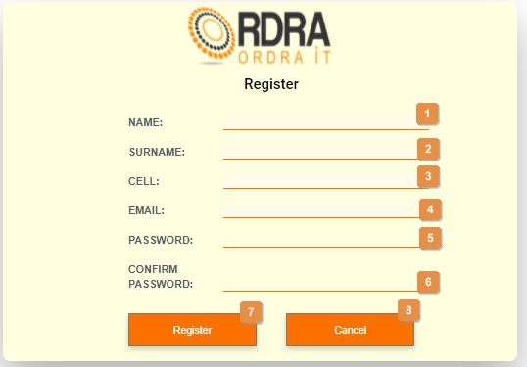

* **Detailed description of the controls:**

|  |  |  |
| --- | --- | --- |
| Reference | Control | Functionality Description |
| 1 | Name Input field | Click here to make an entry for the user name. |
| 2 | Surname Input field | Click here to make an entry for the user surname. |
| 3 | Cell Input field | Click here to make an entry for the user cell number. |
| 4 | Email Input field | Click here to make an entry for the user email address. |
| 5 | Password Input field | Click here to make an entry for the user password. |
| 6 | Confirm Password Input field | Click here to make an entry for the user confirm password. |
| 7 | Register Button | Click the Register button, an alert message will appear to notify the user. |
| 8 | Cancel Button | Re-direct you to the Login screen. Click this button to cancel registration. |

* **Possible Error Messages:** Please refer to the Error and Confirmation Messages, Error Messages, Validation Error Message, Duplicate Entry Message, Item in Use message, Other Messages to view the possible error message(s)).

*Created with the Personal Edition of HelpNDoc:* [*Easy CHM and documentation editor*](https://www.helpndoc.com)

Login

Allows the user to login to the system.

* **Complete layout:**

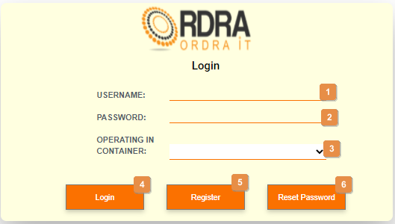

* **Detailed description of the controls:**

|  |  |  |
| --- | --- | --- |
| Reference | Control | Functionality Description |
| 1 | Username input field | Click here to make an entry for the username. |
| 2 | Password input field | Click here to make an entry for the password. |
| 3 | Operating In Container Select Box | Click the select box will display all the containers which user will select container that he is operating in. |
| 4 | Login Button | Click this button to login to the system |
| 5 | Register Button | Re-directs the you to the Register screen. Click this button to register on the system |
| 6 | Reset Password Button | Re-directs the you to the Reset Password Screen. Click this button to reset password on the system |

* **Possible Error Messages:** Please refer to the Error and Confirmation Messages, Error Messages, Validation Error Message, Duplicate Entry Message, Item in Use message, Other Messages to view the possible error message(s)).

*Created with the Personal Edition of HelpNDoc:* [*Free EBook and documentation generator*](https://www.helpndoc.com)

Logout

This control allows the user to logout of the system and go back to the login screen.

* **Navigation process:**
  1. Click Logout Button on the Toolbar.

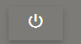

*Created with the Personal Edition of HelpNDoc:* [*Produce online help for Qt applications*](https://www.helpndoc.com/feature-tour/create-help-files-for-the-qt-help-framework)

Reset Password

Allows the user to reset their password used to login to the system.

* **Navigation process:**
  1. Click on the Reset Password Button on the Login Screen.

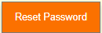

* **Complete layout:**

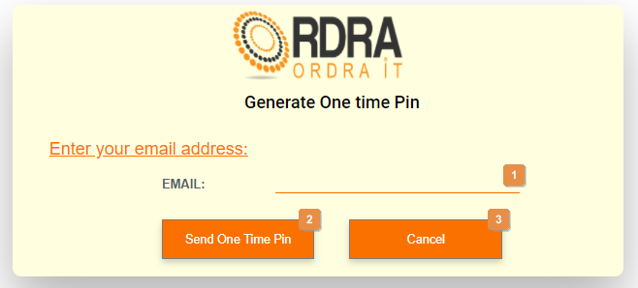

* **Detailed description of the controls:**

|  |  |  |
| --- | --- | --- |
| Reference | Control | Functionality Description |
| 1 | Email Input field | Click here to make an entry for the users email address. |
| 2 | Send One Time Pin Button | Click this button to verify the users email as well as an alert message will appear to notify the user. The Verify One Time Pin screen will display.     |  |  |  | | --- | --- | --- | | Reference | Control | Functionality Description | | 1 | Email Input field | The email will be prepopulated with the user email. | | 2 | One Time Pin Input field | Click here to enter the OTP that was sent to the users email address. | | 3 | Verify One Time Pin Button | Click this button to verify the OTP as well as redirects the user to the Reset Password screen if the OTP is successfully verified.     |  |  |  | | --- | --- | --- | | Reference | Control | Functionality Description | | 1 | Email input field | Click here to make an entry for the username. | | 2 | Password input field | Click here to make an entry for the password. | | 3 | Confirm Password input field | Click here to make the entry for the confirm password. | | 4 | Reset Password Button | Click this button an alert message will appear to notify the user. | | 5 | Cancel Button | Re-directs the you to the Login screen. Click this button to cancel the resetting of the password | | | 4 | Cancel Button | Re-direct you to the Login screen. Click this button to cancel reset password. | |
| 3 | Cancel Button | Re-direct you to the Login screen. Click this button to cancel reset password. |

* **Possible Error Messages:** Please refer to the Error and Confirmation Messages, Error Messages, Validation Error Message, Duplicate Entry Message, Item in Use message, Other Messages to view the possible error message(s)).

*Created with the Personal Edition of HelpNDoc:* [*Generate Kindle eBooks with ease*](https://www.helpndoc.com/feature-tour/create-ebooks-for-amazon-kindle)

**Employee**

*Created with the Personal Edition of HelpNDoc:* [*Easily create CHM Help documents*](https://www.helpndoc.com/feature-tour)

Employment Management Screen

This screen allows the user to navigate through the employee management screen to access either the employee profile options and their relevant functions that each option provides.

* **Navigation process:**
  1. Click on the Employee Management button in the Navbar.

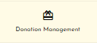

* **Complete layout:**

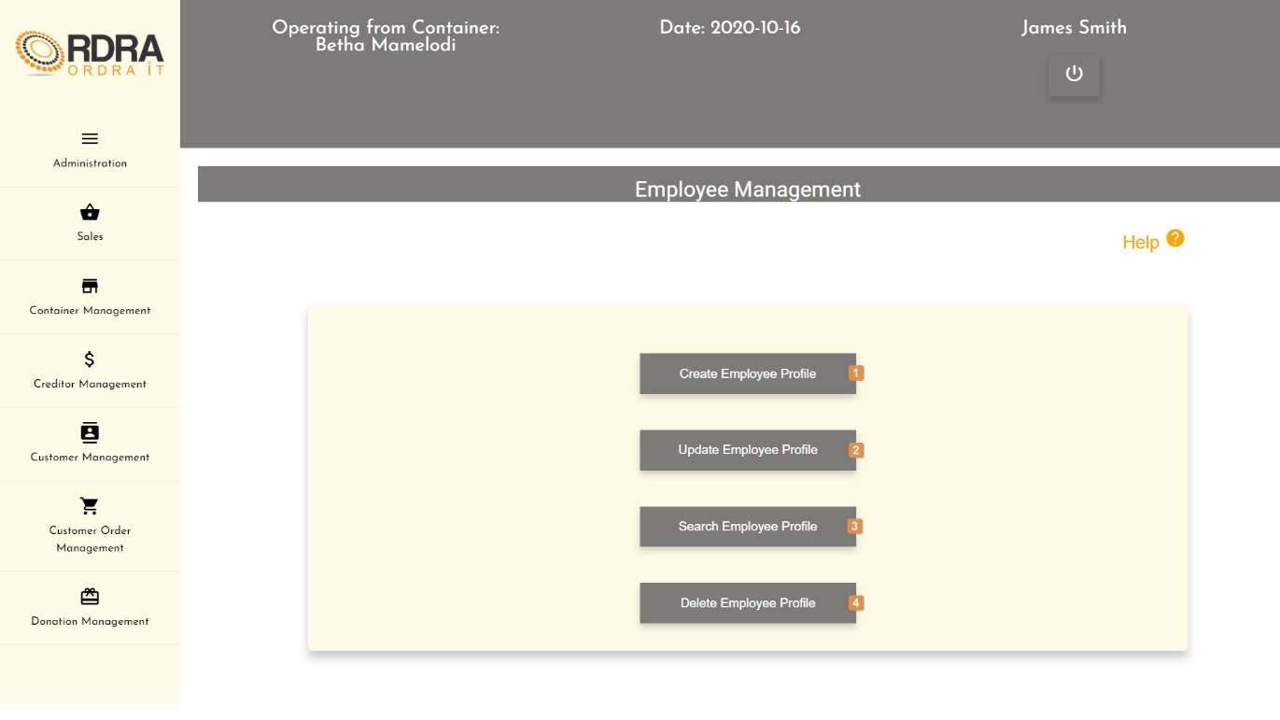

* **Detailed description of the controls:**

|  |  |  |
| --- | --- | --- |
| Reference | Control | Functionality Description |
| 1 | Create Employee Profile Button | Re-directs you to the Create employee profile screen. Click this button to create a new employee profile into the system. |
| 2 | Update Employee profile Button | Re-directs you to the search employee profile screen. Click this button to search a specific employee profile in the system you want to update. |
| 3 | Search Employee Profile Button | Re-directs you to the Search employee profile screen. Click this button to search an employee profile in the system. |
| 4 | Delete Employee Profile Button | Re-directs you to the Search employee profile screen. Click this button to search a specific employee profile in the system you want to remove. |

*Created with the Personal Edition of HelpNDoc:* [*Qt Help documentation made easy*](https://www.helpndoc.com/feature-tour/create-help-files-for-the-qt-help-framework)

Create Employee

Allows the user to create a new employee profile into the system.

* **Navigation process:**
  1. Clicking the Create employee profile button on the Employee Management screen in the Employee profile Card.



* 1. Clicking the search button on the Create Employee Profile screen in the User search Card



* **Complete layout:**

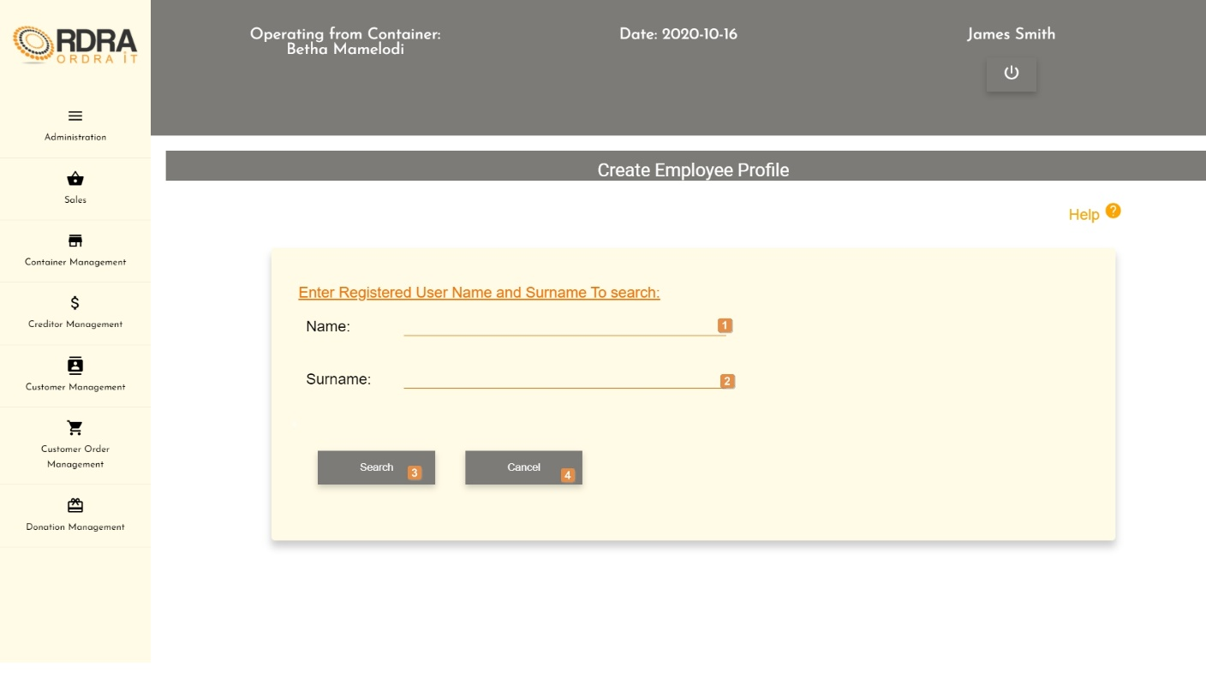

Once the search button is displayed the following cards are displayed

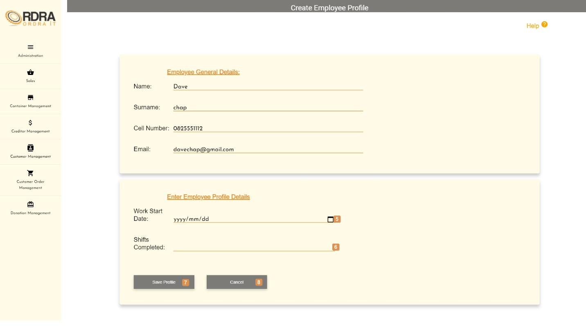

* **Detailed description of the controls:**

|  |  |  |
| --- | --- | --- |
| Reference | Control | Functionality Description |
| 1 | Name input field | Click here to make an entry for the registered user name. |
| 2 | Surname input field | Click here to make an entry for the registered user surname. |
| 3 | Search Button | Click the Save button, a confirmation massage will appear to confirm the adding of a recipient. |
| 4 | Cancel Button | Re-direct you to the Employee Management screen. Click this button to cancel creating an employee profile. |
| 5 | Work start date input field | Click here to make an entry for the work start date for the profile creation |
| 6 | Shifts Completed input field | Click here to make an entry for the Shifts completed for the profile creation |
| 7 | Save profile button | Will display a message of successful creation then Re-direct you to the Employee Management screen. Click here to save the employee profile that you are creating. |
| 8 | Cancel button | Re-direct you to the Employee Management screen. Click this button to cancel creating an employee profile. |

* **Possible Error Messages:** Please refer to the Error and Confirmation Messages, Error Messages, Validation Error Message, Duplicate Entry Message, Item in Use message, Other Messages to view the possible error message(s)).

*Created with the Personal Edition of HelpNDoc:* [*Easily create iPhone documentation*](https://www.helpndoc.com/feature-tour/iphone-website-generation)

Update Employee

Allows the user to update an existing in the system.

* **Navigation process:**
  1. Clicking the Update Employee Profile button on the Employee Management screen in the Employee Card.



* 1. Clicking on the search button on the Search Employee screen. The



* **Complete layout:**

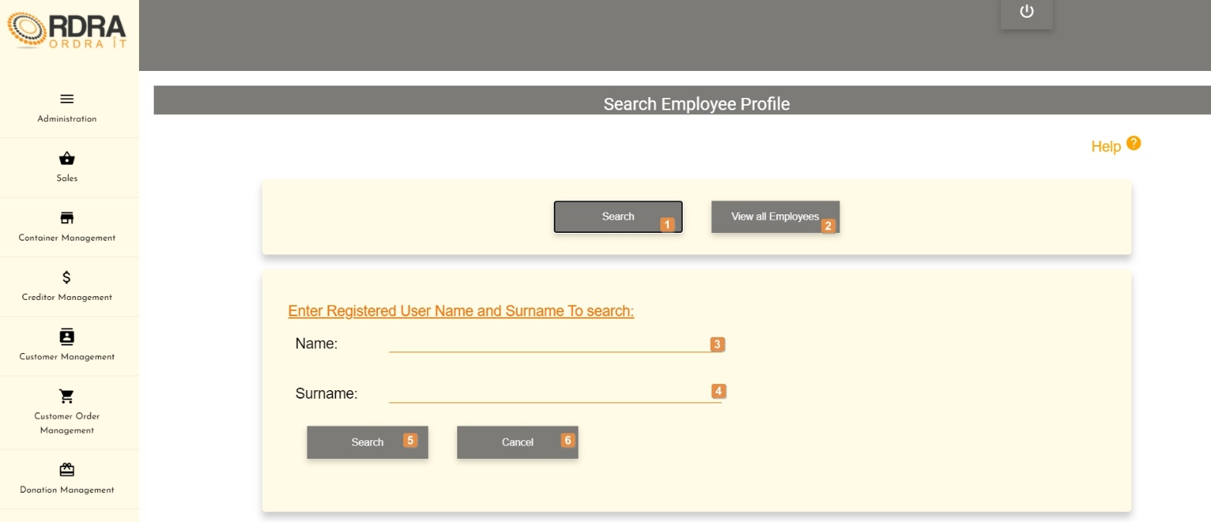

* **Detailed description of the controls:**

|  |  |  |
| --- | --- | --- |
| Reference | Control | Functionality Description |
| 1 | Search Button | Click here to search for a specific employee profile. The Search card is displayed |
| 2 | View all employees button | Click here to view all employee records that have been created. Displays the view all card |
| 3 | Name input field | Click here to make an entry for the registered user name to search |
| 4 | Surname input field | Click here to make an entry for the registered user surname to search |
| 5 | Search button | Click here to search for the employee profile with the entered name and surname. Displays the searched results card |
| 6 | Cancel button | Re-direct you to the Employee Management screen. Click this button to cancel creating an employee profile. |

Once you have searched for the employee profile the following screen is displayed

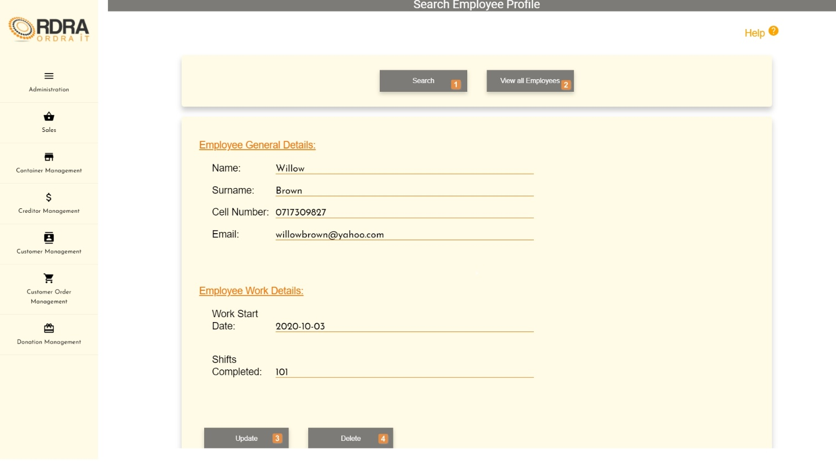

* **Detailed description of the controls:**

|  |  |  |
| --- | --- | --- |
| Reference | Control | Functionality Description |
| 1 | Search Button | Click here to search for a specific employee profile. The Search card is displayed |
| 2 | View all employees button | Click here to view all employee records that have been created. Displays the view all card |
| 3 | Update Button | This button will allow the updating of the details in the Searched Employee profile Details card. When clicked, it makes all the employee profile input fields, in which changes can be made editable. The following buttons will be visible on the screen, to either save or cancel the option to update the details.    Click the Save button, a confirmation message will appear to confirm the update.  Click the Cancel button, a confirmation message will appear to confirm the cancellation. |
| 6 | Delete Button | Click the Delete button, a confirmation message will appear to confirm the deletion. |

If the view button is clicked on the view all card is displayed on the search employee profile screen.

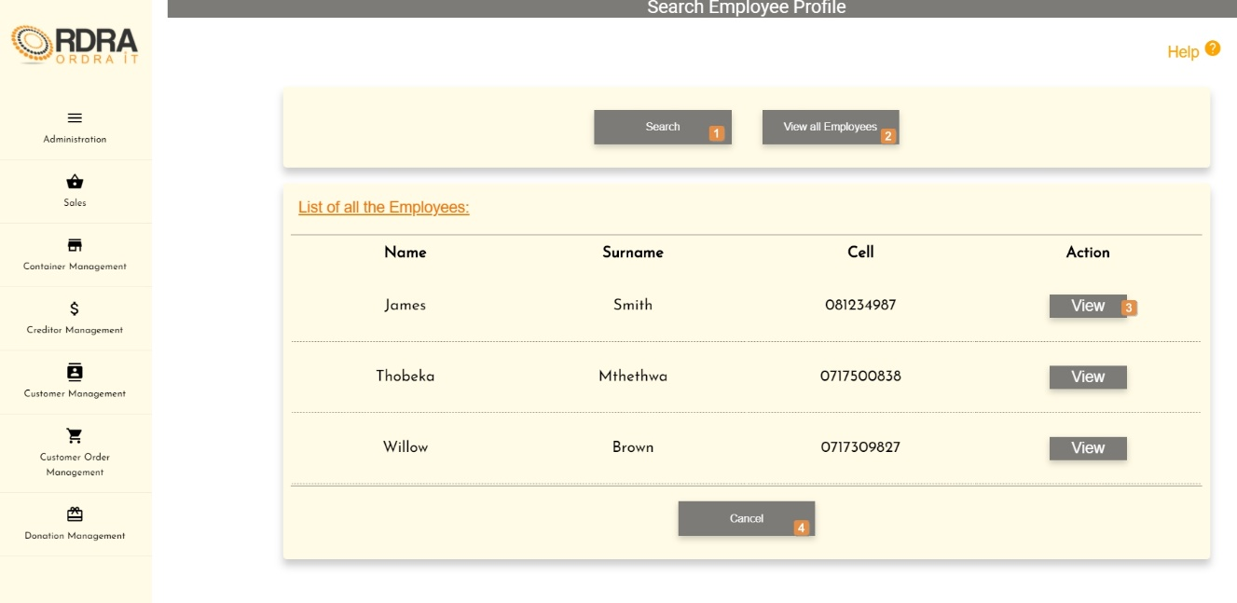

* **Detailed description of the controls:**

|  |  |  |
| --- | --- | --- |
| Reference | Control | Functionality Description |
| 1 | Search Button | Click here to search for a specific employee profile. The Search card is displayed |
| 2 | View all employees button | Click here to view all employee records that have been created. Displays the view all card |
| 3 | View button | Click here to view the selected employee profile. The employee profile card is displayed with the details of the selected profile. |
| 4 | Cancel button | Re-direct you to the Employee Management screen. Click this button to cancel creating an employee profile. |

* **Possible Error Messages:** Please refer to the Error and Confirmation Messages, Error Messages, Validation Error Message, Duplicate Entry Message, Item in Use message, Other Messages to view the possible error message(s)).

*Created with the Personal Edition of HelpNDoc:* [*Free PDF documentation generator*](https://www.helpndoc.com)

Search Employee

Allows the user to search existing Employee recipients in the system.

* **Navigation process:**
  1. Clicking the Search Employee profile button on the Employee Management screen in the Employee profile Card.



1. 2. Clicking on the search button on the Search Employee screen. The



* **Complete layout:**



* **Detailed description of the controls:**

|  |  |  |
| --- | --- | --- |
| Reference | Control | Functionality Description |
| 1 | Search Button | Click here to search for a specific employee profile. The Search card is displayed |
| 2 | View all employees button | Click here to view all employee records that have been created. Displays the view all card |
| 3 | Name input field | Click here to make an entry for the registered user name to search |
| 4 | Surname input field | Click here to make an entry for the registered user surname to search |
| 5 | Search button | Click here to search for the employee profile with the entered name and surname. Displays the searched results card |
| 6 | Cancel button | Re-direct you to the Employee Management screen. Click this button to cancel creating an employee profile. |

Once you have searched for the employee profile the following screen is displayed



* **Detailed description of the controls:**

|  |  |  |
| --- | --- | --- |
| Reference | Control | Functionality Description |
| 1 | Search Button | Click here to search for a specific employee profile. The Search card is displayed |
| 2 | View all employees button | Click here to view all employee records that have been created. Displays the view all card |
| 3 | Update Button | This button will allow the updating of the details in the Searched Employee profile Details card. When clicked, it makes all the employee profile input fields, in which changes can be made editable. The following buttons will be visible on the screen, to either save or cancel the option to update the details.    Click the Save button, a confirmation message will appear to confirm the update.  Click the Cancel button, a confirmation message will appear to confirm the cancellation. |
| 6 | Delete Button | Click the Delete button, a confirmation message will appear to confirm the deletion. |

If the view button is clicked on the view all card is displayed on the search employee profile screen.



* **Detailed description of the controls:**

|  |  |  |
| --- | --- | --- |
| Reference | Control | Functionality Description |
| 1 | Search Button | Click here to search for a specific employee profile. The Search card is displayed |
| 2 | View all employees button | Click here to view all employee records that have been created. Displays the view all card |
| 3 | View button | Click here to view the selected employee profile. The employee profile card is displayed with the details of the selected profile. |
| 4 | Cancel button | Re-direct you to the Employee Management screen. Click this button to cancel creating an employee profile. |

* **Possible Error Messages:** Please refer to the Error and Confirmation Messages, Error Messages, Validation Error Message, Duplicate Entry Message, Item in Use message, Other Messages to view the possible error message(s)).

*Created with the Personal Edition of HelpNDoc:* [*Easily create EBooks*](https://www.helpndoc.com/feature-tour)

Delete Employee

Allows the user to remove an existing employee profile from the system.

* **Navigation process:**
  1. Clicking the Delete Employee Profile button on the Employee Management screen in the Employee profile Card.



* 1. The steps for searching an employee profile are used. The search employee profile screen is then displayed
* **Complete layout:**



* **Detailed description of the controls:**

|  |  |  |
| --- | --- | --- |
| Reference | Control | Functionality Description |
| 1 | Search Button | Click here to search for a specific employee profile. The Search card is displayed |
| 2 | View all employees button | Click here to view all employee records that have been created. Displays the view all card |
| 3 | Update Button | This button will allow the updating of the details in the Searched Employee profile Details card. When clicked, it makes all the employee profile input fields, in which changes can be made editable. The following buttons will be visible on the screen, to either save or cancel the option to update the details.    Click the Save button, a confirmation message will appear to confirm the update.  Click the Cancel button, a confirmation message will appear to confirm the cancellation. |
| 6 | Delete Button | Click the Delete button, a confirmation message will appear to confirm the deletion. |

* **Possible Error Messages:** Please refer to the Error and Confirmation Messages, Error Messages, Validation Error Message, Duplicate Entry Message, Item in Use message, Other Messages to view the possible error message(s)).

*Created with the Personal Edition of HelpNDoc:* [*Benefits of a Help Authoring Tool*](https://www.helpauthoringsoftware.com)

**Manager**

*Created with the Personal Edition of HelpNDoc:* [*Produce Kindle eBooks easily*](https://www.helpndoc.com/feature-tour/create-ebooks-for-amazon-kindle)

Manager Profile Management Screen

This screen allows the user to navigate through the Manager Profile Management screen to add, update, remove or search through the relevant managers.

* **Navigation process:**
  1. Click on the Manager Profile Management button in the Navbar.

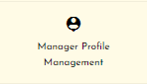

* **Complete layout:**

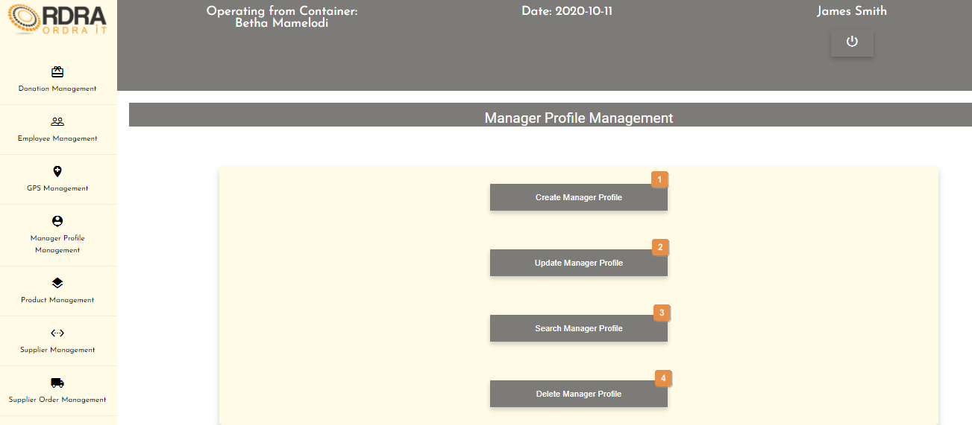

* **Detailed description of the controls:**

|  |  |  |
| --- | --- | --- |
| Reference | Control | Functionality Description |
| 1 | Create Manager Profile Button | Re-directs you to the Create Manager Profile screen. Click this button to add/create a new manager into the system. |
| 2 | Update Manager Profile Button | Re-directs you to the Search Manager Profile screen. Click this button to search a specific manger in the system you want to update. |
| 3 | Search Manager Profile Button | Re-directs you to the Search Manager Profile screen. Click this button to search a manger in the system. |
| 4 | Delete Manager Profile Button | Re-directs you to the Search Manager Profile screen. Click this button to search a specific manger in the system you want to remove. |

*Created with the Personal Edition of HelpNDoc:* [*Full-featured multi-format Help generator*](https://www.helpndoc.com/help-authoring-tool)

Create Manager Profile

Allows the user to add/create a new manger into the system but before the user can add/create a new manager they need to first add that user as an employee into the system.

* **Navigation process:**
  1. Clicking the Create Manage Profile button on the Manager Profile Management screen.



* 1. Clicking the search button once you have entered the manager’s name and surname you want to add/create on the Create Manager Profile screen.



* **Complete layout:**

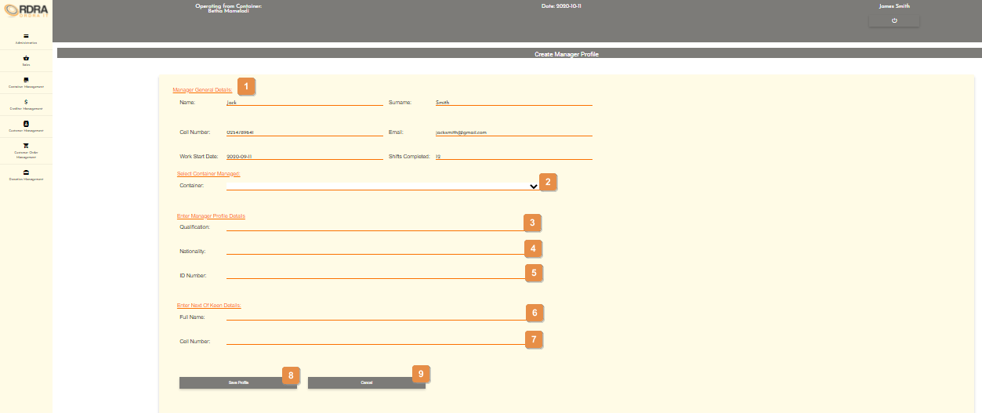

* **Detailed description of the controls:**

|  |  |  |
| --- | --- | --- |
| Reference | Control | Functionality Description |
| 1 | General Manger Detail Section | The input fields under this section will be automatically populated with the user you want to add/create a manger. |
| 2 | Container Select Box | Click the select box will display all the containers in the system. User selects the container that the manager will be managing. |
| 3 | Qualification input field | Click here to make an entry for the manager qualification. |
| 4 | Nationality input field | Click here to make an entry for the manager nationality. |
| 5 | ID Number input field | Click here to make an entry for the manager ID number. |
| 6 | Next of Keen Full Name input field | Click here to make an entry for the manager next of keen full name. |
| 7 | Next of Keen Cell Number input field | Click here to make an entry for the manager next of keen cell number. |
| 8 | Save Profile Button | Click the Save Profile button, a confirmation massage will appear to confirm the adding of a manager. |
| 9 | Cancel button | You will remain on the Create Manager Profile screen. Click this button to cancel adding/creating a manger and the search card will display to search a user you want to add/create as manager. |

* **Possible Error Messages:** Please refer to the Error and Confirmation Messages, Error Messages, Validation Error Message, Duplicate Entry Message, Item in Use message, Other Messages to view the possible error message(s)).

*Created with the Personal Edition of HelpNDoc:* [*What is a Help Authoring tool?*](https://www.helpauthoringsoftware.com)

Update Manager Profile

Allows the user to update an existing manger in the system.

* **Navigation process:**
  1. Clicking the Update Manager Profile button on the Manager Profile Management screen.



* **Complete layout:**

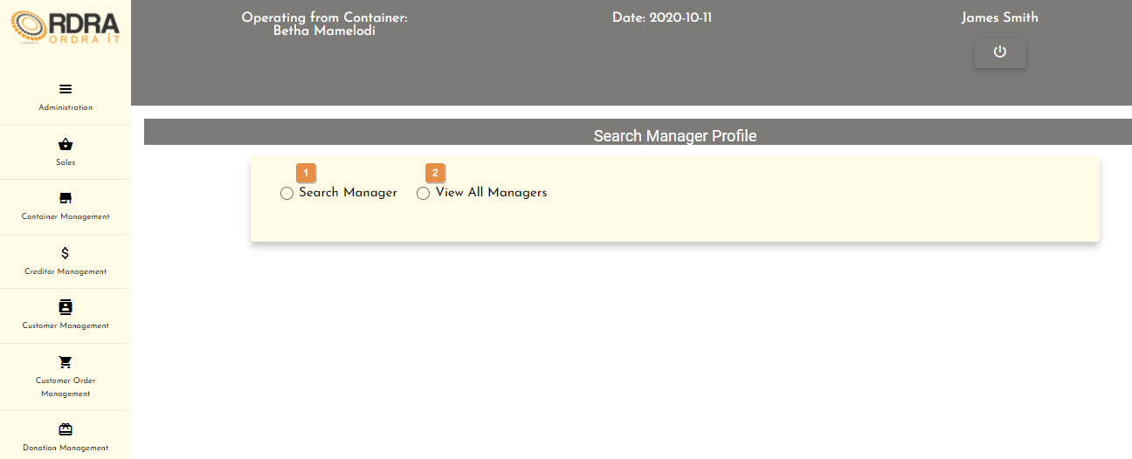

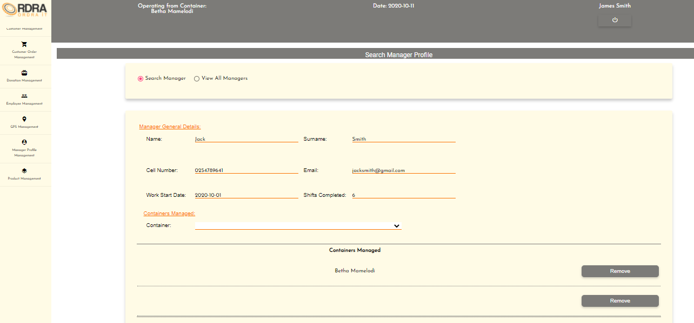

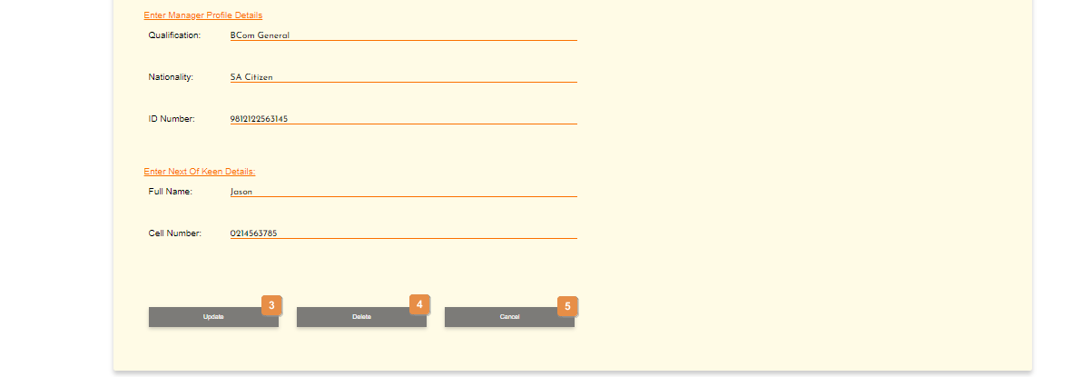

* **Detailed description of the controls:**

|  |  |  |
| --- | --- | --- |
| Reference | Control | Functionality Description |
| 1 | Search Manger Radio Button | This radio button will allow the user to search for a specific manger. Clicking this radio button will make visible the name and surname input fields on the screen to search for a specific manger.     |  |  |  | | --- | --- | --- | | Reference | Control | Functionality Description | | 1 | Name input field | Click here to make an entry for the manager name. | | 2 | Surname input field | Click here to make an entry for the manager surname. | | 3 | Search Button | Click search button will hide the name and surname input fields to search for a specific manger. The manager details card will be displayed. | | 4 | Cancel Button | Re-direct you to the Manager Profile Management screen. Click this button to cancel the search. | |
| 2 | View All Mangers Radio Button | This radio button will allow the user to view all the mangers. Clicking this radio button will display a list on all the mangers in a table format. Next to each manger listed is a view button as well as a cancel button below that list of all mangers.    Clicking this view button, will display that mangers details.    Re-direct you to the Manager Profile Management screen. Click this button to cancel the search. |
| 3 | Update Button | This button will allow the updating of the details under the Manger Profile Details and Next of Keen Details sections. When clicked, it makes all the input fields under the sections mentioned above, in which changes can be made editable. The following buttons will be visible on the screen, to either save or cancel the option to update the details.    Click the Save button, an alert message will appear to notify the user.  Click the Cancel button, to cancel updating of a manger and the search card will display with the two search radio buttons as well as the name and surname input fields to search for a specific manger. |
| 4 | Delete Button | Click the Delete button, a confirmation message will appear to confirm the deletion. |
| 5 | Cancel Button | You will remain on the Search Manager Profile screen. Click this button to cancel searching of a manger and the search card will display with the two search radio buttons as well as the name and surname input fields to search for a specific manger. |

* **Possible Error Messages:** Please refer to the Error and Confirmation Messages, Error Messages, Validation Error Message, Duplicate Entry Message, Item in Use message, Other Messages to view the possible error message(s)).

*Created with the Personal Edition of HelpNDoc:* [*Write eBooks for the Kindle*](https://www.helpndoc.com/feature-tour/create-ebooks-for-amazon-kindle)

Search Manager Profile

Allows the user to search existing mangers in the system.

* **Navigation process:**
  1. Clicking the Search Manger Profile button on the Manager Profile Management screen.



* **Complete layout:**



* **Detailed description of the controls:**

|  |  |  |
| --- | --- | --- |
| Reference | Control | Functionality Description |
| 1 | Search Manger Radio Button | This radio button will allow the user to search for a specific manger. Clicking this radio button will make visible the name and surname input fields on the screen to search for a specific manger.     |  |  |  | | --- | --- | --- | | Reference | Control | Functionality Description | | 1 | Name input field | Click here to make an entry for the manager name. | | 2 | Surname input field | Click here to make an entry for the manager surname. | | 3 | Search Button | Click search button will hide the name and surname input fields to search for a specific manger. The manager details card will be displayed. | | 4 | Cancel Button | Re-direct you to the Manager Profile Management screen. Click this button to cancel the search. | |
| 2 | View All Mangers Radio Button | This radio button will allow the user to view all the mangers. Clicking this radio button will display a list on all the mangers in a table format. Next to each manger listed is a view button as well as a cancel button below that list of all mangers.    Clicking this view button, will display that mangers details.    Re-direct you to the Manager Profile Management screen. Click this button to cancel the search. |

* **Possible Error Messages:** Please refer to the Error and Confirmation Messages, Error Messages, Validation Error Message, Duplicate Entry Message, Item in Use message, Other Messages to view the possible error message(s)).

*Created with the Personal Edition of HelpNDoc:* [*Free CHM Help documentation generator*](https://www.helpndoc.com)

Delete Manger Profile

Allows the user to remove an existing manager from the system.

* **Navigation process:**
  1. Clicking the Delete Manager Profile button on the Manager Profile Management screen.

’

* **Complete layout:**







* **Detailed description of the controls:**

|  |  |  |
| --- | --- | --- |
| Reference | Control | Functionality Description |
| 1 | Search Manger Radio Button | This radio button will allow the user to search for a specific manger. Clicking this radio button will make visible the name and surname input fields on the screen to search for a specific manger.     |  |  |  | | --- | --- | --- | | Reference | Control | Functionality Description | | 1 | Name input field | Click here to make an entry for the manager name. | | 2 | Surname input field | Click here to make an entry for the manager surname. | | 3 | Search Button | Click search button will hide the name and surname input fields to search for a specific manger. The manager details card will be displayed. | | 4 | Cancel Button | Re-direct you to the Manager Profile Management screen. Click this button to cancel the search. | |
| 2 | View All Mangers Radio Button | This radio button will allow the user to view all the mangers. Clicking this radio button will display a list on all the mangers in a table format. Next to each manger listed is a view button as well as a cancel button below that list of all mangers.    Clicking this view button, will display that mangers details.    Re-direct you to the Manager Profile Management screen. Click this button to cancel the search. |
| 3 | Update Button | This button will allow the updating of the details under the Manger Profile Details and Next of Keen Details sections. When clicked, it makes all the input fields under the sections mentioned above, in which changes can be made editable. The following buttons will be visible on the screen, to either save or cancel the option to update the details.    Click the Save button, an alert message will appear to notify the user.  Click the Cancel button, to cancel updating of a manger and the search card will display with the two search radio buttons as well as the name and surname input fields to search for a specific manger. |
| 4 | Delete Button | Click the Delete button, a confirmation message will appear to confirm the deletion. |
| 5 | Cancel Button | You will remain on the Search Manager Profile screen. Click this button to cancel searching of a manger and the search card will display with the two search radio buttons as well as the name and surname input fields to search for a specific manger. |

* **Possible Error Messages:** Please refer to the Error and Confirmation Messages, Error Messages, Validation Error Message, Duplicate Entry Message, Item in Use message, Other Messages to view the possible error message(s)).

*Created with the Personal Edition of HelpNDoc:* [*Full-featured EPub generator*](https://www.helpndoc.com/create-epub-ebooks)

**Container**

*Created with the Personal Edition of HelpNDoc:* [*Full-featured Kindle eBooks generator*](https://www.helpndoc.com/feature-tour/create-ebooks-for-amazon-kindle)

Container Management Screen

This screen allows the user to navigate through the container management screen to add, update, remove or search through the containers the relevant containers.

* **Navigation process:**
  1. Click on the Container Management button in the Navbar.

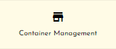

* **Complete layout:**

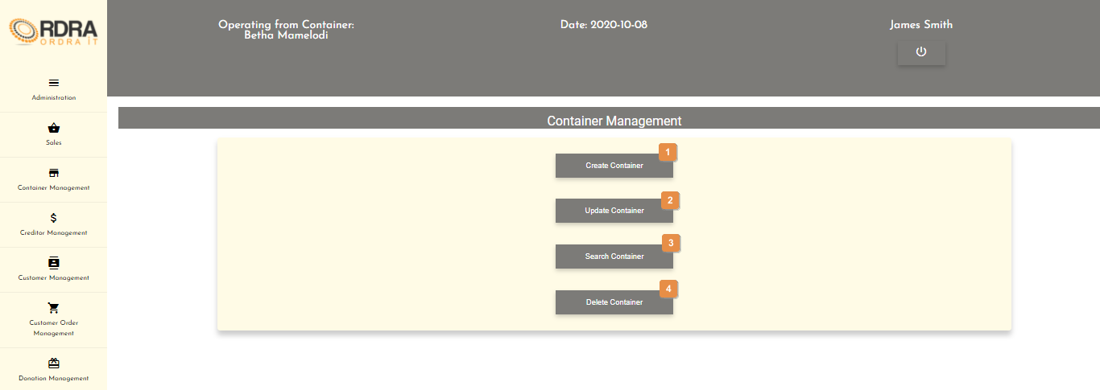

* **Detailed description of the controls:**

|  |  |  |
| --- | --- | --- |
| Reference | Control | Functionality Description |
| 1 | Create Container Button | Re-directs you to the Create Container screen. Click this button to add/create a new container into the system. |
| 2 | Update Container Button | Re-directs you to the Search Container screen. Click this button to search a specific container in the system you want to update. |
| 3 | Search Container Button | Re-directs you to the Search Container screen. Click this button to search a container in the system. |
| 4 | Delete Container Button | Re-directs you to the Search Container screen. Click this button to search a specific container in the system you want to remove. |

*Created with the Personal Edition of HelpNDoc:* [*Free EPub producer*](https://www.helpndoc.com/create-epub-ebooks)

Create Container

Allows the user to add/create a new container into the system.

* **Navigation process:**
  1. Clicking the Create Container button on the Container Management screen.



* **Complete layout:**

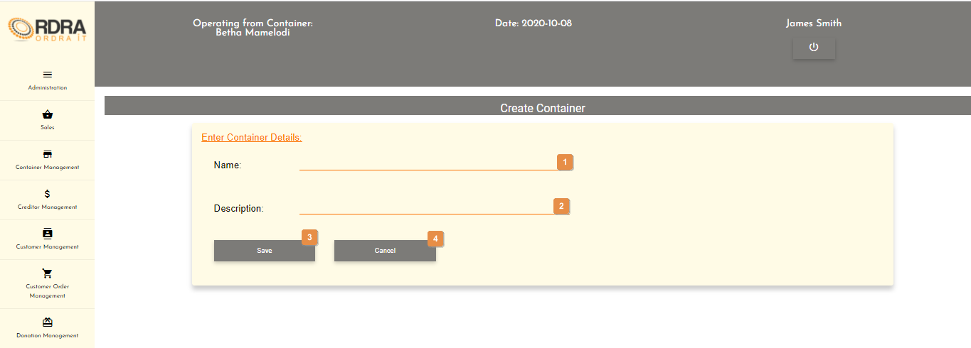

* **Detailed description of the controls:**

|  |  |  |
| --- | --- | --- |
| Reference | Control | Functionality Description |
| 1 | Name input field | Click here to make an entry for the container name. |
| 2 | Description input field | Click here to make an entry for the container description. |
| 3 | Save button | Click the Save button, a confirmation massage will appear to confirm the adding/creating of a container. |
| 4 | Cancel button | Re-direct you to the Container Management screen. Click this button to cancel adding/creating a container. |

* **Possible Error Messages:** Please refer to the Error and Confirmation Messages, Error Messages, Validation Error Message, Duplicate Entry Message, Item in Use message, Other Messages to view the possible error message(s)).

*Created with the Personal Edition of HelpNDoc:* [*Single source CHM, PDF, DOC and HTML Help creation*](https://www.helpndoc.com/help-authoring-tool)

Update Container

Allows the user to update an existing container in the system.

* **Navigation process:**
  1. Clicking the Update Container button on the Container Management screen.



* 1. Clicking on the Input Criteria button on the Search Container screen



* **Complete layout:**

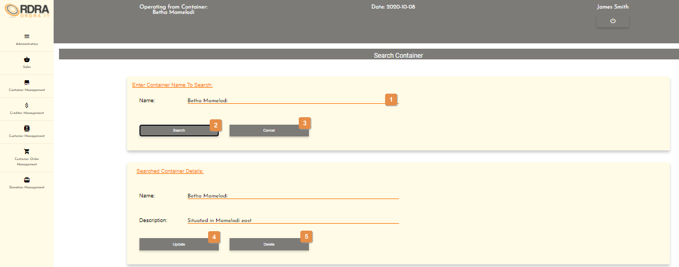

* **Detailed description of the controls:**

|  |  |  |
| --- | --- | --- |
| Reference | Control | Functionality Description |
| 1 | Search Name input field | Click here to make an entry for the container name to search. |
| 2 | Search Button | This button will display the Search Container Details card if the container exists in the system. |
| 3 | Cancel Button | Re-direct you to the Container Management screen. Click this button to cancel the search of a container. |
| 4 | Update Button | This button will allow the updating of the details in the Searched Container Details card. When clicked, it makes all the input fields, in which changes can be made editable. The following buttons will be visible on the screen, to either save or cancel the option to update the details.    Click the Save button, a confirmation message will appear to confirm the update.  Click the Cancel button, a confirmation message will appear to confirm the cancellation. |
| 5 | Delete Button | Click the Delete button, a confirmation message will appear to confirm the deletion. |

* **Possible Error Messages:** Please refer to the Error and Confirmation Messages, Error Messages, Validation Error Message, Duplicate Entry Message, Item in Use message, Other Messages to view the possible error message(s)).

*Created with the Personal Edition of HelpNDoc:* [*Full-featured EBook editor*](https://www.helpndoc.com/create-epub-ebooks)

Search Container

Allows the user to search existing containers in the system.

* **Navigation process:**
  1. Clicking the Search Container button on the Container Management screen.



* **Complete layout:**

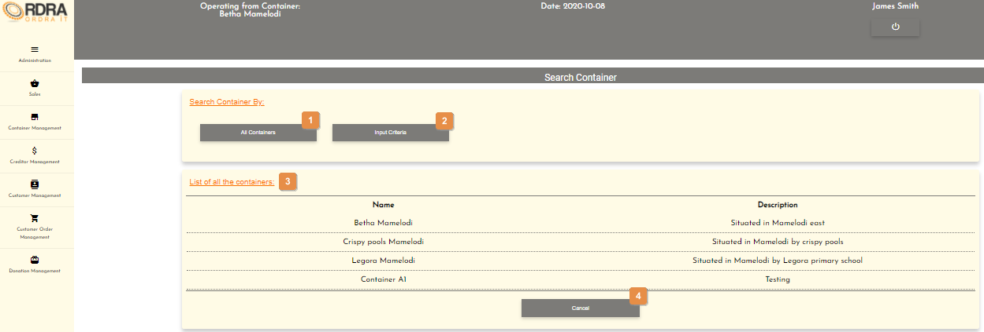

* **Detailed description of the controls:**

|  |  |  |
| --- | --- | --- |
| Reference | Control | Functionality Description |
| 1 | All Containers Button | This button will display the List of all the containers card with a table of all the container that exists in the system. |
| 2 | Input Criteria Button | This button will display the Search Container Details card if the container exists in the system. |
| 3 | List of all the containers table | Shows a list of all the container that exists in the system. |
| 4 | Cancel Button | Re-direct you to the Container Management screen. Click this button to cancel the search of all containers. |

* **Possible Error Messages:** Please refer to the Error and Confirmation Messages, Error Messages, Validation Error Message, Duplicate Entry Message, Item in Use message, Other Messages to view the possible error message(s)).

*Created with the Personal Edition of HelpNDoc:* [*Full-featured Help generator*](https://www.helpndoc.com/feature-tour)

Delete Container

Allows the user to remove an existing container from the system.

* **Navigation process:**
  1. Clicking the Update Container button on the Container Management screen.



* 1. Clicking on the Input Criteria button on the Search Container screen.



* **Complete layout:**



* **Detailed description of the controls:**

|  |  |  |
| --- | --- | --- |
| Reference | Control | Functionality Description |
| 1 | Search Name input field | Click here to make an entry for the container name to search. |
| 2 | Search Button | This button will display the Search Container Details card if the container exists in the system. |
| 3 | Cancel Button | Re-direct you to the Container Management screen. Click this button to cancel the search of a container. |
| 4 | Update Button | This button will allow the updating of the details in the Searched Container Details card. When clicked, it makes all the input fields, in which changes can be made editable. The following buttons will be visible on the screen, to either save or cancel the option to update the details.    Click the Save button, a confirmation message will appear to confirm the update.  Click the Cancel button, a confirmation message will appear to confirm the cancellation. |
| 5 | Delete Button | Click the Delete button, a confirmation message will appear to confirm the deletion. |

* **Possible Error Messages:** Please refer to the Error and Confirmation Messages, Error Messages, Validation Error Message, Duplicate Entry Message, Item in Use message, Other Messages to view the possible error message(s)).

*Created with the Personal Edition of HelpNDoc:* [*Produce electronic books easily*](https://www.helpndoc.com/create-epub-ebooks)

**Product Category**

*Created with the Personal Edition of HelpNDoc:* [*Create help files for the Qt Help Framework*](https://www.helpndoc.com/feature-tour/create-help-files-for-the-qt-help-framework)

Product Management Screen

This screen allows the user to navigate through the product management screen to access the Product, Product Category and Vat options and their relevant functions that each option provides.

* **Navigation process:**
  1. Click on the Product Management button in the Navbar.

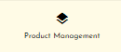

* **Complete layout:**

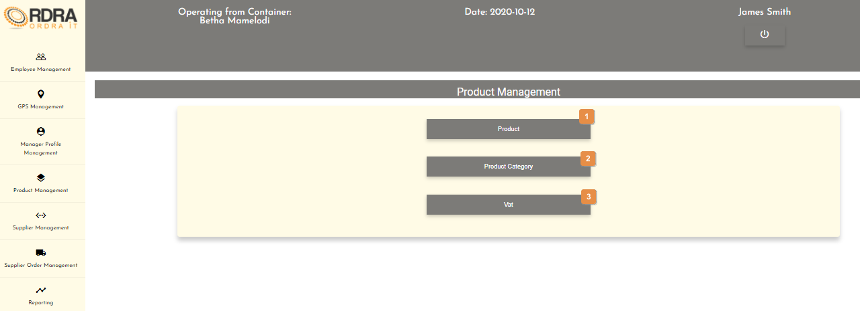

* **Detailed description of the controls:**

|  |  |  |
| --- | --- | --- |
| Reference | Control | Functionality Description |
| 1 | Product Button | Clicking this button will make the Product card visible with various buttons related to the Product. |
| 2 | Product Category Button | Clicking this button will make the Product Category card visible with various buttons related to the Product Category. |
| 3 | Vat Button | Clicking this button will make the VAT card visible with various buttons related to the Vat. |

*Created with the Personal Edition of HelpNDoc:* [*Easy CHM and documentation editor*](https://www.helpndoc.com)

Add Product Category

Allows the user to add a new product category into the system.

* **Navigation process:**
  1. Clicking the Product Category button on the Product Management screen.



* 1. Clicking the Add Product Category button in the Product Category Card.



* **Complete layout:**

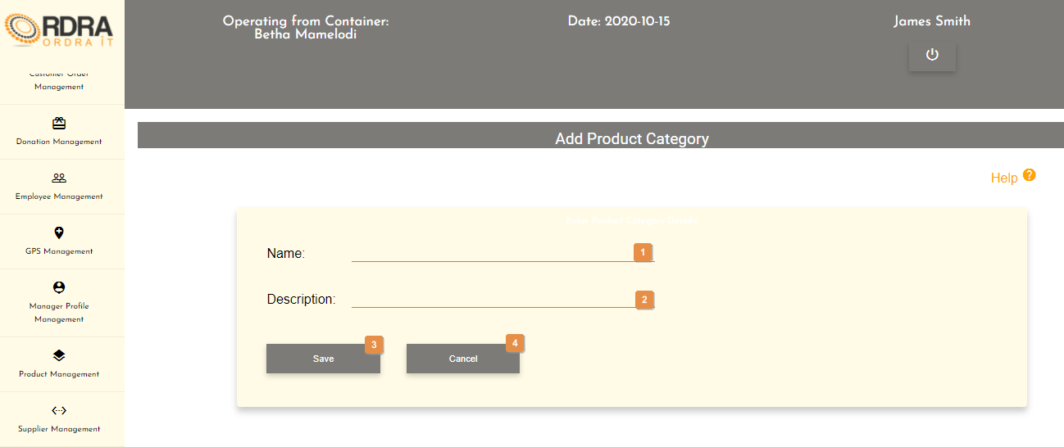

* **Detailed description of the controls:**

|  |  |  |
| --- | --- | --- |
| Reference | Control | Functionality Description |
| 1 | Name input field | Click here to make an entry for the product category name. |
| 2 | Description input field | Click here to make an entry for product category description. |
| 3 | Save Button | Click the Save button, a confirmation box will appear to confirm the adding of a product category. |
| 4 | Cancel Button | Re-direct you to the Product Management screen. Click this button to cancel adding of a product category. |

* **Possible Error Messages:** Please refer to the Error and Confirmation Messages, Error Messages, Validation Error Message, Duplicate Entry Message, Item in Use message, Other Messages to view the possible error message(s)).

*Created with the Personal Edition of HelpNDoc:* [*Free Qt Help documentation generator*](https://www.helpndoc.com)

Update Product Category

Allows the user to update an existing product category in the system.

* **Navigation process:**
  1. Clicking the Product Category button on the Product Management screen.



* 1. Clicking the Update Product Category button in the Product Category Card.



* 1. Clicking on the Input Criteria button on the Search Product Category screen.

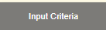

* **Complete layout:**

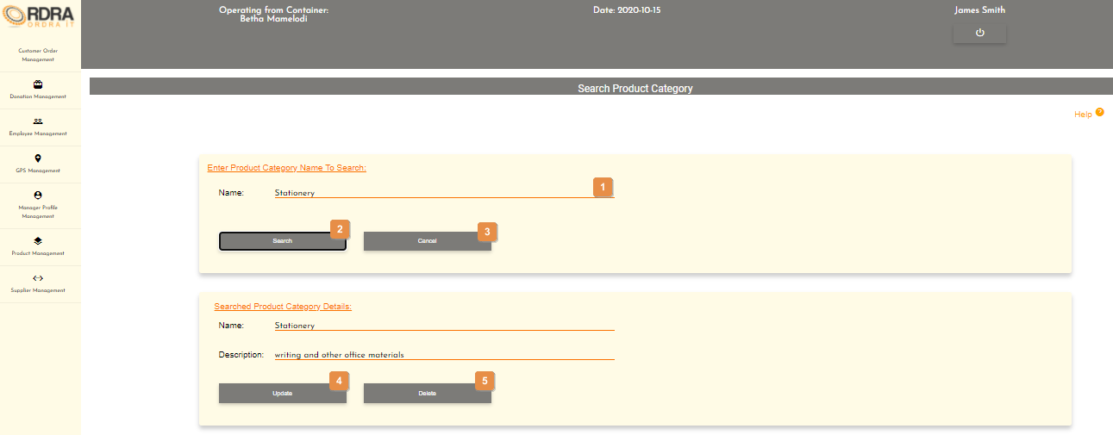

* **Detailed description of the controls:**

|  |  |  |
| --- | --- | --- |
| Reference | Control | Functionality Description |
| 1 | Search Name input field | Click here to make an entry for the product category name to search. |
| 2 | Search Button | This button will display the Search Product Category Details card if the product category exists in the system. |
| 3 | Cancel Button | Re-direct you to the Product Management screen. Click this button to cancel the search of a product category. |
| 4 | Update Button | This button will allow the updating of the details in the Searched Product Category Details card. When clicked, it makes all the input fields, in which changes can be made editable. The following buttons will be visible on the screen, to either save or cancel the option to update the details.    Click the Save button, a confirmation message will appear to confirm the update.  Click the Cancel button, a confirmation message will appear to confirm the cancellation. |
| 5 | Delete Button | Click the Delete button, a confirmation message will appear to confirm the deletion. |

* **Possible Error Messages:** Please refer to the Error and Confirmation Messages, Error Messages, Validation Error Message, Duplicate Entry Message, Item in Use message, Other Messages to view the possible error message(s)).

*Created with the Personal Edition of HelpNDoc:* [*Create cross-platform Qt Help files*](https://www.helpndoc.com/feature-tour/create-help-files-for-the-qt-help-framework)

Search Product Category

Allows the user to search existing product categories in the system.

* **Navigation process:**
  1. Clicking the Product Category button on the Product Management screen.



* 1. Clicking the Search Product Category button in the Product Category Card.



* **Complete layout:**

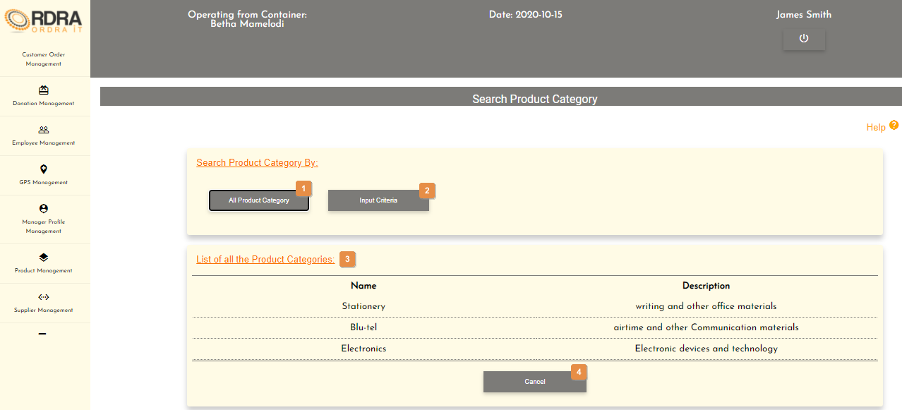

* **Detailed description of the controls:**

|  |  |  |
| --- | --- | --- |
| Reference | Control | Functionality Description |
| 1 | All Product Category Button | This button will display the List of all the product categories card with a table of all the product categories that exists in the system. |
| 2 | Input Criteria Button | This button will display the Search Product Category Details card if the product category exists in the system. |
| 3 | List of all the Product Categories table | Shows a list of all the product categories that exists in the system. |
| 4 | Cancel Button | Re-direct you to the Product Management screen. Click this button to cancel the search of all product category. |

* **Possible Error Messages:** Please refer to the Error and Confirmation Messages, Error Messages, Validation Error Message, Duplicate Entry Message, Item in Use message, Other Messages to view the possible error message(s)).

*Created with the Personal Edition of HelpNDoc:* [*Qt Help documentation made easy*](https://www.helpndoc.com/feature-tour/create-help-files-for-the-qt-help-framework)

Remove Product Category

Allows the user to remove an existing product category from the system.

* **Navigation process:**
  1. Clicking the Product Category button on the Product Management screen.



* 1. Clicking the Remove Product Category button in the Product Category Card.



* 1. Clicking on the Input Criteria button on the Search Product Category screen.



* **Complete layout:**



* **Detailed description of the controls:**

|  |  |  |
| --- | --- | --- |
| Reference | Control | Functionality Description |
| 1 | Search Name input field | Click here to make an entry for the product category name to search. |
| 2 | Search Button | This button will display the Search Product Category Details card if the product category exists in the system. |
| 3 | Cancel Button | Re-direct you to the Product Management screen. Click this button to cancel the search of a product category. |
| 4 | Update Button | This button will allow the updating of the details in the Searched Product Category Details card. When clicked, it makes all the input fields, in which changes can be made editable. The following buttons will be visible on the screen, to either save or cancel the option to update the details.    Click the Save button, a confirmation message will appear to confirm the update.  Click the Cancel button, a confirmation message will appear to confirm the cancellation. |
| 5 | Delete Button | Click the Delete button, a confirmation message will appear to confirm the deletion. |

* **Possible Error Messages:** Please refer to the Error and Confirmation Messages, Error Messages, Validation Error Message, Duplicate Entry Message, Item in Use message, Other Messages to view the possible error message(s)).

*Created with the Personal Edition of HelpNDoc:* [*Free help authoring environment*](https://www.helpndoc.com/help-authoring-tool)

**Supplier**

*Created with the Personal Edition of HelpNDoc:* [*Generate Kindle eBooks with ease*](https://www.helpndoc.com/feature-tour/create-ebooks-for-amazon-kindle)

Supplier Management Screen

This screen allows the user to navigate through the supplier management screen to add, update, remove or search through the relevant suppliers.

* **Navigation process:**
  1. Click on the Supplier Management button in the Navbar.

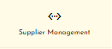

* **Complete layout:**

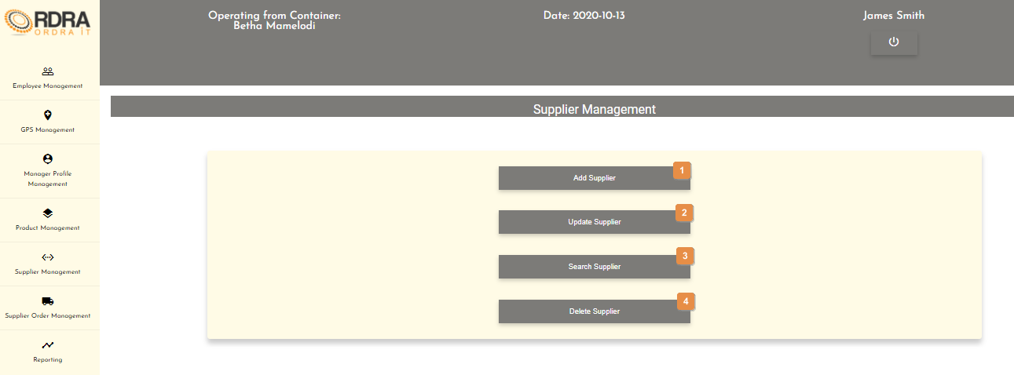

* **Detailed description of the controls:**

|  |  |  |
| --- | --- | --- |
| Reference | Control | Functionality Description |
| 1 | Add Supplier Button | Re-directs you to the Add Supplier screen. Click this button to add a new supplier into the system. |
| 2 | Update Supplier Button | Re-directs you to the Supplier Details screen. Click this button to search a specific supplier in the system you want to update. |
| 3 | Search Supplier Button | Re-directs you to the Supplier Details screen. Click this button to search a supplier in the system. |
| 4 | Delete Supplier Button | Re-directs you to the Supplier Details screen. Click this button to search a specific supplier in the system you want to remove. |

*Created with the Personal Edition of HelpNDoc:* [*Easily create HTML Help documents*](https://www.helpndoc.com/feature-tour)

Add Supplier

Allows the user to add a new supplier into the system.

* **Navigation process:**
  1. Clicking the Add Supplier button on the Supplier Management screen.



* **Complete layout:**

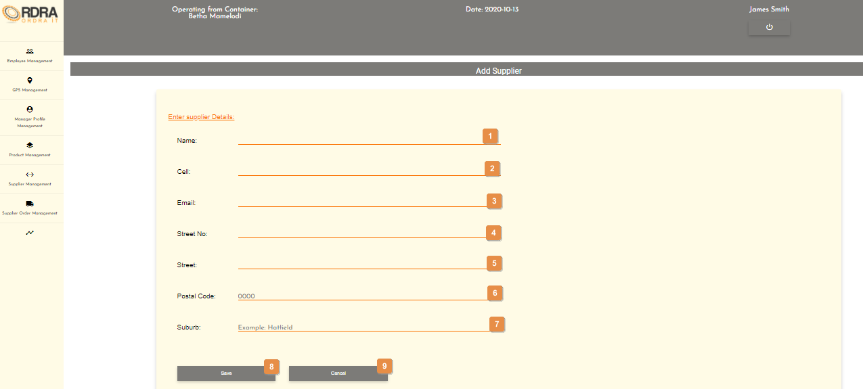

* **Detailed description of the controls:**

|  |  |  |
| --- | --- | --- |
| Reference | Control | Functionality Description |
| 1 | Name input field | Click here to make an entry for the supplier name. |
| 2 | Cell input field | Click here to make an entry for the supplier cell. |
| 3 | Email input field | Click here to make an entry for the supplier email. |
| 4 | Street No. input field | Click here to make an entry for the supplier street no. |
| 5 | Street input field | Click here to make an entry for the supplier street. |
| 6 | Postal Code input field | Click here to make an entry for the supplier postal code. |
| 7 | Suburb input field | Click here to make an entry for the supplier suburb. |
| 8 | Save Button | Click the Save button, a confirmation massage will appear to confirm the adding of a supplier. |
| 9 | Cancel Button | Re-direct you to the Customer Management screen. Click this button to cancel adding a supplier. |

* **Possible Error Messages:** Please refer to the Error and Confirmation Messages, Error Messages, Validation Error Message, Duplicate Entry Message, Item in Use message, Other Messages to view the possible error message(s)).

*Created with the Personal Edition of HelpNDoc:* [*Free Kindle producer*](https://www.helpndoc.com/feature-tour/create-ebooks-for-amazon-kindle)

Update Supplier

Allows the user to update an existing supplier in the system.

* **Navigation process:**
  1. Clicking the Update Supplier button on the Supplier Management screen.



* 1. Clicking the Search button once you have entered the supplier’s name, you want to update in the system on the Supplier Details screen.



* **Complete layout:**

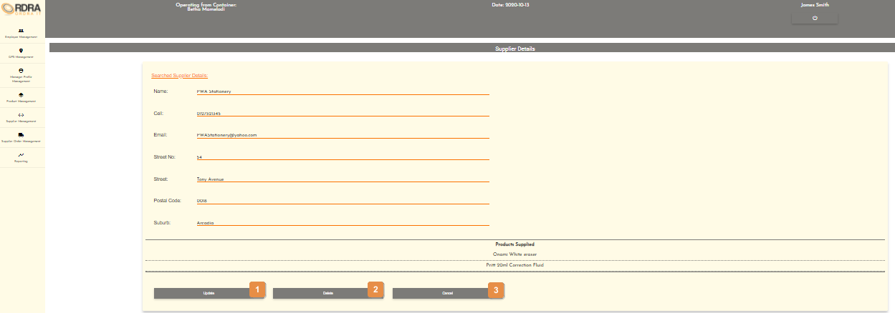

* **Detailed description of the controls:**

|  |  |  |
| --- | --- | --- |
| Reference | Control | Functionality Description |
| 1 | Update Button | This button will allow the updating of the details in the Searched Supplier Details card. When clicked, it makes all the input fields, in which changes can be made editable. The following buttons will be visible on the screen, to either save or cancel the option to update the details.    Click the Save button, a confirmation message will appear to confirm the update.  Click the Cancel button, re-directs you to the Supplier Management screen which cancels the update. |
| 2 | Delete Button | Click the Delete button, an alert message will appear to notify the user. |
| 3 | Cancel Button | Re-direct you to the Supplier Management screen. Click this button to cancel search. |

* **Possible Error Messages:** Please refer to the Error and Confirmation Messages, Error Messages, Validation Error Message, Duplicate Entry Message, Item in Use message, Other Messages to view the possible error message(s)).

*Created with the Personal Edition of HelpNDoc:* [*News and information about help authoring tools and software*](https://www.helpauthoringsoftware.com)

Search Supplier

Allows the user to search existing suppliers in the system.

* **Navigation process:**
  1. Clicking the Search Supplier button on the Supplier Management screen.



* **Complete layout:**

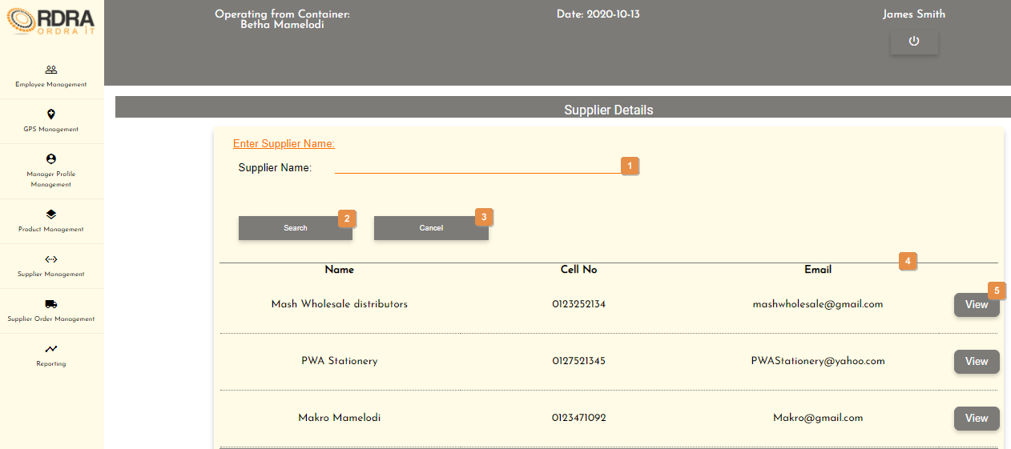

* **Detailed description of the controls:**

|  |  |  |
| --- | --- | --- |
| Reference | Control | Functionality Description |
| 1 | Supplier Name input field | Click here to make an entry for the supplier name you want to search. |
| 2 | Search Button | Re-direct you to the Searched Supplier Details screen. Click this button once you have entered the supplier’s name, you want to search. |
| 3 | Cancel Button | Re-direct you to the Supplier Management screen. Click this button to cancel search. |
| 4 | List of all the supplier table | Shows a list of all the supplier that exists in the system. |
| 5 | View Button | Click this button will display the Searched Supplier Details card with that supplier’s details. |

* **Possible Error Messages:** Please refer to the Error and Confirmation Messages, Error Messages, Validation Error Message, Duplicate Entry Message, Item in Use message, Other Messages to view the possible error message(s)).

*Created with the Personal Edition of HelpNDoc:* [*Produce electronic books easily*](https://www.helpndoc.com/create-epub-ebooks)

Delete Supplier

Allows the user to remove an existing supplier from the system.

* **Navigation process:**
  1. Clicking the Delete Supplier button on the Supplier Management screen.



* 1. Clicking the Search button once you have entered the supplier’s name, you want to remove from the system on the Supplier Details screen.



* **Complete layout:**



* **Detailed description of the controls:**

|  |  |  |
| --- | --- | --- |
| Reference | Control | Functionality Description |
| 1 | Update Button | This button will allow the updating of the details in the Searched Supplier Details card. When clicked, it makes all the input fields, in which changes can be made editable. The following buttons will be visible on the screen, to either save or cancel the option to update the details.    Click the Save button, a confirmation message will appear to confirm the update.  Click the Cancel button, re-directs you to the Supplier Management screen which cancels the update. |
| 2 | Delete Button | Click the Delete button, an alert message will appear to notify the user. |
| 3 | Cancel Button | Re-direct you to the Supplier Management screen. Click this button to cancel search. |

* **Possible Error Messages:** Please refer to the Error and Confirmation Messages, Error Messages, Validation Error Message, Duplicate Entry Message, Item in Use message, Other Messages to view the possible error message(s)).

*Created with the Personal Edition of HelpNDoc:* [*Easy to use tool to create HTML Help files and Help web sites*](https://www.helpndoc.com/help-authoring-tool)

**Product**

*Created with the Personal Edition of HelpNDoc:* [*Easily create CHM Help documents*](https://www.helpndoc.com/feature-tour)

Product Management Screen

This screen allows the user to navigate through the product management screen to access the Product, Product Category and Vat options and their relevant functions that each option provides.

* **Navigation process:**
  1. Click on the Product Management button in the Navbar.



* **Complete layout:**



* **Detailed description of the controls:**

|  |  |  |
| --- | --- | --- |
| Reference | Control | Functionality Description |
| 1 | Product Button | Clicking this button will make the Product card visible with various buttons related to the Product. |
| 2 | Product Category Button | Clicking this button will make the Product Category card visible with various buttons related to the Product Category. |
| 3 | Vat Button | Clicking this button will make the VAT card visible with various buttons related to the Vat. |

*Created with the Personal Edition of HelpNDoc:* [*Easily create EBooks*](https://www.helpndoc.com/feature-tour)

Add Product

Allows the user to add a new product into the system as well as linking existing products to various containers.

* **Navigation process:**
  1. Clicking the Product button on the Product Management screen.



* 1. Clicking the Add Product button in the Product Card.



* **Complete layout:**

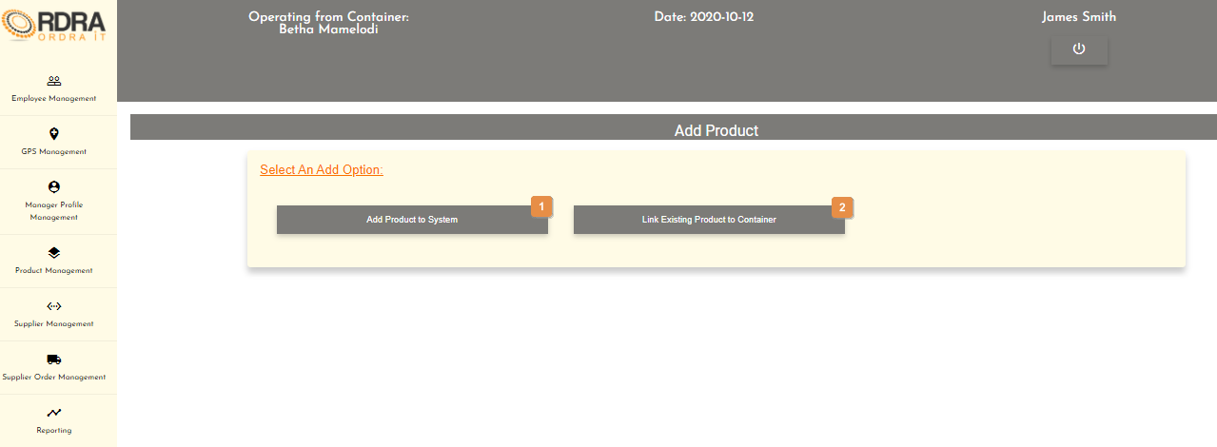

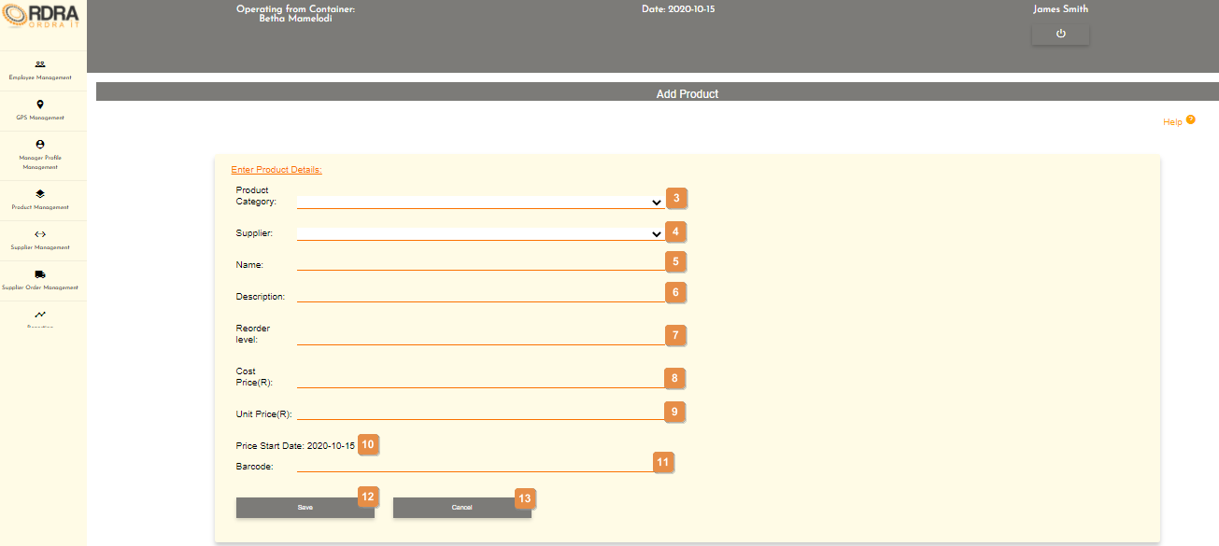

* **Detailed description of the controls:**

|  |  |  |
| --- | --- | --- |
| Reference | Control | Functionality Description |
| 1 | Add Product to System Button | Click the Add Product to System button will display the Product Details card which is where the user will then enter all the details of the new product being added to the system. |
| 2 | Link Existing Product to Container Button | Click the Link Existing Product to Container button will display the Move Product card which is where the user will then be able to link the existing products to the containers.     |  |  |  | | --- | --- | --- | | Reference | Control | Functionality Description | | 1 | Product Select Box | Click the select box will display all the existing products. User selects the product that needs to be linked to a container. | | 2 | Container Select Box | Click the select box will display all the containers. User selects the container that the product should be linked to. | | 3 | Link Button | Click the Link button, an alert message will appear to notify the user. | | 4 | Remove Link Button | Click the Remove Link button, an alert message will appear to notify the user. | | 5 | Cancel Button | Re-direct you to the Product Management screen. Click this button to cancel linking of a product to a container. | |
| 3 | Product Category Select Box | Click the select box will display all the product categories. User selects the product category that the new product falls under. |
| 4 | Supplier Select Box | Click the select box will display all the suppliers. User selects the supplier that the new product will come from. |
| 5 | Name input field | Click here to make an entry for the product name. |
| 6 | Description input field | Click here to make an entry for the product description. |
| 7 | Reorder level input field | Click here to make an entry for the product reorder level. |
| 8 | Cost Price input field | Click here to make an entry for the product cost price. |
| 9 | Unit Price input field | Click here to make an entry for the product unit price. |
| 10 | Price Start Date | Price Start Date is automatically set to the current date. |
| 11 | Barcode input field | Click here to make an entry for the product barcode. |
| 12 | Save Button | Click the Save button, a confirmation massage will appear to confirm the adding of a product. |
| 13 | Cancel Button | Re-direct you to the Product Management screen. Click this button to cancel adding a product. |

* **Possible Error Messages:** Please refer to the Error and Confirmation Messages, Error Messages, Validation Error Message, Duplicate Entry Message, Item in Use message, Other Messages to view the possible error message(s)).

*Created with the Personal Edition of HelpNDoc:* [*Easily create CHM Help documents*](https://www.helpndoc.com/feature-tour)

Update Product

Allows the user to update an existing product in the system.

* **Navigation process:**
  1. Clicking the Product button on the Product Management screen.



* 1. Clicking the Update Product button in the Product Card.



* **Complete layout:**

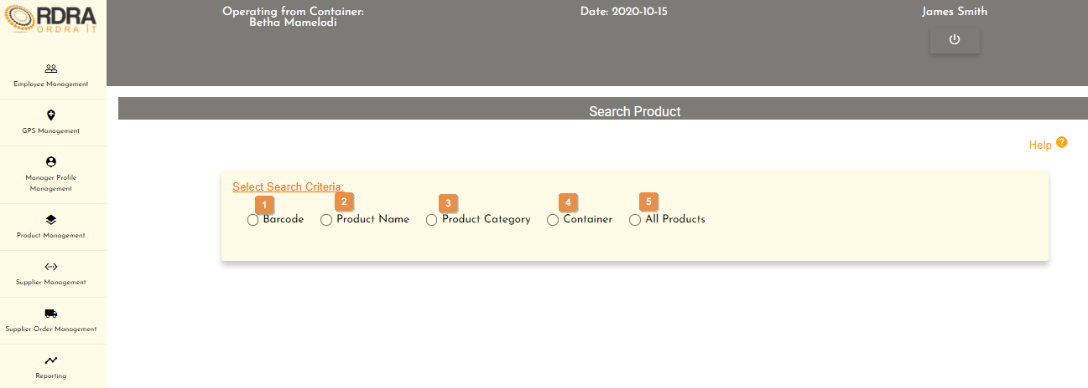

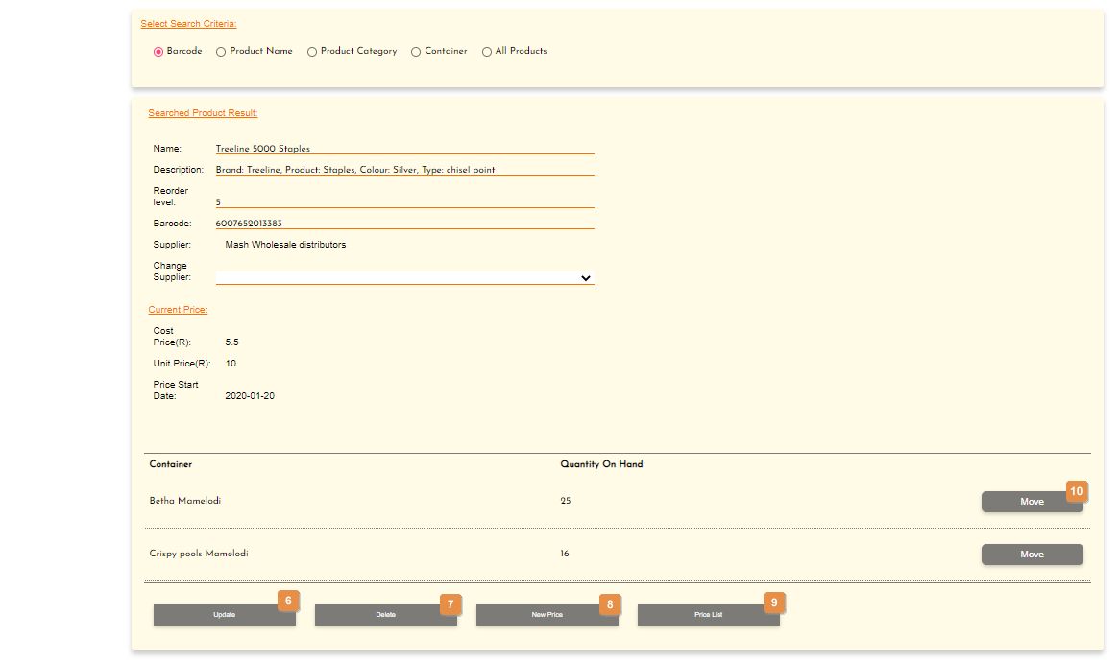

* **Detailed description of the controls:**

|  |  |  |
| --- | --- | --- |
| Reference | Control | Functionality Description |
| 1 | Barcode Radio Button | This radio button will allow the user to search a product by the product barcode. Clicking this radio button will make visible the barcode input field on the screen.     |  |  |  | | --- | --- | --- | | Reference | Control | Functionality Description | | 1 | Barcode input field | Click here to make an entry for the product barcode. | | 2 | Search Button | Click this button will display the Searched Product Result Card which is populated with that products details searched. (See second screen shot above under complete layout) | | 3 | Cancel Button | Re-direct you to the Product Management screen. Click this button to cancel the search. | |
| 2 | Product Name Radio Button | This radio button will allow the user to search a product by the product name. Clicking this radio button will make visible the product select box on the screen.     |  |  |  | | --- | --- | --- | | Reference | Control | Functionality Description | | 1 | Product Select Box | Click the select box will display all the products. User selects the product name that he wants to search. | | 2 | Search Button | Click this button will display the Searched Product Result Card which is populated with that products details searched. (See second screen shot above under complete layout) | | 3 | Cancel Button | Re-direct you to the Product Management screen. Click this button to cancel the search. | |
| 3 | Product Category Radio Button | This radio button will allow the user to search a product by the product category. Clicking this radio button will make visible the product category select box on the screen.     |  |  |  | | --- | --- | --- | | Reference | Control | Functionality Description | | 1 | Product Category Select Box | Click the select box will display all the product categories. User selects the product category that he wants to search. | | 2 | Search Button | Click this button will display the Searched Products List Card which is a list of all the products that fall under that specific category.  Next to each product listed is a view button and a cancel button below the list.    Click the view button, will display the Searched Product Result Card which is populated with that products details    Re-direct you to the Product Management screen. Click this button to cancel the search. | | 3 | Cancel Button | Re-direct you to the Product Management screen. Click this button to cancel the search. | |
| 4 | Container Radio Button | This radio button will allow the user to search a product by the container. Clicking this radio button will make visible the container select box on the screen.     |  |  |  | | --- | --- | --- | | Reference | Control | Functionality Description | | 1 | Container Select Box | Click the select box will display all the containers. User selects the container that he wants to search. | | 2 | Search Button | Click this button will display the Searched Container Results Card which is a list of all the products that fall under that specific container.  Next to each product listed is a view button and a cancel button below the list.    Click the view button, will display the Searched Product Result Card which is populated with that products details    Re-direct you to the Product Management screen. Click this button to cancel the search. | | 3 | Cancel Button | Re-direct you to the Product Management screen. Click this button to cancel the search. | |
| 5 | All Products Radio Button | This radio button will make visible the search button and cancel button.     |  |  |  | | --- | --- | --- | | Reference | Control | Functionality Description | | 1 | Search Button | Click this button will display the Searched Products List Card which is a list of all the products.  Next to each product listed is a view button and a cancel button below the list.    Click the view button, will display the Searched Product Result Card which is populated with that products details    Re-direct you to the Product Management screen. Click this button to cancel the search. | | 2 | Cancel Button | Re-direct you to the Product Management screen. Click this button to cancel the search. | |
| 6 | Update Button | This button will allow the updating of the details in the Searched Product Result Card. When clicked, it makes all the input fields, in which changes can be made editable. The following buttons will be visible on the screen, to either save or cancel the option to update the details.    Click the Save button, a confirmation message will appear to confirm the update.  Click the Cancel button, to cancel the updating of the product and return to the Product Management screen. |
| 7 | Delete Button | Click the Delete button, an alert message will appear to notify the user. |
| 8 | New Price Button | Click this button will make visible the New Price Details on the Searched Product Result Card.     |  |  |  | | --- | --- | --- | | Reference | Control | Functionality Description | | 1 | Cost Price input field | Click here to make an entry for the product cost price. | | 2 | Unit Price input field | Click here to make an entry for the product unit price. | | 3 | Price Start Date | Price Start Date is automatically set to the current date. | | 4 | Save Button | Click the Save button, an alert message will appear to notify the user. | |
| 9 | Price List Button | Click this button will make visible the Price List table that contains the list of prices of that specific product. |
| 10 | Move Button | Click this button will display the Move Card for that specific product the user wants to move that product to different container.     |  |  |  | | --- | --- | --- | | Reference | Control | Functionality Description | | 1 | Container Select Box | Click the select box will display all the containers which the user will select the container he wants to move some of that product to. | | 2 | Quantity input field | Click here to make an entry for the quantity that needs to be move to the container selected. | | 3 | Move Button | Click the Move button, an alert message will appear to notify the user. | | 4 | Cancel Button | Re-direct you to the Product Management screen. Click this button to cancel the movement of the product. | |

* **Possible Error Messages:** Please refer to the Error and Confirmation Messages, Error Messages, Validation Error Message, Duplicate Entry Message, Item in Use message, Other Messages to view the possible error message(s)).

*Created with the Personal Edition of HelpNDoc:* [*Free EPub and documentation generator*](https://www.helpndoc.com)

Search Product

Allows the user to search existing products in the system.

* **Navigation process:**
  1. Clicking the Product button on the Product Management screen.



* 1. Clicking the Search Product button in the Product Card.



* **Complete layout:**





* **Detailed description of the controls:**

|  |  |  |
| --- | --- | --- |
| Reference | Control | Functionality Description |
| 1 | Barcode Radio Button | This radio button will allow the user to search a product by the product barcode. Clicking this radio button will make visible the barcode input field on the screen.     |  |  |  | | --- | --- | --- | | Reference | Control | Functionality Description | | 1 | Barcode input field | Click here to make an entry for the product barcode. | | 2 | Search Button | Click this button will display the Searched Product Result Card which is populated with that products details searched. (See second screen shot above under complete layout) | | 3 | Cancel Button | Re-direct you to the Product Management screen. Click this button to cancel the search. | |
| 2 | Product Name Radio Button | This radio button will allow the user to search a product by the product name. Clicking this radio button will make visible the product select box on the screen.     |  |  |  | | --- | --- | --- | | Reference | Control | Functionality Description | | 1 | Product Select Box | Click the select box will display all the products. User selects the product name that he wants to search. | | 2 | Search Button | Click this button will display the Searched Product Result Card which is populated with that products details searched. (See second screen shot above under complete layout) | | 3 | Cancel Button | Re-direct you to the Product Management screen. Click this button to cancel the search. | |
| 3 | Product Category Radio Button | This radio button will allow the user to search a product by the product category. Clicking this radio button will make visible the product category select box on the screen.     |  |  |  | | --- | --- | --- | | Reference | Control | Functionality Description | | 1 | Product Category Select Box | Click the select box will display all the product categories. User selects the product category that he wants to search. | | 2 | Search Button | Click this button will display the Searched Products List Card which is a list of all the products that fall under that specific category.  Next to each product listed is a view button and a cancel button below the list.    Click the view button, will display the Searched Product Result Card which is populated with that products details    Re-direct you to the Product Management screen. Click this button to cancel the search. | | 3 | Cancel Button | Re-direct you to the Product Management screen. Click this button to cancel the search. | |
| 4 | Container Radio Button | This radio button will allow the user to search a product by the container. Clicking this radio button will make visible the container select box on the screen.     |  |  |  | | --- | --- | --- | | Reference | Control | Functionality Description | | 1 | Container Select Box | Click the select box will display all the containers. User selects the container that he wants to search. | | 2 | Search Button | Click this button will display the Searched Container Results Card which is a list of all the products that fall under that specific container.  Next to each product listed is a view button and a cancel button below the list.    Click the view button, will display the Searched Product Result Card which is populated with that products details    Re-direct you to the Product Management screen. Click this button to cancel the search. | | 3 | Cancel Button | Re-direct you to the Product Management screen. Click this button to cancel the search. | |
| 5 | All Products Radio Button | This radio button will make visible the search button and cancel button.     |  |  |  | | --- | --- | --- | | Reference | Control | Functionality Description | | 1 | Search Button | Click this button will display the Searched Products List Card which is a list of all the products.  Next to each product listed is a view button and a cancel button below the list.    Click the view button, will display the Searched Product Result Card which is populated with that products details    Re-direct you to the Product Management screen. Click this button to cancel the search. | | 2 | Cancel Button | Re-direct you to the Product Management screen. Click this button to cancel the search. | |
| 6 | Update Button | This button will allow the updating of the details in the Searched Product Result Card. When clicked, it makes all the input fields, in which changes can be made editable. The following buttons will be visible on the screen, to either save or cancel the option to update the details.    Click the Save button, a confirmation message will appear to confirm the update.  Click the Cancel button, to cancel the updating of the product and return to the Product Management screen. |
| 7 | Delete Button | Click the Delete button, an alert message will appear to notify the user. |
| 8 | New Price Button | Click this button will make visible the New Price Details on the Searched Product Result Card.     |  |  |  | | --- | --- | --- | | Reference | Control | Functionality Description | | 1 | Cost Price input field | Click here to make an entry for the product cost price. | | 2 | Unit Price input field | Click here to make an entry for the product unit price. | | 3 | Price Start Date | Price Start Date is automatically set to the current date. | | 4 | Save Button | Click the Save button, an alert message will appear to notify the user. | |
| 9 | Price List Button | Click this button will make visible the Price List table that contains the list of prices of that specific product. |
| 10 | Move Button | Click this button will display the Move Card for that specific product the user wants to move that product to different container.     |  |  |  | | --- | --- | --- | | Reference | Control | Functionality Description | | 1 | Container Select Box | Click the select box will display all the containers which the user will select the container he wants to move some of that product to. | | 2 | Quantity input field | Click here to make an entry for the quantity that needs to be move to the container selected. | | 3 | Move Button | Click the Move button, an alert message will appear to notify the user. | | 4 | Cancel Button | Re-direct you to the Product Management screen. Click this button to cancel the movement of the product. | |

* **Possible Error Messages:** Please refer to the Error and Confirmation Messages, Error Messages, Validation Error Message, Duplicate Entry Message, Item in Use message, Other Messages to view the possible error message(s)).

*Created with the Personal Edition of HelpNDoc:* [*Easily create EBooks*](https://www.helpndoc.com/feature-tour)

Remove Product

Allows the user to remove a product from the system.

* **Navigation process:**
  1. Clicking the Product button on the Product Management screen.



* 1. Clicking the Remove Product button in the Product Card.



* **Complete layout:**





* **Detailed description of the controls:**

|  |  |  |
| --- | --- | --- |
| Reference | Control | Functionality Description |
| 1 | Barcode Radio Button | This radio button will allow the user to search a product by the product barcode. Clicking this radio button will make visible the barcode input field on the screen.     |  |  |  | | --- | --- | --- | | Reference | Control | Functionality Description | | 1 | Barcode input field | Click here to make an entry for the product barcode. | | 2 | Search Button | Click this button will display the Searched Product Result Card which is populated with that products details searched. (See second screen shot above under complete layout) | | 3 | Cancel Button | Re-direct you to the Product Management screen. Click this button to cancel the search. | |
| 2 | Product Name Radio Button | This radio button will allow the user to search a product by the product name. Clicking this radio button will make visible the product select box on the screen.     |  |  |  | | --- | --- | --- | | Reference | Control | Functionality Description | | 1 | Product Select Box | Click the select box will display all the products. User selects the product name that he wants to search. | | 2 | Search Button | Click this button will display the Searched Product Result Card which is populated with that products details searched. (See second screen shot above under complete layout) | | 3 | Cancel Button | Re-direct you to the Product Management screen. Click this button to cancel the search. | |
| 3 | Product Category Radio Button | This radio button will allow the user to search a product by the product category. Clicking this radio button will make visible the product category select box on the screen.     |  |  |  | | --- | --- | --- | | Reference | Control | Functionality Description | | 1 | Product Category Select Box | Click the select box will display all the product categories. User selects the product category that he wants to search. | | 2 | Search Button | Click this button will display the Searched Products List Card which is a list of all the products that fall under that specific category.  Next to each product listed is a view button and a cancel button below the list.    Click the view button, will display the Searched Product Result Card which is populated with that products details    Re-direct you to the Product Management screen. Click this button to cancel the search. | | 3 | Cancel Button | Re-direct you to the Product Management screen. Click this button to cancel the search. | |
| 4 | Container Radio Button | This radio button will allow the user to search a product by the container. Clicking this radio button will make visible the container select box on the screen.     |  |  |  | | --- | --- | --- | | Reference | Control | Functionality Description | | 1 | Container Select Box | Click the select box will display all the containers. User selects the container that he wants to search. | | 2 | Search Button | Click this button will display the Searched Container Results Card which is a list of all the products that fall under that specific container.  Next to each product listed is a view button and a cancel button below the list.    Click the view button, will display the Searched Product Result Card which is populated with that products details    Re-direct you to the Product Management screen. Click this button to cancel the search. | | 3 | Cancel Button | Re-direct you to the Product Management screen. Click this button to cancel the search. | |
| 5 | All Products Radio Button | This radio button will make visible the search button and cancel button.     |  |  |  | | --- | --- | --- | | Reference | Control | Functionality Description | | 1 | Search Button | Click this button will display the Searched Products List Card which is a list of all the products.  Next to each product listed is a view button and a cancel button below the list.    Click the view button, will display the Searched Product Result Card which is populated with that products details    Re-direct you to the Product Management screen. Click this button to cancel the search. | | 2 | Cancel Button | Re-direct you to the Product Management screen. Click this button to cancel the search. | |
| 6 | Update Button | This button will allow the updating of the details in the Searched Product Result Card. When clicked, it makes all the input fields, in which changes can be made editable. The following buttons will be visible on the screen, to either save or cancel the option to update the details.    Click the Save button, a confirmation message will appear to confirm the update.  Click the Cancel button, to cancel the updating of the product and return to the Product Management screen. |
| 7 | Delete Button | Click the Delete button, an alert message will appear to notify the user. |
| 8 | New Price Button | Click this button will make visible the New Price Details on the Searched Product Result Card.     |  |  |  | | --- | --- | --- | | Reference | Control | Functionality Description | | 1 | Cost Price input field | Click here to make an entry for the product cost price. | | 2 | Unit Price input field | Click here to make an entry for the product unit price. | | 3 | Price Start Date | Price Start Date is automatically set to the current date. | | 4 | Save Button | Click the Save button, an alert message will appear to notify the user. | |
| 9 | Price List Button | Click this button will make visible the Price List table that contains the list of prices of that specific product. |
| 10 | Move Button | Click this button will display the Move Card for that specific product the user wants to move that product to different container.     |  |  |  | | --- | --- | --- | | Reference | Control | Functionality Description | | 1 | Container Select Box | Click the select box will display all the containers which the user will select the container he wants to move some of that product to. | | 2 | Quantity input field | Click here to make an entry for the quantity that needs to be move to the container selected. | | 3 | Move Button | Click the Move button, an alert message will appear to notify the user. | | 4 | Cancel Button | Re-direct you to the Product Management screen. Click this button to cancel the movement of the product. | |

* **Possible Error Messages:** Please refer to the Error and Confirmation Messages, Error Messages, Validation Error Message, Duplicate Entry Message, Item in Use message, Other Messages to view the possible error message(s)).

*Created with the Personal Edition of HelpNDoc:* [*Free help authoring tool*](https://www.helpndoc.com/help-authoring-tool)

Stock Management Screen

This screen allows the user to navigate through the stock management screen to access the Do Stock Take, Complete Stock Take, Search Stock Take and Generate Low Stock Notification options and their relevant functions that each option provides.

* **Navigation process:**
  1. Clicking the Product button on the Product Management screen.



* 1. Clicking the Stock Management button in the Product Card.



* **Complete layout:**

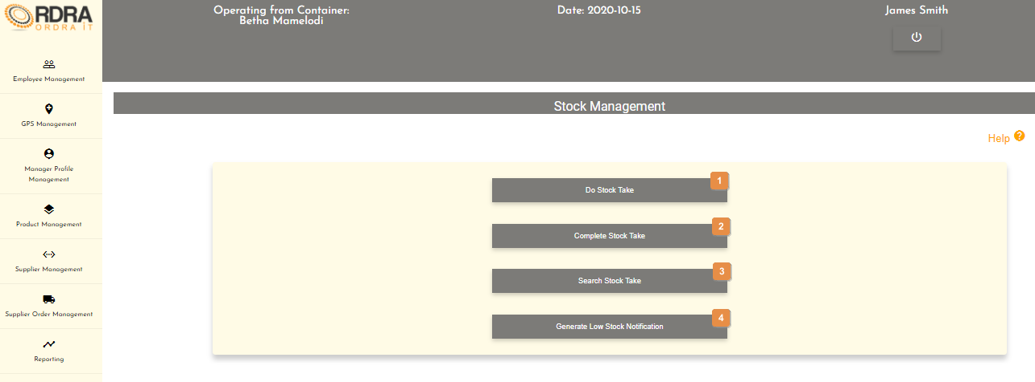

* **Detailed description of the controls:**

|  |  |  |
| --- | --- | --- |
| Reference | Control | Functionality Description |
| 1 | Do Stock Take Button | Re-direct you to the Stock Take Form screen. Click this button to generate the stock take form. |
| 2 | Complete Stock Take Button | Re-direct you to the Complete Stock Take screen. Click this button to complete the stock take. |
| 3 | Search Stock Take Button | Re-direct you to the Search Stock Take screen. Click this button to search for a stock take. |
| 4 | Generate Low Stock Notification Button | Click this button to re-direct to the Low Stock Notification screen. |

*Created with the Personal Edition of HelpNDoc:* [*Full-featured EPub generator*](https://www.helpndoc.com/create-epub-ebooks)

Do Stock Take

Allows the user to generate the stock take form and be able to the stock take form.

* **Navigation process:**
  1. Clicking the Product button on the Product Management screen.



* 1. Clicking the Stock Management button in the Product Card.



* 1. Clicking the Do Stock Take Button in the Stock Management screen.



* **Complete layout:**

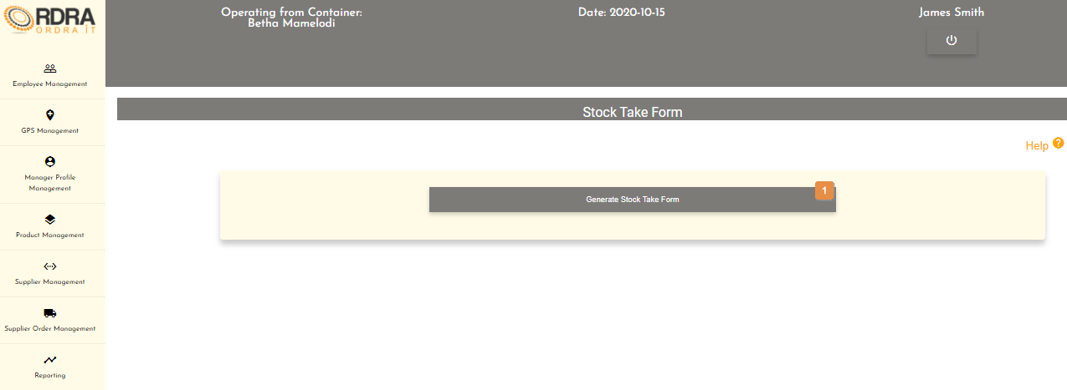

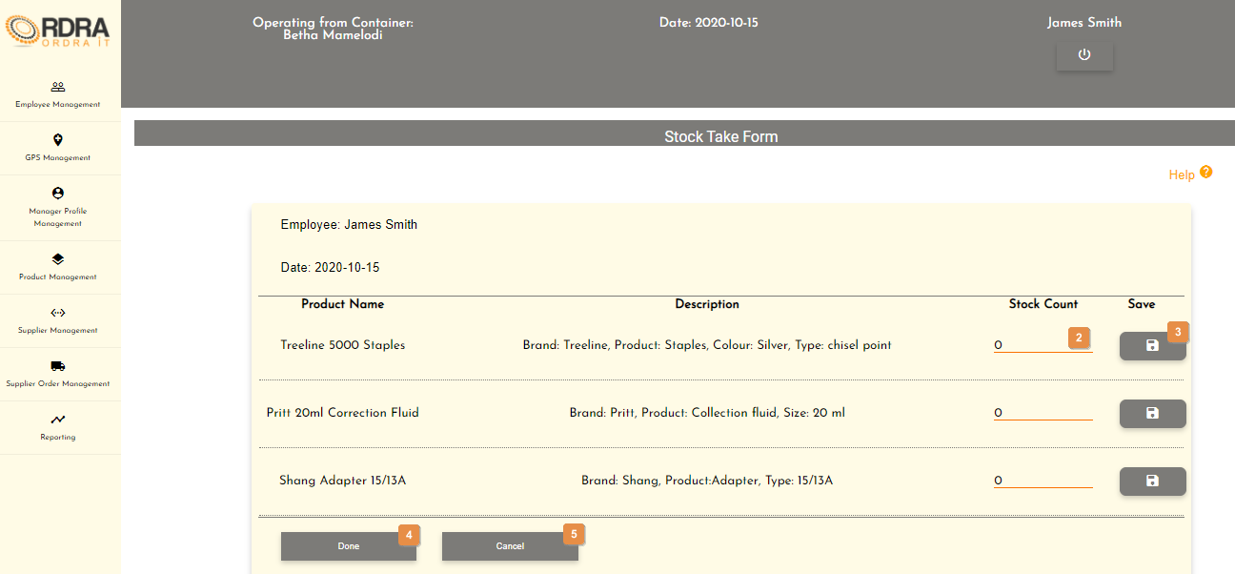

* **Detailed description of the controls:**

|  |  |  |
| --- | --- | --- |
| Reference | Control | Functionality Description |
| 1 | Generate Stock Take Form Button | Click this button to generate the stock take form. |
| 2 | Stock Count input field | Click here to make an entry for the stock count of the product. |
| 3 | Save Button | Click the Save button, will save the stock count. |
| 4 | Done Button | Click the Done button, an alert message will appear to notify the user. |
| 5 | Cancel Button | Re-direct you to the Stock Management screen. Click this button to cancel the stock take. |

* **Possible Error Messages:** Please refer to the Error and Confirmation Messages, Error Messages, Validation Error Message, Duplicate Entry Message, Item in Use message, Other Messages to view the possible error message(s)).

*Created with the Personal Edition of HelpNDoc:* [*Easy CHM and documentation editor*](https://www.helpndoc.com)

Complete Stock Take

Allows the user to complete the stock take.

* **Navigation process:**
  1. Clicking the Product button on the Product Management screen.



* 1. Clicking the Stock Management button in the Product Card.



* 1. Clicking the Do Stock Take Button in the Stock Management screen.



* **Complete layout:**

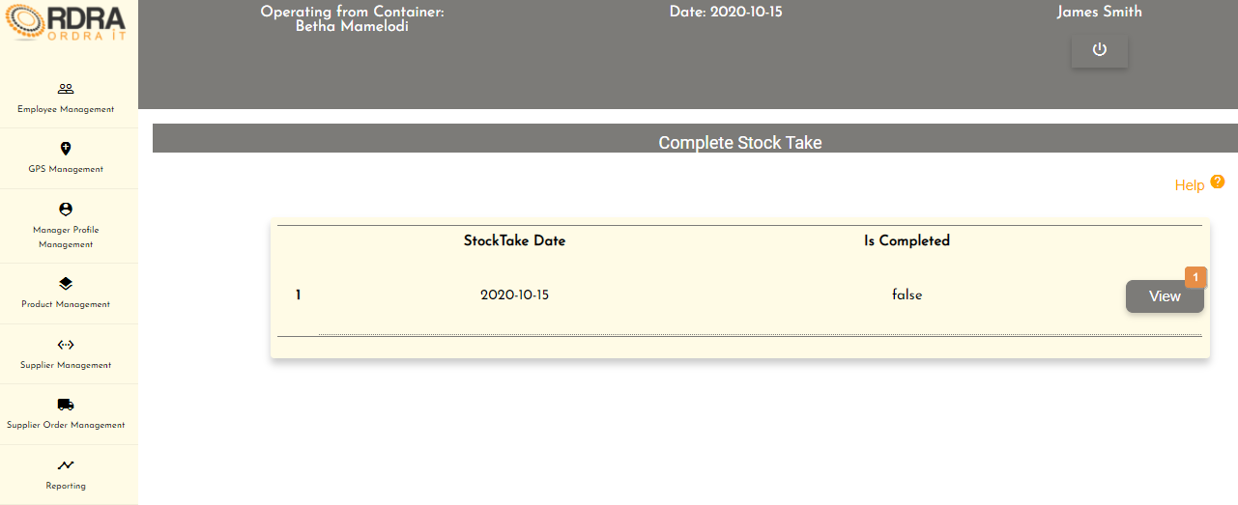

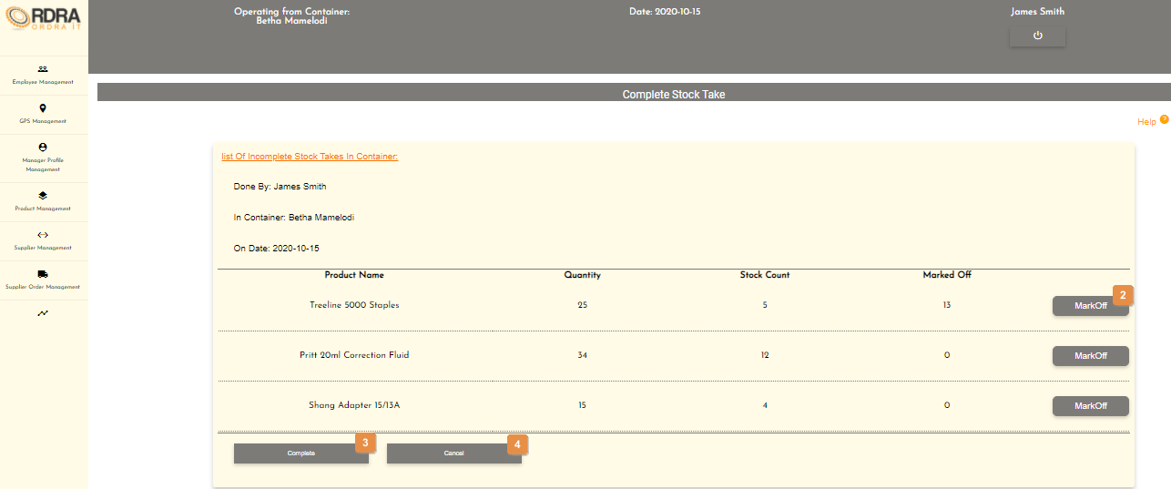

* **Detailed description of the controls:**

|  |  |  |
| --- | --- | --- |
| Reference | Control | Functionality Description |
| 1 | View Button | Click the View button will display the List of Incomplete Stock Take In Container. (See second screen shot above under complete layout) |
| 2 | Mark Off Button | Click the Mark Off button will make the following option below visible.     |  |  |  | | --- | --- | --- | | Reference | Control | Functionality Description | | 1 | Mark Off Reason Select Box | Click the select box will display all the mark off reasons which the user will select the reason why the product is being marked off. | | 2 | Save Button | Click the Save button, will save the marked off reason. | |
| 3 | Complete Button | Click the Complete button, an alert message will appear to notify the user. |
| 4 | Cancel Button | Re-direct you to the Stock Management screen. Click this button to cancel the complete stock take. |

* **Possible Error Messages:** Please refer to the Error and Confirmation Messages, Error Messages, Validation Error Message, Duplicate Entry Message, Item in Use message, Other Messages to view the possible error message(s)).

*Created with the Personal Edition of HelpNDoc:* [*Create cross-platform Qt Help files*](https://www.helpndoc.com/feature-tour/create-help-files-for-the-qt-help-framework)

Search Stock Take

Allows the user to search through the stock takes made in the system.

* **Navigation process:**
  1. Clicking the Product button on the Product Management screen.



* 1. Clicking the Stock Management button in the Product Card.



* 1. Clicking the Search Stock Take Button in the Stock Management screen.



* **Complete layout:**

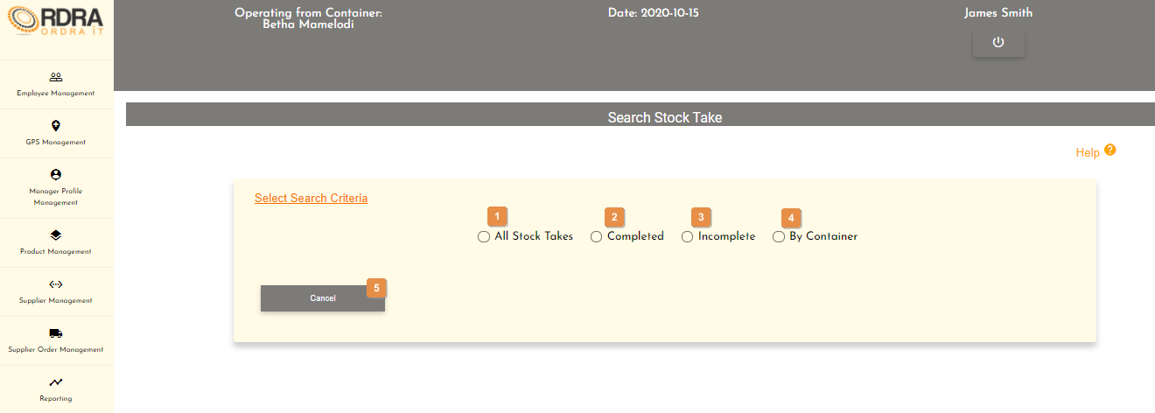

* **Detailed description of the controls:**

|  |  |  |
| --- | --- | --- |
| Reference | Control | Functionality Description |
| 1 | All Stock Takes Radio Button | Clicking this radio button will display a list of all the stock takes in a table format. Next to each listed stock take is a view button and a cancel button at the bottom of the list.    Clicking View button, will display the details of that specific stock take.    Re-direct you to the Stock Management screen. Click this button to cancel the search stock take. |
| 2 | Completed Radio Button | Clicking this radio button will display a list of all the completed stock takes in a table format. Next to each listed stock take is a view button and a cancel button at the bottom of the list.    Clicking View button, will display the details of that specific stock take.    Re-direct you to the Stock Management screen. Click this button to cancel the search stock take. |
| 3 | Incomplete Radio Button | Clicking this radio button will display a list of all the incomplete stock takes in a table format. Next to each listed stock take is a view button and a cancel button at the bottom of the list.    Clicking View button, will display the details of that specific stock take.    Re-direct you to the Stock Management screen. Click this button to cancel the search stock take. |
| 4 | By Container Button | Clicking this radio button will display the container select box to search for the stock take in that specific container selected.     |  |  |  | | --- | --- | --- | | Reference | Control | Functionality Description | | 1 | Container Select Box | Click the select box will display all the mark off reasons which the user will select the reason why the product is being marked off. | | 2 | Search Button | Clicking the Search button will display a list of all the stock takes of the selected container in a table format. Next to each listed stock take is a view button and a cancel button at the bottom of the list.    Clicking View button, will display the details of that specific stock take.    Re-direct you to the Stock Management screen. Click this button to cancel the search stock take. | | 3 | Cancel Button | Re-direct you to the Stock Management screen. Click this button to cancel the search stock take. | |
| 5 | Cancel Button | Re-direct you to the Stock Management screen. Click this button to cancel the search stock take. |

* **Possible Error Messages:** Please refer to the Error and Confirmation Messages, Error Messages, Validation Error Message, Duplicate Entry Message, Item in Use message, Other Messages to view the possible error message(s)).

*Created with the Personal Edition of HelpNDoc:* [*Free Qt Help documentation generator*](https://www.helpndoc.com)

Generate Low Stock Notification

Allows the user to view a list of all the products that are low in stock in and be able to add those listed products to the backlog.

* **Navigation process:**
  1. Clicking the Product button on the Product Management screen.



* 1. Clicking the Stock Management button in the Product Card.



* 1. Clicking the Generate Low Stock Notification Button in the Stock Management screen.



* **Complete layout:**

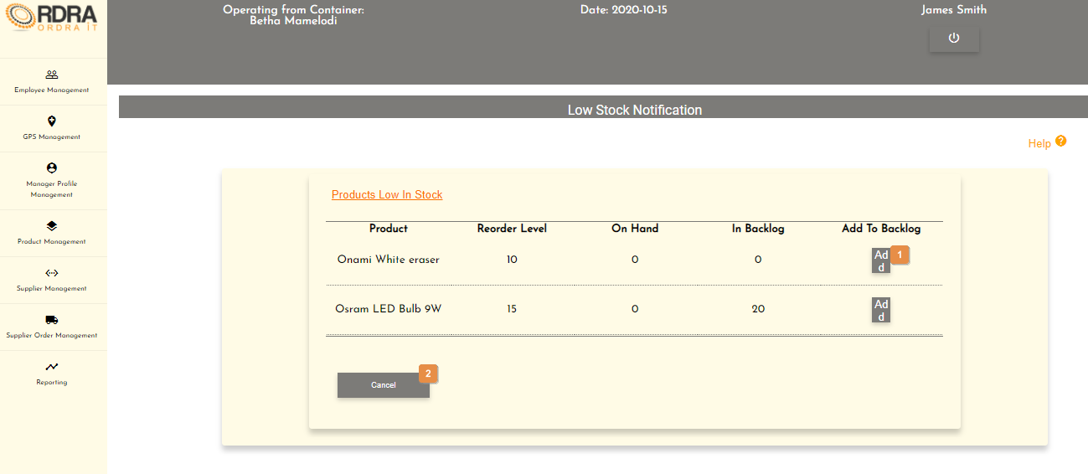

* **Detailed description of the controls:**

|  |  |  |
| --- | --- | --- |
| Reference | Control | Functionality Description |
| 1 | Add Button | Click the Add button, an alert message will appear to notify the user. |
| 2 | Cancel Button | Click this button to re-direct to the Product Management screen. |

**Possible Error Messages:** Please refer to the Error and Confirmation Messages, Error Messages, Validation Error Message, Duplicate Entry Message, Item in Use message, Other Messages to view the possible error message(s)).

*Created with the Personal Edition of HelpNDoc:* [*Free Kindle producer*](https://www.helpndoc.com/feature-tour/create-ebooks-for-amazon-kindle)

Add VAT

Allows the user to add a new vat into the system.

* **Navigation process:**
  1. Clicking the Product button on the Product Management screen.



* 1. Clicking the Add VAT button in the VAT Card.



* **Complete layout:**

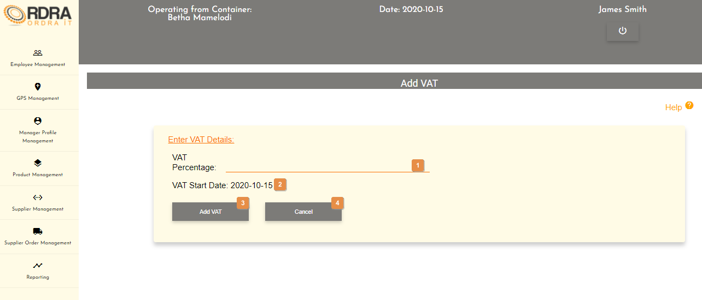

* **Detailed description of the controls:**

|  |  |  |
| --- | --- | --- |
| Reference | Control | Functionality Description |
| 1 | VAT Percentage input field | Click here to make an entry for the VAT Percentage. |
| 2 | VAT Start Date | VAT Start Date is automatically set to the current date. |
| 3 | Add VAT Button | Click the Add VAT button, an alert message will appear to notify the user. |
| 4 | Cancel Button | Re-direct you to the Product Management screen. Click this button to cancel adding the VAT. |

* **Possible Error Messages:** Please refer to the Error and Confirmation Messages, Error Messages, Validation Error Message, Duplicate Entry Message, Item in Use message, Other Messages to view the possible error message(s)).

*Created with the Personal Edition of HelpNDoc:* [*Free CHM Help documentation generator*](https://www.helpndoc.com)

Update VAT

Allows the user to update the vat the system.

* **Navigation process:**
  1. Clicking the Product button on the Product Management screen.



* 1. Clicking the Update VAT button in the VAT Card.



* **Complete layout:**

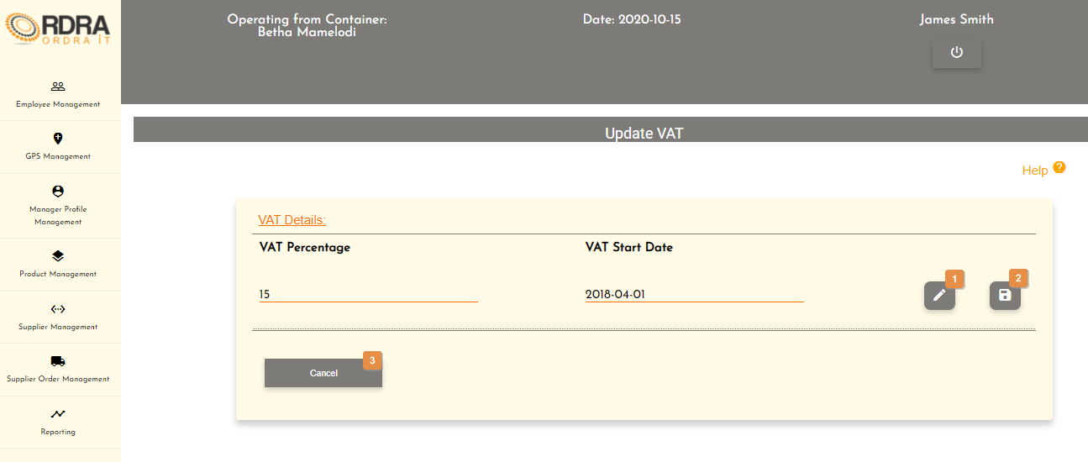

* **Detailed description of the controls:**

|  |  |  |
| --- | --- | --- |
| Reference | Control | Functionality Description |
| 1 | Edit Button | Click this button will enable the VAT Percentage to be editable. |
| 2 | Save Button | Click the Save button, an alert message will appear to notify the user. |
| 3 | Cancel Button | Re-direct you to the Product Management screen. Click this button to cancel updating of VAT. |

* **Possible Error Messages:** Please refer to the Error and Confirmation Messages, Error Messages, Validation Error Message, Duplicate Entry Message, Item in Use message, Other Messages to view the possible error message(s)).

*Created with the Personal Edition of HelpNDoc:* [*Create cross-platform Qt Help files*](https://www.helpndoc.com/feature-tour/create-help-files-for-the-qt-help-framework)

**Customer**

*Created with the Personal Edition of HelpNDoc:* [*Free Kindle producer*](https://www.helpndoc.com/feature-tour/create-ebooks-for-amazon-kindle)

Customer Management Screen

This screen allows the user to navigate through the customer management screen to add, update, remove or search through the relevant customers.

* **Navigation process:**
  1. Click on the Customer Management button in the Navbar.

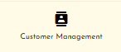

* **Complete layout:**

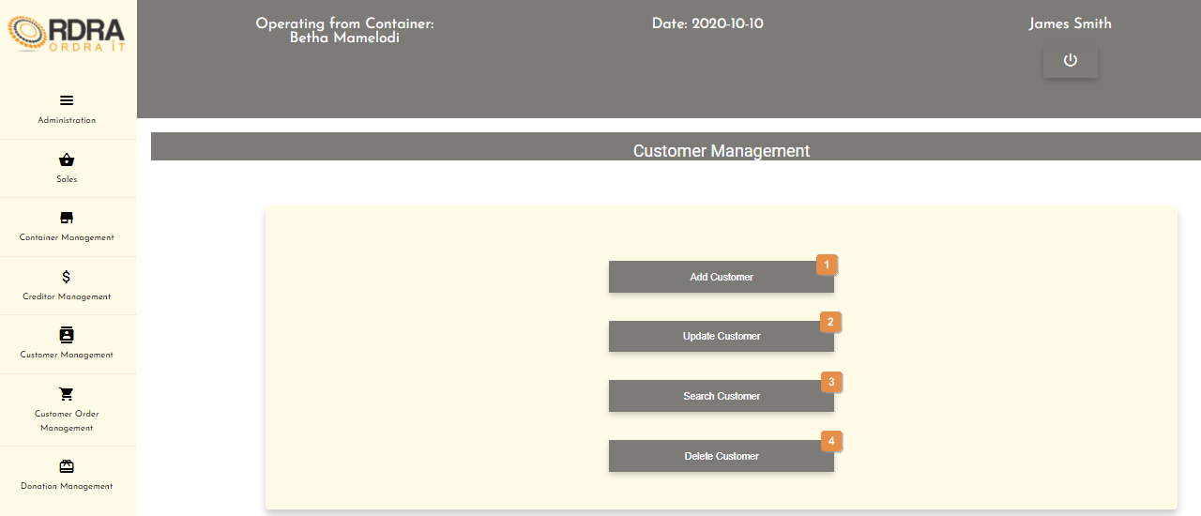

* **Detailed description of the controls:**

|  |  |  |
| --- | --- | --- |
| Reference | Control | Functionality Description |
| 1 | Add Customer Button | Re-directs you to the Add Customer screen. Click this button to add a new customer into the system. |
| 2 | Update Customer Button | Re-directs you to the Customer Details screen. Click this button to search a specific customer in the system you want to update. |
| 3 | Search Customer Button | Re-directs you to the Customer Details screen. Click this button to search a customer in the system. |
| 4 | Delete Customer Button | Re-directs you to the Customer Details screen. Click this button to search a specific customer in the system you want to remove. |

*Created with the Personal Edition of HelpNDoc:* [*Easily create Web Help sites*](https://www.helpndoc.com/feature-tour)

Create Customer

Allows the user to add a new customer into the system.

* **Navigation process:**
  1. Clicking the Add Customer button on the Customer Management screen.



* **Complete layout:**

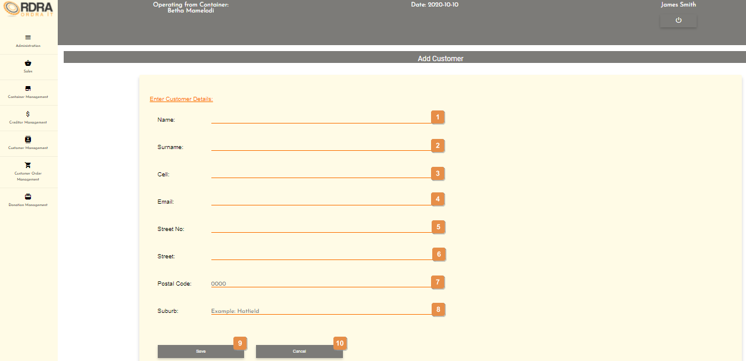

* **Detailed description of the controls:**

|  |  |  |
| --- | --- | --- |
| Reference | Control | Functionality Description |
| 1 | Name input field | Click here to make an entry for the customer name. |
| 2 | Surname input field | Click here to make an entry for the customer surname. |
| 3 | Cell input field | Click here to make an entry for the customer cell. |
| 4 | Email input field | Click here to make an entry for the customer email. |
| 5 | Street No. input field | Click here to make an entry for the customer street no. |
| 6 | Street input field | Click here to make an entry for the customer street. |
| 7 | Postal Code input field | Click here to make an entry for the customer postal code. |
| 8 | Suburb input field | Click here to make an entry for the customer suburb. |
| 9 | Save Button | Click the Save button, a confirmation massage will appear to confirm the adding of a customer. |
| 10 | Cancel Button | Re-direct you to the Customer Management screen. Click this button to cancel adding a customer. |

* **Possible Error Messages:** Please refer to the Error and Confirmation Messages, Error Messages, Validation Error Message, Duplicate Entry Message, Item in Use message, Other Messages to view the possible error message(s)).

*Created with the Personal Edition of HelpNDoc:* [*Easy EBook and documentation generator*](https://www.helpndoc.com)

Update Customer

Allows the user to update an existing customer in the system.

* **Navigation process:**
  1. Clicking the Update Customer button on the Customer Management screen.



* 1. Clicking the search button once you have entered the customer’s name and surname you want to update on the Customer Details screen.



* **Complete layout:**

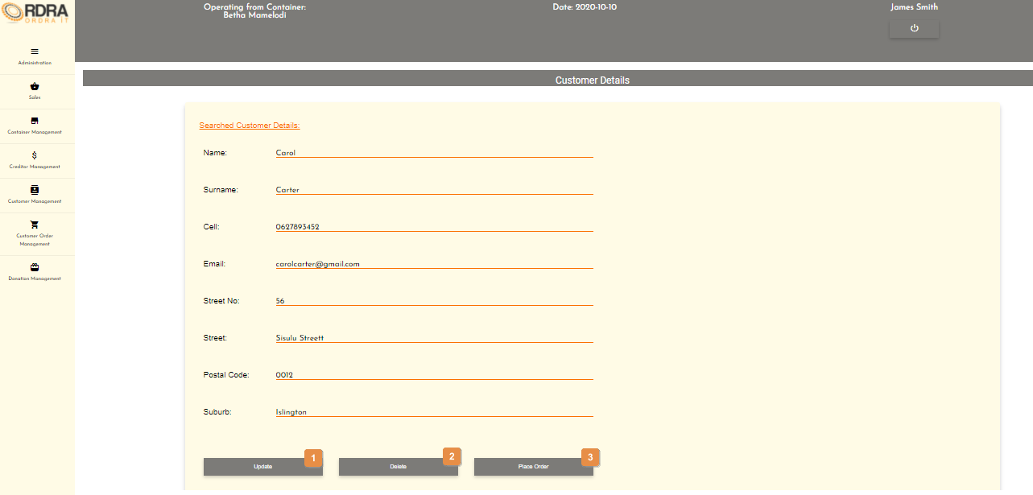

* **Detailed description of the controls:**

|  |  |  |
| --- | --- | --- |
| Reference | Control | Functionality Description |
| 1 | Update Button | This button will allow the updating of the details in the Searched Customer Details card. When clicked, it makes all the input fields, in which changes can be made editable. The following buttons will be visible on the screen, to either save or cancel the option to update the details.    Click the Save button, a confirmation message will appear to confirm the update.  Click the Cancel button, a confirmation message will appear to confirm the cancellation. |
| 2 | Delete Button | Click the Delete button, a confirmation message will appear to confirm the deletion. |
| 3 | Place Order Button | Re-direct you to the Place Order screen. Click this button to place an order. |

* **Possible Error Messages:** Please refer to the Error and Confirmation Messages, Error Messages, Validation Error Message, Duplicate Entry Message, Item in Use message, Other Messages to view the possible error message(s)).

*Created with the Personal Edition of HelpNDoc:* [*Easy EBook and documentation generator*](https://www.helpndoc.com)

Search Customer

Allows the user to search existing customers in the system.

* **Navigation process:**
  1. Clicking the Search Customer button on the Customer Management screen.



* **Complete layout:**

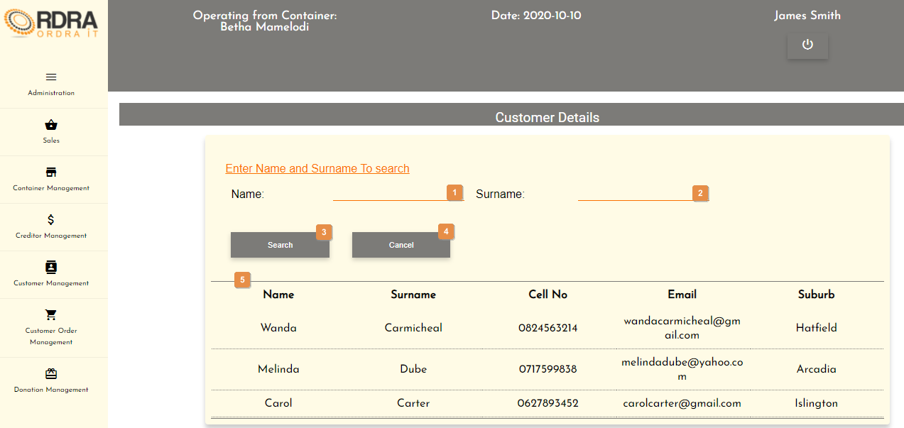

* **Detailed description of the controls:**

|  |  |  |
| --- | --- | --- |
| Reference | Control | Functionality Description |
| 1 | Name input field | Click here to make an entry for the customer name you want to search. |
| 2 | Surname input field | Click here to make an entry for the customer surname you want to search. |
| 3 | Search Button | Re-direct you to the Searched Customer Details screen. Click this button once you have entered the customer’s name and surname you want to search. |
| 4 | Cancel Button | Re-direct you to the Customer Management screen. Click this button to cancel the search. |
| 5 | List of all the customers table | Shows a list of all the customers that exists in the system. |

* **Possible Error Messages:** Please refer to the Error and Confirmation Messages, Error Messages, Validation Error Message, Duplicate Entry Message, Item in Use message, Other Messages to view the possible error message(s)).

*Created with the Personal Edition of HelpNDoc:* [*Create help files for the Qt Help Framework*](https://www.helpndoc.com/feature-tour/create-help-files-for-the-qt-help-framework)

Delete Customer

Allows the user to remove an existing customer from the system.

* **Navigation process:**
  1. Clicking the Delete Customer button on the Customer Management screen.



* 1. Clicking the search button once you have entered the customer’s name and surname you want to remove on the Customer Details screen.



* **Complete layout:**



* **Detailed description of the controls:**

|  |  |  |
| --- | --- | --- |
| Reference | Control | Functionality Description |
| 1 | Update Button | This button will allow the updating of the details in the Searched Customer Details card. When clicked, it makes all the input fields, in which changes can be made editable. The following buttons will be visible on the screen, to either save or cancel the option to update the details.    Click the Save button, a confirmation message will appear to confirm the update.  Click the Cancel button, a confirmation message will appear to confirm the cancellation. |
| 2 | Delete Button | Click the Delete button, a confirmation message will appear to confirm the deletion. |
| 3 | Place Order Button | Re-direct you to the Place Order screen. Click this button to place an order. |

* **Possible Error Messages:** Please refer to the Error and Confirmation Messages, Error Messages, Validation Error Message, Duplicate Entry Message, Item in Use message, Other Messages to view the possible error message(s)).

*Created with the Personal Edition of HelpNDoc:* [*News and information about help authoring tools and software*](https://www.helpauthoringsoftware.com)

**Sales**

*Created with the Personal Edition of HelpNDoc:* [*Create help files for the Qt Help Framework*](https://www.helpndoc.com/feature-tour/create-help-files-for-the-qt-help-framework)

Sale Management Screen

This screen allows the user to navigate through the sale management screen to make a sale, provides help with the card machine as well as being able to search through the sales made.

* **Navigation process:**
  1. Click on the Sales button in the Navbar.



* **Complete layout:**

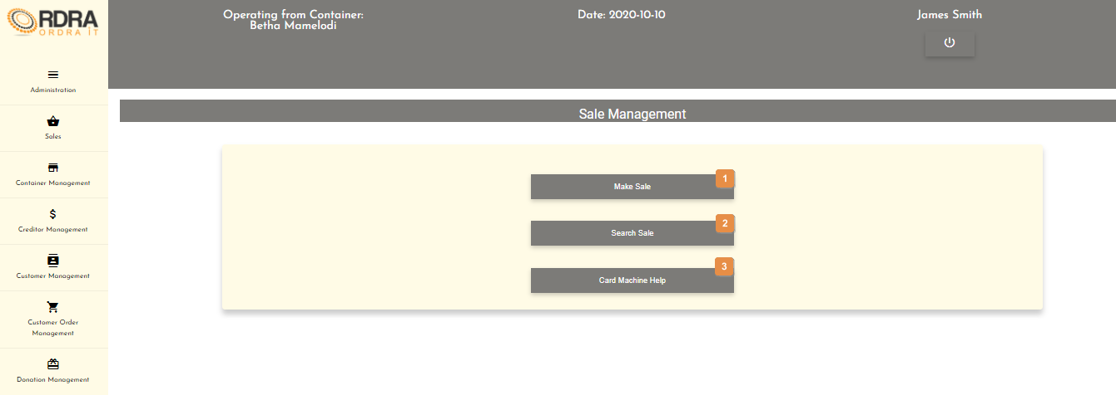

* **Detailed description of the controls:**

|  |  |  |
| --- | --- | --- |
| Reference | Control | Functionality Description |
| 1 | Make Sale Button | Re-directs you to the Make Sale screen. Click this button to make a sale into the system. |
| 2 | Search Sale Button | Re-directs you to the Search Sale screen. Click this button to search a sale in the system. |
| 3 | Card Machine Help Button | Re-directs you to the Card Machine Help screen. Click this button to get help on the card machine. |

*Created with the Personal Edition of HelpNDoc:* [*Free HTML Help documentation generator*](https://www.helpndoc.com)

Make Sales

Allows the user to make a sale into the system.

* **Navigation process:**
  1. Clicking the Make Sale button on the Sale Management screen.



* **Complete layout:**

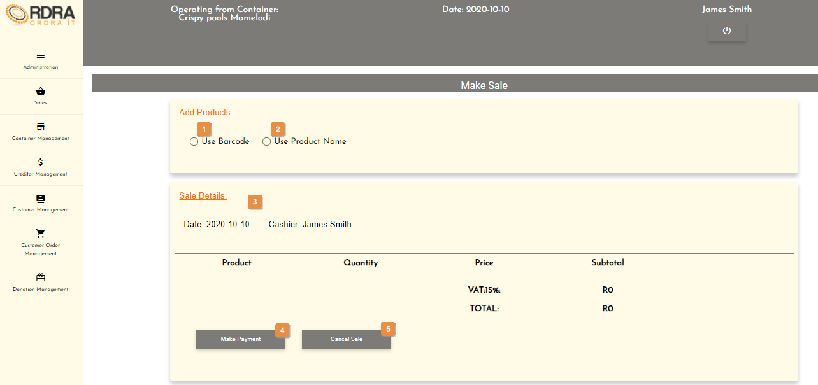

* **Detailed description of the controls:**

|  |  |  |
| --- | --- | --- |
| Reference | Control | Functionality Description |
| 1 | Use Barcode Radio Button | This radio button will allow the cashier to scan the product barcode and added it to the sale being made. Clicking this radio button will make visible the barcode input field on the screen. |
| 2 | Use Product Name Radio Button | This radio button will allow the cashier to select a product name and the quantity amount to add to the sale being made. Clicking this radio button will make visible the product name select box, the quantity input field and the add button on the screen.     |  |  |  | | --- | --- | --- | | Reference | Control | Functionality Description | | 1 | Product Name Select Box | Click the select box will display all the products in the container. User selects the product name that the customer wants to buy. | | 2 | Quantity input field | Click this input field to enter the quantity of the product being purchased. | | 3 | Add Button | Click add button to add the product name and quantity to the sale. | |
| 3 | Sale Details | This displays the sale details in a table format once a product barcode has been scanned (when the barcode radio button is selected) or when the add button is clicked (when the Product Name radio button is selected) with a dustbin button () next to each item. As the items are being scanned or added, the VAT and TOTAL will automatically update accordingly. If the customer wishes to remove an item from their purchase, the cashier can click on the dustbin button () next to that specific item, which will be removed from the sale details. |
| 4 | Make Payment Button | Click the make payment button will make the make payment card visible.     |  |  |  | | --- | --- | --- | | Reference | Control | Functionality Description | | 1 | Payment Method Select Box | Click the select box will display all the types of payment methods. Cashier selects the payment method according to the customer. | | 2 | Amount input field | Click this input field to enter the of money the customer gives according to the sale total. | | 3 | Make Payment Button | Click the make payment button and the system will display the either if there is charge or an outstanding amount. | | 4 | Complete Sale Button | Click the complete sale button once the sale is done, an alert message will appear to notify the cashier. | | 5 | Cancel Sale Button | Click the cancel sale button, an alert message will appear to notify the cashier of the cancellation. | |
| 5 | Cancel Sale Button | Re-direct you to the Sale Management screen. Click this button to cancel the sale being made. |

* **Possible Error Messages:** Please refer to the Error and Confirmation Messages, Error Messages, Validation Error Message, Duplicate Entry Message, Item in Use message, Other Messages to view the possible error message(s)).

*Created with the Personal Edition of HelpNDoc:* [*Easily create Web Help sites*](https://www.helpndoc.com/feature-tour)

Search Sales

Allows the user to search existing sales made in the system.

* **Navigation process:**
  1. Clicking the Search Sale button on the Sale Management screen.



* **Complete layout:**

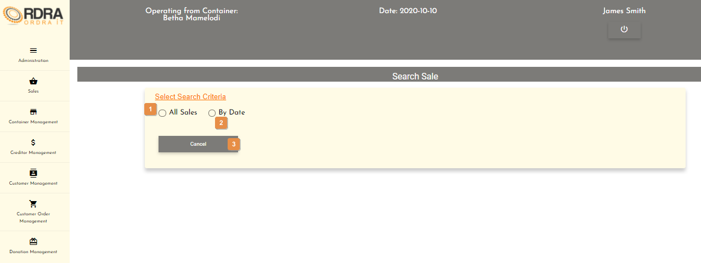

* **Detailed description of the controls:**

|  |  |  |
| --- | --- | --- |
| Reference | Control | Functionality Description |
| 1 | All Sales Radio Button | Clicking this radio button will display the List all sales card which shows a table with all the sales made. Next to each sale listed is a view button.    Clicking the view button will display the Sale details card with the details of that specific sale. |
| 2 | By Date Radio Button | Clicking this radio button will display the only the date card in the Search Sale screen.     |  |  |  | | --- | --- | --- | | Reference | Control | Functionality Description | | 1 | Date input field | Click here to select the date you want to search a sale. | | 2 | Search Button | Click this button will display the Sales card which contains a list of all the sales made on that date you selected. | | 3 | Cancel Button | Re-direct you to the Sale Management screen. Click this button to cancel the search by date. | |
| 3 | Cancel Button | Re-direct you to the Sale Management screen. Click this button to cancel the search. |

*Created with the Personal Edition of HelpNDoc:* [*Write EPub books for the iPad*](https://www.helpndoc.com/create-epub-ebooks)

Make Payment

Refer to the Make Sales above as the Make Payment is integrated into the Make Sales.

*Created with the Personal Edition of HelpNDoc:* [*News and information about help authoring tools and software*](https://www.helpauthoringsoftware.com)

Card Machine Help

Allows the user to get help regarding the card machine.

* **Navigation process:**
  1. Clicking the Card Machine button on the Sale Management screen.



* **Complete layout:**

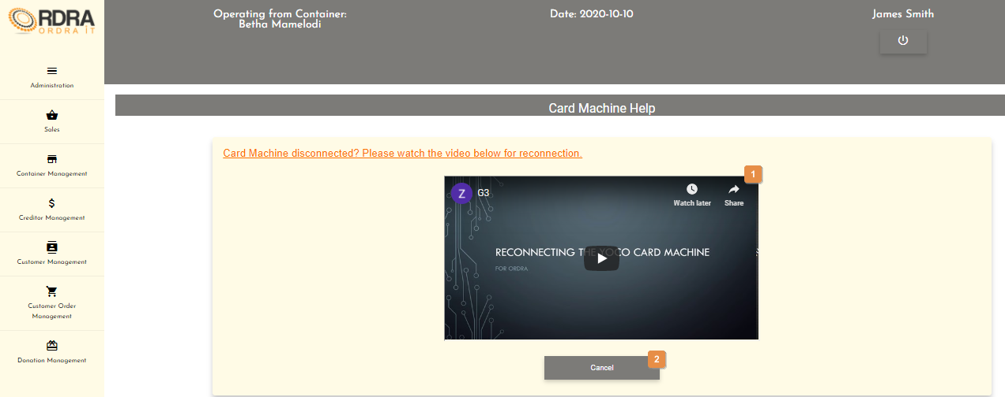

* **Detailed description of the controls:**

|  |  |  |
| --- | --- | --- |
| Reference | Control | Functionality Description |
| 1 | Video | Video contains information on how to reconnect the card machine if it disconnects. Click on the video to play/watch the video. |
| 2 | Cancel Button | Re-direct you to the Sale Management screen. Click this button to return to the Sale Management screen. |

*Created with the Personal Edition of HelpNDoc:* [*Easy EPub and documentation editor*](https://www.helpndoc.com)

**Customer Order**

*Created with the Personal Edition of HelpNDoc:* [*Free Kindle producer*](https://www.helpndoc.com/feature-tour/create-ebooks-for-amazon-kindle)

Customer Order Management Screen

This screen allows the user to navigate through the customer order management screen which includes, placing an order to collecting or cancelling an order as well as being able to search through the orders that were placed and sending order arrival notifications to the customers who have placed orders.

* **Navigation process:**
  1. Click on the Customer Order Management button in the Navbar.

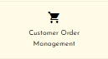

* **Complete layout:**

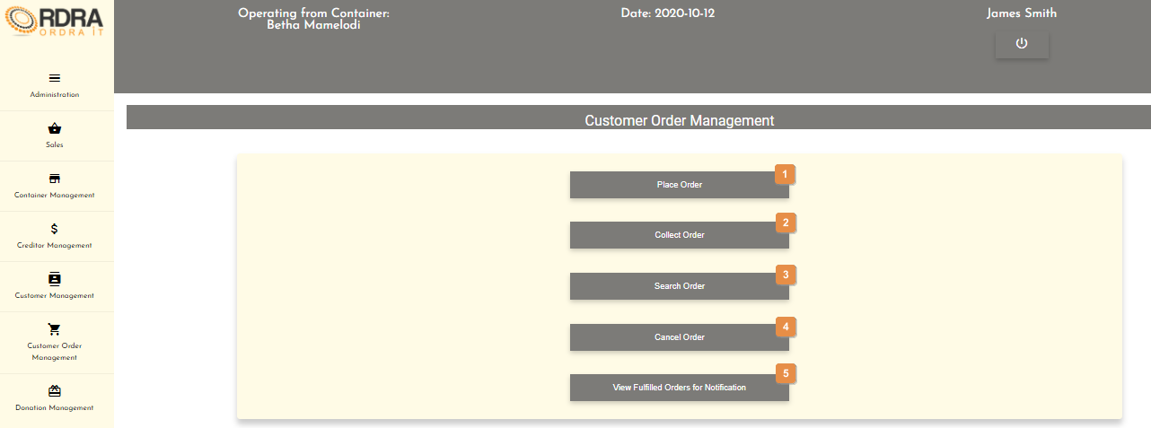

* **Detailed description of the controls:**

|  |  |  |
| --- | --- | --- |
| Reference | Control | Functionality Description |
| 1 | Place Order Button | Re-directs you to the Place Order screen. Click this button to place an order into the system. |
| 2 | Collect Order Button | Re-directs you to the View Customer Order screen. You will be able to search for a specific order which is being collected. |
| 3 | Search Order Button | Re-directs you to the View Customer Order screen. Click this button to search orders in the system. |
| 4 | Cancel Order Button | Re-directs you to the View Customer Order screen.  You will be able to search for a specific order which is needs to be cancelled. |
| 5 | View Fulfilled Orders for Notification Button | Re-directs you to the View Customer Order screen.  You will be able to search an order that are fulfilled and send notifications. |

*Created with the Personal Edition of HelpNDoc:* [*Produce online help for Qt applications*](https://www.helpndoc.com/feature-tour/create-help-files-for-the-qt-help-framework)

Place Order

Allows the user to place an order for a customer into the system.

* **Navigation process:**
  1. Clicking the Place Order button on the Customer Order Management screen.



* **Complete layout:**

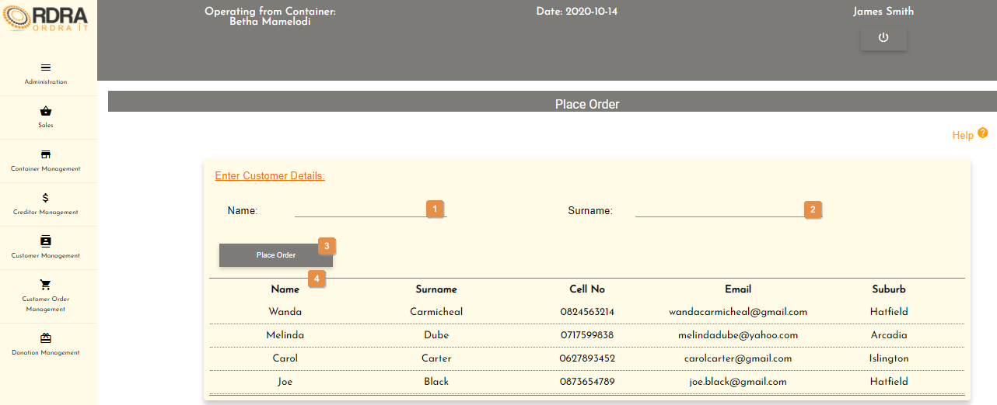

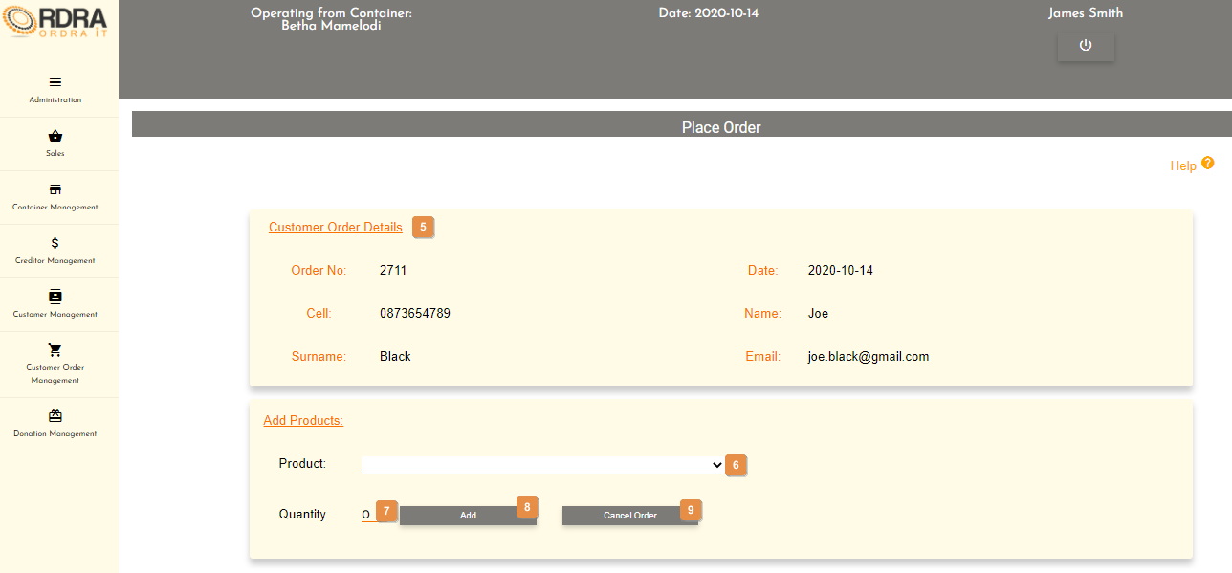

* **Detailed description of the controls:**

|  |  |  |
| --- | --- | --- |
| Reference | Control | Functionality Description |
| 1 | Name input field | Click here to make an entry for the customer name. |
| 2 | Surname input field | Click here to make an entry for the customer surname. |
| 3 | Place Order Button | Click this button will display the Customer Order Details Card with that specific customers details and the Add Products Card to added products to that customers order.  (See the second screen shot above under the complete layout) |
| 4 | List of all the customers table | Shows a list of all the customers that exists in the system. |
| 5 | Customer Order Details Card | Contains the details of the customer that the user is placing an order for. |
| 6 | Product Select Box | Click the select box will display all the products that are not in stock. User selects the product that the customer wants to order. |
| 7 | Quantity input field | Click here to make an entry for the quantity that the customer wants to order. |
| 8 | Add Button | Click the Add button once the user has selected a product and the entered quantity that the customer wants to place in his order. The card below will display with the all the items that the customer wants to place in his order.     |  |  |  | | --- | --- | --- | | Reference | Control | Functionality Description | | 1 | List of items | Show the customers items that he wants to place an order for as well as the VAT and TOTAL amount for the order. | | 2 | Dustbin Button | Click this button will remove the item form the list. | | 3 | Place Order Button | Click add button to add the product name and quantity to the sale. | | 4 | Cancel Button | Click the Cancel button, a confirmation message will appear to confirm the cancellation. | |
| 9 | Cancel Order | Click the Cancel button, a confirmation message will appear to confirm the cancellation. |

* **Possible Error Messages:** Please refer to the Error and Confirmation Messages, Error Messages, Validation Error Message, Duplicate Entry Message, Item in Use message, Other Messages to view the possible error message(s)).

*Created with the Personal Edition of HelpNDoc:* [*Free help authoring environment*](https://www.helpndoc.com/help-authoring-tool)

Collect Order

Allows the user to search for the specific customer order which is being collected.

* **Navigation process:**
  1. Clicking the Collect Order button on the Customer Order Management screen.



* **Complete layout:**

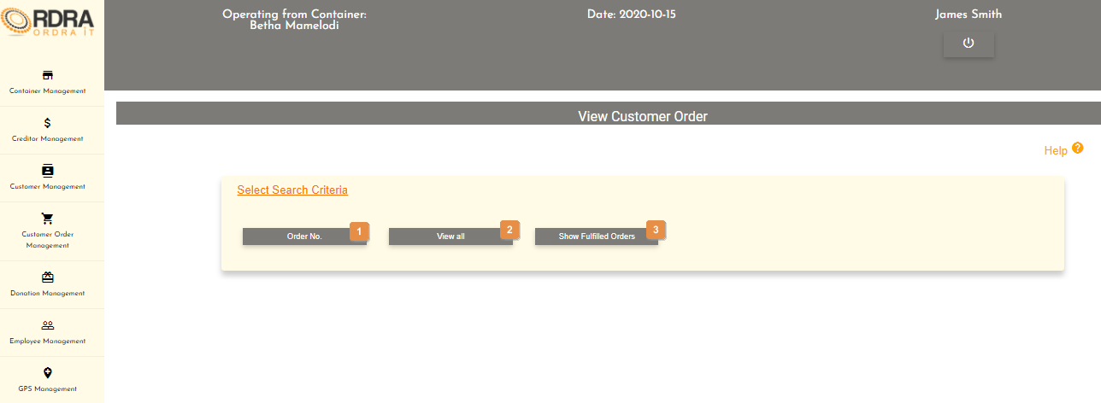

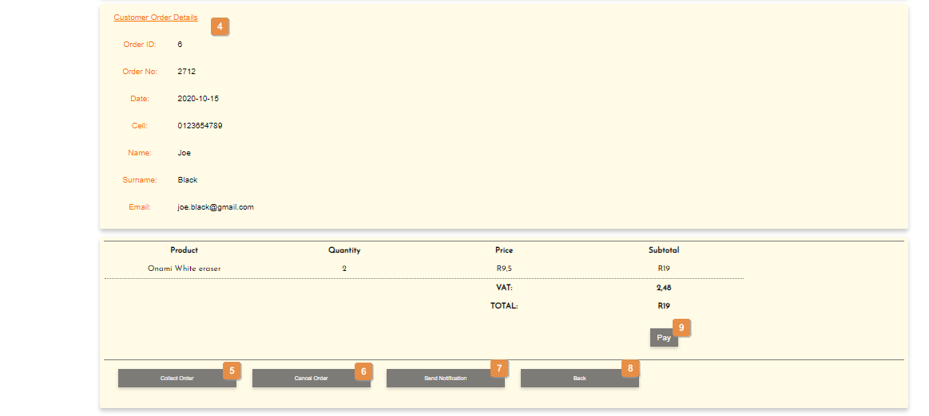

* **Detailed description of the controls:**

|  |  |  |
| --- | --- | --- |
| Reference | Control | Functionality Description |
| 1 | Order No. Button | This button will display the Search Details card to search for an order according to the order number.     |  |  |  | | --- | --- | --- | | Reference | Control | Functionality Description | | 1 | Order Number input field | Click here to make an entry for the order number. | | 2 | Search Button | Click this button will display the Customer Order Details Card with that specific customers details and the List of items in that order.  (See second screen shot above under the complete layout) | | 3 | Cancel Button | Re-direct you to the Customer Order Management screen. Click this button to cancel the search of an order. | |
| 2 | View all Button | Click this button will display the Customer Orders Card as shown below.     |  |  |  | | --- | --- | --- | | Reference | Control | Functionality Description | | 1 | Customer Order Table | Displays a list of all the customer orders. | | 2 | View Button | Click this button will display the Customer Order Details Card with that specific customers details and the List of items in that order.  (See second screen shot above under the complete layout) | |
| 3 | Show Fulfilled Orders Button | Clicking this button, will display the list of all the customer orders in a table format that are fulfilled. Next to each listed order is a view button.    Clicking the View button will display the Customer Order Details Card with that specific customers details and the List of items in that order.  (See second screen shot above under the complete layout) |
| 4 | Customer Order Details Card | Contains the details of the customer that the user is placing an order for. |
| 5 | Collect Order Button | Click the Collect Order button, a confirmation message will appear to confirm the collection. |
| 6 | Cancel Order Button | Click the Cancel button, a confirmation message will appear to confirm the cancellation. |
| 7 | Send Notification Button | Click the Send Notification button, a confirmation message will appear to confirm the send notification. |
| 8 | Back Button | Click this button to return to the Customer Order Management screen. |
| 9 | Pay Button | Clicking the Pay button will make visible the following below.     |  |  |  | | --- | --- | --- | | Reference | Control | Functionality Description | | 1 | Payment Method Select Box | Click the select box will display all the payment methods. User selects the payment method that the customer wants to pay. | | 2 | Amount input field | Click here to make an entry for the amount. | | 3 | Make Payment Button | Click the Make Payment button, an alert message will appear to notify the user. | |

* **Possible Error Messages:** Please refer to the Error and Confirmation Messages, Error Messages, Validation Error Message, Duplicate Entry Message, Item in Use message, Other Messages to view the possible error message(s)).

*Created with the Personal Edition of HelpNDoc:* [*Write EPub books for the iPad*](https://www.helpndoc.com/create-epub-ebooks)

Search Order

Allows the user to search existing customer orders in the system.

* **Navigation process:**
  1. Clicking the Search Order button on the Customer Order Management screen.



* **Complete layout:**





* **Detailed description of the controls:**

|  |  |  |
| --- | --- | --- |
| Reference | Control | Functionality Description |
| 1 | Order No. Button | This button will display the Search Details card to search for an order according to the order number.     |  |  |  | | --- | --- | --- | | Reference | Control | Functionality Description | | 1 | Order Number input field | Click here to make an entry for the order number. | | 2 | Search Button | Click this button will display the Customer Order Details Card with that specific customers details and the List of items in that order.  (See second screen shot above under the complete layout) | | 3 | Cancel Button | Re-direct you to the Customer Order Management screen. Click this button to cancel the search of an order. | |
| 2 | View all Button | Click this button will display the Customer Orders Card as shown below.     |  |  |  | | --- | --- | --- | | Reference | Control | Functionality Description | | 1 | Customer Order Table | Displays a list of all the customer orders. | | 2 | View Button | Click this button will display the Customer Order Details Card with that specific customers details and the List of items in that order.  (See second screen shot above under the complete layout) | |
| 3 | Show Fulfilled Orders Button | Clicking this button, will display the list of all the customer orders in a table format that are fulfilled. Next to each listed order is a view button.    Clicking the View button will display the Customer Order Details Card with that specific customers details and the List of items in that order.  (See second screen shot above under the complete layout) |
| 4 | Customer Order Details Card | Contains the details of the customer that the user is placing an order for. |
| 5 | Collect Order Button | Click the Collect Order button, a confirmation message will appear to confirm the collection. |
| 6 | Cancel Order Button | Click the Cancel button, a confirmation message will appear to confirm the cancellation. |
| 7 | Send Notification Button | Click the Send Notification button, a confirmation message will appear to confirm the send notification. |
| 8 | Back Button | Click this button to return to the Customer Order Management screen. |
| 9 | Pay Button | Clicking the Pay button will make visible the following below.     |  |  |  | | --- | --- | --- | | Reference | Control | Functionality Description | | 1 | Payment Method Select Box | Click the select box will display all the payment methods. User selects the payment method that the customer wants to pay. | | 2 | Amount input field | Click here to make an entry for the amount. | | 3 | Make Payment Button | Click the Make Payment button, an alert message will appear to notify the user. | |

* **Possible Error Messages:** Please refer to the Error and Confirmation Messages, Error Messages, Validation Error Message, Duplicate Entry Message, Item in Use message, Other Messages to view the possible error message(s)).

*Created with the Personal Edition of HelpNDoc:* [*Full-featured EBook editor*](https://www.helpndoc.com/create-epub-ebooks)

Cancel Order

Allows the user to cancel the customers order as requested by the customer.

* **Navigation process:**
  1. Clicking the Cancel Order button on the Customer Order Management screen.



* **Complete layout:**





* **Detailed description of the controls:**

|  |  |  |
| --- | --- | --- |
| Reference | Control | Functionality Description |
| 1 | Order No. Button | This button will display the Search Details card to search for an order according to the order number.     |  |  |  | | --- | --- | --- | | Reference | Control | Functionality Description | | 1 | Order Number input field | Click here to make an entry for the order number. | | 2 | Search Button | Click this button will display the Customer Order Details Card with that specific customers details and the List of items in that order.  (See second screen shot above under the complete layout) | | 3 | Cancel Button | Re-direct you to the Customer Order Management screen. Click this button to cancel the search of an order. | |
| 2 | View all Button | Click this button will display the Customer Orders Card as shown below.     |  |  |  | | --- | --- | --- | | Reference | Control | Functionality Description | | 1 | Customer Order Table | Displays a list of all the customer orders. | | 2 | View Button | Click this button will display the Customer Order Details Card with that specific customers details and the List of items in that order.  (See second screen shot above under the complete layout) | |
| 3 | Show Fulfilled Orders Button | Clicking this button, will display the list of all the customer orders in a table format that are fulfilled. Next to each listed order is a view button.    Clicking the View button will display the Customer Order Details Card with that specific customers details and the List of items in that order.  (See second screen shot above under the complete layout) |
| 4 | Customer Order Details Card | Contains the details of the customer that the user is placing an order for. |
| 5 | Collect Order Button | Click the Collect Order button, a confirmation message will appear to confirm the collection. |
| 6 | Cancel Order Button | Click the Cancel button, a confirmation message will appear to confirm the cancellation. |
| 7 | Send Notification Button | Click the Send Notification button, a confirmation message will appear to confirm the send notification. |
| 8 | Back Button | Click this button to return to the Customer Order Management screen. |
| 9 | Pay Button | Clicking the Pay button will make visible the following below.     |  |  |  | | --- | --- | --- | | Reference | Control | Functionality Description | | 1 | Payment Method Select Box | Click the select box will display all the payment methods. User selects the payment method that the customer wants to pay. | | 2 | Amount input field | Click here to make an entry for the amount. | | 3 | Make Payment Button | Click the Make Payment button, an alert message will appear to notify the user. | |

* **Possible Error Messages:** Please refer to the Error and Confirmation Messages, Error Messages, Validation Error Message, Duplicate Entry Message, Item in Use message, Other Messages to view the possible error message(s)).

*Created with the Personal Edition of HelpNDoc:* [*Write EPub books for the iPad*](https://www.helpndoc.com/create-epub-ebooks)

View Fulfilled Order for Notification

Allows the user to view the customer orders that have been fulfilled.

* **Navigation process:**
  1. Clicking the View Fulfilled Order for Notification button on the Customer Order Management screen.



* **Complete layout:**





* **Detailed description of the controls:**

|  |  |  |
| --- | --- | --- |
| Reference | Control | Functionality Description |
| 1 | Order No. Button | This button will display the Search Details card to search for an order according to the order number.     |  |  |  | | --- | --- | --- | | Reference | Control | Functionality Description | | 1 | Order Number input field | Click here to make an entry for the order number. | | 2 | Search Button | Click this button will display the Customer Order Details Card with that specific customers details and the List of items in that order.  (See second screen shot above under the complete layout) | | 3 | Cancel Button | Re-direct you to the Customer Order Management screen. Click this button to cancel the search of an order. | |
| 2 | View all Button | Click this button will display the Customer Orders Card as shown below.     |  |  |  | | --- | --- | --- | | Reference | Control | Functionality Description | | 1 | Customer Order Table | Displays a list of all the customer orders. | | 2 | View Button | Click this button will display the Customer Order Details Card with that specific customers details and the List of items in that order.  (See second screen shot above under the complete layout) | |
| 3 | Show Fulfilled Orders Button | Clicking this button, will display the list of all the customer orders in a table format that are fulfilled. Next to each listed order is a view button.    Clicking the View button will display the Customer Order Details Card with that specific customers details and the List of items in that order.  (See second screen shot above under the complete layout) |
| 4 | Customer Order Details Card | Contains the details of the customer that the user is placing an order for. |
| 5 | Collect Order Button | Click the Collect Order button, a confirmation message will appear to confirm the collection. |
| 6 | Cancel Order Button | Click the Cancel button, a confirmation message will appear to confirm the cancellation. |
| 7 | Send Notification Button | Click the Send Notification button, a confirmation message will appear to confirm the send notification. |
| 8 | Back Button | Click this button to return to the Customer Order Management screen. |
| 9 | Pay Button | Clicking the Pay button will make visible the following below.     |  |  |  | | --- | --- | --- | | Reference | Control | Functionality Description | | 1 | Payment Method Select Box | Click the select box will display all the payment methods. User selects the payment method that the customer wants to pay. | | 2 | Amount input field | Click here to make an entry for the amount. | | 3 | Make Payment Button | Click the Make Payment button, an alert message will appear to notify the user. | |

* **Possible Error Messages:** Please refer to the Error and Confirmation Messages, Error Messages, Validation Error Message, Duplicate Entry Message, Item in Use message, Other Messages to view the possible error message(s)).

*Created with the Personal Edition of HelpNDoc:* [*Generate Kindle eBooks with ease*](https://www.helpndoc.com/feature-tour/create-ebooks-for-amazon-kindle)

**Supplier Order**

*Created with the Personal Edition of HelpNDoc:* [*Easily create iPhone documentation*](https://www.helpndoc.com/feature-tour/iphone-website-generation)

Supplier Order Management Screen

This screen allows the user to navigate through the supplier order management screen to place supplier order, search through the relevant supplier orders, cancel supplier order and receive stock.

* **Navigation process:**
  1. Click on the Supplier Order Management button in the Navbar.

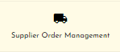

* **Complete layout:**

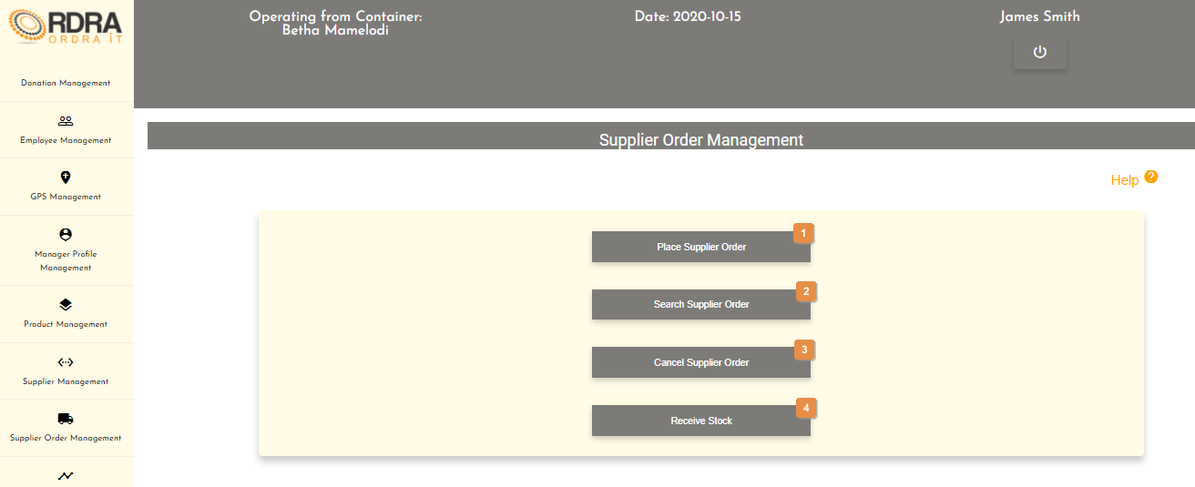

* **Detailed description of the controls:**

|  |  |  |
| --- | --- | --- |
| Reference | Control | Functionality Description |
| 1 | Place Supplier Order Button | Re-directs you to the Place Supplier Order screen. Click this button to search the container backlog products and place an order. |
| 2 | Search Supplier Order Button | Re-directs you to the Search Supplier Order screen. Click this button to search the supplier order. |
| 3 | Cancel Supplier Order Button | Re-directs you to the Search Supplier Order screen. Click this button to search the specific supplier order that needs to be cancelled. |
| 4 | Receive Stock Button | Click this button will redirect you to the Receive Stock screen. |

*Created with the Personal Edition of HelpNDoc:* [*Easy EPub and documentation editor*](https://www.helpndoc.com)

Place Supplier Order

Allows the user to search the container backlog products and place an order.

* **Navigation process:**
  1. Clicking the Place Supplier Order button on the Supplier Order Management screen.



* **Complete layout:**

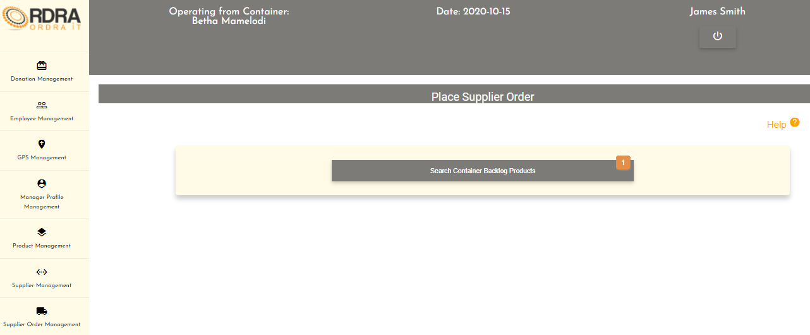

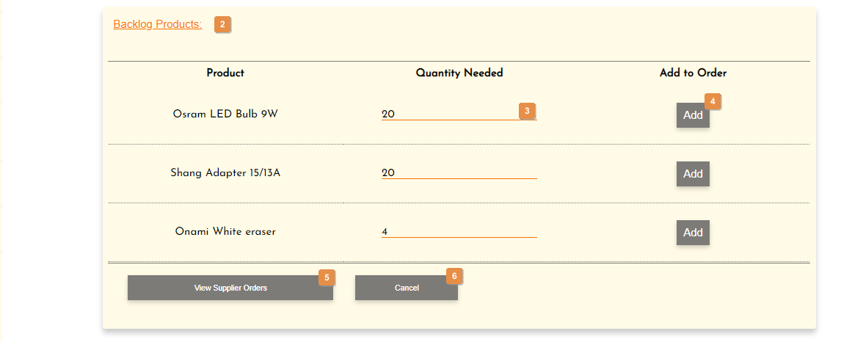

* **Detailed description of the controls:**

|  |  |  |
| --- | --- | --- |
| Reference | Control | Functionality Description |
| 1 | Search Container Backlog Products | Clicking this button will make display the Backlog Products Card. |
| 2 | Backlog Products Table | Shows a list of all the backlog products in a table. |
| 3 | Quantity needed input field | Click here to make an entry for the quantity needed. |
| 4 | Add Button | Click the Add button to add the product to the order. |
| 5 | View Supplier Orders Button | Clicking this button will display a list of the supplier orders in a table format. Next to each listed supplier order is a view button.    Click the View button, will display the Supplier Order Details Card.     |  |  |  | | --- | --- | --- | | Reference | Control | Functionality Description | | 1 | Supplier Order Details | Shows the supplier order details along with the products in the order. | | 2 | Place Order Button | Click the Place Order button, a confirmation message will appear to confirm the placing of the order. | | 3 | Cancel Order Button | Click the Cancel Order button, a confirmation message will appear to confirm the cancellation. | | 4 | Back To List Button | Clicking this button will return to the list of supplier orders. | |
| 6 | Cancel Button | Click this button to redirect to the Supplier Order Management screen |

* **Possible Error Messages:** Please refer to the Error and Confirmation Messages, Error Messages, Validation Error Message, Duplicate Entry Message, Item in Use message, Other Messages to view the possible error message(s)).

*Created with the Personal Edition of HelpNDoc:* [*Easily create PDF Help documents*](https://www.helpndoc.com/feature-tour)

Search Supplier Order

Allows the user to be able to search through the supplier orders in the system.

* **Navigation process:**
  1. Clicking the Search Supplier Order button on the Supplier Order Management screen.



* **Complete layout:**

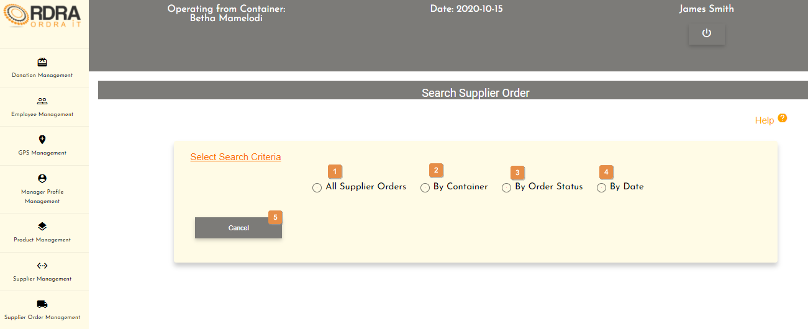

* **Detailed description of the controls:**

|  |  |  |
| --- | --- | --- |
| Reference | Control | Functionality Description |
| 1 | All Supplier Orders Radio Button | Click this radio button will display a list of all the supplier orders in a table format. Next to each supplier order listed is a view button.    Click the View button will display the Supplier Order Details Card of that specific supplier order.     |  |  |  | | --- | --- | --- | | Reference | Control | Functionality Description | | 1 | Cancel Order Button | Click the Cancel Order button, a confirmation message will appear to confirm the cancellation. | | 2 | Back To List Button | Clicking this button will return to the list of all the supplier orders. | |
| 2 | By Container Radio Button | This radio button will allow the user to search supplier orders by container. Clicking this radio button will make visible the container select box on the screen.     |  |  |  | | --- | --- | --- | | Reference | Control | Functionality Description | | 1 | Container Select Box | Click the select box will display all the containers. User selects the container that he wants to search for supplier orders. | | 2 | Search Button | Click this button will display the list of all the supplier order in a table format of that specific container selected. Next to each supplier order listed is a view button    Click the View button will display the Supplier Order Details Card of that specific supplier order along with the Cancel Order button and Back To List button    Cancel Order button, a confirmation message will appear to confirm the cancellation.  Back To List button, will return to the list of all the supplier orders by containers. | |
| 3 | By Order Status Radio Button | This radio button will allow the user to search supplier orders by the order status. Clicking this radio button will make visible the status select box on the screen.     |  |  |  | | --- | --- | --- | | Reference | Control | Functionality Description | | 1 | Status Select Box | Click the select box will display all the order status. User selects the order that he wants to search for supplier orders. | | 2 | Search Button | Click this button will display the list of all the supplier order in a table format of that specific order status selected. Next to each supplier order listed is a view button    Click the View button will display the Supplier Order Details Card of that specific supplier order along with the Cancel Order button and Back To List button    Cancel Order button, a confirmation message will appear to confirm the cancellation.  Back To List button, will return to the list of all the supplier orders by containers. | |
| 4 | By Date Radio Button | This radio button will allow the user to search supplier orders by the date. Clicking this radio button will make visible the date input field on the screen.     |  |  |  | | --- | --- | --- | | Reference | Control | Functionality Description | | 1 | Date input field | Click here to make an entry for the date. | | 2 | Search Button | Click this button will display the list of all the supplier order in a table format of that specific date. Next to each supplier order listed is a view button    Click the View button will display the Supplier Order Details Card of that specific supplier order along with the Cancel Order button and Back To List button    Cancel Order button, a confirmation message will appear to confirm the cancellation.  Back To List button, will return to the list of all the supplier orders by date searched. | |
| 5 | Cancel Button | Re-direct you to the Supplier Order Management screen. Click this button to cancel the search. |

* **Possible Error Messages:** Please refer to the Error and Confirmation Messages, Error Messages, Validation Error Message, Duplicate Entry Message, Item in Use message, Other Messages to view the possible error message(s)).

*Created with the Personal Edition of HelpNDoc:* [*Full-featured EBook editor*](https://www.helpndoc.com/create-epub-ebooks)

Cancel Supplier Order

Allows the user to search through the supplier orders and be able to cancel a supplier order in the system.

* **Navigation process:**
  1. Clicking the Cancel Supplier Order button on the Supplier Order Management screen.



* **Complete layout:**



* **Detailed description of the controls:**

|  |  |  |
| --- | --- | --- |
| Reference | Control | Functionality Description |
| 1 | All Supplier Orders Radio Button | Click this radio button will display a list of all the supplier orders in a table format. Next to each supplier order listed is a view button.    Click the View button will display the Supplier Order Details Card of that specific supplier order.     |  |  |  | | --- | --- | --- | | Reference | Control | Functionality Description | | 1 | Cancel Order Button | Click the Cancel Order button, a confirmation message will appear to confirm the cancellation. | | 2 | Back To List Button | Clicking this button will return to the list of all the supplier orders. | |
| 2 | By Container Radio Button | This radio button will allow the user to search supplier orders by container. Clicking this radio button will make visible the container select box on the screen.     |  |  |  | | --- | --- | --- | | Reference | Control | Functionality Description | | 1 | Container Select Box | Click the select box will display all the containers. User selects the container that he wants to search for supplier orders. | | 2 | Search Button | Click this button will display the list of all the supplier order in a table format of that specific container selected. Next to each supplier order listed is a view button    Click the View button will display the Supplier Order Details Card of that specific supplier order along with the Cancel Order button and Back To List button    Cancel Order button, a confirmation message will appear to confirm the cancellation.  Back To List button, will return to the list of all the supplier orders by containers. | |
| 3 | By Order Status Radio Button | This radio button will allow the user to search supplier orders by the order status. Clicking this radio button will make visible the status select box on the screen.     |  |  |  | | --- | --- | --- | | Reference | Control | Functionality Description | | 1 | Status Select Box | Click the select box will display all the order status. User selects the order that he wants to search for supplier orders. | | 2 | Search Button | Click this button will display the list of all the supplier order in a table format of that specific order status selected. Next to each supplier order listed is a view button    Click the View button will display the Supplier Order Details Card of that specific supplier order along with the Cancel Order button and Back To List button    Cancel Order button, a confirmation message will appear to confirm the cancellation.  Back To List button, will return to the list of all the supplier orders by containers. | |
| 4 | By Date Radio Button | This radio button will allow the user to search supplier orders by the date. Clicking this radio button will make visible the date input field on the screen.     |  |  |  | | --- | --- | --- | | Reference | Control | Functionality Description | | 1 | Date input field | Click here to make an entry for the date. | | 2 | Search Button | Click this button will display the list of all the supplier order in a table format of that specific date. Next to each supplier order listed is a view button    Click the View button will display the Supplier Order Details Card of that specific supplier order along with the Cancel Order button and Back To List button    Cancel Order button, a confirmation message will appear to confirm the cancellation.  Back To List button, will return to the list of all the supplier orders by date searched. | |
| 5 | Cancel Button | Re-direct you to the Supplier Order Management screen. Click this button to cancel the search. |

* **Possible Error Messages:** Please refer to the Error and Confirmation Messages, Error Messages, Validation Error Message, Duplicate Entry Message, Item in Use message, Other Messages to view the possible error message(s)).

*Created with the Personal Edition of HelpNDoc:* [*Free iPhone documentation generator*](https://www.helpndoc.com/feature-tour/iphone-website-generation)

Receive Stock

Allows the user the stock that the supplier has delivered into the system.

* **Navigation process:**
  1. Clicking the Receive Stock button on the Supplier Order Management screen.



* **Complete layout:**

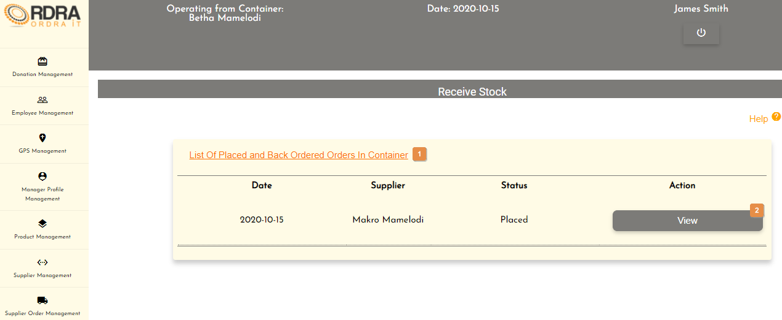

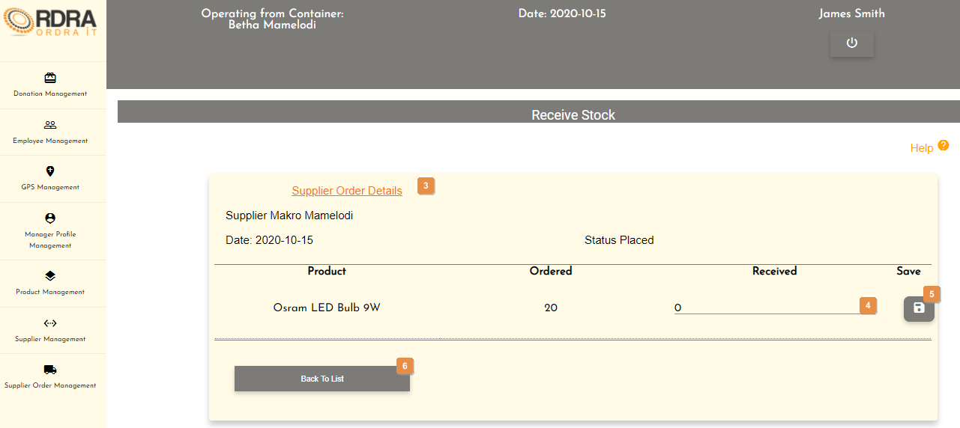

* **Detailed description of the controls:**

|  |  |  |
| --- | --- | --- |
| Reference | Control | Functionality Description |
| 1 | List of Placed and Back Ordered Orders In Container | Show the list of all the placed and back ordered orders in the container. |
| 2 | View Button | Click this button will display the Supplier Order Details Card with that specific orders details. |
| 3 | Supplier Order Details Card | Shows the supplier order details along with the products in the order. |
| 4 | Received input field | Click here to make an entry for the amount of stock that was received. |
| 5 | Save Button | Click the Save button to save the containers product quantity update. The Order Complete button and the Place Back Order button will be made visible.    Click the Order Complete button, an alert message will appear to notify the user.  Click the Place Back Order button, a confirmation message will appear to confirm the place back order. |
| 6 | Back To List Button | Click this button to return to the list of all the placed and back ordered orders in the container. |

* **Possible Error Messages:** Please refer to the Error and Confirmation Messages, Error Messages, Validation Error Message, Duplicate Entry Message, Item in Use message, Other Messages to view the possible error message(s)).

*Created with the Personal Edition of HelpNDoc:* [*Easy CHM and documentation editor*](https://www.helpndoc.com)

**Creditor**

*Created with the Personal Edition of HelpNDoc:* [*Write eBooks for the Kindle*](https://www.helpndoc.com/feature-tour/create-ebooks-for-amazon-kindle)

Creditor Management Screen

This screen allows the user to navigate through the creditor management screen to access the Creditor and Creditor Payment options as well as their relevant functions that each option provides.

* **Navigation process:**
  1. Click on the Creditor Management button in the Navbar.

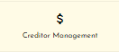

* **Complete layout:**

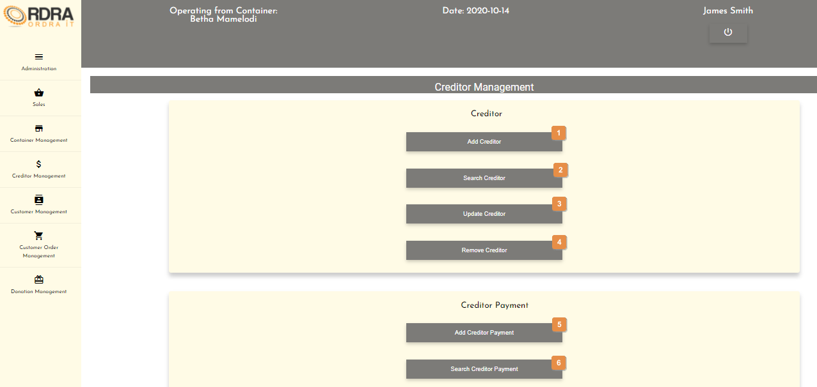

* **Detailed description of the controls:**

|  |  |  |
| --- | --- | --- |
| Reference | Control | Functionality Description |
| 1 | Add Creditor Button | Re-directs you to the Add Creditor screen. Click this button to add a new creditor into the system. |
| 2 | Search Creditor Button | Re-directs you to the Search Creditor screen. Click this button to search a creditor in the system. |
| 3 | Update Creditor Button | Re-directs you to the Search Creditor screen. Click this button to search a creditor in the system, you want to update. |
| 4 | Remove Creditor Button | Re-directs you to the Search Creditor screen. Click this button to search a creditor in the system, you want to remove. |
| 5 | Add Creditor Payment Button | Re-directs you to the Add Creditor Payment screen. Click this button to add a creditor payment into the system. |
| 6 | Search Creditor Payment Button | Re-directs you to the Creditor Payment Details screen. Click this button to add a creditor payment into the system. |

*Created with the Personal Edition of HelpNDoc:* [*Easily create Help documents*](https://www.helpndoc.com/feature-tour)

Create Creditor

Allows the user to add a creditor into the system.

* **Navigation process:**
  1. Clicking the Add Creditor button in the Creditor Card.



* **Complete layout:**

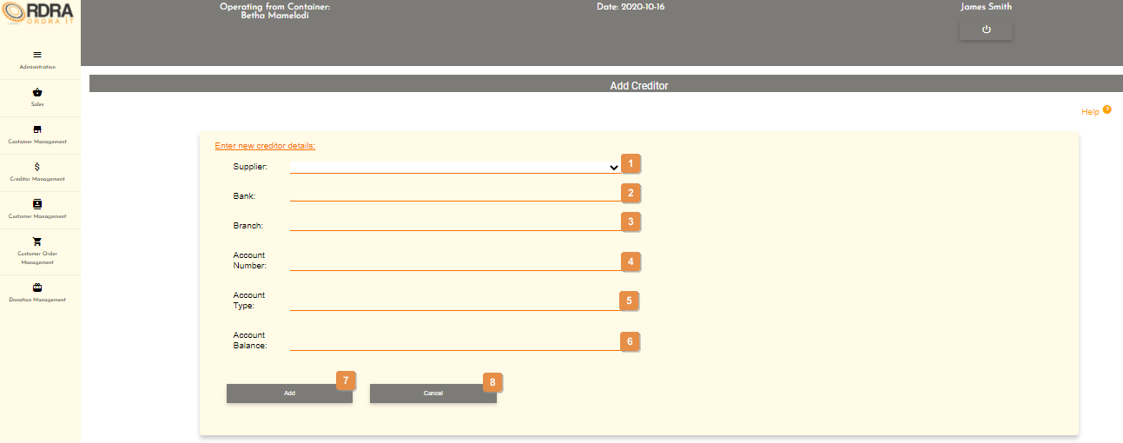

* **Detailed description of the controls:**

|  |  |  |
| --- | --- | --- |
| Reference | Control | Functionality Description |
| 1 | Supplier Select Box | Click the select box will display all the suppliers and the user selects the supplier. |
| 2 | Bank input field | Click here to make an entry for the bank name. |
| 3 | Branch input field | Click here to make an entry for the branch code. |
| 4 | Account Number input field | Click here to make an entry for the account number. |
| 5 | Account Type input field | Click here to make an entry for the account type. |
| 6 | Account Balance input field | Click here to make an entry for the account balance. |
| 7 | Add Button | Click add button, a confirmation box will appear to confirm the adding of a creditor |
| 8 | Cancel Button | Re-directs the user to the Creditor Management screen. Click this button to cancel add creditor. |

* **Possible Error Messages:** Please refer to the Error and Confirmation Messages, Error Messages, Validation Error Message, Duplicate Entry Message, Item in Use message, Other Messages to view the possible error message(s)).

*Created with the Personal Edition of HelpNDoc:* [*News and information about help authoring tools and software*](https://www.helpauthoringsoftware.com)

Update Creditor

Allows the user to update an existing creditor in the system.

* **Navigation process:**
  1. Clicking the Update Creditor button in the Creditor Card.



* 1. Clicking the search button once you have entered the creditors name, you want to update on the Search Creditor screen.



* **Complete layout:**

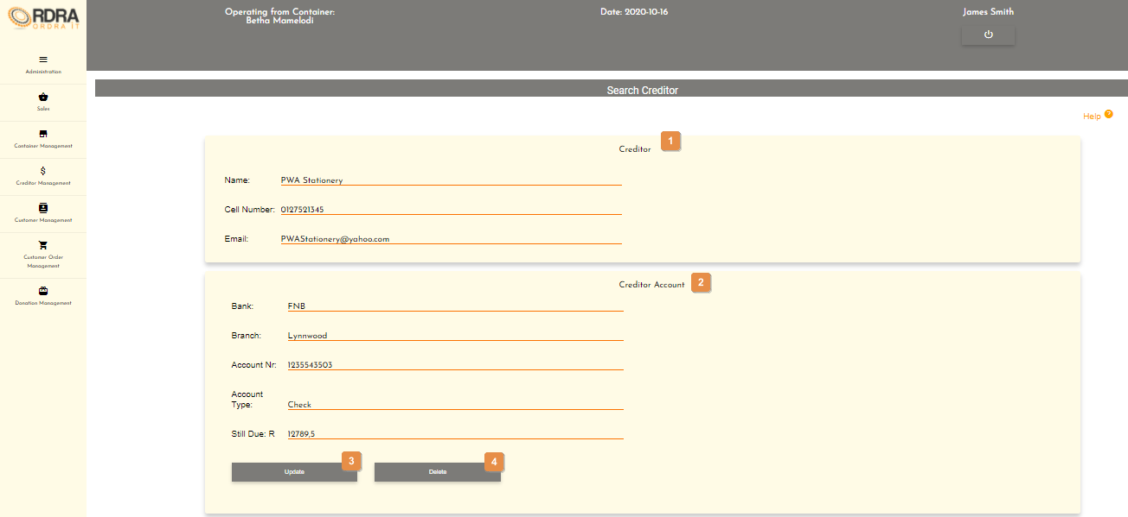

* **Detailed description of the controls:**

|  |  |  |
| --- | --- | --- |
| Reference | Control | Functionality Description |
| 1 | Creditor Card | This Creditor Card contains the creditors details. |
| 2 | Creditor Account | This Creditor Account Card contains the creditors account details. |
| 3 | Update Button | This button will allow the updating of the details in the Creditor Account Card. When clicked, it makes all the input fields, in which changes can be made editable. The following buttons will be visible on the screen, to either save or cancel the option to update the details.    Click the Save button, a confirmation message will appear to confirm the update.  Click the Cancel button, a confirmation message will appear to confirm the cancellation. |
| 4 | Delete Button | Shows a list of all the creditors in a table format. |

* **Possible Error Messages:** Please refer to the Error and Confirmation Messages, Error Messages, Validation Error Message, Duplicate Entry Message, Item in Use message, Other Messages to view the possible error message(s)).

*Created with the Personal Edition of HelpNDoc:* [*Create iPhone web-based documentation*](https://www.helpndoc.com/feature-tour/iphone-website-generation)

Search Creditor

Allows the user to search through the existing creditors in the system.

* **Navigation process:**
  1. Clicking the Add Creditor button in the Creditor Card.



* **Complete layout:**

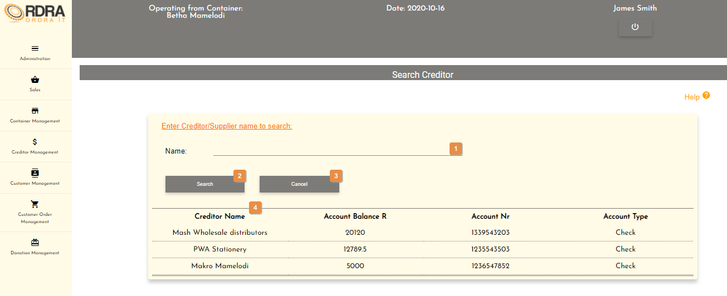

* **Detailed description of the controls:**

|  |  |  |
| --- | --- | --- |
| Reference | Control | Functionality Description |
| 1 | Name Input Field | Click here to make an entry for the creditor name. |
| 2 | Search Button | Clicking the button will display the Creditor Card and the Creditor Account Card. |
| 3 | Cancel Button | Re-direct you to the Creditor Management screen. Click this button to cancel searching a creditor. |
| 4 | Creditor Table | Shows a list of all the creditors in a table format. |

* **Possible Error Messages:** Please refer to the Error and Confirmation Messages, Error Messages, Validation Error Message, Duplicate Entry Message, Item in Use message, Other Messages to view the possible error message(s)).

*Created with the Personal Edition of HelpNDoc:* [*Full-featured Documentation generator*](https://www.helpndoc.com)

Remove Creditor

Allows the user to remove an existing creditor from the system.

* **Navigation process:**
  1. Clicking the Remove Creditor button in the Creditor Card.



* 1. Clicking the search button once you have entered the creditors name, you want to update on the Search Creditor screen.



* **Complete layout:**



* **Detailed description of the controls:**

|  |  |  |
| --- | --- | --- |
| Reference | Control | Functionality Description |
| 1 | Creditor Card | This Creditor Card contains the creditors details. |
| 2 | Creditor Account | This Creditor Account Card contains the creditors account details. |
| 3 | Update Button | This button will allow the updating of the details in the Creditor Account Card. When clicked, it makes all the input fields, in which changes can be made editable. The following buttons will be visible on the screen, to either save or cancel the option to update the details.    Click the Save button, a confirmation message will appear to confirm the update.  Click the Cancel button, a confirmation message will appear to confirm the cancellation. |
| 4 | Delete Button | Shows a list of all the creditors in a table format. |

* **Possible Error Messages:** Please refer to the Error and Confirmation Messages, Error Messages, Validation Error Message, Duplicate Entry Message, Item in Use message, Other Messages to view the possible error message(s)).

*Created with the Personal Edition of HelpNDoc:* [*Easily create PDF Help documents*](https://www.helpndoc.com/feature-tour)

**Creditor Payment**

*Created with the Personal Edition of HelpNDoc:* [*Easily create Help documents*](https://www.helpndoc.com/feature-tour)

Creditor Management Screen

This screen allows the user to navigate through the creditor management screen to access the Creditor and Creditor Payment options as well as their relevant functions that each option provides.

* **Navigation process:**
  1. Click on the Creditor Management button in the Navbar.



* **Complete layout:**



* **Detailed description of the controls:**

|  |  |  |
| --- | --- | --- |
| Reference | Control | Functionality Description |
| 1 | Add Creditor Button | Re-directs you to the Add Creditor screen. Click this button to add a new creditor into the system. |
| 2 | Search Creditor Button | Re-directs you to the Search Creditor screen. Click this button to search a creditor in the system. |
| 3 | Update Creditor Button | Re-directs you to the Search Creditor screen. Click this button to search a creditor in the system, you want to update. |
| 4 | Remove Creditor Button | Re-directs you to the Search Creditor screen. Click this button to search a creditor in the system, you want to remove. |
| 5 | Add Creditor Payment Button | Re-directs you to the Add Creditor Payment screen. Click this button to add a creditor payment into the system. |
| 6 | Search Creditor Payment Button | Re-directs you to the Creditor Payment Details screen. Click this button to add a creditor payment into the system. |

*Created with the Personal Edition of HelpNDoc:* [*Easy CHM and documentation editor*](https://www.helpndoc.com)

Add Payment

Allows the user to add an creditor payment into the system.

* **Navigation process:**
  1. Clicking the Add Creditor Payment button in the Creditor Payment Card.



* **Complete layout:**

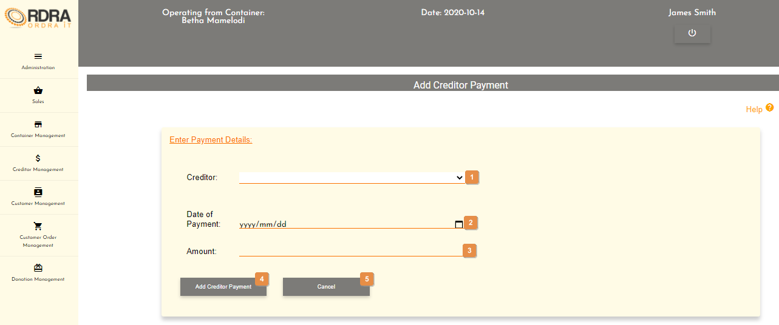

* **Detailed description of the controls:**

|  |  |  |
| --- | --- | --- |
| Reference | Control | Functionality Description |
| 1 | Creditor Select Box | Click the select box will display all the creditors and the user selects the creditor. |
| 2 | Date input field | Click here to select the date of payment. |
| 3 | Amount input field | Click here to make an entry for the payment amount. |
| 4 | Add Creditor Payment Button | Click the Save button, a confirmation massage will appear to confirm the adding of the creditor payment. |
| 5 | Cancel Button | Re-direct you to the Creditor Management screen. Click this button to cancel adding a creditor payment. |

* **Possible Error Messages:** Please refer to the Error and Confirmation Messages, Error Messages, Validation Error Message, Duplicate Entry Message, Item in Use message, Other Messages to view the possible error message(s)).

*Created with the Personal Edition of HelpNDoc:* [*Full-featured EPub generator*](https://www.helpndoc.com/create-epub-ebooks)

Search Payment

Allows the user to search the creditor payments made in the system.

* **Navigation process:**
  1. Clicking the Search Creditor Payment button in the Creditor Payment Card.



* **Complete layout:**

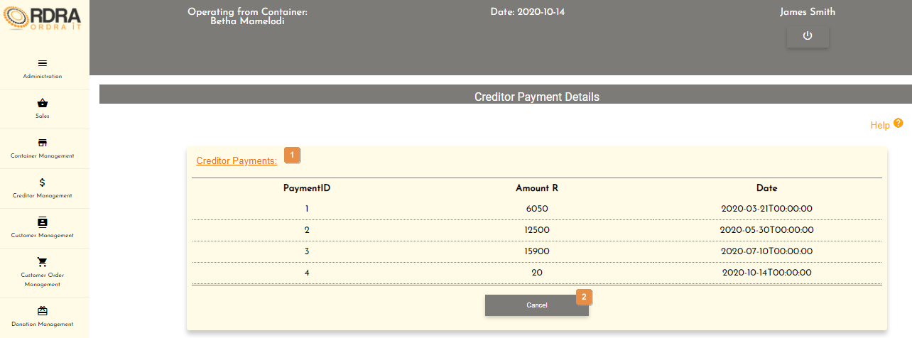

* **Detailed description of the controls:**

|  |  |  |
| --- | --- | --- |
| Reference | Control | Functionality Description |
| 1 | Creditor Payments Table | Shows a list of all the creditor payment that have been made in a table format. |
| 2 | Cancel Button | Re-direct you to the Creditor Management screen. Click this button to cancel the search. |

*Created with the Personal Edition of HelpNDoc:* [*Create help files for the Qt Help Framework*](https://www.helpndoc.com/feature-tour/create-help-files-for-the-qt-help-framework)

**Province**

*Created with the Personal Edition of HelpNDoc:* [*Easily create iPhone documentation*](https://www.helpndoc.com/feature-tour/iphone-website-generation)

GPS Management Screen

This screen allows the user to navigate through the GPS management screen to access the Location, Area and Province options and their relevant functions that each option provides.

* **Navigation process:**
  1. Click on the GPS Management button in the Navbar.

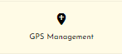

* **Complete layout:**

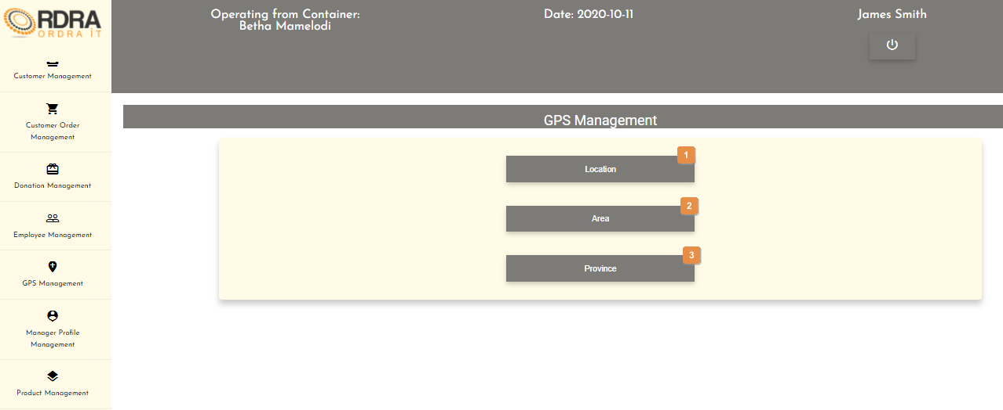

* **Detailed description of the controls:**

|  |  |  |
| --- | --- | --- |
| Reference | Control | Functionality Description |
| 1 | Location Button | Clicking this button will make the Location card visible with various buttons related to the location. |
| 2 | Area Button | Clicking this button will make the Area card visible with various buttons related to the area. |
| 3 | Province Button | Clicking this button will make the Province card visible with various buttons related to the province. |

*Created with the Personal Edition of HelpNDoc:* [*News and information about help authoring tools and software*](https://www.helpauthoringsoftware.com)

Add Province

Allows the user to add a province into the system.

* **Navigation process:**
  1. Clicking the Province button on the GPS Management screen.



* 1. Clicking the Add Province button in the Province Card.



* **Complete layout:**

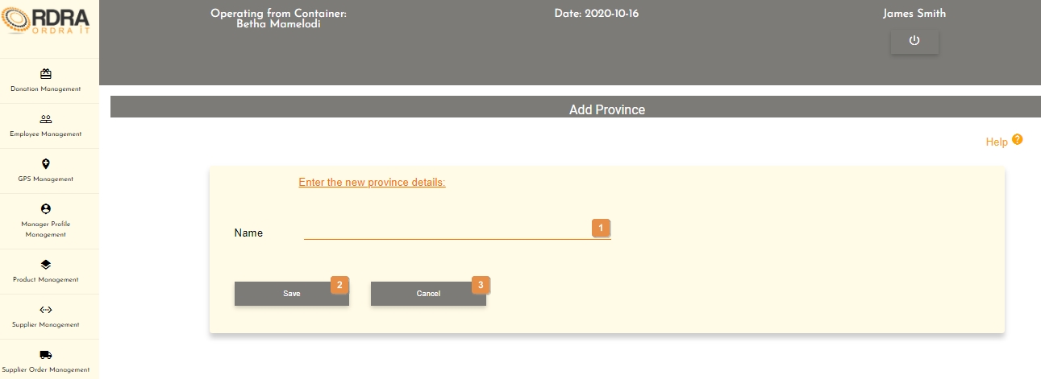

* **Detailed description of the controls:**

|  |  |  |
| --- | --- | --- |
| Reference | Control | Functionality Description |
| 1 | Province Name input field | Click here to make an entry for the province name. |
| 5 | Save Button | Click the Save button, a confirmation massage will appear to confirm the adding of the province. |
| 6 | Cancel Button | Re-direct you to the GPS Management screen. Click this button to cancel adding a province. |

* **Possible Error Messages:** Please refer to the Error and Confirmation Messages, Error Messages, Validation Error Message, Duplicate Entry Message, Item in Use message, Other Messages to view the possible error message(s)).

*Created with the Personal Edition of HelpNDoc:* [*Full-featured EBook editor*](https://www.helpndoc.com/create-epub-ebooks)

Search Province

Allows the user to search existing provinces in the system.

* **Navigation process:**
  1. Clicking the Province button on the GPS Management screen.



* 1. Clicking the Search Province button in the Province Card.



* **Complete layout:**

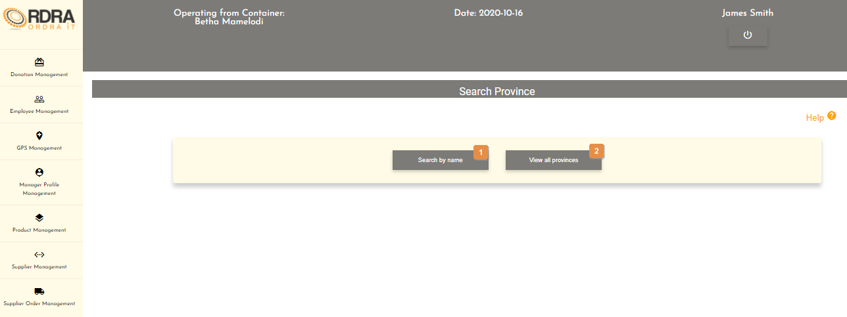

* **Detailed description of the controls:**

|  |  |  |
| --- | --- | --- |
| Reference | Control | Functionality Description |
| 1 | Search by name Button | Click this button will display the Search by name card as displayed below.     |  |  |  | | --- | --- | --- | | Reference | Control | Functionality Description | | 1 | Name input field | Click here to make an entry for the province name you want to search. | | 2 | Search Button | Click this button will display the Searched Province Details card with that provinces details, if the province exists in the system. | | 3 | Cancel Button | Re-direct you to the GPS Management screen. Click this button to cancel the search. | |
| 2 | View all provinces Button | Click the View all provinces button will display the List of all the provinces card which shows a list of all the provinces is a table format. Next to each province listed is a view button as well as a cancel button below that list of all provinces.    Click this button will display the Search Province card prepopulated with the specific province name as well as the Searched Province Details card with that province’s details.    Re-direct you to the GPS Management Screen |

* **Possible Error Messages:** Please refer to the Error and Confirmation Messages, Error Messages, Validation Error Message, Duplicate Entry Message, Item in Use message, Other Messages to view the possible error message(s)).

*Created with the Personal Edition of HelpNDoc:* [*Full-featured EPub generator*](https://www.helpndoc.com/create-epub-ebooks)

Update Province

Allows the user to update an existing province in the system.

* **Navigation process:**
  1. Clicking the Province button on the GPS Management screen.



* 1. Clicking the Update Province button in the Province Card.



* 1. Clicking the Search by name button on the Search Province screen.



* 1. Click the Search button after entering the area name in the province name input field, you want to update.



**Alternative Action**

* Clicking the View all provinces button on the Search Province screen.



* Clicking the View button next to the that province, you want to update.



* **Complete layout:**

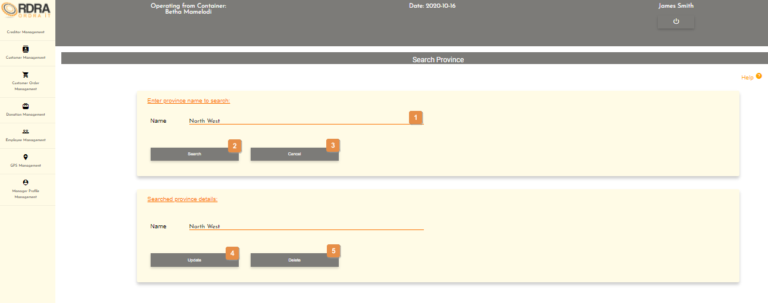

* **Detailed description of the controls:**

|  |  |  |
| --- | --- | --- |
| Reference | Control | Functionality Description |
| 1 | Province name input field | Click here to make an entry for the province name. |
| 2 | Search Button | Click this button will display the Searched Province Details card with that provinces details, if the province exists in the system. |
| 3 | Cancel Button | Re-direct you to the GPS Management screen. Click this button to cancel. |
| 4 | Update Button | This button will allow the updating of the details in the Searched Province Details card. When clicked, it makes all the input fields, in which changes can be made editable. The following buttons will be visible on the screen, to either save or cancel the option to update the details.    Click the Save button, a confirmation message will appear to confirm the update.  Click the Cancel button, a confirmation message will appear to confirm the cancellation. |
| 5 | Delete Button | Click the Delete button, a confirmation message will appear to confirm the delete. |

* **Possible Error Messages:** Please refer to the Error and Confirmation Messages, Error Messages, Validation Error Message, Duplicate Entry Message, Item in Use message, Other Messages to view the possible error message(s)).

*Created with the Personal Edition of HelpNDoc:* [*Easily create EPub books*](https://www.helpndoc.com/feature-tour)

Remove Province

Allows the user to remove an existing province in the system.

* **Navigation process:**
  1. Clicking the Province button on the GPS Management screen.



* 1. Clicking the Remove Area button in the Province Card.



* 1. Clicking the Search by name button on the Search Province screen.



* 1. Click the Search button after entering the area name in the province name input field, you want to update.



**Alternative Action**

* Clicking the View all provinces button on the Search Province screen.



* Clicking the View button next to the that province, you want to update.



* **Complete layout:**



* **Detailed description of the controls:**

|  |  |  |
| --- | --- | --- |
| Reference | Control | Functionality Description |
| 1 | Province name input field | Click here to make an entry for the province name. |
| 2 | Search Button | Click this button will display the Searched Province Details card with that provinces details, if the province exists in the system. |
| 3 | Cancel Button | Re-direct you to the GPS Management screen. Click this button to cancel. |
| 4 | Update Button | This button will allow the updating of the details in the Searched Province Details card. When clicked, it makes all the input fields, in which changes can be made editable. The following buttons will be visible on the screen, to either save or cancel the option to update the details.    Click the Save button, a confirmation message will appear to confirm the update.  Click the Cancel button, a confirmation message will appear to confirm the cancellation. |
| 5 | Delete Button | Click the Delete button, a confirmation message will appear to confirm the delete. |

* **Possible Error Messages:** Please refer to the Error and Confirmation Messages, Error Messages, Validation Error Message, Duplicate Entry Message, Item in Use message, Other Messages to view the possible error message(s)).

*Created with the Personal Edition of HelpNDoc:* [*Free CHM Help documentation generator*](https://www.helpndoc.com)

**Area**

*Created with the Personal Edition of HelpNDoc:* [*Easily create Help documents*](https://www.helpndoc.com/feature-tour)

GPS Management Screen

This screen allows the user to navigate through the GPS management screen to access the Location, Area and Province options and their relevant functions that each option provides.

* **Navigation process:**
  1. Click on the GPS Management button in the Navbar.



* **Complete layout:**



* **Detailed description of the controls:**

|  |  |  |
| --- | --- | --- |
| Reference | Control | Functionality Description |
| 1 | Location Button | Clicking this button will make the Location card visible with various buttons related to the location. |
| 2 | Area Button | Clicking this button will make the Area card visible with various buttons related to the area. |
| 3 | Province Button | Clicking this button will make the Province card visible with various buttons related to the province. |

*Created with the Personal Edition of HelpNDoc:* [*Qt Help documentation made easy*](https://www.helpndoc.com/feature-tour/create-help-files-for-the-qt-help-framework)

Add Area

Allows the user to add a new area into the system.

* **Navigation process:**
  1. Clicking the Area button on the GPS Management screen.



* 1. Clicking the Add Area button in the Area Card.



* **Complete layout:**

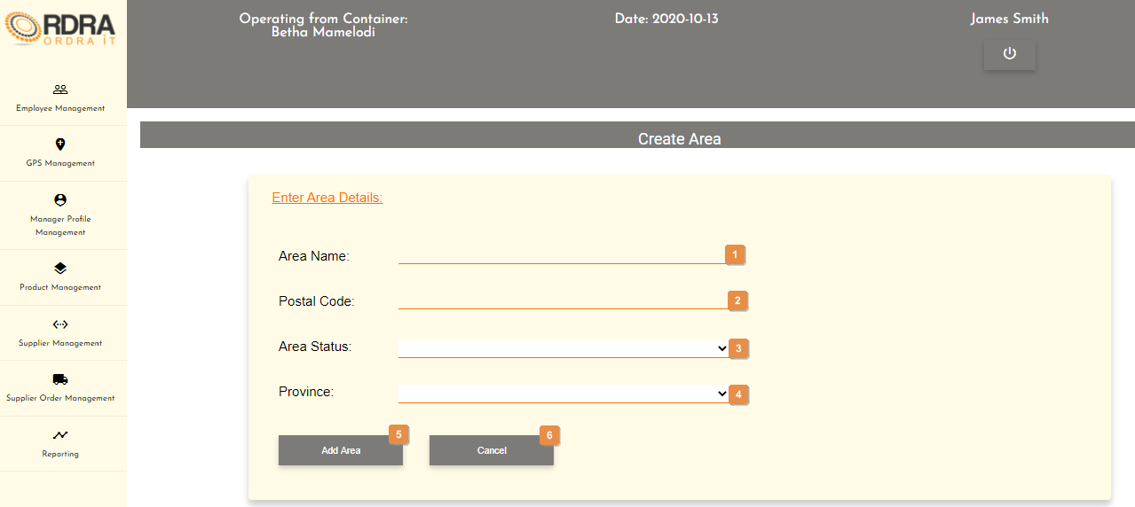

* **Detailed description of the controls:**

|  |  |  |
| --- | --- | --- |
| Reference | Control | Functionality Description |
| 1 | Area Name input field | Click here to make an entry for the area name. |
| 2 | Postal Code input field | Click here to make an entry for the area postal code. |
| 3 | Area Status Select Box | Click the select box will display all the area statuses and the user selects the area status. |
| 4 | Province Status Select Box | Click the select box will display all the provinces and the user selects the province. |
| 5 | Add Area Button | Click the Add Area button, a confirmation massage will appear to confirm the adding of the area. |
| 6 | Cancel Button | Re-direct you to the GPS Management screen. Click this button to cancel adding an area. |

* **Possible Error Messages:** Please refer to the Error and Confirmation Messages, Error Messages, Validation Error Message, Duplicate Entry Message, Item in Use message, Other Messages to view the possible error message(s)).

*Created with the Personal Edition of HelpNDoc:* [*Produce electronic books easily*](https://www.helpndoc.com/create-epub-ebooks)

Search Area

Allows the user to search existing areas in the system.

* **Navigation process:**
  1. Clicking the Area button on the GPS Management screen.



* 1. Clicking the Search Area button in the Area Card.



* **Complete layout:**

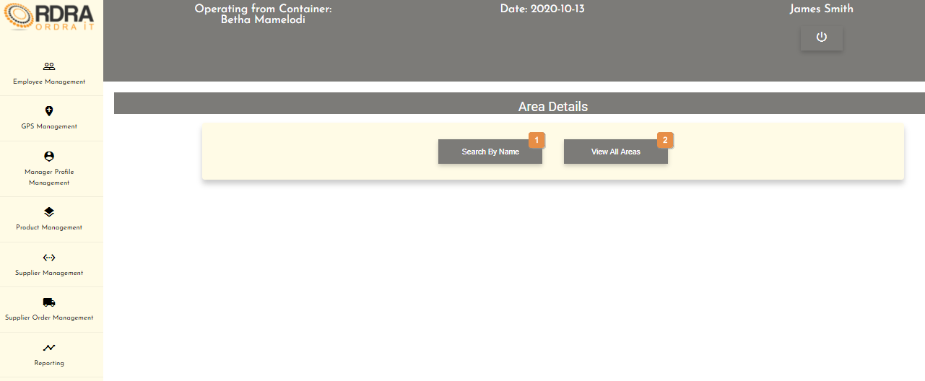

* **Detailed description of the controls:**

|  |  |  |
| --- | --- | --- |
| Reference | Control | Functionality Description |
| 1 | Search By Name Button | Click this button will display the Search Area by Name card as displayed below.     |  |  |  | | --- | --- | --- | | Reference | Control | Functionality Description | | 1 | Area Name input field | Click here to make an entry for the area name you want to search. | | 2 | Search Button | Click this button will display the Searched Area Details card with that areas details, if the area exists in the system. | | 3 | Cancel Button | Re-direct you to the GPS Management screen. Click this button to cancel the search. | |
| 2 | View All Areas Button | Click the View All Areas button will display the List of all Areas card which shows a list of all the areas is a table format. Next to each area listed is a view button as well as a cancel button below that list of all areas.    Click this button will display the Searched Area Details card with that area’s details.    Re-direct you to the Area Details screen with the two options to search by which is the Search By Name and View All Areas buttons. Click this button to cancel the search. |

* **Possible Error Messages:** Please refer to the Error and Confirmation Messages, Error Messages, Validation Error Message, Duplicate Entry Message, Item in Use message, Other Messages to view the possible error message(s)).

*Created with the Personal Edition of HelpNDoc:* [*Create help files for the Qt Help Framework*](https://www.helpndoc.com/feature-tour/create-help-files-for-the-qt-help-framework)

Update Area

Allows the user to update an existing area in the system.

* **Navigation process:**
  1. Clicking the Area button on the GPS Management screen.



* 1. Clicking the Update Area button in the Area Card.



* 1. Clicking the Search By Name button on the Area Details screen.

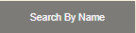

* 1. Click the Search button after entering the area name in the area name input field, you want to update.



**Alternative Action**

* Clicking the View All Areas button on the Area Details screen.



* Clicking the View button next to the that area, you want to update.



* **Complete layout:**

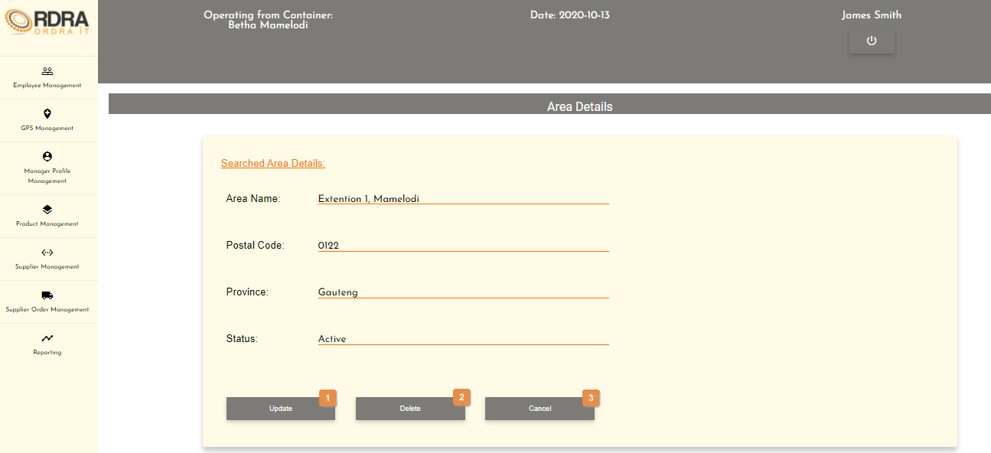

* **Detailed description of the controls:**

|  |  |  |
| --- | --- | --- |
| Reference | Control | Functionality Description |
| 1 | Update Button | This button will allow the updating of the details in the Searched Area Details card. When clicked, it makes all the input fields, in which changes can be made editable. The following buttons will be visible on the screen, to either save or cancel the option to update the details.    Click the Update button, a confirmation message will appear to confirm the update.  Click the Cancel button, re-direct you to the GPS Management screen. |
| 2 | Delete Button | Click the Delete button, a confirmation message will appear to confirm the delete. |
| 3 | Cancel Button | Re-direct you to the GPS Management screen. Click this button to cancel. |

* **Possible Error Messages:** Please refer to the Error and Confirmation Messages, Error Messages, Validation Error Message, Duplicate Entry Message, Item in Use message, Other Messages to view the possible error message(s)).

*Created with the Personal Edition of HelpNDoc:* [*Free Kindle producer*](https://www.helpndoc.com/feature-tour/create-ebooks-for-amazon-kindle)

Remove Area

Allows the user to remove an existing area in the system.

* **Navigation process:**
  1. Clicking the Area button on the GPS Management screen.



* 1. Clicking the Remove Area button in the Area Card.



* 1. Clicking the Search By Name button on the Area Details screen.



* 1. Click the Search button after entering the area name in the area name input field, you want to remove.



**Alternative Action**

* Clicking the View All Areas button on the Area Details screen.



* Clicking the View button next to the that area, you want to remove.



* **Complete layout:**



* **Detailed description of the controls:**

|  |  |  |
| --- | --- | --- |
| Reference | Control | Functionality Description |
| 1 | Update Button | This button will allow the updating of the details in the Searched Area Details card. When clicked, it makes all the input fields, in which changes can be made editable. The following buttons will be visible on the screen, to either save or cancel the option to update the details.    Click the Update button, a confirmation message will appear to confirm the update.  Click the Cancel button, re-direct you to the GPS Management screen. |
| 2 | Delete Button | Click the Delete button, a confirmation message will appear to confirm the delete. |
| 3 | Cancel Button | Re-direct you to the GPS Management screen. Click this button to cancel. |

* **Possible Error Messages:** Please refer to the Error and Confirmation Messages, Error Messages, Validation Error Message, Duplicate Entry Message, Item in Use message, Other Messages to view the possible error message(s)).

*Created with the Personal Edition of HelpNDoc:* [*Free help authoring environment*](https://www.helpndoc.com/help-authoring-tool)

**Location**

*Created with the Personal Edition of HelpNDoc:* [*Free help authoring tool*](https://www.helpndoc.com/help-authoring-tool)

GPS Management Screen

This screen allows the user to navigate through the GPS management screen to access the Location, Area and Province options and their relevant functions that each option provides.

1. **Navigation process:**
   1. Click on the GPS Management button in the Navbar.



1. **Complete layout:**



1. **Detailed description of the controls:**

|  |  |  |
| --- | --- | --- |
| Reference | Control | Functionality Description |
| 1 | Location Button | Clicking this button will make the Location card visible with various buttons related to the location. |
| 2 | Area Button | Clicking this button will make the Area card visible with various buttons related to the area. |
| 3 | Province Button | Clicking this button will make the Province card visible with various buttons related to the province. |

*Created with the Personal Edition of HelpNDoc:* [*Easily create PDF Help documents*](https://www.helpndoc.com/feature-tour)

Create Location

Allows the user to add a new location into the system.

* **Navigation process:**
  1. Clicking the Location button on the GPS Management screen.



* 1. Clicking the Add Location button in the Location Card.



* **Complete layout:**

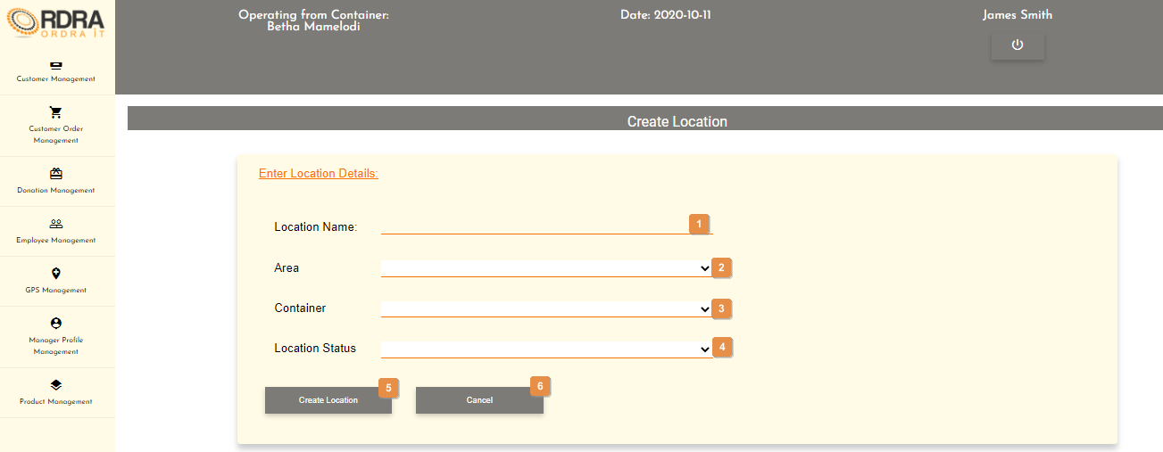

* **Detailed description of the controls:**

|  |  |  |
| --- | --- | --- |
| Reference | Control | Functionality Description |
| 1 | Location Name input field | Click here to make an entry for the location name. |
| 2 | Area Select Box | Click the select box will display all the areas and the user selects the area. |
| 3 | Container Select Box | Click the select box will display all the containers and the user selects the container. |
| 4 | Location Status Select Box | Click the select box will display all the location statuses and the user selects the location status. |
| 5 | Save Button | Click the Save button, a confirmation massage will appear to confirm the adding of the location. |
| 6 | Cancel Button | Re-direct you to the GPS Management screen. Click this button to cancel adding a location. |

* **Possible Error Messages:** Please refer to the Error and Confirmation Messages, Error Messages, Validation Error Message, Duplicate Entry Message, Item in Use message, Other Messages to view the possible error message(s)).

*Created with the Personal Edition of HelpNDoc:* [*Full-featured Kindle eBooks generator*](https://www.helpndoc.com/feature-tour/create-ebooks-for-amazon-kindle)

Search Location

Allows the user to search existing locations in the system.

1. **Navigation process:**
   1. Clicking the Location button on the GPS Management screen.



* 1. Clicking the Search Location button in the Location Card.



1. **Complete layout:**

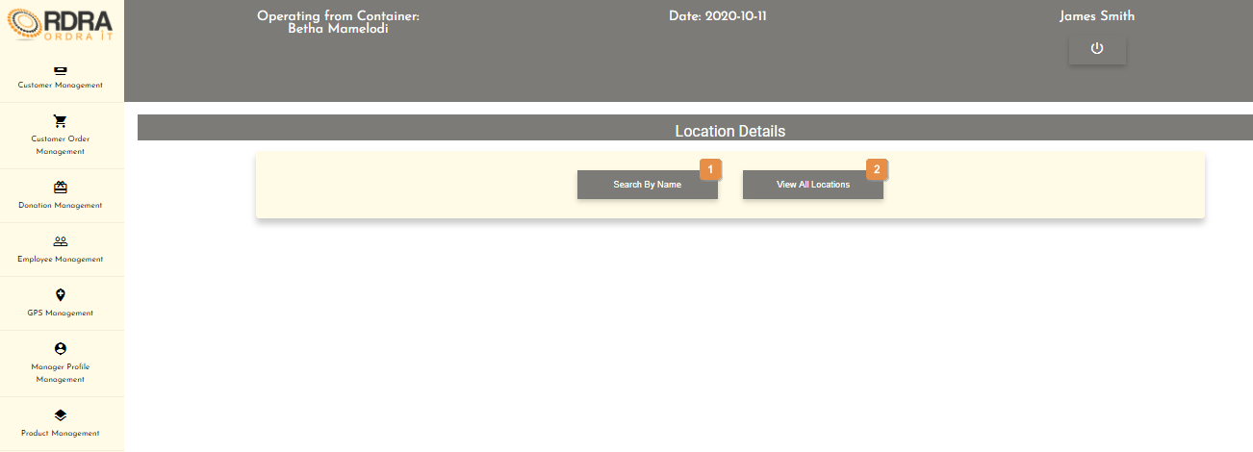

1. **Detailed description of the controls:**

|  |  |  |
| --- | --- | --- |
| Reference | Control | Functionality Description |
| 1 | Search By Name Button | Click this button will display the Search Location by Name card as displayed below.     |  |  |  | | --- | --- | --- | | Reference | Control | Functionality Description | | 1 | Location Name input field | Click here to make an entry for the location name you want to search. | | 2 | Search Button | Click this button will display the Searched Location Details card with that locations details, if the location exists in the system. | | 3 | Cancel Button | Re-direct you to the GPS Management screen. Click this button to cancel the search. | |
| 2 | View All Locations Button | Click the View All Locations button will display the List of all Locations card which shows a list of all the location is a table format. Next to each location listed is a view button as well as a cancel button below that list of all locations.    Click this button will display the Searched Location Details card with that location’s details.    Re-direct you to the GPS Management screen. Click this button to cancel the search. |

1. **Possible Error Messages:** Please refer to the Error and Confirmation Messages, Error Messages, Validation Error Message, Duplicate Entry Message, Item in Use message, Other Messages to view the possible error message(s)).

*Created with the Personal Edition of HelpNDoc:* [*Produce online help for Qt applications*](https://www.helpndoc.com/feature-tour/create-help-files-for-the-qt-help-framework)

Update Location

Allows the user to update an existing location in the system.

* **Navigation process:**
  1. Clicking the Location button on the GPS Management screen.



* 1. Clicking the Update Location button in the Location Card.



* **Complete layout:**

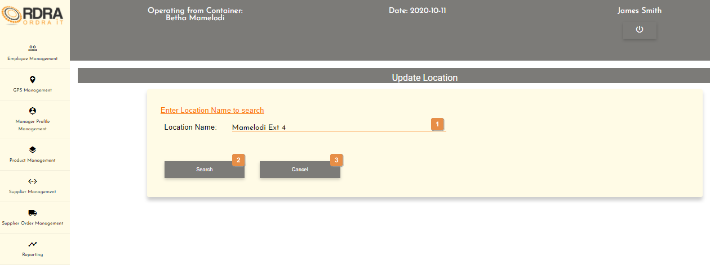

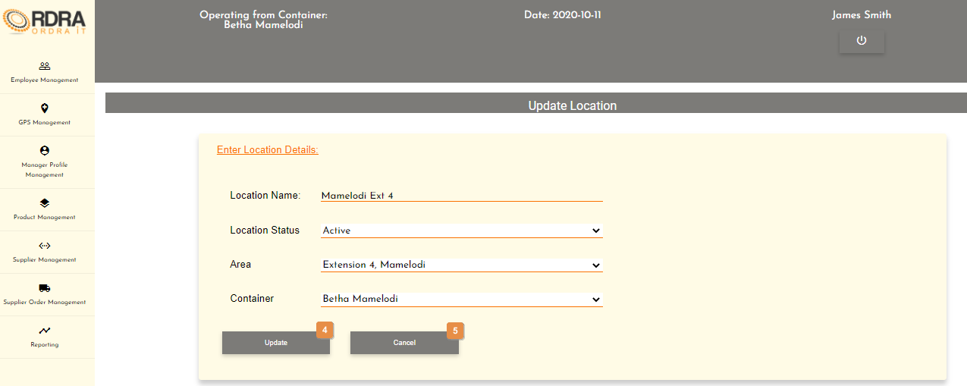

* **Detailed description of the controls:**

|  |  |  |
| --- | --- | --- |
| Reference | Control | Functionality Description |
| 1 | Location Name input field | Click here to make an entry for the location name you want to search. |
| 2 | Search Button | Click this button will display the Searched Location Details card with that locations details, if the location exists in the system as shown in the second screen shot above. |
| 3 | Cancel Button | Re-direct you to the GPS Management screen. Click this button to cancel the search. |
| 4 | Update Button | Click the Update button, a confirmation message will appear to confirm the update. |
| 5 | Cancel Button | Re-direct you to the GPS Management screen. Click this button to cancel the update. |

* **Possible Error Messages:** Please refer to the Error and Confirmation Messages, Error Messages, Validation Error Message, Duplicate Entry Message, Item in Use message, Other Messages to view the possible error message(s)).

*Created with the Personal Edition of HelpNDoc:* [*Full-featured Help generator*](https://www.helpndoc.com/feature-tour)

**Donation Recipient**

*Created with the Personal Edition of HelpNDoc:* [*Easily create EBooks*](https://www.helpndoc.com/feature-tour)

Donation Management Screen

This screen allows the user to navigate through the donation management screen to access either the Donation Recipient or Donation options and their relevant functions that each option provides.

* **Navigation process:**
  1. Click on the Donation Management button in the Navbar.



* **Complete layout:**

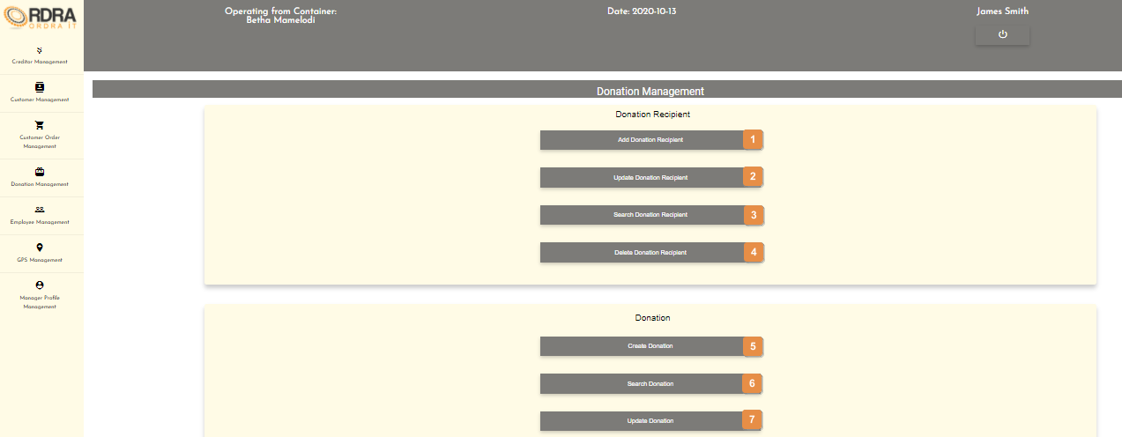

* **Detailed description of the controls:**

|  |  |  |
| --- | --- | --- |
| Reference | Control | Functionality Description |
| 1 | Add Donation Recipient Button | Re-directs you to the Add Donation Recipient screen. Click this button to add a new donation recipient into the system. |
| 2 | Update Donation Recipient Button | Re-directs you to the Search Donation Recipient screen. Click this button to search a specific recipient in the system you want to update. |
| 3 | Search Donation Recipient Button | Re-directs you to the Search Donation Recipient screen. Click this button to search a recipient in the system. |
| 4 | Delete Donation Recipient Button | Re-directs you to the Search Donation Recipient screen. Click this button to search a specific recipient in the system you want to remove. |
| 5 | Create Donation Button | Re-directs you to the Create Donation screen. Click this button to create a new donation into the system. |
| 6 | Search Donation Button | Re-directs you to the Search Donation screen. Click this button to search a donation in the system. |
| 7 | Update Donation Button | Re-directs you to the Search Donation screen. Click this button to search a donation in the system you want to update. |

*Created with the Personal Edition of HelpNDoc:* [*Generate Kindle eBooks with ease*](https://www.helpndoc.com/feature-tour/create-ebooks-for-amazon-kindle)

Create Donation Recipient

Allows the user to add a new donation recipient into the system.

* **Navigation process:**
  1. Clicking the Add Donation Recipient button on the Donation Management screen in the Donation Recipient Card.



* **Complete layout:**

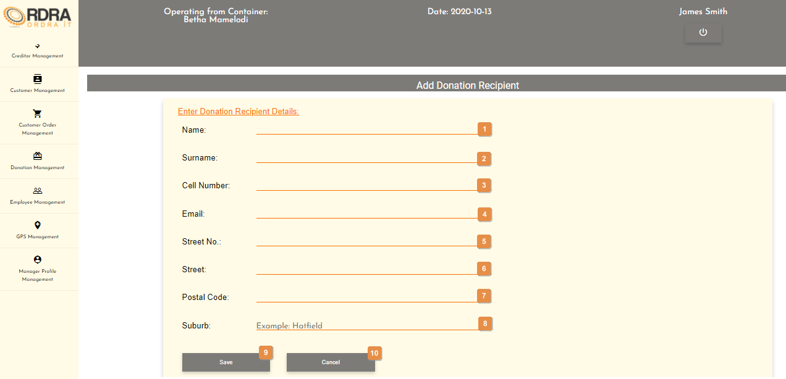

* **Detailed description of the controls:**

|  |  |  |
| --- | --- | --- |
| Reference | Control | Functionality Description |
| 1 | Name input field | Click here to make an entry for the recipient name. |
| 2 | Surname input field | Click here to make an entry for the recipient surname. |
| 3 | Cell Number input field | Click here to make an entry for the recipient cell number. |
| 4 | Email input field | Click here to make an entry for the recipient email. |
| 5 | Street No. input field | Click here to make an entry for the recipient street no. |
| 6 | Street input field | Click here to make an entry for the recipient street. |
| 7 | Postal Code input field | Click here to make an entry for the recipient postal code. |
| 8 | Suburb input field | Click here to make an entry for the recipient suburb. |
| 9 | Save Button | Click the Save button, a confirmation massage will appear to confirm the adding of a recipient. |
| 10 | Cancel Button | Re-direct you to the Donation Management screen. Click this button to cancel adding a recipient. |

* **Possible Error Messages:** Please refer to the Error and Confirmation Messages, Error Messages, Validation Error Message, Duplicate Entry Message, Item in Use message, Other Messages to view the possible error message(s)).

*Created with the Personal Edition of HelpNDoc:* [*Free iPhone documentation generator*](https://www.helpndoc.com/feature-tour/iphone-website-generation)

Update Donation Recipient

Allows the user to update an existing recipient in the system.

* **Navigation process:**
  1. Clicking the Update Donation Recipient button on the Donation Management screen in the Donation Recipient Card.



* 1. Clicking on the Input Criteria button on the Search Donation Recipient screen.



* **Complete layout:**

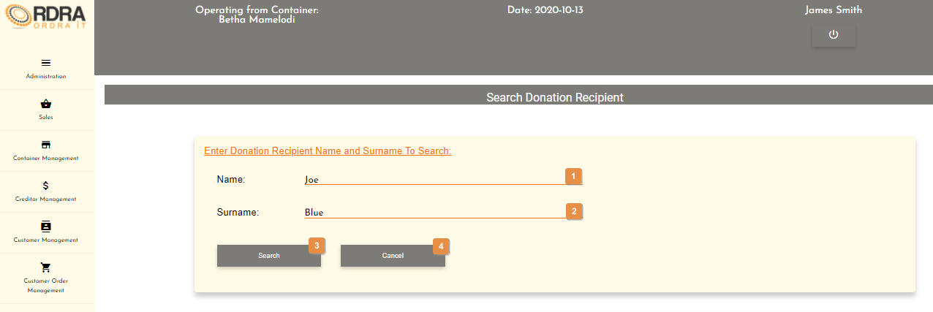

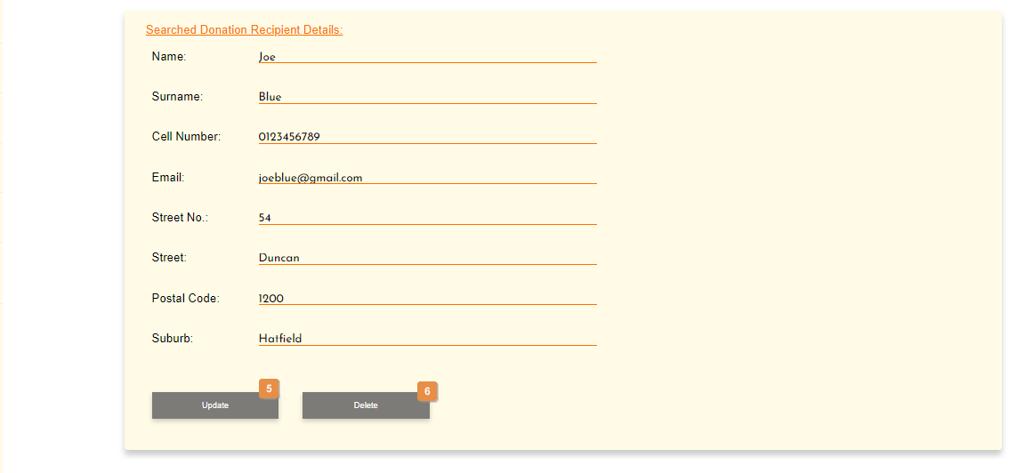

* **Detailed description of the controls:**

|  |  |  |
| --- | --- | --- |
| Reference | Control | Functionality Description |
| 1 | Search Name input field | Click here to make an entry for the recipient name to search. |
| 2 | Search Surname input field | Click here to make an entry for the recipient surname to search. |
| 3 | Search Button | This button will display the Search Donation Recipient Details card if the recipient exists in the system. |
| 4 | Cancel Button | Re-direct you to the Donation Management screen. Click this button to cancel the search of a recipient. |
| 5 | Update Button | This button will allow the updating of the details in the Searched Donation Recipient Details card. When clicked, it makes all the input fields, in which changes can be made editable. The following buttons will be visible on the screen, to either save or cancel the option to update the details.    Click the Save button, a confirmation message will appear to confirm the update.  Click the Cancel button, a confirmation message will appear to confirm the cancellation. |
| 6 | Delete Button | Click the Delete button, a confirmation message will appear to confirm the deletion. |

* **Possible Error Messages:** Please refer to the Error and Confirmation Messages, Error Messages, Validation Error Message, Duplicate Entry Message, Item in Use message, Other Messages to view the possible error message(s)).

*Created with the Personal Edition of HelpNDoc:* [*Create help files for the Qt Help Framework*](https://www.helpndoc.com/feature-tour/create-help-files-for-the-qt-help-framework)

Search Donation Recipient

Allows the user to search existing donation recipients in the system.

1. **Navigation process:**
   1. Clicking the Search Donation Recipient button on the Donation Management screen in the Donation Recipient Card.



1. **Complete layout:**

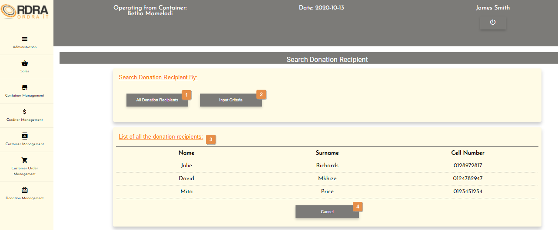

1. **Detailed description of the controls:**

|  |  |  |
| --- | --- | --- |
| Reference | Control | Functionality Description |
| 1 | All Donation Recipients Button | This button will display the List of all the donation recipients card with a table of all the recipients that exists in the system. |
| 2 | Input Criteria Button | This button will display the Search Donation Recipient Details card if the container exists in the system. |
| 3 | List of all the donation recipients table | Shows a list of all the donation recipients that exists in the system. |
| 4 | Cancel Button | Re-direct you to the Donation Management screen. Click this button to cancel the search of all recipients. |

1. **Possible Error Messages:** Please refer to the Error and Confirmation Messages, Error Messages, Validation Error Message, Duplicate Entry Message, Item in Use message, Other Messages to view the possible error message(s)).

*Created with the Personal Edition of HelpNDoc:* [*Free Qt Help documentation generator*](https://www.helpndoc.com)

Remove Donation Recipient

Allows the user to remove an existing donation recipient from the system.

* **Navigation process:**
  1. Clicking the Delete Donation Recipient button on the Donation Management screen in the Donation Recipient Card.



* 1. Clicking on the Input Criteria button on the Search Donation Recipient screen.



* **Complete layout:**





* **Detailed description of the controls:**

|  |  |  |
| --- | --- | --- |
| Reference | Control | Functionality Description |
| 1 | Search Name input field | Click here to make an entry for the recipient name to search. |
| 2 | Search Surname input field | Click here to make an entry for the recipient surname to search. |
| 3 | Search Button | This button will display the Search Donation Recipient Details card if the recipient exists in the system. |
| 4 | Cancel Button | Re-direct you to the Donation Management screen. Click this button to cancel the search of a recipient. |
| 5 | Update Button | This button will allow the updating of the details in the Searched Donation Recipient Details card. When clicked, it makes all the input fields, in which changes can be made editable. The following buttons will be visible on the screen, to either save or cancel the option to update the details.    Click the Save button, a confirmation message will appear to confirm the update.  Click the Cancel button, a confirmation message will appear to confirm the cancellation. |
| 6 | Delete Button | Click the Delete button, a confirmation message will appear to confirm the deletion. |

* **Possible Error Messages:** Please refer to the Error and Confirmation Messages, Error Messages, Validation Error Message, Duplicate Entry Message, Item in Use message, Other Messages to view the possible error message(s)).

*Created with the Personal Edition of HelpNDoc:* [*News and information about help authoring tools and software*](https://www.helpauthoringsoftware.com)

**Donations**

*Created with the Personal Edition of HelpNDoc:* [*Free help authoring environment*](https://www.helpndoc.com/help-authoring-tool)

Donation Management Screen

This screen allows the user to navigate through the donation management screen to access either the Donation Recipient or Donation options and their relevant functions that each option provides.

1. **Navigation process:**
   1. Click on the Donation Management button in the Navbar.



1. **Complete layout:**



1. **Detailed description of the controls:**

|  |  |  |
| --- | --- | --- |
| Reference | Control | Functionality Description |
| 1 | Add Donation Recipient Button | Re-directs you to the Add Donation Recipient screen. Click this button to add a new donation recipient into the system. |
| 2 | Update Donation Recipient Button | Re-directs you to the Search Donation Recipient screen. Click this button to search a specific recipient in the system you want to update. |
| 3 | Search Donation Recipient Button | Re-directs you to the Search Donation Recipient screen. Click this button to search a recipient in the system. |
| 4 | Delete Donation Recipient Button | Re-directs you to the Search Donation Recipient screen. Click this button to search a specific recipient in the system you want to remove. |
| 5 | Create Donation Button | Re-directs you to the Create Donation screen. Click this button to create a new donation into the system. |
| 6 | Search Donation Button | Re-directs you to the Search Donation screen. Click this button to search a donation in the system. |
| 7 | Update Donation Button | Re-directs you to the Search Donation screen. Click this button to search a donation in the system you want to update. |

*Created with the Personal Edition of HelpNDoc:* [*Free Web Help generator*](https://www.helpndoc.com)

Create Donation

Allows the user to create a new donation into the system.

* **Navigation process:**

Creating a donation by searching for a donation recipient using the recipients cell number.

* 1. Clicking the Create Donation button on the Donation Management screen in the Donation Card.



* 1. Clicking the Search by Cell button on the Create Donation screen in the search Donation Card.



* 1. Clicking the Search button on the Create Donation screen in the search Donation Card.



* **Complete layout:**

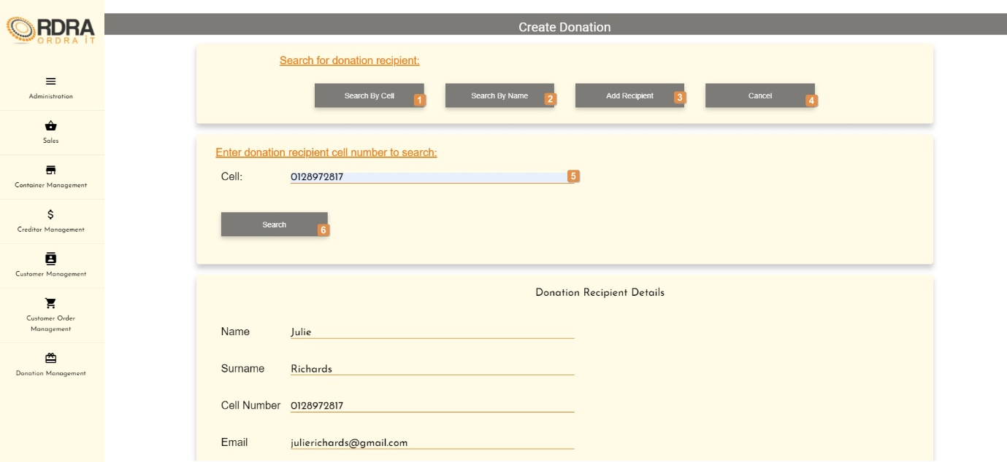

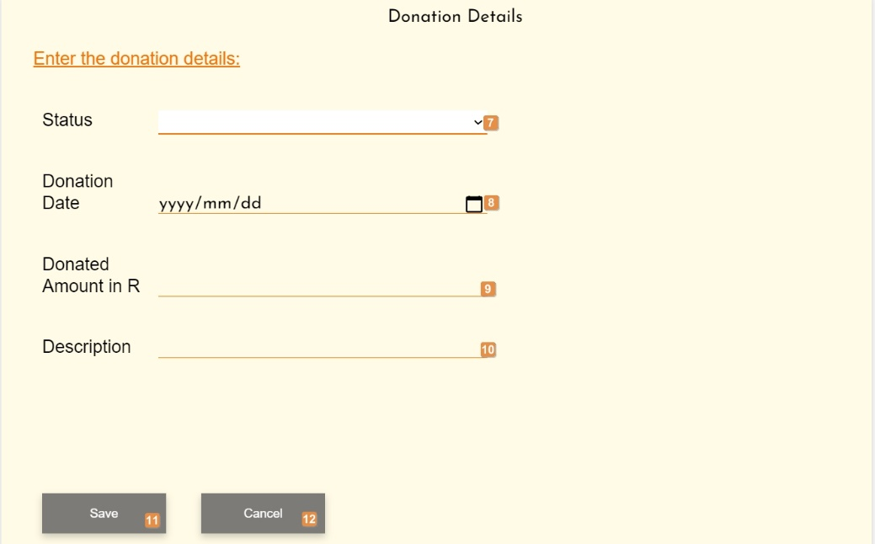

* **Detailed description of the controls:**

|  |  |  |
| --- | --- | --- |
| Reference | Control | Functionality Description |
| 1 | Search By Cell Button | Displays search by cell card. Click here to search for a Donation Recipient using the recipient’s cell number. |
| 2 | Search By Name Button | Displays search by name card. Click here to search for a Donation Recipient using the recipient’s name. |
| 3 | Add Recipient Button | Re-direct you to the Add Donation Recipient screen. Click this button to add a new donation recipient |
| 4 | Cancel Button | Re-direct you to the Donation Management screen. Click this button to cancel adding a recipient. |
| 5 | Search Cell input field | Click here to make an entry for the recipient cell number to search. |
| 6 | Search Button | Displays Donation recipient with entered cell number. Click the Search button to search for recipient with entered Cell number. |
| 7 | Status input field | Click here to select the status of the donation being created |
| 8 | Donation date input field | Click here to select the date the donation was made |
| 9 | Donated amount in R input field | Click here to enter the amount donated of the donation being created |
| 10 | Description input field | Click here to enter a description of the donation being created |
| 11 | Save button | Click here to save a new donation with the details entered in the input fields.  Re-directs you to the Create Donation screen. |
| 12 | Cancel button | Re-directs you to the Create Donation screen. Click this button to create a new donation into the system. |

* **Navigation process:**

Creating a donation by searching for a donation recipient using the recipients name.

* 1. Clicking the Create Donation button on the Donation Management screen in the Donation Card.



* 1. Clicking the Search by Name button on the Create Donation screen in the search Donation Card.



* 1. Clicking the Search button on the Create Donation screen in the search Donation Card.



* **Complete layout:**

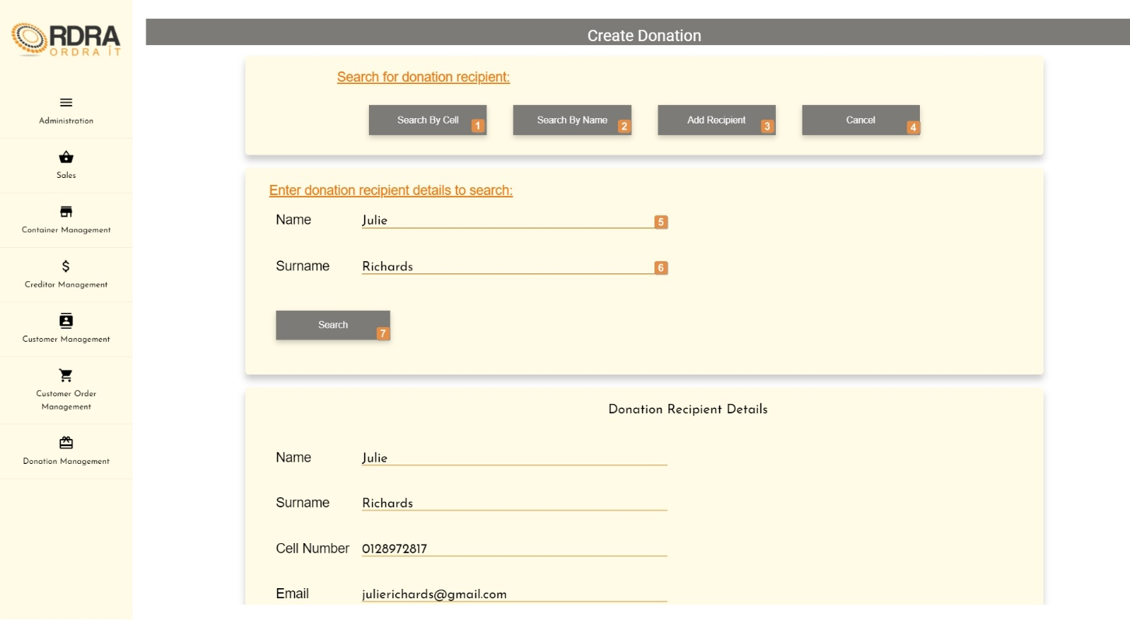

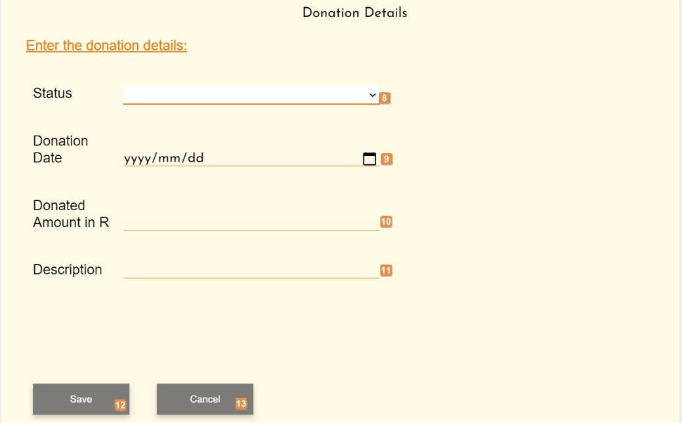

* **Detailed description of the controls:**

|  |  |  |
| --- | --- | --- |
| Reference | Control | Functionality Description |
| 1 | Search By Cell Button | Displays search by cell card. Click here to search for a Donation Recipient using the recipient’s cell number. |
| 2 | Search By Name Button | Displays search by name card. Click here to search for a Donation Recipient using the recipient’s name. |
| 3 | Add Recipient Button | Re-direct you to the Add Donation Recipient screen. Click this button to add a new donation recipient |
| 4 | Cancel Button | Re-direct you to the Donation Management screen. Click this button to cancel adding a recipient. |
| 5 | Search Name input field | Click here to make an entry for the recipient name to search. |
| 6 | Search Surname | Click here to make an entry for the recipient surname to search. |
| 7 | Search Button | Displays Donation recipient with entered cell number. Click the Search button to search for recipient with entered Cell number. |
| 8 | Status input field | Click here to select the status of the donation being created |
| 9 | Donation date input field | Click here to select the date the donation was made |
| 10 | Donated amount in R input field | Click here to enter the amount donated of the donation being created |
| 11 | Description input field | Click here to enter a description of the donation being created |
| 12 | Save button | Click here to save a new donation with the details entered in the input fields.  Re-directs you to the Create Donation screen. |
| 13 | Cancel button | Re-direct you to the Donation Management screen. Click this button to cancel searching a donation. |

* **Possible Error Messages:** Please refer to the Error and Confirmation Messages, Error Messages, Validation Error Message, Duplicate Entry Message, Item in Use message, Other Messages to view the possible error message(s)).

*Created with the Personal Edition of HelpNDoc:* [*Generate Kindle eBooks with ease*](https://www.helpndoc.com/feature-tour/create-ebooks-for-amazon-kindle)

Update Donation

Allows the user to update an existing donation the system.

* **Navigation process:**
  1. Clicking the Update Donation button on the Donation Management screen in the Donation Card.



* 1. The Search donation screen is displayed and the donation has to be searched prior to you being able to update it. The following card is then displayed in addition to the search results
* **Complete layout:**

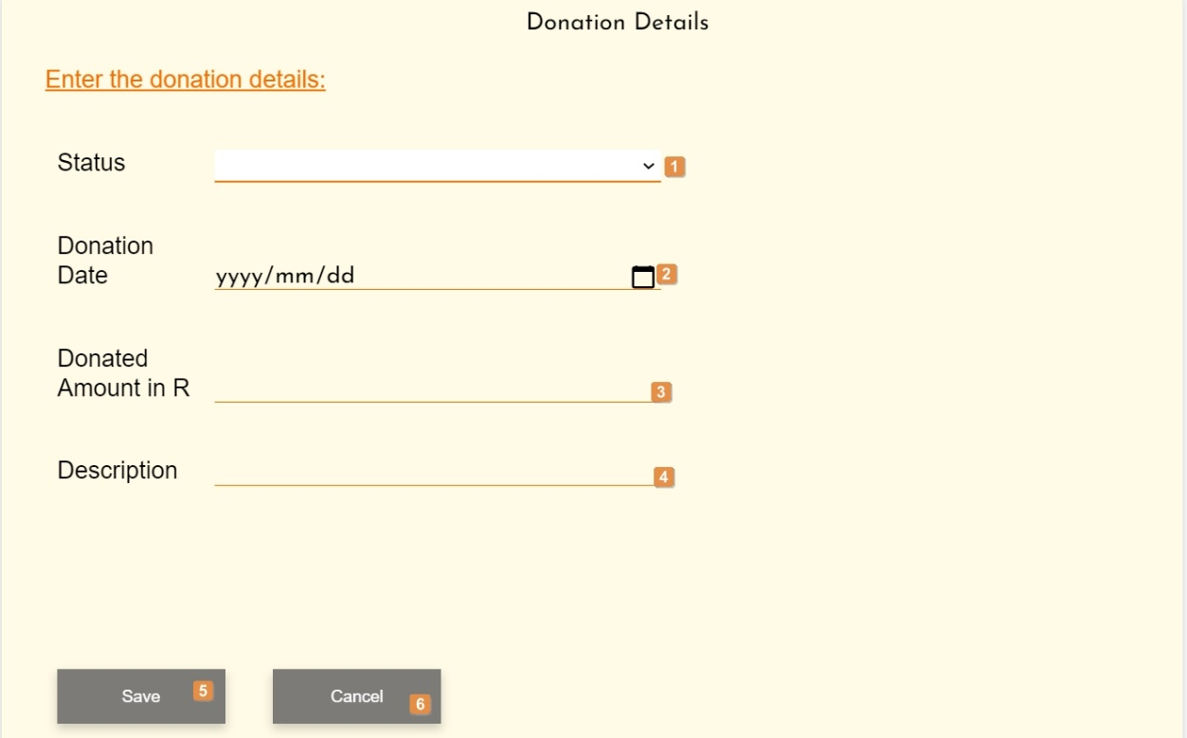

* **Detailed description of the controls:**

|  |  |  |
| --- | --- | --- |
| Reference | Control | Functionality Description |
| 1 | Status input field | Click here to update the status of the donation being updated |
| 2 | Donation date input field | Click here to update the date of the donation being updates |
| 3 | Donated amount in R input field | Click here to update the amount donated of the donation being update |
| 4 | Description input field | Click here to update the description of the donation being updated |
| 5 | Save button | Click here to save the updated donation with the details entered in the input fields.  Re-directs you to the Donation management screen. |
| 6 | Cancel button | Re-direct you to the Donation Management screen. Click this button to cancel searching a donation. |

* **Possible Error Messages:** Please refer to the Error and Confirmation Messages, Error Messages, Validation Error Message, Duplicate Entry Message, Item in Use message, Other Messages to view the possible error message(s)).

*Created with the Personal Edition of HelpNDoc:* [*Easily create EBooks*](https://www.helpndoc.com/feature-tour)

Search Donation

Allows the user to search existing donation in the system.

* **Navigation process:**

Creating a donation by searching for a donation recipient using the recipient’s cell.

* 1. Clicking the Search Donation button on the Donation Management screen in the Donation Card.



* 1. Clicking the Search by cell button on the Search Donation screen in the search Donation Card.



* 1. Clicking the Search button on the Search Donation screen in the search Donation Card.



* **Complete layout:**

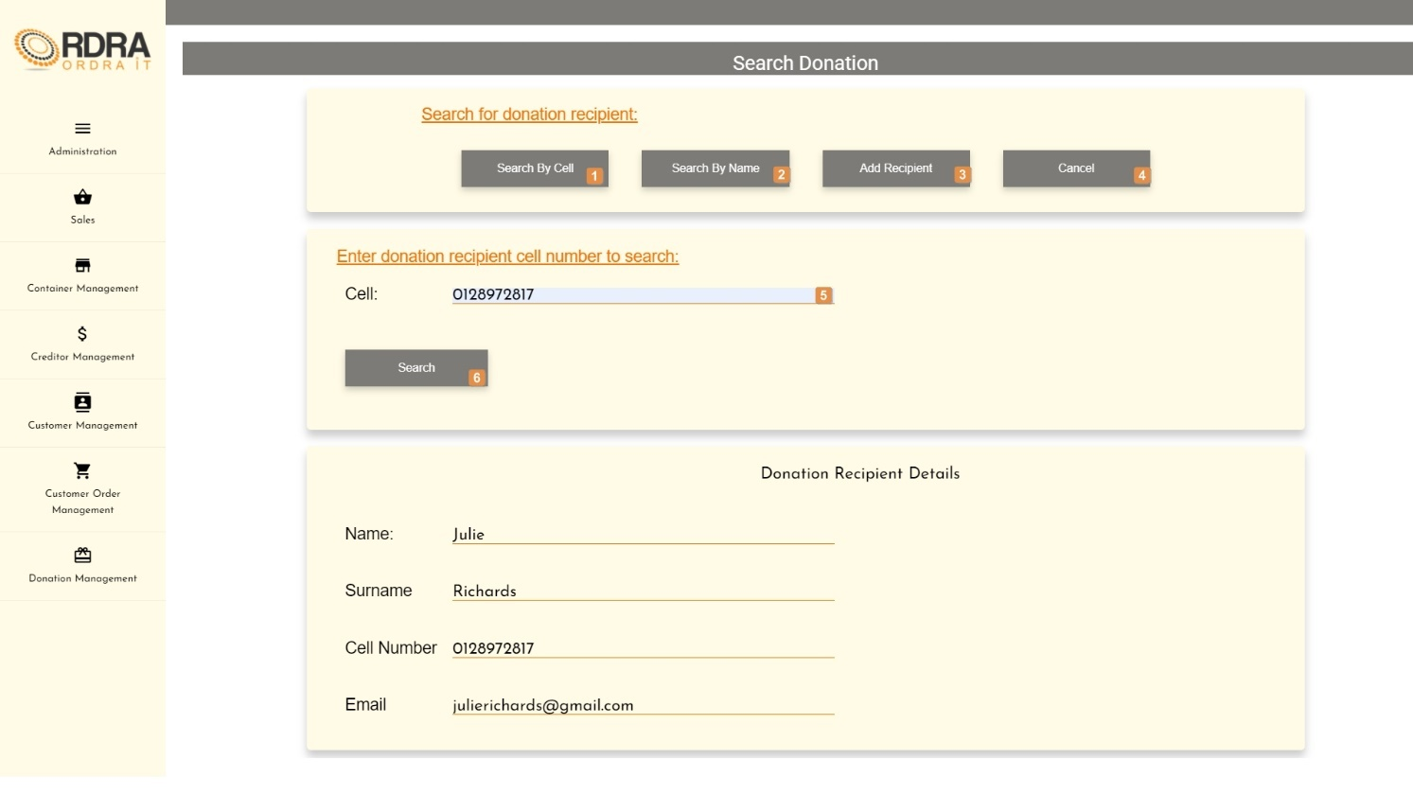

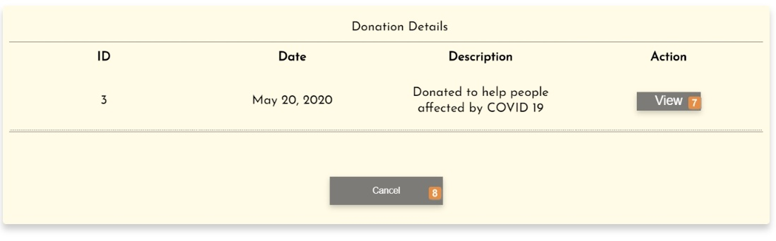

Donation details card is only displayed once the view button has been clicked.

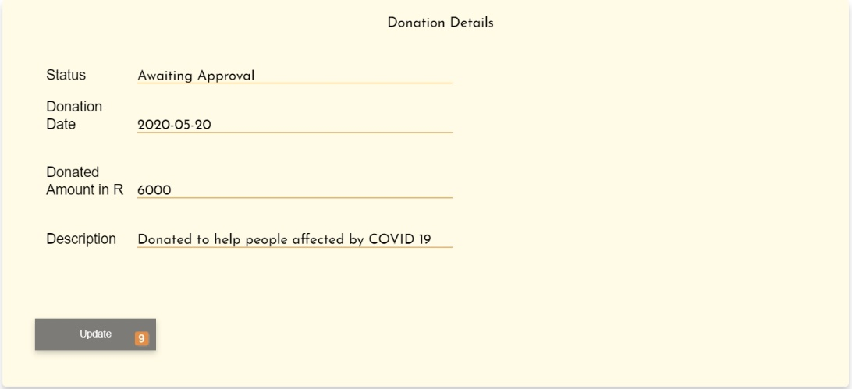

* **Detailed description of the controls:**

|  |  |  |
| --- | --- | --- |
| Reference | Control | Functionality Description |
| 1 | Search By Cell Button | Displays search by cell card. Click here to search for a Donation Recipient using the recipient’s cell number. |
| 2 | Search By Name Button | Displays search by name card. Click here to search for a Donation Recipient using the recipient’s name. |
| 3 | Add Recipient Button | Re-direct you to the Add Donation Recipient screen. Click this button to add a new donation recipient |
| 4 | Cancel Button | Re-direct you to the Donation Management screen. Click this button to cancel searching a donation. |
| 5 | Search cell input field | Click here to make an entry for the recipient cell to search. |
| 6 | Search Button | Displays Donation recipient with entered cell number. Click the Search button to search for recipient with entered Cell number. |
| 7 | View button | Displays the selected donation record. Click here to view the details of the selected donation record. |
| 8 | Cancel button | Re-direct you to the Donation Management screen. Click this button to cancel searching a donation. |
| 9 | Update button | The donation details input fields become editable. Click here to update the donation details displayed. |

* **Possible Error Messages:** Please refer to the Error and Confirmation Messages, Error Messages, Validation Error Message, Record not found Message, Item in Use message, Other Messages to view the possible error message(s)).
* **Navigation process:**

Searching a donation by searching for a donation recipient using the recipient’s name.

* 1. Clicking the Search Donation button on the Donation Management screen in the Donation Card.



* 1. Clicking the Search by Name button on the Search Donation screen in the search Donation recipient Card.



* 1. Clicking the Search button on the Search donation screen in the search Donation Card.



* **Complete layout:**

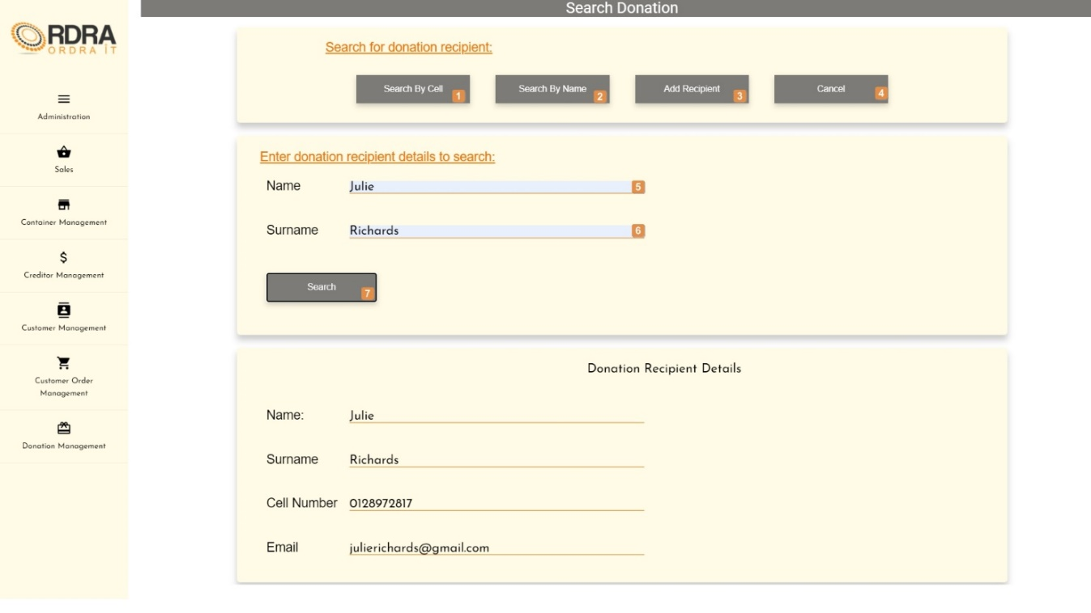

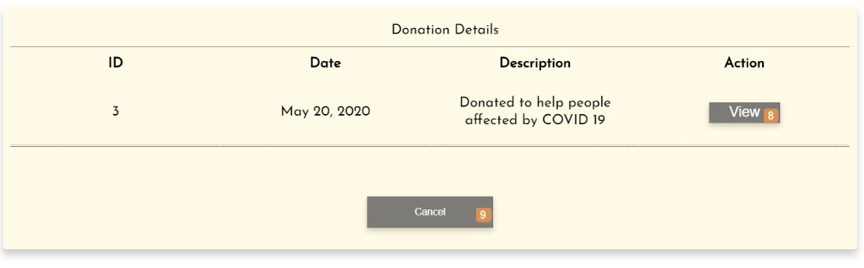

Donation details card is only displayed once the view button has been clicked.

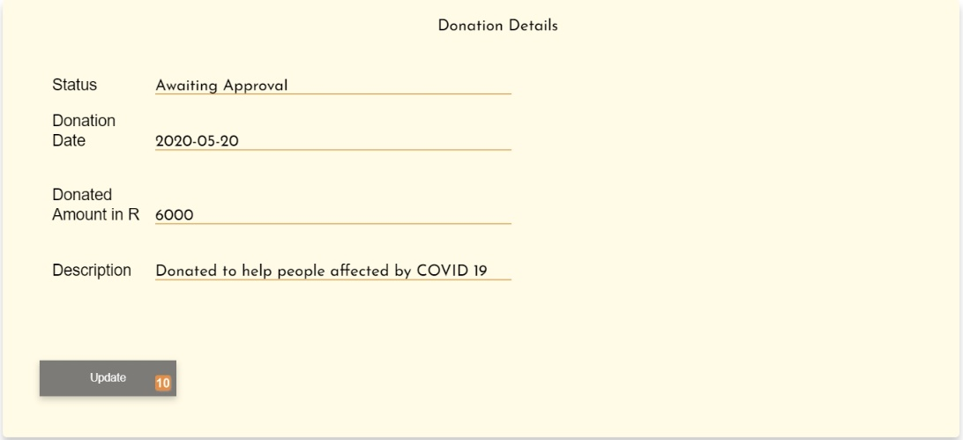

* **Detailed description of the controls:**

|  |  |  |
| --- | --- | --- |
| Reference | Control | Functionality Description |
| 1 | Search By Cell Button | Displays search by cell card. Click here to search for a Donation Recipient using the recipient’s cell number. |
| 2 | Search By Name Button | Displays search by name card. Click here to search for a Donation Recipient using the recipient’s name. |
| 3 | Add Recipient Button | Re-direct you to the Add Donation Recipient screen. Click this button to add a new donation recipient |
| 4 | Cancel Button | Re-direct you to the Donation Management screen. Click this button to cancel adding a recipient. |
| 5 | Search Name input field | Click here to make an entry for the recipient name to search. |
| 6 | Search Surname | Click here to make an entry for the recipient surname to search. |
| 7 | Search Button | Displays Donation recipient with entered cell number. Click the Search button to search for recipient with entered Cell number. |
| 8 | View Button | Displays the selected donation record. Click here to view the details of the selected donation record. |
| 9 | Cancel button | Re-direct you to the Donation Management screen. Click this button to cancel searching a donation. |
| 10 | Update button | The donation details input fields become editable. Click here to update the donation details displayed. |

* **Possible Error Messages:** Please refer to the Error and Confirmation Messages, Error Messages, Validation Error Message, Duplicate Entry Message, Item in Use message, Other Messages to view the possible error message(s)).

*Created with the Personal Edition of HelpNDoc:* [*Free Web Help generator*](https://www.helpndoc.com)

**Reporting**

*Created with the Personal Edition of HelpNDoc:* [*Full-featured Kindle eBooks generator*](https://www.helpndoc.com/feature-tour/create-ebooks-for-amazon-kindle)

Reporting Management Screen

This screen allows the user to navigate through the reporting management screen to the various reporting options provided.

* **Navigation process:**
  1. Click on the Reporting button in the Navbar.



* **Complete layout:**

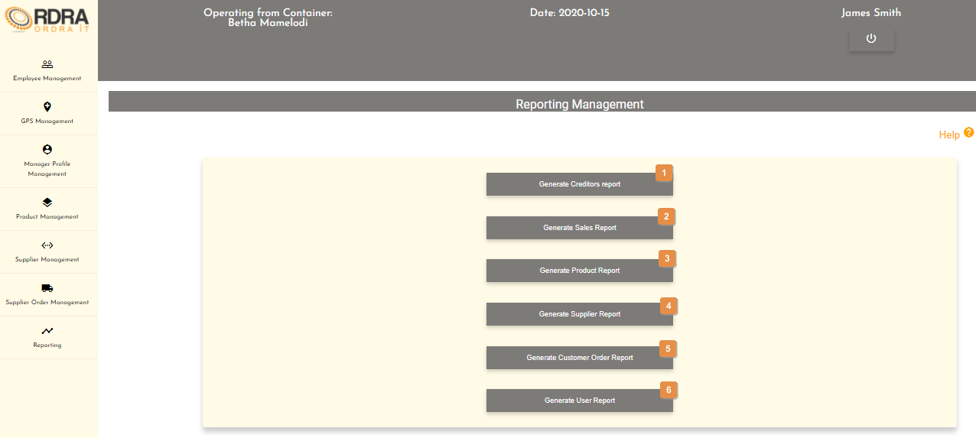

* **Detailed description of the controls:**

|  |  |  |
| --- | --- | --- |
| Reference | Control | Functionality Description |
| 1 | Generate Creditors Report Button | Re-directs you to the Generate Creditors Report screen. Click this button to generate a creditors report from the system. |
| 2 | Generate Sale Report Button | Re-directs you to the Generate Sale Report screen. Click this button to generate a sale report from the system. |
| 3 | Generate Product Report Button | Re-directs you to the Generate Product Report screen. Click this button to generate a product report from the system. |
| 4 | Generate Supplier Report Button | Re-directs you to the Generate Supplier Report screen. Click this button to generate a supplier’s report from the system. |
| 5 | Generate Customer Order Report Button | Re-directs you to the Generate Customer Order Report screen. Click this button to generate a customer order report from the system. |
| 6 | Generate User Report Button | Re-directs you to the Generate User Report screen. Click this button to generate a user report from the system. |

*Created with the Personal Edition of HelpNDoc:* [*Easily create Help documents*](https://www.helpndoc.com/feature-tour)

Generate Creditors (Suppliers) Report

Allows the user to either generate a creditor report or a graph from the system.

* **Navigation process:**
  1. Clicking the Generate Creditors Report button on the Reporting Management screen.



* **Complete layout:**

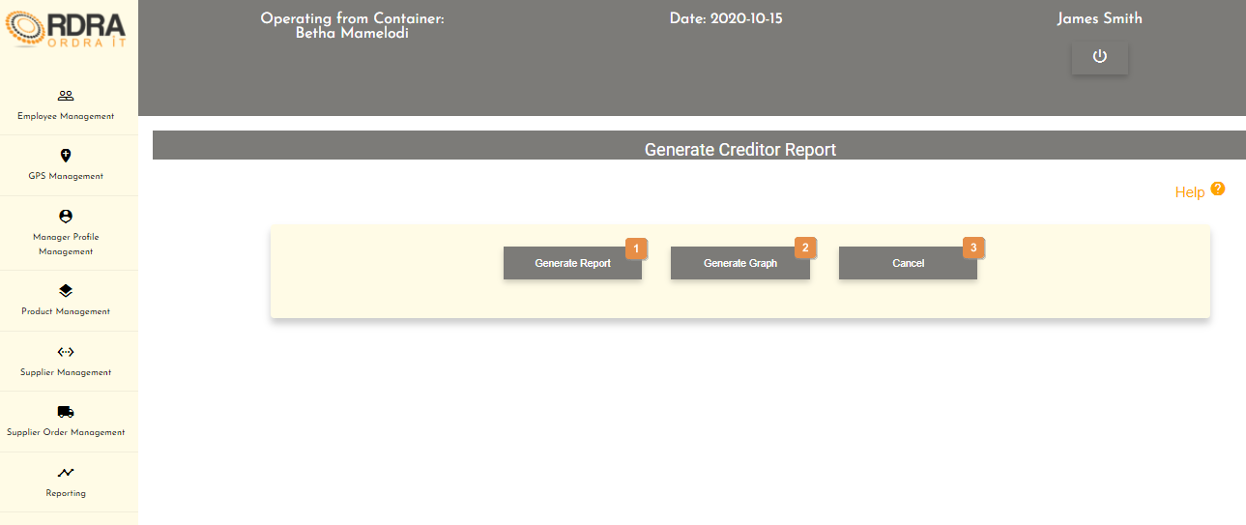

* **Detailed description of the controls:**

|  |  |  |
| --- | --- | --- |
| Reference | Control | Functionality Description |
| 1 | Generate Report Button | Click here to generate the creditors report. |
| 2 | Generate Graph Button | Click here to generate the creditor chart. |
| 3 | Cancel Button | Click this button return to the Reporting Management screen |

* **Creditor Report Example:**

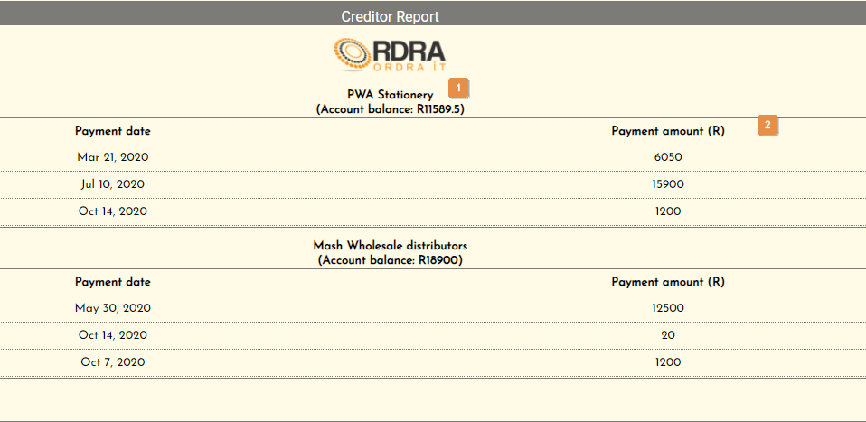

* **Detailed description of the Creditors Report:**

|  |  |
| --- | --- |
| Reference | Description |
| 1 | This shows the creditors name as well as the account balance that is still due. |
| 2 | This show the payment dates and the payment amounts which were made to the creditor. |

* **Creditor Chart Example:**

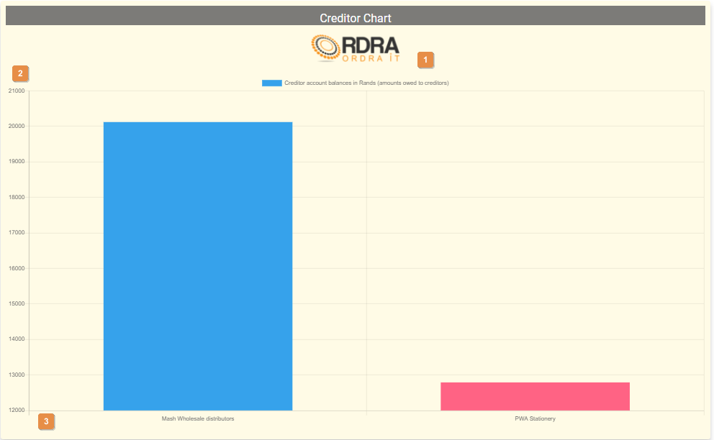

* **Detailed description of the Creditor Chart:**

|  |  |
| --- | --- |
| Reference | Description |
| 1 | This shows the heading of what the chart is all about (Creditor amount balance in Rands (amount owed to creditors)) |
| 2 | The y-axis displays the scale is rand amounts |
| 3 | The x-axis displays the creditors |

*Created with the Personal Edition of HelpNDoc:* [*Create cross-platform Qt Help files*](https://www.helpndoc.com/feature-tour/create-help-files-for-the-qt-help-framework)

Generate Sales Report

Allows the user to generate the sales report from the system.

* **Navigation process:**
  1. Clicking the Generate Sales Report button on the Reporting Management screen.



* **Complete layout:**

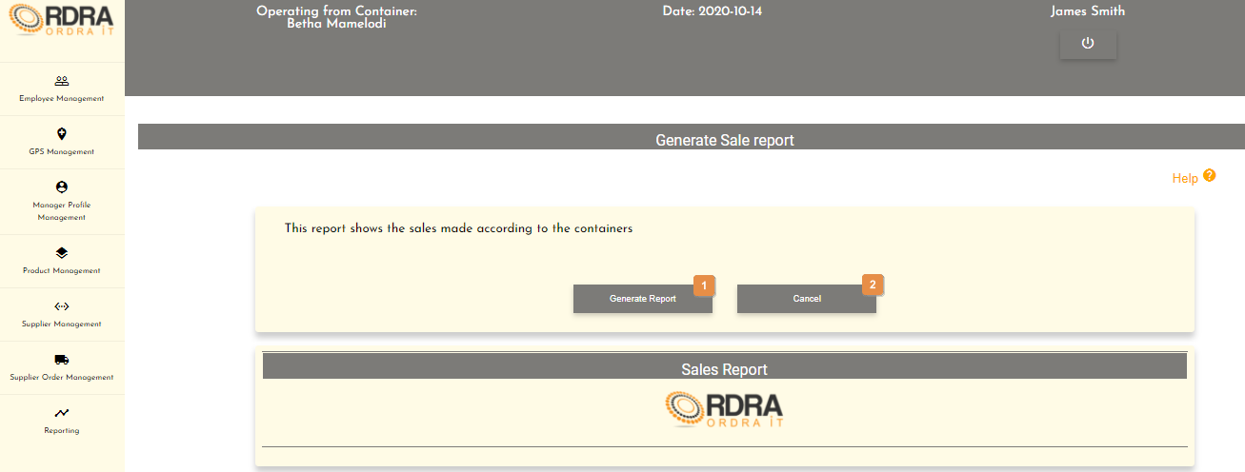

* **Detailed description of the controls:**

|  |  |  |
| --- | --- | --- |
| Reference | Control | Functionality Description |
| 1 | Generate Report Button | Click here to generate the sales report. |
| 2 | Cancel Button | Click this button return to the Reporting Management screen |

* **Sales Report Example:**

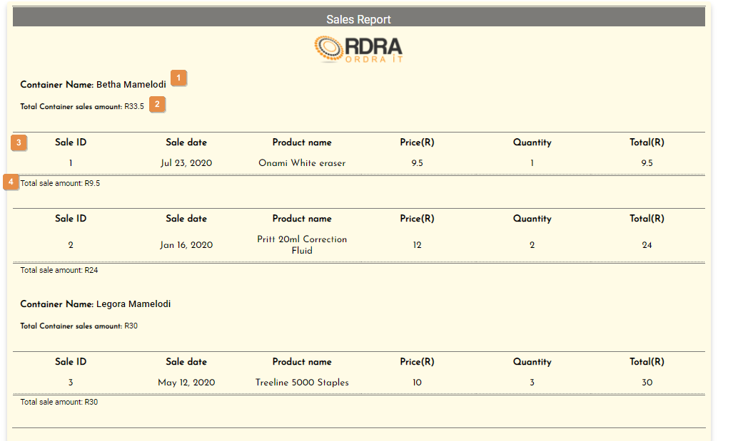

* **Detailed description of the Sales Report:**

|  |  |
| --- | --- |
| Reference | Description |
| 1 | This shows the container name of where the sale was made. |
| 2 | This shows the total sale amount for the container. |
| 3 | This shows the details of the sale made in the container |
| 4 | This shows the total sale amount made for the sale |

*Created with the Personal Edition of HelpNDoc:* [*Full-featured Documentation generator*](https://www.helpndoc.com)

Generate Customer Order Report

Allows the user to generate the customer order report from the system.

* **Navigation process:**
  1. Clicking the Generate Customer Order Report button on the Reporting Management screen.



* **Complete layout:**

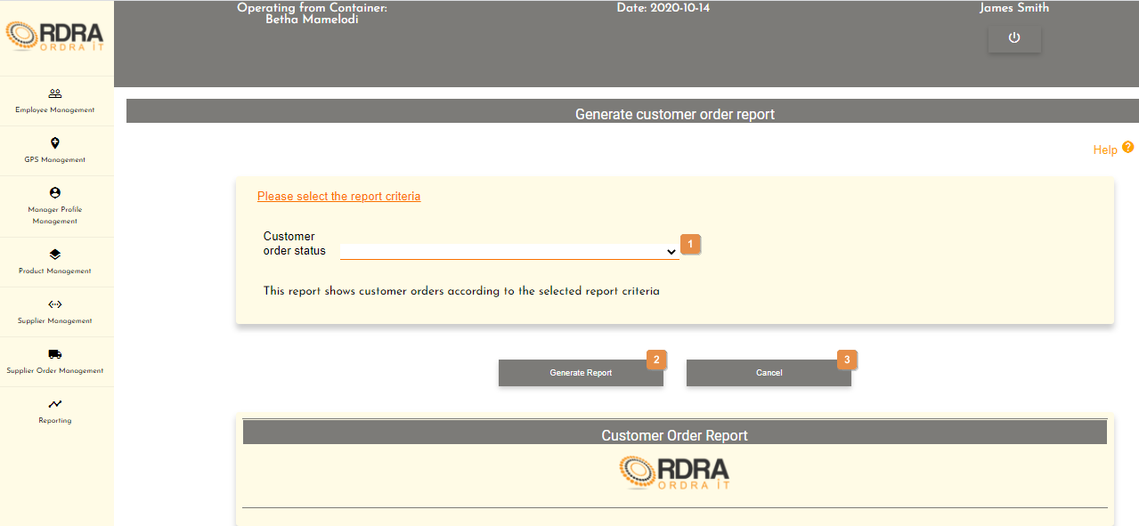

* **Detailed description of the controls:**

|  |  |  |
| --- | --- | --- |
| Reference | Control | Functionality Description |
| 1 | Customer Order Status Select Box | Click the select box will display all the customer order status which the user must select a status. |
| 1 | Generate Report Button | Click here to generate the customer order report according to the customer order status selected. |
| 2 | Cancel Button | Click this button return to the Reporting Management screen |

* **Possible Error Messages:** Please refer to the Error and Confirmation Messages, Error Messages, Validation Error Message, Duplicate Entry Message, Item in Use message, Other Messages to view the possible error message(s)).
* **Customer Order Report Example:**  
  This Customer Order Report is according to the Collected status.

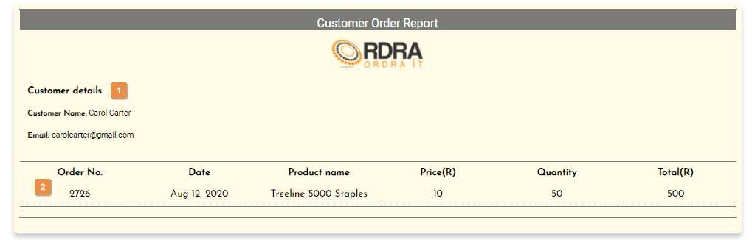

* **Detailed description of the Customer Order Report:**

|  |  |
| --- | --- |
| Reference | Description |
| 1 | This shows the customers details for the order. |
| 2 | This shows the details of the customer’s order. |

*Created with the Personal Edition of HelpNDoc:* [*Produce electronic books easily*](https://www.helpndoc.com/create-epub-ebooks)

Generate Supplier Report

Allows the user to generate the supplier report from the system.

* **Navigation process:**
  1. Clicking the Generate Supplier Report button on the Reporting Management screen.



* **Complete layout:**

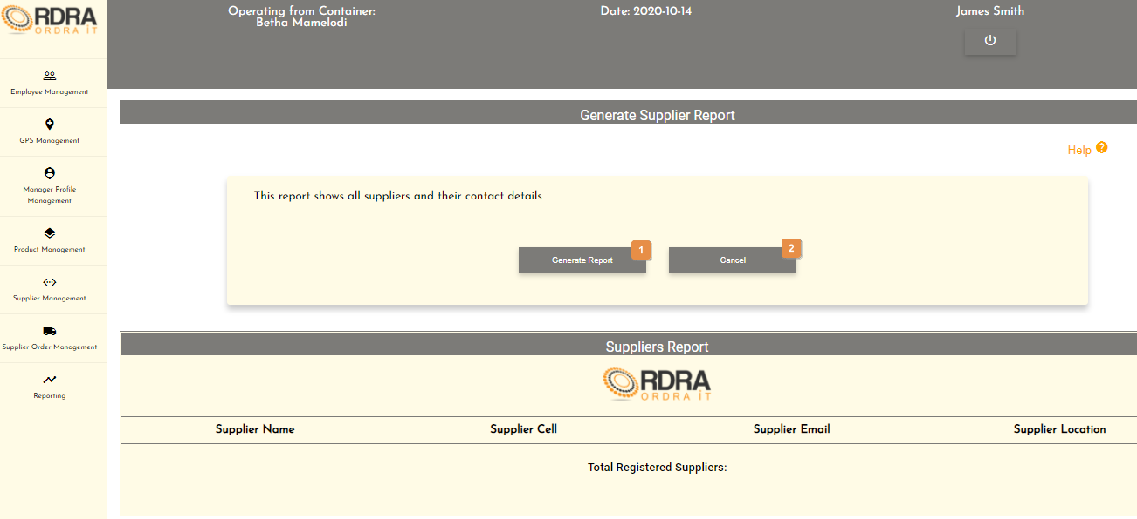

* **Detailed description of the controls:**

|  |  |  |
| --- | --- | --- |
| Reference | Control | Functionality Description |
| 1 | Generate Report Button | Click here to generate the supplier report. |
| 2 | Cancel Button | Click this button return to the Reporting Management screen |

* **Supplier Report Example:**

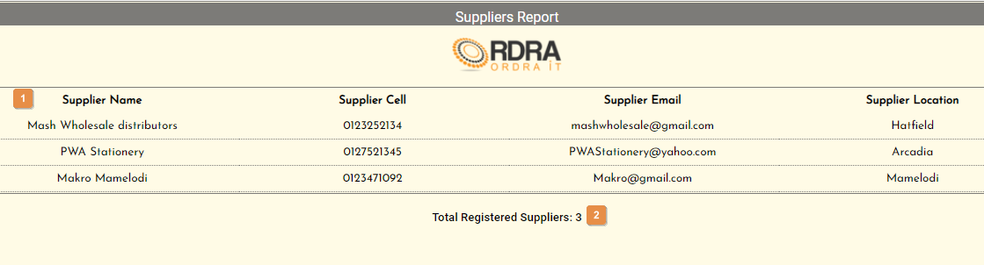

* **Detailed description of the Suppliers Report:**

|  |  |
| --- | --- |
| Reference | Description |
| 1 | This shows a list of all the supplier that exist in the system. |
| 2 | This show the total amount of supplier that are register in the system. |

*Created with the Personal Edition of HelpNDoc:* [*Qt Help documentation made easy*](https://www.helpndoc.com/feature-tour/create-help-files-for-the-qt-help-framework)

Generate Product Report

Allows the user to generate the product report from the system.

* **Navigation process:**
  1. Clicking the Generate Product Report button on the Reporting Management screen.



* **Complete layout:**

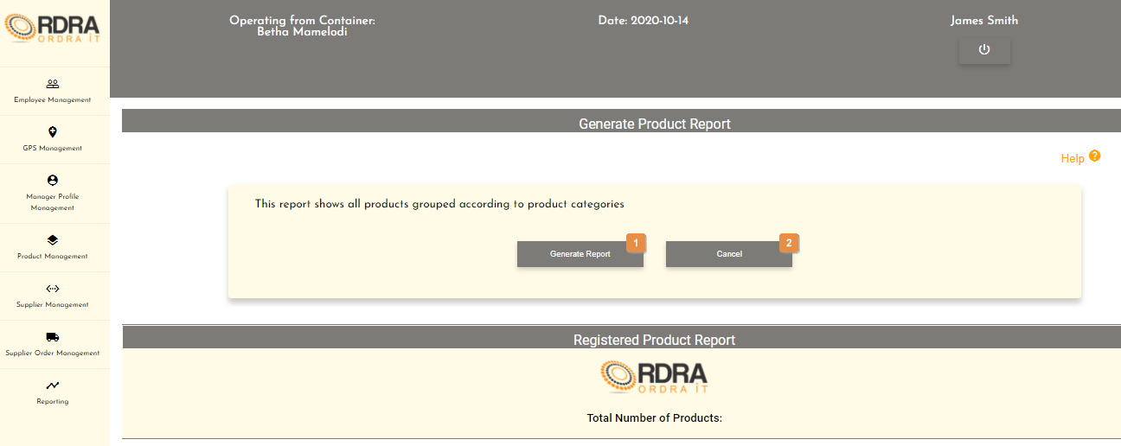

* **Detailed description of the controls:**

|  |  |  |
| --- | --- | --- |
| Reference | Control | Functionality Description |
| 1 | Generate Report Button | Click here to generate the product report. |
| 2 | Cancel Button | Click this button return to the Reporting Management screen |

* **Product Report Example:**

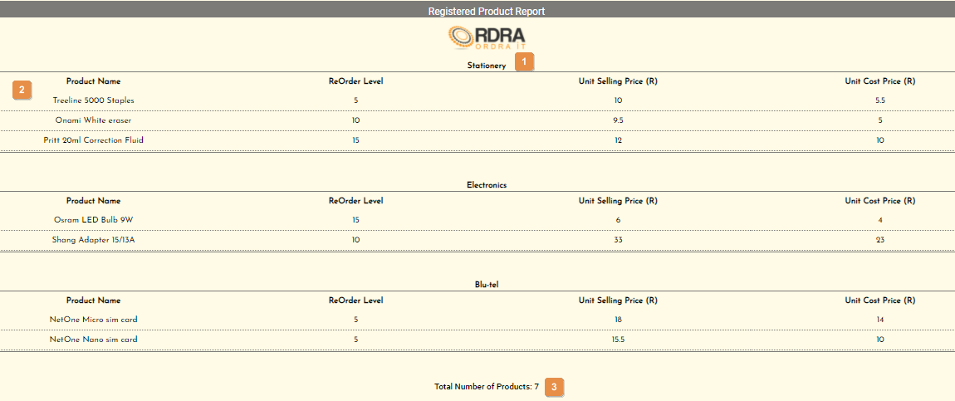

* **Detailed description of the Product Report:**

|  |  |
| --- | --- |
| Reference | Description |
| 1 | This shows the product category name. |
| 2 | This shows the details of all the products that fall under the product category name. |
| 3 | This shows the total number of all the products no matter which category the product fall under. |

*Created with the Personal Edition of HelpNDoc:* [*Write eBooks for the Kindle*](https://www.helpndoc.com/feature-tour/create-ebooks-for-amazon-kindle)

Generate User Report

Allows the user to generate the user report from the system.

* **Navigation process:**
  1. Clicking the Generate User Report button on the Reporting Management screen.



* **Complete layout:**

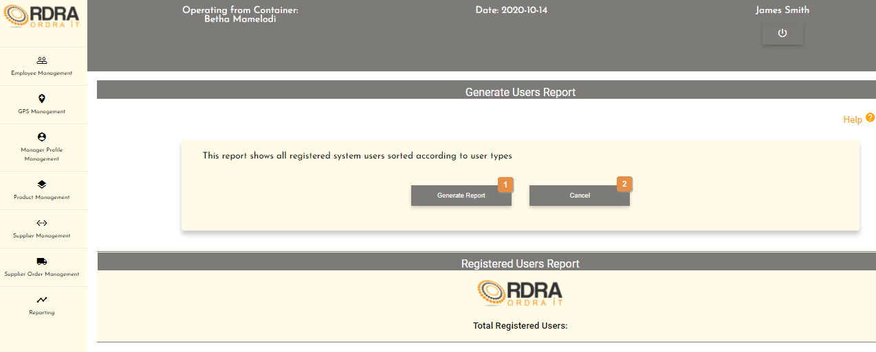

* **Detailed description of the controls:**

|  |  |  |
| --- | --- | --- |
| Reference | Control | Functionality Description |
| 1 | Generate Report Button | Click here to generate the user report. |
| 2 | Cancel Button | Click this button return to the Reporting Management screen |

* **User Report Example:**

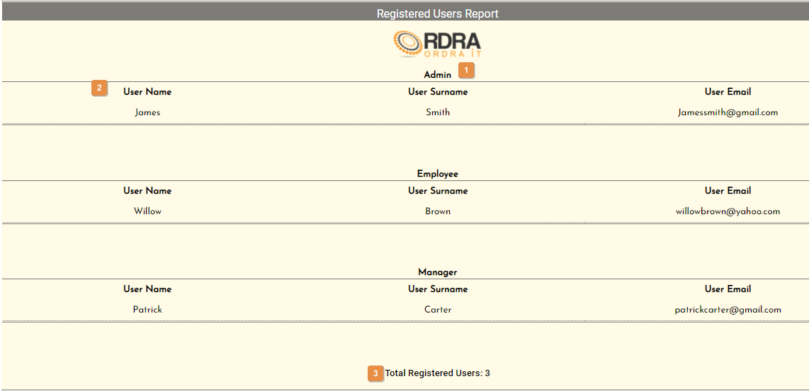

* **Detailed description of the User Report:**

|  |  |
| --- | --- |
| Reference | Description |
| 1 | This shows the user type. |
| 2 | This shows the details of all the users that fall under the user type. |
| 3 | This shows the total number of all the users no matter which user type the user fall under. |

*Created with the Personal Edition of HelpNDoc:* [*Easy EPub and documentation editor*](https://www.helpndoc.com)

**Home Screen**

This screen display once the user has login into the system.

* **Navigation process:**
  1. Click the Login button on the Login screen.

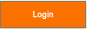

* **Complete layout:**

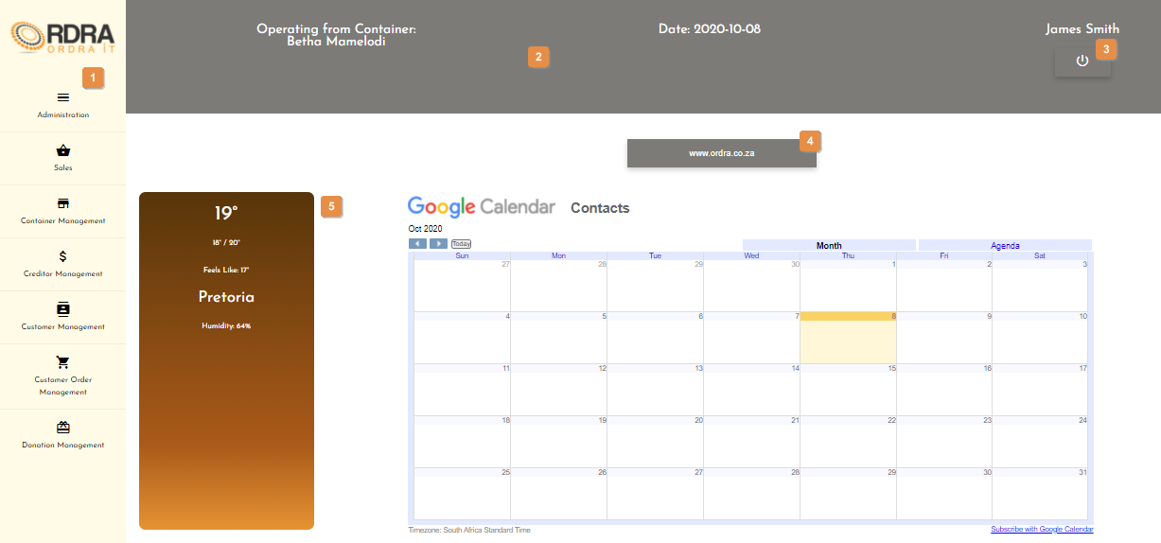

* **Detailed description of the controls:**

|  |  |  |
| --- | --- | --- |
| Reference | Control | Functionality Description |
| 1 | Navbar | Contains the navigation components of the system. |
| 2 | Toolbar | Contains buttons for frequently used commands in the system. |
| 3 | Logout Button | Re-directs you to the Login screen. Click this button to logout of the system. |
| 4 | Website Button | Re-directs you to the ORDRA website. Click this button to view the ORDRA website. |
| 5 | OpenWeather | Displays the weather for the day. |

*Created with the Personal Edition of HelpNDoc:* [*Free Qt Help documentation generator*](https://www.helpndoc.com)

**Administration**

This screen allows the user to navigate through the administration screen to View the Dashboard and User Type Access Management options as well as their relevant functions that each option provides.

* **Navigation process:**
  1. Click on the Administration button in the Navbar.

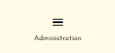

* **Complete layout:**

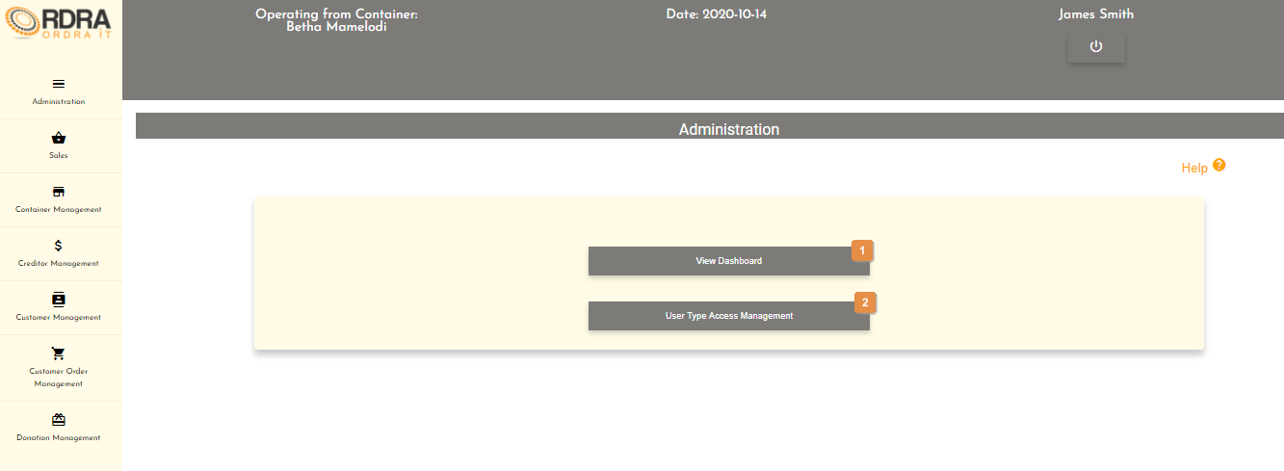

* **Detailed description of the controls:**

|  |  |  |
| --- | --- | --- |
| Reference | Control | Functionality Description |
| 1 | View Dashboard Button | Re-directs you to the Dashboard screen. Click this button to view the Sale Revenue per container for the current bar graph and the Sale Revenue per container for the year pie chart. |
| 2 | User Type Access Management Button | Re-directs you to the User Type Access Management Screen. Click this button to make changes to the user types in the system. |

*Created with the Personal Edition of HelpNDoc:* [*Free CHM Help documentation generator*](https://www.helpndoc.com)

Dashboard

Allows the user to view the Sales Revenue per container for the current bar graph and the Sales Revenue per container for the year pie chart.

* **Navigation process:**
  1. Clicking the View Dashboard button on the Administration screen.



* **Complete layout:**

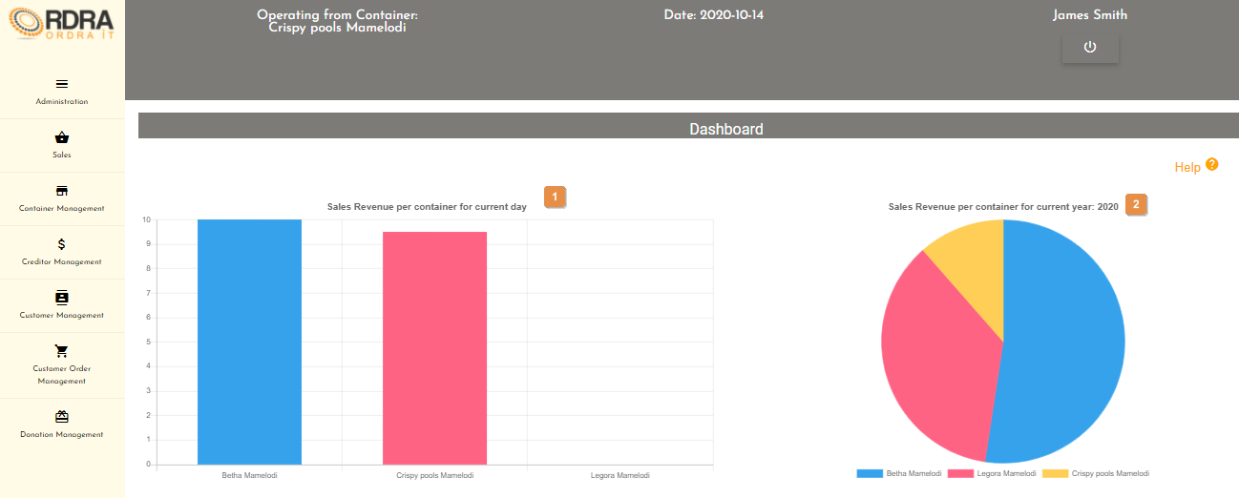

* **Detailed description of the controls:**

|  |  |  |
| --- | --- | --- |
| Reference | Control | Functionality Description |
| 1 | Sales Revenue per container for the current bar graph | A bar graph that displays the current sales revenue per container for the current day. |
| 2 | Sales Revenue per container for the year pie chart | A pie chart that displays the current sales revenue per container for the current year. |

*Created with the Personal Edition of HelpNDoc:* [*Create HTML Help, DOC, PDF and print manuals from 1 single source*](https://www.helpndoc.com/help-authoring-tool)

User Type Access Management

Allow the user to make change to the user types in the system.

* **Navigation process:**
  1. Clicking the User Type Access Management button on the Administration screen.



* **Complete layout:**

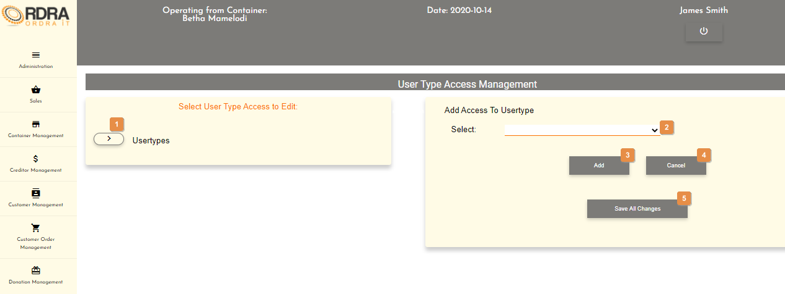

* **Detailed description of the controls:**

|  |  |  |
| --- | --- | --- |
| Reference | Control | Functionality Description |
| 1 | Drop Down Arrow | Click this button will display the user types. Next to each user types is a drop-down arrow.    Clicking the drop-down arrow next a user will display the list of option that user has access to as shown below.    Clicking the () to remove access form that user type. |
| 2 | Select Box | Click the select box will display all the options that the user can select to add to the user type to access. |
| 3 | Add Button | Clicking the Add button will add the option selected in the select box to the user type you have clicked on. |
| 4 | Cancel Button | Re-direct you to the Administration screen. Click this button to cancel the changing of the user types. |
| 5 | Save All Changes Button | Click the Save All Changes button, will save all the changes made and an alert message will appear to notify the user. |

* **Possible Error Messages:** Please refer to the Error and Confirmation Messages, Error Messages, Validation Error Message, Duplicate Entry Message, Item in Use message, Other Messages to view the possible error message(s)).

*Created with the Personal Edition of HelpNDoc:* [*Free Web Help generator*](https://www.helpndoc.com)

**Conclusion**

The user functionality of the web application is described here to assist the user. This is shown subsystem by subsystem with the visual aids and pointers.

*Created with the Personal Edition of HelpNDoc:* [*News and information about help authoring tools and software*](https://www.helpauthoringsoftware.com)

**User Functionality Desktop Application**

*Created with the Personal Edition of HelpNDoc:* [*Create help files for the Qt Help Framework*](https://www.helpndoc.com/feature-tour/create-help-files-for-the-qt-help-framework)

**Introduction**

The user functionality of the desktop application is described here to assist the user. This is shown subsystem by subsystem with the visual aids and pointers.

*Created with the Personal Edition of HelpNDoc:* [*Benefits of a Help Authoring Tool*](https://www.helpauthoringsoftware.com)

**Subsystems**

*Created with the Personal Edition of HelpNDoc:* [*Free iPhone documentation generator*](https://www.helpndoc.com/feature-tour/iphone-website-generation)

**Login**

*Created with the Personal Edition of HelpNDoc:* [*Easily create CHM Help documents*](https://www.helpndoc.com/feature-tour)

Register

Allows a new user for the ORDRA system to be able to register onto to system.

* **Navigation process:** 
  1. Click on the Register Button on the Login Screen.



* **Complete layout:**



* **Detailed description of the controls:**

|  |  |  |
| --- | --- | --- |
| Reference | Control | Functionality Description |
| 1 | Name Input field | Click here to make an entry for the user name. |
| 2 | Surname Input field | Click here to make an entry for the user surname. |
| 3 | Cell Input field | Click here to make an entry for the user cell number. |
| 4 | Email Input field | Click here to make an entry for the user email address. |
| 5 | Password Input field | Click here to make an entry for the user password. |
| 6 | Confirm Password Input field | Click here to make an entry for the user confirm password. |
| 7 | Register Button | Click the Register button, an alert message will appear to notify the user. |
| 8 | Cancel Button | Re-direct you to the Login screen. Click this button to cancel registration. |

* **Possible Error Messages:** Please refer to the Error and Confirmation Messages, Error Messages, Validation Error Message, Duplicate Entry Message, Item in Use message, Other Messages to view the possible error message(s)).

*Created with the Personal Edition of HelpNDoc:* [*iPhone web sites made easy*](https://www.helpndoc.com/feature-tour/iphone-website-generation)

Login

Allows the user to login to the system.

* **Complete layout:**



* **Detailed description of the controls:**

|  |  |  |
| --- | --- | --- |
| Reference | Control | Functionality Description |
| 1 | Username input field | Click here to make an entry for the username. |
| 2 | Password input field | Click here to make an entry for the password. |
| 3 | Operating In Container Select Box | Click the select box will display all the containers which user will select container that he is operating in. |
| 4 | Login Button | Click this button to login to the system |
| 5 | Register Button | Re-directs the you to the Register screen. Click this button to register on the system |
| 6 | Reset Password Button | Re-directs the you to the Reset Password Screen. Click this button to reset password on the system |

* **Possible Error Messages:** Please refer to the Error and Confirmation Messages, Error Messages, Validation Error Message, Duplicate Entry Message, Item in Use message, Other Messages to view the possible error message(s)).

*Created with the Personal Edition of HelpNDoc:* [*Generate EPub eBooks with ease*](https://www.helpndoc.com/create-epub-ebooks)

Logout

This control allows the user to logout of the system and go back to the login screen.

* **Navigation process:**
  1. Click Logout Button on the Toolbar.



*Created with the Personal Edition of HelpNDoc:* [*Free Qt Help documentation generator*](https://www.helpndoc.com)

Reset Password

Allows the user to reset their password used to login to the system.

* **Navigation process:**
  1. Click on the Reset Password Button on the Login Screen.



* **Complete layout:**



* **Detailed description of the controls:**

|  |  |  |
| --- | --- | --- |
| Reference | Control | Functionality Description |
| 1 | Email Input field | Click here to make an entry for the users email address. |
| 2 | Send One Time Pin Button | Click this button to verify the users email as well as an alert message will appear to notify the user. The Verify One Time Pin screen will display.     |  |  |  | | --- | --- | --- | | Reference | Control | Functionality Description | | 1 | Email Input field | The email will be prepopulated with the user email. | | 2 | One Time Pin Input field | Click here to enter the OTP that was sent to the users email address. | | 3 | Verify One Time Pin Button | Click this button to verify the OTP as well as redirects the user to the Reset Password screen if the OTP is successfully verified.     |  |  |  | | --- | --- | --- | | Reference | Control | Functionality Description | | 1 | Email input field | Click here to make an entry for the username. | | 2 | Password input field | Click here to make an entry for the password. | | 3 | Confirm Password input field | Click here to make the entry for the confirm password. | | 4 | Reset Password Button | Click this button an alert message will appear to notify the user. | | 5 | Cancel Button | Re-directs the you to the Login screen. Click this button to cancel the resetting of the password | | | 4 | Cancel Button | Re-direct you to the Login screen. Click this button to cancel reset password. | |
| 3 | Cancel Button | Re-direct you to the Login screen. Click this button to cancel reset password. |

* **Possible Error Messages:** Please refer to the Error and Confirmation Messages, Error Messages, Validation Error Message, Duplicate Entry Message, Item in Use message, Other Messages to view the possible error message(s)).

*Created with the Personal Edition of HelpNDoc:* [*Full-featured EPub generator*](https://www.helpndoc.com/create-epub-ebooks)

**Employee**

*Created with the Personal Edition of HelpNDoc:* [*Full-featured EBook editor*](https://www.helpndoc.com/create-epub-ebooks)

Employee Management Screen

This screen allows the user to navigate through the employee management screen to access either the employee profile options and their relevant functions that each option provides.

* **Navigation process:**
  1. Click on the Employee Management button in the Navbar.



* **Complete layout:**



* **Detailed description of the controls:**

|  |  |  |
| --- | --- | --- |
| Reference | Control | Functionality Description |
| 1 | Create Employee Profile Button | Re-directs you to the Create employee profile screen. Click this button to create a new employee profile into the system. |
| 2 | Update Employee profile Button | Re-directs you to the search employee profile screen. Click this button to search a specific employee profile in the system you want to update. |
| 3 | Search Employee Profile Button | Re-directs you to the Search employee profile screen. Click this button to search an employee profile in the system. |
| 4 | Delete Employee Profile Button | Re-directs you to the Search employee profile screen. Click this button to search a specific employee profile in the system you want to remove. |

*Created with the Personal Edition of HelpNDoc:* [*Write eBooks for the Kindle*](https://www.helpndoc.com/feature-tour/create-ebooks-for-amazon-kindle)

Create Employee

Allows the user to create a new employee profile into the system.

* **Navigation process:**
  1. Clicking the Create employee profile button on the Employee Management screen in the Employee profile Card.



* 1. Clicking the search button on the Create Employee Profile screen in the User search Card



* **Complete layout:**



Once the search button is displayed the following cards are displayed



* **Detailed description of the controls:**

|  |  |  |
| --- | --- | --- |
| Reference | Control | Functionality Description |
| 1 | Name input field | Click here to make an entry for the registered user name. |
| 2 | Surname input field | Click here to make an entry for the registered user surname. |
| 3 | Search Button | Click the Save button, a confirmation massage will appear to confirm the adding of a recipient. |
| 4 | Cancel Button | Re-direct you to the Employee Management screen. Click this button to cancel creating an employee profile. |
| 5 | Work start date input field | Click here to make an entry for the work start date for the profile creation |
| 6 | Shifts Completed input field | Click here to make an entry for the Shifts completed for the profile creation |
| 7 | Save profile button | Will display a message of successful creation then Re-direct you to the Employee Management screen. Click here to save the employee profile that you are creating. |
| 8 | Cancel button | Re-direct you to the Employee Management screen. Click this button to cancel creating an employee profile. |

* **Possible Error Messages:** Please refer to the Error and Confirmation Messages, Error Messages, Validation Error Message, Duplicate Entry Message, Item in Use message, Other Messages to view the possible error message(s)).

*Created with the Personal Edition of HelpNDoc:* [*Easily create CHM Help documents*](https://www.helpndoc.com/feature-tour)

Update Employee

Allows the user to update an existing in the system.

* **Navigation process:**
  1. Clicking the Update Employee Profile button on the Employee Management screen in the Employee Card.



* 1. Clicking on the search button on the Search Employee screen. The



* **Complete layout:**



* **Detailed description of the controls:**

|  |  |  |
| --- | --- | --- |
| Reference | Control | Functionality Description |
| 1 | Search Button | Click here to search for a specific employee profile. The Search card is displayed |
| 2 | View all employees button | Click here to view all employee records that have been created. Displays the view all card |
| 3 | Name input field | Click here to make an entry for the registered user name to search |
| 4 | Surname input field | Click here to make an entry for the registered user surname to search |
| 5 | Search button | Click here to search for the employee profile with the entered name and surname. Displays the searched results card |
| 6 | Cancel button | Re-direct you to the Employee Management screen. Click this button to cancel creating an employee profile. |

Once you have searched for the employee profile the following screen is displayed



* **Detailed description of the controls:**

|  |  |  |
| --- | --- | --- |
| Reference | Control | Functionality Description |
| 1 | Search Button | Click here to search for a specific employee profile. The Search card is displayed |
| 2 | View all employees button | Click here to view all employee records that have been created. Displays the view all card |
| 3 | Update Button | This button will allow the updating of the details in the Searched Employee profile Details card. When clicked, it makes all the employee profile input fields, in which changes can be made editable. The following buttons will be visible on the screen, to either save or cancel the option to update the details.    Click the Save button, a confirmation message will appear to confirm the update.  Click the Cancel button, a confirmation message will appear to confirm the cancellation. |
| 6 | Delete Button | Click the Delete button, a confirmation message will appear to confirm the deletion. |

If the view button is clicked on the view all card is displayed on the search employee profile screen.



* **Detailed description of the controls:**

|  |  |  |
| --- | --- | --- |
| Reference | Control | Functionality Description |
| 1 | Search Button | Click here to search for a specific employee profile. The Search card is displayed |
| 2 | View all employees button | Click here to view all employee records that have been created. Displays the view all card |
| 3 | View button | Click here to view the selected employee profile. The employee profile card is displayed with the details of the selected profile. |
| 4 | Cancel button | Re-direct you to the Employee Management screen. Click this button to cancel creating an employee profile. |

* **Possible Error Messages:** Please refer to the Error and Confirmation Messages, Error Messages, Validation Error Message, Duplicate Entry Message, Item in Use message, Other Messages to view the possible error message(s)).

*Created with the Personal Edition of HelpNDoc:* [*Full-featured EPub generator*](https://www.helpndoc.com/create-epub-ebooks)

Search Employee

Allows the user to search existing Employee recipients in the system.

* **Navigation process:**
  1. Clicking the Search Employee profile button on the Employee Management screen in the Employee profile Card.



* 2. Clicking on the search button on the Search Employee screen. The



* **Complete layout:**



* **Detailed description of the controls:**

|  |  |  |
| --- | --- | --- |
| Reference | Control | Functionality Description |
| 1 | Search Button | Click here to search for a specific employee profile. The Search card is displayed |
| 2 | View all employees button | Click here to view all employee records that have been created. Displays the view all card |
| 3 | Name input field | Click here to make an entry for the registered user name to search |
| 4 | Surname input field | Click here to make an entry for the registered user surname to search |
| 5 | Search button | Click here to search for the employee profile with the entered name and surname. Displays the searched results card |
| 6 | Cancel button | Re-direct you to the Employee Management screen. Click this button to cancel creating an employee profile. |

Once you have searched for the employee profile the following screen is displayed



* **Detailed description of the controls:**

|  |  |  |
| --- | --- | --- |
| Reference | Control | Functionality Description |
| 1 | Search Button | Click here to search for a specific employee profile. The Search card is displayed |
| 2 | View all employees button | Click here to view all employee records that have been created. Displays the view all card |
| 3 | Update Button | This button will allow the updating of the details in the Searched Employee profile Details card. When clicked, it makes all the employee profile input fields, in which changes can be made editable. The following buttons will be visible on the screen, to either save or cancel the option to update the details.    Click the Save button, a confirmation message will appear to confirm the update.  Click the Cancel button, a confirmation message will appear to confirm the cancellation. |
| 6 | Delete Button | Click the Delete button, a confirmation message will appear to confirm the deletion. |

If the view button is clicked on the view all card is displayed on the search employee profile screen.



* **Detailed description of the controls:**

|  |  |  |
| --- | --- | --- |
| Reference | Control | Functionality Description |
| 1 | Search Button | Click here to search for a specific employee profile. The Search card is displayed |
| 2 | View all employees button | Click here to view all employee records that have been created. Displays the view all card |
| 3 | View button | Click here to view the selected employee profile. The employee profile card is displayed with the details of the selected profile. |
| 4 | Cancel button | Re-direct you to the Employee Management screen. Click this button to cancel creating an employee profile. |

* **Possible Error Messages:** Please refer to the Error and Confirmation Messages, Error Messages, Validation Error Message, Duplicate Entry Message, Item in Use message, Other Messages to view the possible error message(s)).

*Created with the Personal Edition of HelpNDoc:* [*Free CHM Help documentation generator*](https://www.helpndoc.com)

Delete Employee

Allows the user to remove an existing employee profile from the system.

* **Navigation process:**
  1. Clicking the Delete Employee Profile button on the Employee Management screen in the Employee profile Card.



* 1. The steps for searching an employee profile are used. The search employee profile screen is then displayed
* **Complete layout:**



* **Detailed description of the controls:**

|  |  |  |
| --- | --- | --- |
| Reference | Control | Functionality Description |
| 1 | Search Button | Click here to search for a specific employee profile. The Search card is displayed |
| 2 | View all employees button | Click here to view all employee records that have been created. Displays the view all card |
| 3 | Update Button | This button will allow the updating of the details in the Searched Employee profile Details card. When clicked, it makes all the employee profile input fields, in which changes can be made editable. The following buttons will be visible on the screen, to either save or cancel the option to update the details.    Click the Save button, a confirmation message will appear to confirm the update.  Click the Cancel button, a confirmation message will appear to confirm the cancellation. |
| 6 | Delete Button | Click the Delete button, a confirmation message will appear to confirm the deletion. |

* **Possible Error Messages:** Please refer to the Error and Confirmation Messages, Error Messages, Validation Error Message, Duplicate Entry Message, Item in Use message, Other Messages to view the possible error message(s)).

*Created with the Personal Edition of HelpNDoc:* [*Easily create iPhone documentation*](https://www.helpndoc.com/feature-tour/iphone-website-generation)

**Customer**

*Created with the Personal Edition of HelpNDoc:* [*Create help files for the Qt Help Framework*](https://www.helpndoc.com/feature-tour/create-help-files-for-the-qt-help-framework)

Customer Management Screen

This screen allows the user to navigate through the customer management screen to add, update, remove or search through the relevant customers.

* **Navigation process:**
  1. Click on the Customer Management button in the Navbar.



* **Complete layout:**



* **Detailed description of the controls:**

|  |  |  |
| --- | --- | --- |
| Reference | Control | Functionality Description |
| 1 | Add Customer Button | Re-directs you to the Add Customer screen. Click this button to add a new customer into the system. |
| 2 | Update Customer Button | Re-directs you to the Customer Details screen. Click this button to search a specific customer in the system you want to update. |
| 3 | Search Customer Button | Re-directs you to the Customer Details screen. Click this button to search a customer in the system. |
| 4 | Delete Customer Button | Re-directs you to the Customer Details screen. Click this button to search a specific customer in the system you want to remove. |

*Created with the Personal Edition of HelpNDoc:* [*Easy EPub and documentation editor*](https://www.helpndoc.com)

Create Customer

Allows the user to add a new customer into the system.

* **Navigation process:**
  1. Clicking the Add Customer button on the Customer Management screen.



* **Complete layout:**



* **Detailed description of the controls:**

|  |  |  |
| --- | --- | --- |
| Reference | Control | Functionality Description |
| 1 | Name input field | Click here to make an entry for the customer name. |
| 2 | Surname input field | Click here to make an entry for the customer surname. |
| 3 | Cell input field | Click here to make an entry for the customer cell. |
| 4 | Email input field | Click here to make an entry for the customer email. |
| 5 | Street No. input field | Click here to make an entry for the customer street no. |
| 6 | Street input field | Click here to make an entry for the customer street. |
| 7 | Postal Code input field | Click here to make an entry for the customer postal code. |
| 8 | Suburb input field | Click here to make an entry for the customer suburb. |
| 9 | Save Button | Click the Save button, a confirmation massage will appear to confirm the adding of a customer. |
| 10 | Cancel Button | Re-direct you to the Customer Management screen. Click this button to cancel adding a customer. |

* **Possible Error Messages:** Please refer to the Error and Confirmation Messages, Error Messages, Validation Error Message, Duplicate Entry Message, Item in Use message, Other Messages to view the possible error message(s)).

*Created with the Personal Edition of HelpNDoc:* [*Generate Kindle eBooks with ease*](https://www.helpndoc.com/feature-tour/create-ebooks-for-amazon-kindle)

Update Customer

Allows the user to update an existing customer in the system.

* **Navigation process:**
  1. Clicking the Update Customer button on the Customer Management screen.



* 1. Clicking the search button once you have entered the customer’s name and surname you want to update on the Customer Details screen.



* **Complete layout:**



* **Detailed description of the controls:**

|  |  |  |
| --- | --- | --- |
| Reference | Control | Functionality Description |
| 1 | Update Button | This button will allow the updating of the details in the Searched Customer Details card. When clicked, it makes all the input fields, in which changes can be made editable. The following buttons will be visible on the screen, to either save or cancel the option to update the details.    Click the Save button, a confirmation message will appear to confirm the update.  Click the Cancel button, a confirmation message will appear to confirm the cancellation. |
| 2 | Delete Button | Click the Delete button, a confirmation message will appear to confirm the deletion. |
| 3 | Place Order Button | Re-direct you to the Place Order screen. Click this button to place an order. |

* **Possible Error Messages:** Please refer to the Error and Confirmation Messages, Error Messages, Validation Error Message, Duplicate Entry Message, Item in Use message, Other Messages to view the possible error message(s)).

*Created with the Personal Edition of HelpNDoc:* [*Free iPhone documentation generator*](https://www.helpndoc.com/feature-tour/iphone-website-generation)

Search Customer

Allows the user to search existing customers in the system.

* **Navigation process:**
  1. Clicking the Search Customer button on the Customer Management screen.



* **Complete layout:**



* **Detailed description of the controls:**

|  |  |  |
| --- | --- | --- |
| Reference | Control | Functionality Description |
| 1 | Name input field | Click here to make an entry for the customer name you want to search. |
| 2 | Surname input field | Click here to make an entry for the customer surname you want to search. |
| 3 | Search Button | Re-direct you to the Searched Customer Details screen. Click this button once you have entered the customer’s name and surname you want to search. |
| 4 | Cancel Button | Re-direct you to the Customer Management screen. Click this button to cancel the search. |
| 5 | List of all the customers table | Shows a list of all the customers that exists in the system. |

* **Possible Error Messages:** Please refer to the Error and Confirmation Messages, Error Messages, Validation Error Message, Duplicate Entry Message, Item in Use message, Other Messages to view the possible error message(s)).

*Created with the Personal Edition of HelpNDoc:* [*Easy CHM and documentation editor*](https://www.helpndoc.com)

Delete Customer

Allows the user to remove an existing customer from the system.

* **Navigation process:**
  1. Clicking the Delete Customer button on the Customer Management screen.



* 1. Clicking the search button once you have entered the customer’s name and surname you want to remove on the Customer Details screen.



* **Complete layout:**



* **Detailed description of the controls:**

|  |  |  |
| --- | --- | --- |
| Reference | Control | Functionality Description |
| 1 | Update Button | This button will allow the updating of the details in the Searched Customer Details card. When clicked, it makes all the input fields, in which changes can be made editable. The following buttons will be visible on the screen, to either save or cancel the option to update the details.    Click the Save button, a confirmation message will appear to confirm the update.  Click the Cancel button, a confirmation message will appear to confirm the cancellation. |
| 2 | Delete Button | Click the Delete button, a confirmation message will appear to confirm the deletion. |
| 3 | Place Order Button | Re-direct you to the Place Order screen. Click this button to place an order. |

* **Possible Error Messages:** Please refer to the Error and Confirmation Messages, Error Messages, Validation Error Message, Duplicate Entry Message, Item in Use message, Other Messages to view the possible error message(s)).

*Created with the Personal Edition of HelpNDoc:* [*What is a Help Authoring tool?*](https://www.helpauthoringsoftware.com)

**Product**

*Created with the Personal Edition of HelpNDoc:* [*Create HTML Help, DOC, PDF and print manuals from 1 single source*](https://www.helpndoc.com/help-authoring-tool)

Product Management Screen

This screen allows the user to navigate through the product management screen to access the Product, Product Category and Vat options and their relevant functions that each option provides.

* **Navigation process:**
  1. Click on the Product Management button in the Navbar.



* **Complete layout:**



* **Detailed description of the controls:**

|  |  |  |
| --- | --- | --- |
| Reference | Control | Functionality Description |
| 1 | Product Button | Clicking this button will make the Product card visible with various buttons related to the Product. |
| 2 | Product Category Button | Clicking this button will make the Product Category card visible with various buttons related to the Product Category. |
| 3 | Vat Button | Clicking this button will make the VAT card visible with various buttons related to the Vat. |

*Created with the Personal Edition of HelpNDoc:* [*Free help authoring tool*](https://www.helpndoc.com/help-authoring-tool)

Add Product

Allows the user to add a new product into the system as well as linking existing products to various containers.

* **Navigation process:**
  1. Clicking the Product button on the Product Management screen.



* 1. Clicking the Add Product button in the Product Card.



* **Complete layout:**





* **Detailed description of the controls:**

|  |  |  |
| --- | --- | --- |
| Reference | Control | Functionality Description |
| 1 | Add Product to System Button | Click the Add Product to System button will display the Product Details card which is where the user will then enter all the details of the new product being added to the system. |
| 2 | Link Existing Product to Container Button | Click the Link Existing Product to Container button will display the Move Product card which is where the user will then be able to link the existing products to the containers.     |  |  |  | | --- | --- | --- | | Reference | Control | Functionality Description | | 1 | Product Select Box | Click the select box will display all the existing products. User selects the product that needs to be linked to a container. | | 2 | Container Select Box | Click the select box will display all the containers. User selects the container that the product should be linked to. | | 3 | Link Button | Click the Link button, an alert message will appear to notify the user. | | 4 | Remove Link Button | Click the Remove Link button, an alert message will appear to notify the user. | | 5 | Cancel Button | Re-direct you to the Product Management screen. Click this button to cancel linking of a product to a container. | |
| 3 | Product Category Select Box | Click the select box will display all the product categories. User selects the product category that the new product falls under. |
| 4 | Supplier Select Box | Click the select box will display all the suppliers. User selects the supplier that the new product will come from. |
| 5 | Name input field | Click here to make an entry for the product name. |
| 6 | Description input field | Click here to make an entry for the product description. |
| 7 | Reorder level input field | Click here to make an entry for the product reorder level. |
| 8 | Cost Price input field | Click here to make an entry for the product cost price. |
| 9 | Unit Price input field | Click here to make an entry for the product unit price. |
| 10 | Price Start Date | Price Start Date is automatically set to the current date. |
| 11 | Barcode input field | Click here to make an entry for the product barcode. |
| 12 | Save Button | Click the Save button, a confirmation massage will appear to confirm the adding of a product. |
| 13 | Cancel Button | Re-direct you to the Product Management screen. Click this button to cancel adding a product. |

* **Possible Error Messages:** Please refer to the Error and Confirmation Messages, Error Messages, Validation Error Message, Duplicate Entry Message, Item in Use message, Other Messages to view the possible error message(s)).

*Created with the Personal Edition of HelpNDoc:* [*Free help authoring environment*](https://www.helpndoc.com/help-authoring-tool)

Update Product

Allows the user to update an existing product in the system.

* **Navigation process:**
  1. Clicking the Product button on the Product Management screen.



* 1. Clicking the Update Product button in the Product Card.



* **Complete layout:**





* **Detailed description of the controls:**

|  |  |  |
| --- | --- | --- |
| Reference | Control | Functionality Description |
| 1 | Barcode Radio Button | This radio button will allow the user to search a product by the product barcode. Clicking this radio button will make visible the barcode input field on the screen.     |  |  |  | | --- | --- | --- | | Reference | Control | Functionality Description | | 1 | Barcode input field | Click here to make an entry for the product barcode. | | 2 | Search Button | Click this button will display the Searched Product Result Card which is populated with that products details searched. (See second screen shot above under complete layout) | | 3 | Cancel Button | Re-direct you to the Product Management screen. Click this button to cancel the search. | |
| 2 | Product Name Radio Button | This radio button will allow the user to search a product by the product name. Clicking this radio button will make visible the product select box on the screen.     |  |  |  | | --- | --- | --- | | Reference | Control | Functionality Description | | 1 | Product Select Box | Click the select box will display all the products. User selects the product name that he wants to search. | | 2 | Search Button | Click this button will display the Searched Product Result Card which is populated with that products details searched. (See second screen shot above under complete layout) | | 3 | Cancel Button | Re-direct you to the Product Management screen. Click this button to cancel the search. | |
| 3 | Product Category Radio Button | This radio button will allow the user to search a product by the product category. Clicking this radio button will make visible the product category select box on the screen.     |  |  |  | | --- | --- | --- | | Reference | Control | Functionality Description | | 1 | Product Category Select Box | Click the select box will display all the product categories. User selects the product category that he wants to search. | | 2 | Search Button | Click this button will display the Searched Products List Card which is a list of all the products that fall under that specific category.  Next to each product listed is a view button and a cancel button below the list.    Click the view button, will display the Searched Product Result Card which is populated with that products details    Re-direct you to the Product Management screen. Click this button to cancel the search. | | 3 | Cancel Button | Re-direct you to the Product Management screen. Click this button to cancel the search. | |
| 4 | Container Radio Button | This radio button will allow the user to search a product by the container. Clicking this radio button will make visible the container select box on the screen.     |  |  |  | | --- | --- | --- | | Reference | Control | Functionality Description | | 1 | Container Select Box | Click the select box will display all the containers. User selects the container that he wants to search. | | 2 | Search Button | Click this button will display the Searched Container Results Card which is a list of all the products that fall under that specific container.  Next to each product listed is a view button and a cancel button below the list.    Click the view button, will display the Searched Product Result Card which is populated with that products details    Re-direct you to the Product Management screen. Click this button to cancel the search. | | 3 | Cancel Button | Re-direct you to the Product Management screen. Click this button to cancel the search. | |
| 5 | All Products Radio Button | This radio button will make visible the search button and cancel button.     |  |  |  | | --- | --- | --- | | Reference | Control | Functionality Description | | 1 | Search Button | Click this button will display the Searched Products List Card which is a list of all the products.  Next to each product listed is a view button and a cancel button below the list.    Click the view button, will display the Searched Product Result Card which is populated with that products details    Re-direct you to the Product Management screen. Click this button to cancel the search. | | 2 | Cancel Button | Re-direct you to the Product Management screen. Click this button to cancel the search. | |
| 6 | Update Button | This button will allow the updating of the details in the Searched Product Result Card. When clicked, it makes all the input fields, in which changes can be made editable. The following buttons will be visible on the screen, to either save or cancel the option to update the details.    Click the Save button, a confirmation message will appear to confirm the update.  Click the Cancel button, to cancel the updating of the product and return to the Product Management screen. |
| 7 | Delete Button | Click the Delete button, an alert message will appear to notify the user. |
| 8 | New Price Button | Click this button will make visible the New Price Details on the Searched Product Result Card.     |  |  |  | | --- | --- | --- | | Reference | Control | Functionality Description | | 1 | Cost Price input field | Click here to make an entry for the product cost price. | | 2 | Unit Price input field | Click here to make an entry for the product unit price. | | 3 | Price Start Date | Price Start Date is automatically set to the current date. | | 4 | Save Button | Click the Save button, an alert message will appear to notify the user. | |
| 9 | Price List Button | Click this button will make visible the Price List table that contains the list of prices of that specific product. |
| 10 | Move Button | Click this button will display the Move Card for that specific product the user wants to move that product to different container.     |  |  |  | | --- | --- | --- | | Reference | Control | Functionality Description | | 1 | Container Select Box | Click the select box will display all the containers which the user will select the container he wants to move some of that product to. | | 2 | Quantity input field | Click here to make an entry for the quantity that needs to be move to the container selected. | | 3 | Move Button | Click the Move button, an alert message will appear to notify the user. | | 4 | Cancel Button | Re-direct you to the Product Management screen. Click this button to cancel the movement of the product. | |

* **Possible Error Messages:** Please refer to the Error and Confirmation Messages, Error Messages, Validation Error Message, Duplicate Entry Message, Item in Use message, Other Messages to view the possible error message(s)).

*Created with the Personal Edition of HelpNDoc:* [*Full-featured multi-format Help generator*](https://www.helpndoc.com/help-authoring-tool)

Search Product

Allows the user to search existing products in the system.

1. **Navigation process:**
   1. Clicking the Product button on the Product Management screen.



* 1. Clicking the Search Product button in the Product Card.



1. **Complete layout:**





1. **Detailed description of the controls:**

|  |  |  |
| --- | --- | --- |
| Reference | Control | Functionality Description |
| 1 | Barcode Radio Button | This radio button will allow the user to search a product by the product barcode. Clicking this radio button will make visible the barcode input field on the screen.     |  |  |  | | --- | --- | --- | | Reference | Control | Functionality Description | | 1 | Barcode input field | Click here to make an entry for the product barcode. | | 2 | Search Button | Click this button will display the Searched Product Result Card which is populated with that products details searched. (See second screen shot above under complete layout) | | 3 | Cancel Button | Re-direct you to the Product Management screen. Click this button to cancel the search. | |
| 2 | Product Name Radio Button | This radio button will allow the user to search a product by the product name. Clicking this radio button will make visible the product select box on the screen.     |  |  |  | | --- | --- | --- | | Reference | Control | Functionality Description | | 1 | Product Select Box | Click the select box will display all the products. User selects the product name that he wants to search. | | 2 | Search Button | Click this button will display the Searched Product Result Card which is populated with that products details searched. (See second screen shot above under complete layout) | | 3 | Cancel Button | Re-direct you to the Product Management screen. Click this button to cancel the search. | |
| 3 | Product Category Radio Button | This radio button will allow the user to search a product by the product category. Clicking this radio button will make visible the product category select box on the screen.     |  |  |  | | --- | --- | --- | | Reference | Control | Functionality Description | | 1 | Product Category Select Box | Click the select box will display all the product categories. User selects the product category that he wants to search. | | 2 | Search Button | Click this button will display the Searched Products List Card which is a list of all the products that fall under that specific category.  Next to each product listed is a view button and a cancel button below the list.    Click the view button, will display the Searched Product Result Card which is populated with that products details    Re-direct you to the Product Management screen. Click this button to cancel the search. | | 3 | Cancel Button | Re-direct you to the Product Management screen. Click this button to cancel the search. | |
| 4 | Container Radio Button | This radio button will allow the user to search a product by the container. Clicking this radio button will make visible the container select box on the screen.     |  |  |  | | --- | --- | --- | | Reference | Control | Functionality Description | | 1 | Container Select Box | Click the select box will display all the containers. User selects the container that he wants to search. | | 2 | Search Button | Click this button will display the Searched Container Results Card which is a list of all the products that fall under that specific container.  Next to each product listed is a view button and a cancel button below the list.    Click the view button, will display the Searched Product Result Card which is populated with that products details    Re-direct you to the Product Management screen. Click this button to cancel the search. | | 3 | Cancel Button | Re-direct you to the Product Management screen. Click this button to cancel the search. | |
| 5 | All Products Radio Button | This radio button will make visible the search button and cancel button.     |  |  |  | | --- | --- | --- | | Reference | Control | Functionality Description | | 1 | Search Button | Click this button will display the Searched Products List Card which is a list of all the products.  Next to each product listed is a view button and a cancel button below the list.    Click the view button, will display the Searched Product Result Card which is populated with that products details    Re-direct you to the Product Management screen. Click this button to cancel the search. | | 2 | Cancel Button | Re-direct you to the Product Management screen. Click this button to cancel the search. | |
| 6 | Update Button | This button will allow the updating of the details in the Searched Product Result Card. When clicked, it makes all the input fields, in which changes can be made editable. The following buttons will be visible on the screen, to either save or cancel the option to update the details.    Click the Save button, a confirmation message will appear to confirm the update.  Click the Cancel button, to cancel the updating of the product and return to the Product Management screen. |
| 7 | Delete Button | Click the Delete button, an alert message will appear to notify the user. |
| 8 | New Price Button | Click this button will make visible the New Price Details on the Searched Product Result Card.     |  |  |  | | --- | --- | --- | | Reference | Control | Functionality Description | | 1 | Cost Price input field | Click here to make an entry for the product cost price. | | 2 | Unit Price input field | Click here to make an entry for the product unit price. | | 3 | Price Start Date | Price Start Date is automatically set to the current date. | | 4 | Save Button | Click the Save button, an alert message will appear to notify the user. | |
| 9 | Price List Button | Click this button will make visible the Price List table that contains the list of prices of that specific product. |
| 10 | Move Button | Click this button will display the Move Card for that specific product the user wants to move that product to different container.     |  |  |  | | --- | --- | --- | | Reference | Control | Functionality Description | | 1 | Container Select Box | Click the select box will display all the containers which the user will select the container he wants to move some of that product to. | | 2 | Quantity input field | Click here to make an entry for the quantity that needs to be move to the container selected. | | 3 | Move Button | Click the Move button, an alert message will appear to notify the user. | | 4 | Cancel Button | Re-direct you to the Product Management screen. Click this button to cancel the movement of the product. | |

1. **Possible Error Messages:** Please refer to the Error and Confirmation Messages, Error Messages, Validation Error Message, Duplicate Entry Message, Item in Use message, Other Messages to view the possible error message(s)).

*Created with the Personal Edition of HelpNDoc:* [*Easily create EBooks*](https://www.helpndoc.com/feature-tour)

Remove Product

Allows the user to remove a product from the system.

* **Navigation process:**
  1. Clicking the Product button on the Product Management screen.



* 1. Clicking the Remove Product button in the Product Card.



* **Complete layout:**





* **Detailed description of the controls:**

|  |  |  |
| --- | --- | --- |
| Reference | Control | Functionality Description |
| 1 | Barcode Radio Button | This radio button will allow the user to search a product by the product barcode. Clicking this radio button will make visible the barcode input field on the screen.     |  |  |  | | --- | --- | --- | | Reference | Control | Functionality Description | | 1 | Barcode input field | Click here to make an entry for the product barcode. | | 2 | Search Button | Click this button will display the Searched Product Result Card which is populated with that products details searched. (See second screen shot above under complete layout) | | 3 | Cancel Button | Re-direct you to the Product Management screen. Click this button to cancel the search. | |
| 2 | Product Name Radio Button | This radio button will allow the user to search a product by the product name. Clicking this radio button will make visible the product select box on the screen.     |  |  |  | | --- | --- | --- | | Reference | Control | Functionality Description | | 1 | Product Select Box | Click the select box will display all the products. User selects the product name that he wants to search. | | 2 | Search Button | Click this button will display the Searched Product Result Card which is populated with that products details searched. (See second screen shot above under complete layout) | | 3 | Cancel Button | Re-direct you to the Product Management screen. Click this button to cancel the search. | |
| 3 | Product Category Radio Button | This radio button will allow the user to search a product by the product category. Clicking this radio button will make visible the product category select box on the screen.     |  |  |  | | --- | --- | --- | | Reference | Control | Functionality Description | | 1 | Product Category Select Box | Click the select box will display all the product categories. User selects the product category that he wants to search. | | 2 | Search Button | Click this button will display the Searched Products List Card which is a list of all the products that fall under that specific category.  Next to each product listed is a view button and a cancel button below the list.    Click the view button, will display the Searched Product Result Card which is populated with that products details    Re-direct you to the Product Management screen. Click this button to cancel the search. | | 3 | Cancel Button | Re-direct you to the Product Management screen. Click this button to cancel the search. | |
| 4 | Container Radio Button | This radio button will allow the user to search a product by the container. Clicking this radio button will make visible the container select box on the screen.     |  |  |  | | --- | --- | --- | | Reference | Control | Functionality Description | | 1 | Container Select Box | Click the select box will display all the containers. User selects the container that he wants to search. | | 2 | Search Button | Click this button will display the Searched Container Results Card which is a list of all the products that fall under that specific container.  Next to each product listed is a view button and a cancel button below the list.    Click the view button, will display the Searched Product Result Card which is populated with that products details    Re-direct you to the Product Management screen. Click this button to cancel the search. | | 3 | Cancel Button | Re-direct you to the Product Management screen. Click this button to cancel the search. | |
| 5 | All Products Radio Button | This radio button will make visible the search button and cancel button.     |  |  |  | | --- | --- | --- | | Reference | Control | Functionality Description | | 1 | Search Button | Click this button will display the Searched Products List Card which is a list of all the products.  Next to each product listed is a view button and a cancel button below the list.    Click the view button, will display the Searched Product Result Card which is populated with that products details    Re-direct you to the Product Management screen. Click this button to cancel the search. | | 2 | Cancel Button | Re-direct you to the Product Management screen. Click this button to cancel the search. | |
| 6 | Update Button | This button will allow the updating of the details in the Searched Product Result Card. When clicked, it makes all the input fields, in which changes can be made editable. The following buttons will be visible on the screen, to either save or cancel the option to update the details.    Click the Save button, a confirmation message will appear to confirm the update.  Click the Cancel button, to cancel the updating of the product and return to the Product Management screen. |
| 7 | Delete Button | Click the Delete button, an alert message will appear to notify the user. |
| 8 | New Price Button | Click this button will make visible the New Price Details on the Searched Product Result Card.     |  |  |  | | --- | --- | --- | | Reference | Control | Functionality Description | | 1 | Cost Price input field | Click here to make an entry for the product cost price. | | 2 | Unit Price input field | Click here to make an entry for the product unit price. | | 3 | Price Start Date | Price Start Date is automatically set to the current date. | | 4 | Save Button | Click the Save button, an alert message will appear to notify the user. | |
| 9 | Price List Button | Click this button will make visible the Price List table that contains the list of prices of that specific product. |
| 10 | Move Button | Click this button will display the Move Card for that specific product the user wants to move that product to different container.     |  |  |  | | --- | --- | --- | | Reference | Control | Functionality Description | | 1 | Container Select Box | Click the select box will display all the containers which the user will select the container he wants to move some of that product to. | | 2 | Quantity input field | Click here to make an entry for the quantity that needs to be move to the container selected. | | 3 | Move Button | Click the Move button, an alert message will appear to notify the user. | | 4 | Cancel Button | Re-direct you to the Product Management screen. Click this button to cancel the movement of the product. | |

* **Possible Error Messages:** Please refer to the Error and Confirmation Messages, Error Messages, Validation Error Message, Duplicate Entry Message, Item in Use message, Other Messages to view the possible error message(s)).

*Created with the Personal Edition of HelpNDoc:* [*Create iPhone web-based documentation*](https://www.helpndoc.com/feature-tour/iphone-website-generation)

Stock Management Screen

This screen allows the user to navigate through the stock management screen to access the Do Stock Take, Complete Stock Take, Search Stock Take and Generate Low Stock Notification options and their relevant functions that each option provides.

* **Navigation process:**
  1. Clicking the Product button on the Product Management screen.



* 1. Clicking the Stock Management button in the Product Card.



* **Complete layout:**



* **Detailed description of the controls:**

|  |  |  |
| --- | --- | --- |
| Reference | Control | Functionality Description |
| 1 | Do Stock Take Button | Re-direct you to the Stock Take Form screen. Click this button to generate the stock take form. |
| 2 | Complete Stock Take Button | Re-direct you to the Complete Stock Take screen. Click this button to complete the stock take. |
| 3 | Search Stock Take Button | Re-direct you to the Search Stock Take screen. Click this button to search for a stock take. |
| 4 | Generate Low Stock Notification Button | Click this button to re-direct to the Low Stock Notification screen. |

*Created with the Personal Edition of HelpNDoc:* [*Full-featured Kindle eBooks generator*](https://www.helpndoc.com/feature-tour/create-ebooks-for-amazon-kindle)

Do Stock Take

Allows the user to generate the stock take form and be able to the stock take form.

* **Navigation process:**
  1. Clicking the Product button on the Product Management screen.



* 1. Clicking the Stock Management button in the Product Card.



* 1. Clicking the Do Stock Take Button in the Stock Management screen.



* **Complete layout:**





* **Detailed description of the controls:**

|  |  |  |
| --- | --- | --- |
| Reference | Control | Functionality Description |
| 1 | Generate Stock Take Form Button | Click this button to generate the stock take form. |
| 2 | Stock Count input field | Click here to make an entry for the stock count of the product. |
| 3 | Save Button | Click the Save button, will save the stock count. |
| 4 | Done Button | Click the Done button, an alert message will appear to notify the user. |
| 5 | Cancel Button | Re-direct you to the Stock Management screen. Click this button to cancel the stock take. |

* **Possible Error Messages:** Please refer to the Error and Confirmation Messages, Error Messages, Validation Error Message, Duplicate Entry Message, Item in Use message, Other Messages to view the possible error message(s)).

*Created with the Personal Edition of HelpNDoc:* [*Free Web Help generator*](https://www.helpndoc.com)

Complete Stock Take

Allows the user to complete the stock take.

* **Navigation process:**
  1. Clicking the Product button on the Product Management screen.



* 1. Clicking the Stock Management button in the Product Card.



* 1. Clicking the Do Stock Take Button in the Stock Management screen.



* **Complete layout:**





* **Detailed description of the controls:**

|  |  |  |
| --- | --- | --- |
| Reference | Control | Functionality Description |
| 1 | View Button | Click the View button will display the List of Incomplete Stock Take In Container. (See second screen shot above under complete layout) |
| 2 | Mark Off Button | Click the Mark Off button will make the following option below visible.     |  |  |  | | --- | --- | --- | | Reference | Control | Functionality Description | | 1 | Mark Off Reason Select Box | Click the select box will display all the mark off reasons which the user will select the reason why the product is being marked off. | | 2 | Save Button | Click the Save button, will save the marked off reason. | |
| 3 | Complete Button | Click the Complete button, an alert message will appear to notify the user. |
| 4 | Cancel Button | Re-direct you to the Stock Management screen. Click this button to cancel the complete stock take. |

* **Possible Error Messages:** Please refer to the Error and Confirmation Messages, Error Messages, Validation Error Message, Duplicate Entry Message, Item in Use message, Other Messages to view the possible error message(s)).

*Created with the Personal Edition of HelpNDoc:* [*Free help authoring environment*](https://www.helpndoc.com/help-authoring-tool)

Search Stock Take

Allows the user to search through the stock takes made in the system.

* **Navigation process:**
  1. Clicking the Product button on the Product Management screen.



* 1. Clicking the Stock Management button in the Product Card.



* 1. Clicking the Search Stock Take Button in the Stock Management screen.



* **Complete layout:**



* **Detailed description of the controls:**

|  |  |  |
| --- | --- | --- |
| Reference | Control | Functionality Description |
| 1 | All Stock Takes Radio Button | Clicking this radio button will display a list of all the stock takes in a table format. Next to each listed stock take is a view button and a cancel button at the bottom of the list.    Clicking View button, will display the details of that specific stock take.    Re-direct you to the Stock Management screen. Click this button to cancel the search stock take. |
| 2 | Completed Radio Button | Clicking this radio button will display a list of all the completed stock takes in a table format. Next to each listed stock take is a view button and a cancel button at the bottom of the list.    Clicking View button, will display the details of that specific stock take.    Re-direct you to the Stock Management screen. Click this button to cancel the search stock take. |
| 3 | Incomplete Radio Button | Clicking this radio button will display a list of all the incomplete stock takes in a table format. Next to each listed stock take is a view button and a cancel button at the bottom of the list.    Clicking View button, will display the details of that specific stock take.    Re-direct you to the Stock Management screen. Click this button to cancel the search stock take. |
| 4 | By Container Button | Clicking this radio button will display the container select box to search for the stock take in that specific container selected.     |  |  |  | | --- | --- | --- | | Reference | Control | Functionality Description | | 1 | Container Select Box | Click the select box will display all the mark off reasons which the user will select the reason why the product is being marked off. | | 2 | Search Button | Clicking the Search button will display a list of all the stock takes of the selected container in a table format. Next to each listed stock take is a view button and a cancel button at the bottom of the list.    Clicking View button, will display the details of that specific stock take.    Re-direct you to the Stock Management screen. Click this button to cancel the search stock take. | | 3 | Cancel Button | Re-direct you to the Stock Management screen. Click this button to cancel the search stock take. | |
| 5 | Cancel Button | Re-direct you to the Stock Management screen. Click this button to cancel the search stock take. |

* **Possible Error Messages:** Please refer to the Error and Confirmation Messages, Error Messages, Validation Error Message, Duplicate Entry Message, Item in Use message, Other Messages to view the possible error message(s)).

*Created with the Personal Edition of HelpNDoc:* [*Easily create Web Help sites*](https://www.helpndoc.com/feature-tour)

Generate low Stock Notification

Allows the user to view a list of all the products that are low in stock in and be able to add those listed products to the backlog.

* **Navigation process:**
  1. Clicking the Product button on the Product Management screen.



* 1. Clicking the Stock Management button in the Product Card.



* 1. Clicking the Generate Low Stock Notification Button in the Stock Management screen.



* **Complete layout:**



* **Detailed description of the controls:**

|  |  |  |
| --- | --- | --- |
| Reference | Control | Functionality Description |
| 1 | Add Button | Click the Add button, an alert message will appear to notify the user. |
| 2 | Cancel Button | Click this button to re-direct to the Product Management screen. |

* **Possible Error Messages:** Please refer to the Error and Confirmation Messages, Error Messages, Validation Error Message, Duplicate Entry Message, Item in Use message, Other Messages to view the possible error message(s)).

*Created with the Personal Edition of HelpNDoc:* [*Free PDF documentation generator*](https://www.helpndoc.com)

Add VAT

Allows the user to add a new vat into the system.

* **Navigation process:**
  1. Clicking the Product button on the Product Management screen.



* 1. Clicking the Add VAT button in the VAT Card.



* **Complete layout:**



* **Detailed description of the controls:**

|  |  |  |
| --- | --- | --- |
| Reference | Control | Functionality Description |
| 1 | VAT Percentage input field | Click here to make an entry for the VAT Percentage. |
| 2 | VAT Start Date | VAT Start Date is automatically set to the current date. |
| 3 | Add VAT Button | Click the Add VAT button, an alert message will appear to notify the user. |
| 4 | Cancel Button | Re-direct you to the Product Management screen. Click this button to cancel adding the VAT. |

* **Possible Error Messages:** Please refer to the Error and Confirmation Messages, Error Messages, Validation Error Message, Duplicate Entry Message, Item in Use message, Other Messages to view the possible error message(s)).

*Created with the Personal Edition of HelpNDoc:* [*Full-featured Kindle eBooks generator*](https://www.helpndoc.com/feature-tour/create-ebooks-for-amazon-kindle)

Update VAT

Allows the user to update the vat the system.

* **Navigation process:**
  1. Clicking the Product button on the Product Management screen.



* 1. Clicking the Update VAT button in the VAT Card.



* **Complete layout:**



* **Detailed description of the controls:**

|  |  |  |
| --- | --- | --- |
| Reference | Control | Functionality Description |
| 1 | Edit Button | Click this button will enable the VAT Percentage to be editable. |
| 2 | Save Button | Click the Save button, an alert message will appear to notify the user. |
| 3 | Cancel Button | Re-direct you to the Product Management screen. Click this button to cancel updating of VAT. |

* **Possible Error Messages:** Please refer to the Error and Confirmation Messages, Error Messages, Validation Error Message, Duplicate Entry Message, Item in Use message, Other Messages to view the possible error message(s)).

*Created with the Personal Edition of HelpNDoc:* [*Free Kindle producer*](https://www.helpndoc.com/feature-tour/create-ebooks-for-amazon-kindle)

**Sales**

*Created with the Personal Edition of HelpNDoc:* [*Free Kindle producer*](https://www.helpndoc.com/feature-tour/create-ebooks-for-amazon-kindle)

Sale Management Screen

This screen allows the user to navigate through the sale management screen to make a sale, provides help with the card machine as well as being able to search through the sales made.

* **Navigation process:**
  1. Click on the Sales button in the Navbar.



* **Complete layout:**



* **Detailed description of the controls:**

|  |  |  |
| --- | --- | --- |
| Reference | Control | Functionality Description |
| 1 | Make Sale Button | Re-directs you to the Make Sale screen. Click this button to make a sale into the system. |
| 2 | Search Sale Button | Re-directs you to the Search Sale screen. Click this button to search a sale in the system. |
| 3 | Card Machine Help Button | Re-directs you to the Card Machine Help screen. Click this button to get help on the card machine. |

*Created with the Personal Edition of HelpNDoc:* [*Create cross-platform Qt Help files*](https://www.helpndoc.com/feature-tour/create-help-files-for-the-qt-help-framework)

Make Sales

Allows the user to make a sale into the system.

* **Navigation process:**
  1. Clicking the Make Sale button on the Sale Management screen.



* **Complete layout:**



* **Detailed description of the controls:**

|  |  |  |
| --- | --- | --- |
| Reference | Control | Functionality Description |
| 1 | Use Barcode Radio Button | This radio button will allow the cashier to scan the product barcode and added it to the sale being made. Clicking this radio button will make visible the barcode input field on the screen. |
| 2 | Use Product Name Radio Button | This radio button will allow the cashier to select a product name and the quantity amount to add to the sale being made. Clicking this radio button will make visible the product name select box, the quantity input field and the add button on the screen.     |  |  |  | | --- | --- | --- | | Reference | Control | Functionality Description | | 1 | Product Name Select Box | Click the select box will display all the products in the container. User selects the product name that the customer wants to buy. | | 2 | Quantity input field | Click this input field to enter the quantity of the product being purchased. | | 3 | Add Button | Click add button to add the product name and quantity to the sale. | |
| 3 | Sale Details | This displays the sale details in a table format once a product barcode has been scanned (when the barcode radio button is selected) or when the add button is clicked (when the Product Name radio button is selected) with a dustbin button () next to each item. As the items are being scanned or added, the VAT and TOTAL will automatically update accordingly. If the customer wishes to remove an item from their purchase, the cashier can click on the dustbin button () next to that specific item, which will be removed from the sale details. |
| 4 | Make Payment Button | Click the make payment button will make the make payment card visible.     |  |  |  | | --- | --- | --- | | Reference | Control | Functionality Description | | 1 | Payment Method Select Box | Click the select box will display all the types of payment methods. Cashier selects the payment method according to the customer. | | 2 | Amount input field | Click this input field to enter the of money the customer gives according to the sale total. | | 3 | Make Payment Button | Click the make payment button and the system will display the either if there is charge or an outstanding amount. | | 4 | Complete Sale Button | Click the complete sale button once the sale is done, an alert message will appear to notify the cashier. | | 5 | Cancel Sale Button | Click the cancel sale button, an alert message will appear to notify the cashier of the cancellation. | |
| 5 | Cancel Sale Button | Re-direct you to the Sale Management screen. Click this button to cancel the sale being made. |

* **Possible Error Messages:** Please refer to the Error and Confirmation Messages, Error Messages, Validation Error Message, Duplicate Entry Message, Item in Use message, Other Messages to view the possible error message(s)).

*Created with the Personal Edition of HelpNDoc:* [*Free EPub and documentation generator*](https://www.helpndoc.com)

Search Sales

Allows the user to search existing sales made in the system.

* **Navigation process:**
  1. Clicking the Search Sale button on the Sale Management screen.



* **Complete layout:**



* **Detailed description of the controls:**

|  |  |  |
| --- | --- | --- |
| Reference | Control | Functionality Description |
| 1 | All Sales Radio Button | Clicking this radio button will display the List all sales card which shows a table with all the sales made. Next to each sale listed is a view button.    Clicking the view button will display the Sale details card with the details of that specific sale. |
| 2 | By Date Radio Button | Clicking this radio button will display the only the date card in the Search Sale screen.     |  |  |  | | --- | --- | --- | | Reference | Control | Functionality Description | | 1 | Date input field | Click here to select the date you want to search a sale. | | 2 | Search Button | Click this button will display the Sales card which contains a list of all the sales made on that date you selected. | | 3 | Cancel Button | Re-direct you to the Sale Management screen. Click this button to cancel the search by date. | |
| 3 | Cancel Button | Re-direct you to the Sale Management screen. Click this button to cancel the search. |

*Created with the Personal Edition of HelpNDoc:* [*Full-featured Kindle eBooks generator*](https://www.helpndoc.com/feature-tour/create-ebooks-for-amazon-kindle)

Make Payment

Refer to the Make Sales above as the Make Payment is integrated into the Make Sales.

*Created with the Personal Edition of HelpNDoc:* [*Create iPhone web-based documentation*](https://www.helpndoc.com/feature-tour/iphone-website-generation)

Card Machine Help

Allows the user to get help regarding the card machine.

* **Navigation process:**
  1. Clicking the Card Machine button on the Sale Management screen.



* **Complete layout:**



* **Detailed description of the controls:**

|  |  |  |
| --- | --- | --- |
| Reference | Control | Functionality Description |
| 1 | Video | Video contains information on how to reconnect the card machine if it disconnects. Click on the video to play/watch the video. |
| 2 | Cancel Button | Re-direct you to the Sale Management screen. Click this button to return to the Sale Management screen. |

*Created with the Personal Edition of HelpNDoc:* [*Free help authoring tool*](https://www.helpndoc.com/help-authoring-tool)

**Customer Order**

*Created with the Personal Edition of HelpNDoc:* [*Produce online help for Qt applications*](https://www.helpndoc.com/feature-tour/create-help-files-for-the-qt-help-framework)

Customer Order Management Screen

This screen allows the user to navigate through the customer order management screen which includes, placing an order to collecting or cancelling an order as well as being able to search through the orders that were placed and sending order arrival notifications to the customers who have placed orders.

* **Navigation process:**
  1. Click on the Customer Order Management button in the Navbar.



* **Complete layout:**



* **Detailed description of the controls:**

|  |  |  |
| --- | --- | --- |
| Reference | Control | Functionality Description |
| 1 | Place Order Button | Re-directs you to the Place Order screen. Click this button to place an order into the system. |
| 2 | Collect Order Button | Re-directs you to the View Customer Order screen. You will be able to search for a specific order which is being collected. |
| 3 | Search Order Button | Re-directs you to the View Customer Order screen. Click this button to search orders in the system. |
| 4 | Cancel Order Button | Re-directs you to the View Customer Order screen.  You will be able to search for a specific order which is needs to be cancelled. |
| 5 | View Fulfilled Orders for Notification Button | Re-directs you to the View Customer Order screen.  You will be able to search an order that are fulfilled and send notifications. |

*Created with the Personal Edition of HelpNDoc:* [*Benefits of a Help Authoring Tool*](https://www.helpauthoringsoftware.com)

Place Order

Allows the user to place an order for a customer into the system.

* **Navigation process:**
  1. Clicking the Place Order button on the Customer Order Management screen.



* **Complete layout:**





* **Detailed description of the controls:**

|  |  |  |
| --- | --- | --- |
| Reference | Control | Functionality Description |
| 1 | Name input field | Click here to make an entry for the customer name. |
| 2 | Surname input field | Click here to make an entry for the customer surname. |
| 3 | Place Order Button | Click this button will display the Customer Order Details Card with that specific customers details and the Add Products Card to added products to that customers order.  (See the second screen shot above under the complete layout) |
| 4 | List of all the customers table | Shows a list of all the customers that exists in the system. |
| 5 | Customer Order Details Card | Contains the details of the customer that the user is placing an order for. |
| 6 | Product Select Box | Click the select box will display all the products that are not in stock. User selects the product that the customer wants to order. |
| 7 | Quantity input field | Click here to make an entry for the quantity that the customer wants to order. |
| 8 | Add Button | Click the Add button once the user has selected a product and the entered quantity that the customer wants to place in his order. The card below will display with the all the items that the customer wants to place in his order.     |  |  |  | | --- | --- | --- | | Reference | Control | Functionality Description | | 1 | List of items | Show the customers items that he wants to place an order for as well as the VAT and TOTAL amount for the order. | | 2 | Dustbin Button | Click this button will remove the item form the list. | | 3 | Place Order Button | Click add button to add the product name and quantity to the sale. | | 4 | Cancel Button | Click the Cancel button, a confirmation message will appear to confirm the cancellation. | |
| 9 | Cancel Order | Click the Cancel button, a confirmation message will appear to confirm the cancellation. |

* **Possible Error Messages:** Please refer to the Error and Confirmation Messages, Error Messages, Validation Error Message, Duplicate Entry Message, Item in Use message, Other Messages to view the possible error message(s)).

*Created with the Personal Edition of HelpNDoc:* [*Free iPhone documentation generator*](https://www.helpndoc.com/feature-tour/iphone-website-generation)

Collect Order

Allows the user to search for the specific customer order which is being collected.

* **Navigation process:**
  1. Clicking the Collect Order button on the Customer Order Management screen.



* **Complete layout:**





* **Detailed description of the controls:**

|  |  |  |
| --- | --- | --- |
| Reference | Control | Functionality Description |
| 1 | Order No. Button | This button will display the Search Details card to search for an order according to the order number.     |  |  |  | | --- | --- | --- | | Reference | Control | Functionality Description | | 1 | Order Number input field | Click here to make an entry for the order number. | | 2 | Search Button | Click this button will display the Customer Order Details Card with that specific customers details and the List of items in that order.  (See second screen shot above under the complete layout) | | 3 | Cancel Button | Re-direct you to the Customer Order Management screen. Click this button to cancel the search of an order. | |
| 2 | View all Button | Click this button will display the Customer Orders Card as shown below.     |  |  |  | | --- | --- | --- | | Reference | Control | Functionality Description | | 1 | Customer Order Table | Displays a list of all the customer orders. | | 2 | View Button | Click this button will display the Customer Order Details Card with that specific customers details and the List of items in that order.  (See second screen shot above under the complete layout) | |
| 3 | Show Fulfilled Orders Button | Clicking this button, will display the list of all the customer orders in a table format that are fulfilled. Next to each listed order is a view button.    Clicking the View button will display the Customer Order Details Card with that specific customers details and the List of items in that order.  (See second screen shot above under the complete layout) |
| 4 | Customer Order Details Card | Contains the details of the customer that the user is placing an order for. |
| 5 | Collect Order Button | Click the Collect Order button, a confirmation message will appear to confirm the collection. |
| 6 | Cancel Order Button | Click the Cancel button, a confirmation message will appear to confirm the cancellation. |
| 7 | Send Notification Button | Click the Send Notification button, a confirmation message will appear to confirm the send notification. |
| 8 | Back Button | Click this button to return to the Customer Order Management screen. |
| 9 | Pay Button | Clicking the Pay button will make visible the following below.     |  |  |  | | --- | --- | --- | | Reference | Control | Functionality Description | | 1 | Payment Method Select Box | Click the select box will display all the payment methods. User selects the payment method that the customer wants to pay. | | 2 | Amount input field | Click here to make an entry for the amount. | | 3 | Make Payment Button | Click the Make Payment button, an alert message will appear to notify the user. | |

* **Possible Error Messages:** Please refer to the Error and Confirmation Messages, Error Messages, Validation Error Message, Duplicate Entry Message, Item in Use message, Other Messages to view the possible error message(s)).

*Created with the Personal Edition of HelpNDoc:* [*Create help files for the Qt Help Framework*](https://www.helpndoc.com/feature-tour/create-help-files-for-the-qt-help-framework)

Search Order

Allows the user to search existing customer orders in the system.

* **Navigation process:**
  1. Clicking the Search Order button on the Customer Order Management screen.



* **Complete layout:**





* **Detailed description of the controls:**

|  |  |  |
| --- | --- | --- |
| Reference | Control | Functionality Description |
| 1 | Order No. Button | This button will display the Search Details card to search for an order according to the order number.     |  |  |  | | --- | --- | --- | | Reference | Control | Functionality Description | | 1 | Order Number input field | Click here to make an entry for the order number. | | 2 | Search Button | Click this button will display the Customer Order Details Card with that specific customers details and the List of items in that order.  (See second screen shot above under the complete layout) | | 3 | Cancel Button | Re-direct you to the Customer Order Management screen. Click this button to cancel the search of an order. | |
| 2 | View all Button | Click this button will display the Customer Orders Card as shown below.     |  |  |  | | --- | --- | --- | | Reference | Control | Functionality Description | | 1 | Customer Order Table | Displays a list of all the customer orders. | | 2 | View Button | Click this button will display the Customer Order Details Card with that specific customers details and the List of items in that order.  (See second screen shot above under the complete layout) | |
| 3 | Show Fulfilled Orders Button | Clicking this button, will display the list of all the customer orders in a table format that are fulfilled. Next to each listed order is a view button.    Clicking the View button will display the Customer Order Details Card with that specific customers details and the List of items in that order.  (See second screen shot above under the complete layout) |
| 4 | Customer Order Details Card | Contains the details of the customer that the user is placing an order for. |
| 5 | Collect Order Button | Click the Collect Order button, a confirmation message will appear to confirm the collection. |
| 6 | Cancel Order Button | Click the Cancel button, a confirmation message will appear to confirm the cancellation. |
| 7 | Send Notification Button | Click the Send Notification button, a confirmation message will appear to confirm the send notification. |
| 8 | Back Button | Click this button to return to the Customer Order Management screen. |
| 9 | Pay Button | Clicking the Pay button will make visible the following below.     |  |  |  | | --- | --- | --- | | Reference | Control | Functionality Description | | 1 | Payment Method Select Box | Click the select box will display all the payment methods. User selects the payment method that the customer wants to pay. | | 2 | Amount input field | Click here to make an entry for the amount. | | 3 | Make Payment Button | Click the Make Payment button, an alert message will appear to notify the user. | |

* **Possible Error Messages:** Please refer to the Error and Confirmation Messages, Error Messages, Validation Error Message, Duplicate Entry Message, Item in Use message, Other Messages to view the possible error message(s)).

*Created with the Personal Edition of HelpNDoc:* [*Produce electronic books easily*](https://www.helpndoc.com/create-epub-ebooks)

Cancel Order

Allows the user to cancel the customers order as requested by the customer.

* **Navigation process:**
  1. Clicking the Cancel Order button on the Customer Order Management screen.



* **Complete layout:**





* **Detailed description of the controls:**

|  |  |  |
| --- | --- | --- |
| Reference | Control | Functionality Description |
| 1 | Order No. Button | This button will display the Search Details card to search for an order according to the order number.     |  |  |  | | --- | --- | --- | | Reference | Control | Functionality Description | | 1 | Order Number input field | Click here to make an entry for the order number. | | 2 | Search Button | Click this button will display the Customer Order Details Card with that specific customers details and the List of items in that order.  (See second screen shot above under the complete layout) | | 3 | Cancel Button | Re-direct you to the Customer Order Management screen. Click this button to cancel the search of an order. | |
| 2 | View all Button | Click this button will display the Customer Orders Card as shown below.     |  |  |  | | --- | --- | --- | | Reference | Control | Functionality Description | | 1 | Customer Order Table | Displays a list of all the customer orders. | | 2 | View Button | Click this button will display the Customer Order Details Card with that specific customers details and the List of items in that order.  (See second screen shot above under the complete layout) | |
| 3 | Show Fulfilled Orders Button | Clicking this button, will display the list of all the customer orders in a table format that are fulfilled. Next to each listed order is a view button.    Clicking the View button will display the Customer Order Details Card with that specific customers details and the List of items in that order.  (See second screen shot above under the complete layout) |
| 4 | Customer Order Details Card | Contains the details of the customer that the user is placing an order for. |
| 5 | Collect Order Button | Click the Collect Order button, a confirmation message will appear to confirm the collection. |
| 6 | Cancel Order Button | Click the Cancel button, a confirmation message will appear to confirm the cancellation. |
| 7 | Send Notification Button | Click the Send Notification button, a confirmation message will appear to confirm the send notification. |
| 8 | Back Button | Click this button to return to the Customer Order Management screen. |
| 9 | Pay Button | Clicking the Pay button will make visible the following below.     |  |  |  | | --- | --- | --- | | Reference | Control | Functionality Description | | 1 | Payment Method Select Box | Click the select box will display all the payment methods. User selects the payment method that the customer wants to pay. | | 2 | Amount input field | Click here to make an entry for the amount. | | 3 | Make Payment Button | Click the Make Payment button, an alert message will appear to notify the user. | |

* **Possible Error Messages:** Please refer to the Error and Confirmation Messages, Error Messages, Validation Error Message, Duplicate Entry Message, Item in Use message, Other Messages to view the possible error message(s)).

*Created with the Personal Edition of HelpNDoc:* [*Free help authoring tool*](https://www.helpndoc.com/help-authoring-tool)

View Fulfilled Order for Notification

Allows the user to view the customer orders that have been fulfilled.

* **Navigation process:**
  1. Clicking the View Fulfilled Order for Notification button on the Customer Order Management screen.



* **Complete layout:**





* **Detailed description of the controls:**

|  |  |  |
| --- | --- | --- |
| Reference | Control | Functionality Description |
| 1 | Order No. Button | This button will display the Search Details card to search for an order according to the order number.     |  |  |  | | --- | --- | --- | | Reference | Control | Functionality Description | | 1 | Order Number input field | Click here to make an entry for the order number. | | 2 | Search Button | Click this button will display the Customer Order Details Card with that specific customers details and the List of items in that order.  (See second screen shot above under the complete layout) | | 3 | Cancel Button | Re-direct you to the Customer Order Management screen. Click this button to cancel the search of an order. | |
| 2 | View all Button | Click this button will display the Customer Orders Card as shown below.     |  |  |  | | --- | --- | --- | | Reference | Control | Functionality Description | | 1 | Customer Order Table | Displays a list of all the customer orders. | | 2 | View Button | Click this button will display the Customer Order Details Card with that specific customers details and the List of items in that order.  (See second screen shot above under the complete layout) | |
| 3 | Show Fulfilled Orders Button | Clicking this button, will display the list of all the customer orders in a table format that are fulfilled. Next to each listed order is a view button.    Clicking the View button will display the Customer Order Details Card with that specific customers details and the List of items in that order.  (See second screen shot above under the complete layout) |
| 4 | Customer Order Details Card | Contains the details of the customer that the user is placing an order for. |
| 5 | Collect Order Button | Click the Collect Order button, a confirmation message will appear to confirm the collection. |
| 6 | Cancel Order Button | Click the Cancel button, a confirmation message will appear to confirm the cancellation. |
| 7 | Send Notification Button | Click the Send Notification button, a confirmation message will appear to confirm the send notification. |
| 8 | Back Button | Click this button to return to the Customer Order Management screen. |
| 9 | Pay Button | Clicking the Pay button will make visible the following below.     |  |  |  | | --- | --- | --- | | Reference | Control | Functionality Description | | 1 | Payment Method Select Box | Click the select box will display all the payment methods. User selects the payment method that the customer wants to pay. | | 2 | Amount input field | Click here to make an entry for the amount. | | 3 | Make Payment Button | Click the Make Payment button, an alert message will appear to notify the user. | |

* **Possible Error Messages:** Please refer to the Error and Confirmation Messages, Error Messages, Validation Error Message, Duplicate Entry Message, Item in Use message, Other Messages to view the possible error message(s)).

*Created with the Personal Edition of HelpNDoc:* [*Easily create EPub books*](https://www.helpndoc.com/feature-tour)

**Home Screen**

This screen display once the user has login into the system.

* **Navigation process:**
  1. Click the Login button on the Login screen.



* **Complete layout:**



* **Detailed description of the controls:**

|  |  |  |
| --- | --- | --- |
| Reference | Control | Functionality Description |
| 1 | Navbar | Contains the navigation components of the system. |
| 2 | Toolbar | Contains buttons for frequently used commands in the system. |
| 3 | Logout Button | Re-directs you to the Login screen. Click this button to logout of the system. |
| 4 | Website Button | Re-directs you to the ORDRA website. Click this button to view the ORDRA website. |
| 5 | OpenWeather | Displays the weather for the day. |

*Created with the Personal Edition of HelpNDoc:* [*Create cross-platform Qt Help files*](https://www.helpndoc.com/feature-tour/create-help-files-for-the-qt-help-framework)

**Conclusion**

The user functionality of the desktop application is described here to assist the user. This is shown subsystem by subsystem with the visual aids and pointers.

*Created with the Personal Edition of HelpNDoc:* [*Free PDF documentation generator*](https://www.helpndoc.com)

**Possible Confirmation and Error Messages**

*Created with the Personal Edition of HelpNDoc:* [*Full-featured Help generator*](https://www.helpndoc.com/feature-tour)

**Introduction**

This section contains all the possible confirmation and error message that are used in the web, desktop and mobile application.

*Created with the Personal Edition of HelpNDoc:* [*Easily create CHM Help documents*](https://www.helpndoc.com/feature-tour)

**Error and Confirmation Messages: Web Application**

*Created with the Personal Edition of HelpNDoc:* [*Free EPub producer*](https://www.helpndoc.com/create-epub-ebooks)

**Confirmation and Alert Messages: Subsystems**

*Created with the Personal Edition of HelpNDoc:* [*Free iPhone documentation generator*](https://www.helpndoc.com/feature-tour/iphone-website-generation)

Login

*Created with the Personal Edition of HelpNDoc:* [*Free Web Help generator*](https://www.helpndoc.com)

Successful Registration Alert Message

This successful registration alert message will appear when the user has been successfully registered to the system and the Register button has been clicked. The system displays this successful registration alert message with an OK button.

* Clicking the OK button, the screen will redirect to the Login screen.

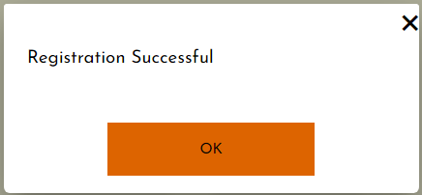

*Created with the Personal Edition of HelpNDoc:* [*Benefits of a Help Authoring Tool*](https://www.helpauthoringsoftware.com)

Mail Sent Alert Message

This mail sent alert message will appear when a user wants to reset their password and enters their email for a one time pin to be sent as well as clicked the Send One Time Pin button. The system displays this mail sent alert message with an OK button.

* Clicking the OK button, the screen will redirect to the Login screen.

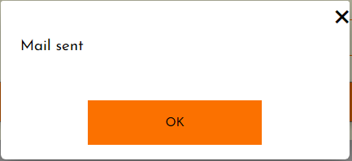

*Created with the Personal Edition of HelpNDoc:* [*Free iPhone documentation generator*](https://www.helpndoc.com/feature-tour/iphone-website-generation)

Verified Successful Alert Message

This verified successful alert message will appear when the user has entered the one time pin that was sent to the, via email and has clicked the Verify One Time Pin. The system displays this verified successful alert message with an OK button.

* Clicking the OK button, the screen will redirect to the Reset Password screen.

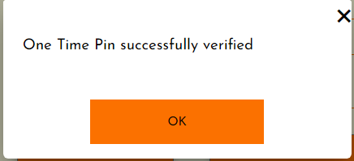

*Created with the Personal Edition of HelpNDoc:* [*Full-featured EPub generator*](https://www.helpndoc.com/create-epub-ebooks)

Update Successful Alert Message

This update successful alert message will appear when the password has been successfully reset on the system and the Reset Password button has been clicked. The system displays this update successful alert message with an OK button.

* Clicking the OK button, the screen will redirect to the Login screen.

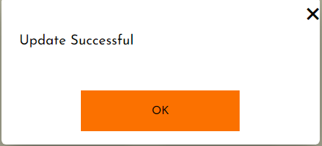

*Created with the Personal Edition of HelpNDoc:* [*Full-featured multi-format Help generator*](https://www.helpndoc.com/help-authoring-tool)

Employee

*Created with the Personal Edition of HelpNDoc:* [*What is a Help Authoring tool?*](https://www.helpauthoringsoftware.com)

Addition Confirm Message

This addition confirmation message will appear when a new employee profile is being added to the system and the Save button has been clicked. The system will prompt the user to either confirm (YES) or deny (NO) the addition of the new employee profile details.

* Clicking the YES button, the addition will be confirmed, and the changes will be made to the database. If the addition is successful, a successful alert message will be displayed (see Successful Alert Message)
* Clicking the NO button, the addition will not be confirmed, and the confirmation message will no longer be displayed.

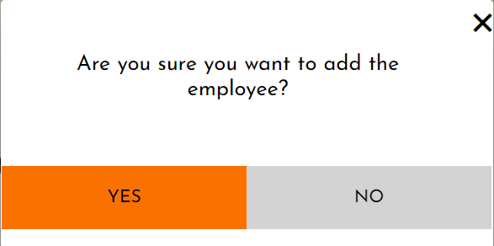

*Created with the Personal Edition of HelpNDoc:* [*Free Qt Help documentation generator*](https://www.helpndoc.com)

Successful Alert Message

This successful alert message will appear when the container has been successfully added to the system. The system displays this successful alert message with an OK button.

* Clicking the OK button, the screen will redirect to the Employee Management screen.

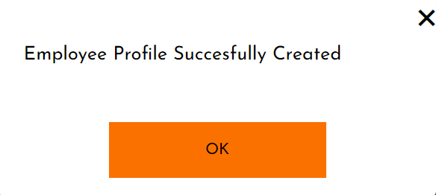

*Created with the Personal Edition of HelpNDoc:* [*iPhone web sites made easy*](https://www.helpndoc.com/feature-tour/iphone-website-generation)

Update Confirmation Message

This update confirmation will appear when a employee profile details is being updated and the Save button has been clicked. The system will prompt the user to either confirm (YES) or deny (NO) the recipient update.

* Clicking the YES button, the update will be confirmed, and the changes will be made to the database. If the update is successful, an update successful alert message will be displayed (see Update Successful Alert Message)
* Clicking the NO button, the update will not be confirmed, and the confirmation message will no longer be displayed.

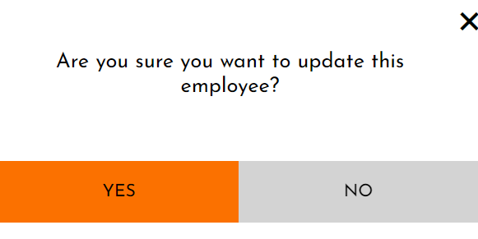

*Created with the Personal Edition of HelpNDoc:* [*Easy EBook and documentation generator*](https://www.helpndoc.com)

Update Successful Alert Message

This update successful alert message will appear when the employee profile has been successfully updated on the system. The system displays this update successful alert message with an OK button.

* Clicking the OK button, the screen will redirect to the Employee Management screen.

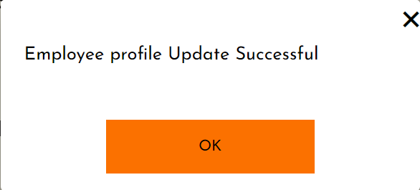

*Created with the Personal Edition of HelpNDoc:* [*Write EPub books for the iPad*](https://www.helpndoc.com/create-epub-ebooks)

Cancel Confirmation Message

This cancel confirmation will appear when a employee profile details is being updated and the Cancel button has been clicked. The system will prompt the user to either confirm (YES) or deny (NO) the cancellation.

* Clicking the YES button, the cancellation will be confirmed, and the system will redirect the user the Search Employee profile screen.
* Clicking the NO button, the cancellation will not be confirmed, and the system will redirect the user the Search Employee profile screen.

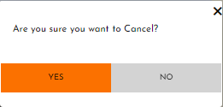

*Created with the Personal Edition of HelpNDoc:* [*Free iPhone documentation generator*](https://www.helpndoc.com/feature-tour/iphone-website-generation)

Deletion Confirm Message

This deletion confirmation message will appear when an employee profile is being removed from the system and the Delete button has been clicked. The system will prompt the user to either confirm (YES) or deny (NO) the deletion of the recipient.

* Clicking the YES button, the deletion will be confirmed, and the changes will be made to the database. If the deletion is successful, a delete successful alert message will be displayed (see Delete Successful Alert Message)
* Clicking the NO button, the deletion will not be confirmed, and the confirmation message will no longer be displayed.

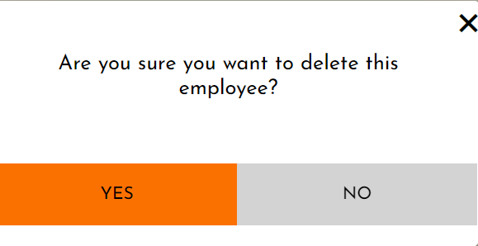

*Created with the Personal Edition of HelpNDoc:* [*Produce Kindle eBooks easily*](https://www.helpndoc.com/feature-tour/create-ebooks-for-amazon-kindle)

Delete Successful Alert Message

This delete successful alert message will appear when the employee profile has been successfully deleted from the system. The system displays this delete successful alert message with an OK button.

* Clicking the OK button, the screen will redirect to the Employee Management screen.

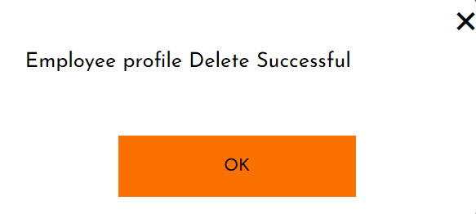

*Created with the Personal Edition of HelpNDoc:* [*Produce electronic books easily*](https://www.helpndoc.com/create-epub-ebooks)

Manager

*Created with the Personal Edition of HelpNDoc:* [*Single source CHM, PDF, DOC and HTML Help creation*](https://www.helpndoc.com/help-authoring-tool)

Addition Confirm Message

This addition confirmation message will appear when a new manager is being added to the system and the Save Profile button has been clicked. The system will prompt the user to either confirm (YES) or deny (NO) the addition of the new manager details.

* Clicking the YES button, the addition will be confirmed, and the changes will be made to the database. If the addition is successful, a successful alert message will be displayed (see Successful Alert Message)
* Clicking the NO button, the addition will not be confirmed, and the confirmation message will no longer be displayed.

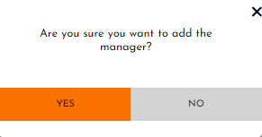

*Created with the Personal Edition of HelpNDoc:* [*Full-featured Documentation generator*](https://www.helpndoc.com)

Successful Alert Message

This successful alert message will appear when the manager has been successfully added to the system. The system displays this successful alert message with an OK button.

* Clicking the OK button, the screen will redirect to the Manager Profile Management screen.

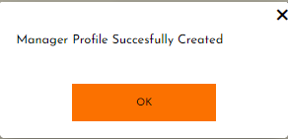

*Created with the Personal Edition of HelpNDoc:* [*Create HTML Help, DOC, PDF and print manuals from 1 single source*](https://www.helpndoc.com/help-authoring-tool)

Update Successful Alert Message

This update successful alert message will appear once the Save Button is clicked, and the manager has been successfully updated on the system. The system displays this update successful alert message with an OK button.

* Clicking the OK button, the screen will redirect to the Manager Profile Management screen.

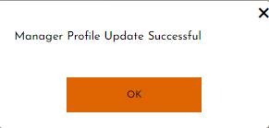

*Created with the Personal Edition of HelpNDoc:* [*Full-featured EBook editor*](https://www.helpndoc.com/create-epub-ebooks)

Deletion Confirm Message

This deletion confirmation message will appear when a manager is being removed from the system and the Delete button has been clicked. The system will prompt the user to either confirm (YES) or deny (NO) the deletion of the manager.

* Clicking the YES button, the deletion will be confirmed, and the changes will be made to the database. If the deletion is successful, a delete successful alert message will be displayed (see Delete Successful Alert Message)
* Clicking the NO button, the deletion will not be confirmed, and the confirmation message will no longer be displayed.

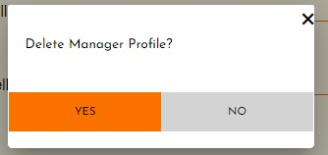

*Created with the Personal Edition of HelpNDoc:* [*Easily create EBooks*](https://www.helpndoc.com/feature-tour)

Delete Successful Alert Message

This delete successful alert message will appear when the manager has been successfully deleted from the system. The system displays this delete successful alert message with an OK button.

* Clicking the OK button, the screen will redirect to the Manager Profile Management screen.

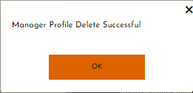

*Created with the Personal Edition of HelpNDoc:* [*Create HTML Help, DOC, PDF and print manuals from 1 single source*](https://www.helpndoc.com/help-authoring-tool)

Container

*Created with the Personal Edition of HelpNDoc:* [*Free Qt Help documentation generator*](https://www.helpndoc.com)

Addition Confirm Message

This addition confirmation message will appear when a new container is being added to the system and the Save button has been clicked. The system will prompt the user to either confirm (YES) or deny (NO) the addition of the new container details.

* Clicking the YES button, the addition will be confirmed, and the changes will be made to the database. If the addition is successful, a successful alert message will be displayed (see Successful Alert Message)
* Clicking the NO button, the addition will not be confirmed, and the confirmation message will no longer be displayed.

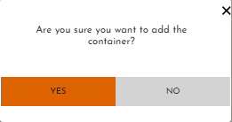

*Created with the Personal Edition of HelpNDoc:* [*Free EPub producer*](https://www.helpndoc.com/create-epub-ebooks)

Successful Alert Message

This successful alert message will appear when the container has been successfully added to the system. The system displays this successful alert message with an OK button.

* Clicking the OK button, the screen will redirect to the Container Management screen.

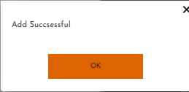

*Created with the Personal Edition of HelpNDoc:* [*Free EPub producer*](https://www.helpndoc.com/create-epub-ebooks)

Update Confirmation Message

This update confirmation will appear when a container details is being updated and the Save button has been clicked. The system will prompt the user to either confirm (YES) or deny (NO) the container update.

* Clicking the YES button, the update will be confirmed, and the changes will be made to the database. If the update is successful, an update successful alert message will be displayed (see Update Successful Alert Message)
* Clicking the NO button, the update will not be confirmed, and the confirmation message will no longer be displayed.

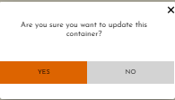

*Created with the Personal Edition of HelpNDoc:* [*Write eBooks for the Kindle*](https://www.helpndoc.com/feature-tour/create-ebooks-for-amazon-kindle)

Update Successful Alert Message

This update successful alert message will appear when the container has been successfully updated on the system. The system displays this update successful alert message with an OK button.

* Clicking the OK button, the screen will redirect to the Container Management screen.

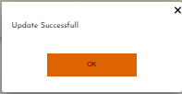

*Created with the Personal Edition of HelpNDoc:* [*Full-featured Documentation generator*](https://www.helpndoc.com)

Cancel Confirmation Message

This cancel confirmation will appear when a container details is being updated and the Cancel button has been clicked. The system will prompt the user to either confirm (YES) or deny (NO) the cancellation.

* Clicking the YES button, the cancellation will be confirmed, and the system will redirect the user the Search Container screen.
* Clicking the NO button, the cancellation will not be confirmed, and the system will redirect the user the Search Container screen.

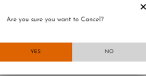

*Created with the Personal Edition of HelpNDoc:* [*Create HTML Help, DOC, PDF and print manuals from 1 single source*](https://www.helpndoc.com/help-authoring-tool)

Deletion Confirm Message

This deletion confirmation message will appear when a container is being removed from the system and the Delete button has been clicked. The system will prompt the user to either confirm (YES) or deny (NO) the deletion of the container.

* Clicking the YES button, the deletion will be confirmed, and the changes will be made to the database. If the deletion is successful, a delete successful alert message will be displayed (see Delete Successful Alert Message)
* Clicking the NO button, the deletion will not be confirmed, and the confirmation message will no longer be displayed.

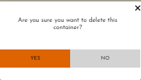

*Created with the Personal Edition of HelpNDoc:* [*Create help files for the Qt Help Framework*](https://www.helpndoc.com/feature-tour/create-help-files-for-the-qt-help-framework)

Delete Successful Alert Message

This delete successful alert message will appear when the container has been successfully deleted from the system. The system displays this delete successful alert message with an OK button.

* Clicking the OK button, the screen will redirect to the Container Management screen.

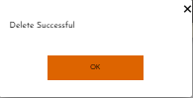

*Created with the Personal Edition of HelpNDoc:* [*Easy CHM and documentation editor*](https://www.helpndoc.com)

Product Category

*Created with the Personal Edition of HelpNDoc:* [*Full-featured Kindle eBooks generator*](https://www.helpndoc.com/feature-tour/create-ebooks-for-amazon-kindle)

Addition Confirm Message

This addition confirmation message will appear when a new product category is being added to the system and the Save button has been clicked. The system will prompt the user to either confirm (YES) or deny (NO) the addition of the new product category details.

* Clicking the YES button, the addition will be confirmed, and the changes will be made to the database. If the addition is successful, a successful alert message will be displayed (see Successful Alert Message)
* Clicking the NO button, the addition will not be confirmed, and the confirmation message will no longer be displayed.

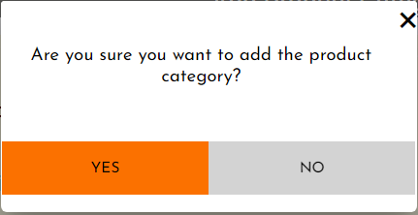

*Created with the Personal Edition of HelpNDoc:* [*Full-featured Documentation generator*](https://www.helpndoc.com)

Successful Alert Message

This successful alert message will appear when the product category has been successfully added to the system. The system displays this successful alert message with an OK button.

* Clicking the OK button, the screen will redirect to the Product Management screen.



*Created with the Personal Edition of HelpNDoc:* [*Easy to use tool to create HTML Help files and Help web sites*](https://www.helpndoc.com/help-authoring-tool)

Update Confirmation Message

This update confirmation will appear when the product categories details are being updated and the Save button has been clicked. The system will prompt the user to either confirm (YES) or deny (NO) the product category update.

* Clicking the YES button, the update will be confirmed, and the changes will be made to the database. If the update is successful, an update successful alert message will be displayed (see Update Successful Alert Message)
* Clicking the NO button, the update will not be confirmed, and the confirmation message will no longer be displayed.

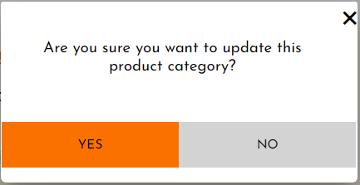

*Created with the Personal Edition of HelpNDoc:* [*Write eBooks for the Kindle*](https://www.helpndoc.com/feature-tour/create-ebooks-for-amazon-kindle)

Update Successful Alert Message

This update successful alert message will appear when the product category has been successfully updated on the system. The system displays this update successful alert message with an OK button.

* Clicking the OK button, the screen will redirect to the Product Management screen.



*Created with the Personal Edition of HelpNDoc:* [*Qt Help documentation made easy*](https://www.helpndoc.com/feature-tour/create-help-files-for-the-qt-help-framework)

Cancel Confirmation Message

This cancel confirmation will appear when the product category details is being updated and the Cancel button has been clicked. The system will prompt the user to either confirm (YES) or deny (NO) the cancellation.

* Clicking the YES button, the cancellation will be confirmed, and the system will redirect the user the Search Product category screen.
* Clicking the NO button, the cancellation will not be confirmed, and the system will redirect the user the Search Product category screen.



*Created with the Personal Edition of HelpNDoc:* [*Full-featured EBook editor*](https://www.helpndoc.com/create-epub-ebooks)

Deletion Confirm Message

This deletion confirmation message will appear when the product category is being removed from the system and the Delete button has been clicked. The system will prompt the user to either confirm (YES) or deny (NO) the deletion of the product category.

* Clicking the YES button, the deletion will be confirmed, and the changes will be made to the database. If the deletion is successful, a delete successful alert message will be displayed (see Delete Successful Alert Message)
* Clicking the NO button, the deletion will not be confirmed, and the confirmation message will no longer be displayed.

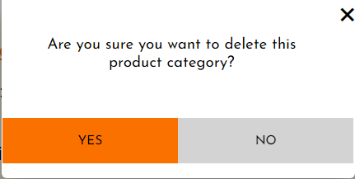

*Created with the Personal Edition of HelpNDoc:* [*Free PDF documentation generator*](https://www.helpndoc.com)

Delete Successful Alert Message

This delete successful alert message will appear when the container has been successfully deleted from the system. The system displays this delete successful alert message with an OK button.

* Clicking the OK button, the screen will redirect to the Product Management screen.



*Created with the Personal Edition of HelpNDoc:* [*Easy CHM and documentation editor*](https://www.helpndoc.com)

Supplier

*Created with the Personal Edition of HelpNDoc:* [*Easy CHM and documentation editor*](https://www.helpndoc.com)

Addition Confirm Message

This addition confirmation message will appear when a new supplier is being added to the system and the Save button has been clicked. The system will prompt the user to either confirm (YES) or deny (NO) the addition of the new supplier details.

* Clicking the YES button, the addition will be confirmed, and the changes will be made to the database. If the addition is successful, a successful alert message will be displayed (see Successful Alert Message)
* Clicking the NO button, the addition will not be confirmed, and the confirmation message will no longer be displayed.

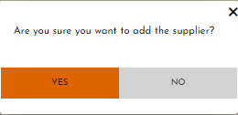

*Created with the Personal Edition of HelpNDoc:* [*Qt Help documentation made easy*](https://www.helpndoc.com/feature-tour/create-help-files-for-the-qt-help-framework)

Successful Alert Message

This successful alert message will appear when the supplier has been successfully added to the system. The system displays this successful alert message with an OK button.

* Clicking the OK button, the screen will redirect to the Supplier Management screen.

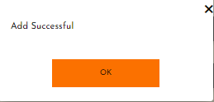

*Created with the Personal Edition of HelpNDoc:* [*Free EPub and documentation generator*](https://www.helpndoc.com)

Update Confirmation Message

This update confirmation will appear when a supplier details is being updated and the Save button has been clicked. The system will prompt the user to either confirm (YES) or deny (NO) the supplier update.

* Clicking the YES button, the update will be confirmed, and the changes will be made to the database. If the update is successful, an update successful alert message will be displayed (see Update Successful Alert Message)
* Clicking the NO button, the update will not be confirmed, and the confirmation message will no longer be displayed.

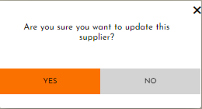

*Created with the Personal Edition of HelpNDoc:* [*Full-featured Help generator*](https://www.helpndoc.com/feature-tour)

Update Successful Alert Message

This update successful alert message will appear when the supplier has been successfully updated on the system. The system displays this update successful alert message with an OK button.

* Clicking the OK button, the screen will redirect to the Supplier Management screen.

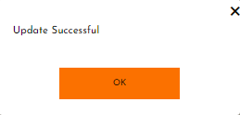

*Created with the Personal Edition of HelpNDoc:* [*Qt Help documentation made easy*](https://www.helpndoc.com/feature-tour/create-help-files-for-the-qt-help-framework)

Delete Successful Alert Message

This delete successful alert message will appear when the supplier has been successfully deleted from the system. The system displays this delete successful alert message with an OK button.

* Clicking the OK button, the screen will redirect to the Supplier Management screen.

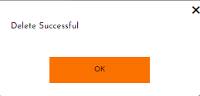

*Created with the Personal Edition of HelpNDoc:* [*Free PDF documentation generator*](https://www.helpndoc.com)

Product

*Created with the Personal Edition of HelpNDoc:* [*Create help files for the Qt Help Framework*](https://www.helpndoc.com/feature-tour/create-help-files-for-the-qt-help-framework)

Addition Confirm Message

This addition confirmation message will appear when a new product is being added to the system and the Save button has been clicked. The system will prompt the user to either confirm (YES) or deny (NO) the addition of the new product details.

* Clicking the YES button, the addition will be confirmed, and the changes will be made to the database. If the addition is successful, a successful alert message will be displayed (see Successful Alert Message)
* Clicking the NO button, the addition will not be confirmed, and the confirmation message will no longer be displayed.

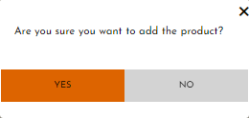

*Created with the Personal Edition of HelpNDoc:* [*Qt Help documentation made easy*](https://www.helpndoc.com/feature-tour/create-help-files-for-the-qt-help-framework)

Successful Alert Message

This successful alert message will appear when the product has been successfully added to the system. The system displays this successful alert message with an OK button.

* Clicking the OK button, the screen will redirect to the Product Management screen.

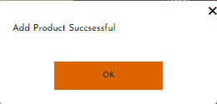

*Created with the Personal Edition of HelpNDoc:* [*Easily create CHM Help documents*](https://www.helpndoc.com/feature-tour)

Add Product To Container Alert Message

This add product to container alert message will appear when the product has been successfully added to a container. The system displays this add product to container alert message with an OK button.

* Clicking the OK button, the screen will redirect to the Product Management screen.

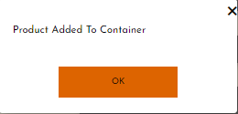

*Created with the Personal Edition of HelpNDoc:* [*Create cross-platform Qt Help files*](https://www.helpndoc.com/feature-tour/create-help-files-for-the-qt-help-framework)

Product Removed From Container Alert Message

This product removed from container alert message will appear when the product has been successfully removed from a container. The system displays this product removed from container alert message with an OK button.

* Clicking the OK button, the screen will redirect to the Product Management screen.

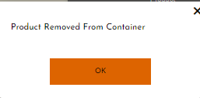

*Created with the Personal Edition of HelpNDoc:* [*Free HTML Help documentation generator*](https://www.helpndoc.com)

Update Confirmation Message

This update confirmation will appear when a product details is being updated and the Save button has been clicked. The system will prompt the user to either confirm (YES) or deny (NO) the product update.

* Clicking the YES button, the update will be confirmed, and the changes will be made to the database. If the update is successful, an update successful alert message will be displayed (see Update Successful Alert Message)
* Clicking the NO button, the update will not be confirmed, and the confirmation message will no longer be displayed.

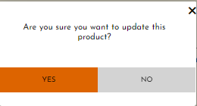

*Created with the Personal Edition of HelpNDoc:* [*News and information about help authoring tools and software*](https://www.helpauthoringsoftware.com)

Update Successful Alert Message

This update successful alert message will appear when the product has been successfully updated on the system. The system displays this update successful alert message with an OK button.

* Clicking the OK button, the screen will redirect to the Product Management screen.

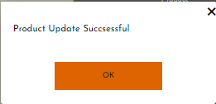

*Created with the Personal Edition of HelpNDoc:* [*What is a Help Authoring tool?*](https://www.helpauthoringsoftware.com)

Movement Alert Message

This movement alert message will appear when the product has been successfully moved the selected container and the Move button has been clicked. The system displays this movement alert message with an OK button.

* Clicking the OK button, the screen will redirect to the display the searched product results card and the alert message will no longer be displayed.

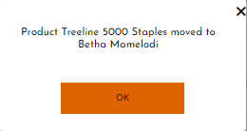

*Created with the Personal Edition of HelpNDoc:* [*Free Kindle producer*](https://www.helpndoc.com/feature-tour/create-ebooks-for-amazon-kindle)

Price Added Alert Message

This price added alert message will appear when the new price has been successfully added and the Save button has been clicked. The system displays this price added alert message with an OK button.

* Clicking the OK button, the screen will redirect to the display the searched product results card and the alert message will no longer be displayed.

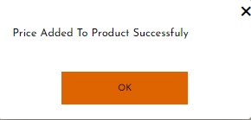

*Created with the Personal Edition of HelpNDoc:* [*Generate Kindle eBooks with ease*](https://www.helpndoc.com/feature-tour/create-ebooks-for-amazon-kindle)

Saved Stock Form Alert Message

This saved stock form alert message will appear when the stock form has been successfully saved and the Done button has been clicked. The system displays this saved stock form alert message with an OK button.

* Clicking the OK button, the screen will redirect to the display the Stock Management screen and the alert message will no longer be displayed.

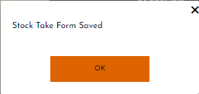

*Created with the Personal Edition of HelpNDoc:* [*Free help authoring environment*](https://www.helpndoc.com/help-authoring-tool)

Stock Take Completed Alert Message

This stock take completed alert message will appear when the stock take has been completed successfully and the Complete button has been clicked. The system displays this stock take completed alert message with an OK button.

* Clicking the OK button, the screen will redirect to the display the Stock Management screen and the alert message will no longer be displayed.

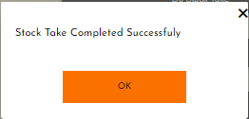

*Created with the Personal Edition of HelpNDoc:* [*Free EPub producer*](https://www.helpndoc.com/create-epub-ebooks)

Add To Backlog Alert Message

This add to backlog alert message will appear when the product low in stock has successfully added to the backlog and the Add button has been clicked. The system displays this add to backlog alert message with an OK button.

* Clicking the OK button, the alert message will no longer be displayed.

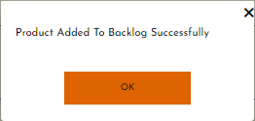

*Created with the Personal Edition of HelpNDoc:* [*Produce Kindle eBooks easily*](https://www.helpndoc.com/feature-tour/create-ebooks-for-amazon-kindle)

Add VAT Successful Alert Message

This add vat successful alert message will appear when the vat has been successfully added to the system and the Add VAT button has been clicked. The system displays this add vat successful alert message with an OK button.

* Clicking the OK button, the screen will redirect to the Product Management screen.

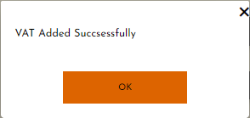

*Created with the Personal Edition of HelpNDoc:* [*Full-featured Help generator*](https://www.helpndoc.com/feature-tour)

Update VAT Successful Alert Message

This update vat successful alert message will appear when the vat has been successfully updated and the Save button has been clicked. The system displays this update vat successful alert message with an OK button.

* Clicking the OK button, the screen will redirect to the Product Management screen.

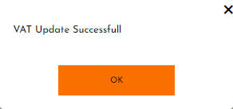

*Created with the Personal Edition of HelpNDoc:* [*Full-featured Documentation generator*](https://www.helpndoc.com)

Delete Successful Alert Message

This delete successful alert message will appear when the product has been successfully deleted from the system and the Delete Button has been clicked. The system displays this delete successful alert message with an OK button.

* Clicking the OK button, the screen will redirect to the Product Management screen.

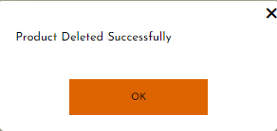

*Created with the Personal Edition of HelpNDoc:* [*Generate EPub eBooks with ease*](https://www.helpndoc.com/create-epub-ebooks)

Customer

*Created with the Personal Edition of HelpNDoc:* [*Full-featured Kindle eBooks generator*](https://www.helpndoc.com/feature-tour/create-ebooks-for-amazon-kindle)

Addition Confirm Message

This addition confirmation message will appear when a new customer is being added to the system and the Save button has been clicked. The system will prompt the user to either confirm (YES) or deny (NO) the addition of the new customer details.

* Clicking the YES button, the addition will be confirmed, and the changes will be made to the database. If the addition is successful, a successful alert message will be displayed (see Successful Alert Message)
* Clicking the NO button, the addition will not be confirmed, and the confirmation message will no longer be displayed.

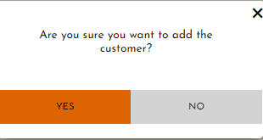

*Created with the Personal Edition of HelpNDoc:* [*Easily create EPub books*](https://www.helpndoc.com/feature-tour)

Successful Alert Message

This successful alert message will appear when the customer has been successfully added to the system. The system displays this successful alert message with an OK button.

* Clicking the OK button, the screen will redirect to the Customer Management screen.

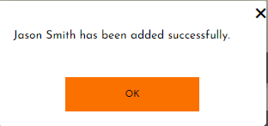

*Created with the Personal Edition of HelpNDoc:* [*Free EPub producer*](https://www.helpndoc.com/create-epub-ebooks)

Update Confirmation Message

This update confirmation will appear when a customer details is being updated and the Save button has been clicked. The system will prompt the user to either confirm (YES) or deny (NO) the customer update.

* Clicking the YES button, the update will be confirmed, and the changes will be made to the database. If the update is successful, an update successful alert message will be displayed (see Update Successful Alert Message)
* Clicking the NO button, the update will not be confirmed, and the confirmation message will no longer be displayed.

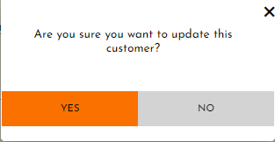

*Created with the Personal Edition of HelpNDoc:* [*Easily create PDF Help documents*](https://www.helpndoc.com/feature-tour)

Update Successful Alert Message

This update successful alert message will appear when the customer has been successfully updated on the system. The system displays this update successful alert message with an OK button.

* Clicking the OK button, the screen will redirect to the Customer Management screen.

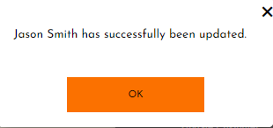

*Created with the Personal Edition of HelpNDoc:* [*Easily create Help documents*](https://www.helpndoc.com/feature-tour)

Cancel Confirmation Message

This cancel confirmation will appear when a customer details is being updated and the Cancel button has been clicked. The system will prompt the user to either confirm (YES) or deny (NO) the cancellation.

* Clicking the YES button, the cancellation will be confirmed, and the system will redirect the user the Customer Details screen.
* Clicking the NO button, the cancellation will not be confirmed, and the system will redirect the user the Customer Details screen.

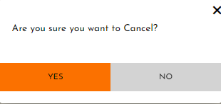

*Created with the Personal Edition of HelpNDoc:* [*Easy EBook and documentation generator*](https://www.helpndoc.com)

Deletion Confirm Message

This deletion confirmation message will appear when a customer is being removed from the system and the Delete button has been clicked. The system will prompt the user to either confirm (YES) or deny (NO) the deletion of the customer.

* Clicking the YES button, the deletion will be confirmed, and the changes will be made to the database. If the deletion is successful, a delete successful alert message will be displayed (see Delete Successful Alert Message)
* Clicking the NO button, the deletion will not be confirmed, and the confirmation message will no longer be displayed.

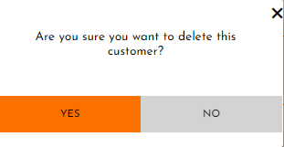

*Created with the Personal Edition of HelpNDoc:* [*Easily create HTML Help documents*](https://www.helpndoc.com/feature-tour)

Delete Successful Alert Message

This delete successful alert message will appear when the customer has been successfully deleted from the system. The system displays this delete successful alert message with an OK button.

* Clicking the OK button, the screen will redirect to the Customer Management screen.

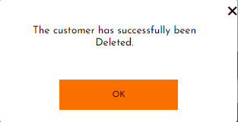

*Created with the Personal Edition of HelpNDoc:* [*Full-featured Help generator*](https://www.helpndoc.com/feature-tour)

Sales

*Created with the Personal Edition of HelpNDoc:* [*Easily create Qt Help files*](https://www.helpndoc.com/feature-tour)

Sale Incomplete Alert Message

This sale incomplete alert message will appear when the Complete Sale button is clicked and there is an outstanding amount. The system displays this sale incomplete alert message with an OK button.

* Clicking the OK button, the screen will remain on the Make Sale screen.

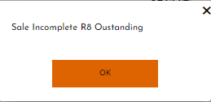

*Created with the Personal Edition of HelpNDoc:* [*Easily create Qt Help files*](https://www.helpndoc.com/feature-tour)

Sale Completed Alert Message

This sale completed alert message will appear when the Complete Sale button is clicked, and the sale made was successful. The system displays this sale completed alert message with an OK button.

* Clicking the OK button, the screen will redirect to the Sale Management screen.

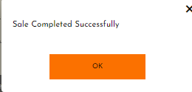

*Created with the Personal Edition of HelpNDoc:* [*Produce electronic books easily*](https://www.helpndoc.com/create-epub-ebooks)

Low Stock Alert Message

This low stock alert message will appear when the Complete Sale button is clicked, and the product in the container are equal to or below the reorder level. The system displays this low stock alert message with an OK button.

* Clicking the OK button, the screen will redirect to the Low Stock Notification screen.

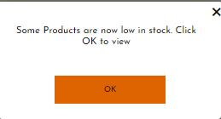

*Created with the Personal Edition of HelpNDoc:* [*Produce Kindle eBooks easily*](https://www.helpndoc.com/feature-tour/create-ebooks-for-amazon-kindle)

Sale Cancelled Alert Message

This sale cancelled alert message will appear when the Cancel Sale button is clicked. The system displays this sale cancelled alert message with an OK button.

* Clicking the OK button, the screen will redirect to the Sale Management screen.

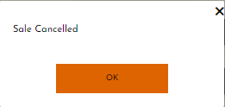

*Created with the Personal Edition of HelpNDoc:* [*Single source CHM, PDF, DOC and HTML Help creation*](https://www.helpndoc.com/help-authoring-tool)

Customer Order

*Created with the Personal Edition of HelpNDoc:* [*Produce Kindle eBooks easily*](https://www.helpndoc.com/feature-tour/create-ebooks-for-amazon-kindle)

Order Successful Alert Message

This order successful alert message will appear when the customers order has been placed successfully to the system and the Place Order button has been clicked. The system displays this order successful alert message with an OK button.

* Clicking the OK button, the screen will redirect to the Customer Order Management screen.

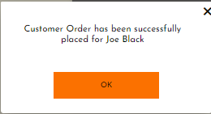

*Created with the Personal Edition of HelpNDoc:* [*Benefits of a Help Authoring Tool*](https://www.helpauthoringsoftware.com)

Cancel Confirmation Message

This cancel confirmation will appear when a customer order is being placed and the Cancel button has been clicked. The system will prompt the user to either confirm (YES) or deny (NO) the cancellation.

* Clicking the YES button, the cancellation will be confirmed, and the system will redirect the user the Customer Order Management screen.
* Clicking the NO button, the cancellation will not be confirmed, and the cancel confirmation message will no longer be displayed.

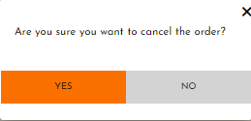

*Created with the Personal Edition of HelpNDoc:* [*Easily create EBooks*](https://www.helpndoc.com/feature-tour)

Cancelled Alert Message

This cancelled alert message will appear when the customer order has been cancelled. The system displays this cancelled alert message with an OK button.

* Clicking the OK button, the screen will redirect to the Customer Order Management screen.

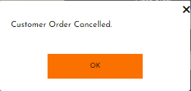

*Created with the Personal Edition of HelpNDoc:* [*Full-featured EBook editor*](https://www.helpndoc.com/create-epub-ebooks)

Email Confirmation Message

This email confirmation will appear when customer order is ready for collection and the Send Notification button has been clicked. The system will prompt the user to either confirm (YES) or deny (NO) sending the customer an email.

* Clicking the YES button, the send email will be confirmed, and the system will redirect the user the Customer Order Management screen.
* Clicking the NO button, the send email will not be confirmed, and the email confirmation message will no longer be displayed.

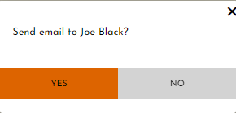

*Created with the Personal Edition of HelpNDoc:* [*Easily create CHM Help documents*](https://www.helpndoc.com/feature-tour)

Email Alert Message

This email alert message will appear when the email was successfully sent to the customer. The system displays this email alert message with an OK button.

* Clicking the OK button, the email alert message will no longer be displayed.

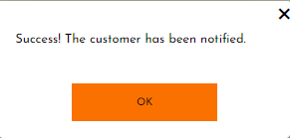

*Created with the Personal Edition of HelpNDoc:* [*Create help files for the Qt Help Framework*](https://www.helpndoc.com/feature-tour/create-help-files-for-the-qt-help-framework)

Collection Confirmation Message

This collection confirmation will appear when customer order is being collected and the Collect Order button has been clicked. The system will prompt the user to either confirm (YES) or deny (NO) to confirm the collection.

* Clicking the YES button, the collection will be confirmed, and the system will redirect the user the Customer Order Management screen.
* Clicking the NO button, the collection will not be confirmed, and the collection confirmation message will no longer be displayed.

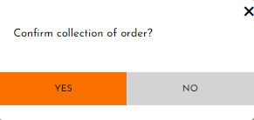

*Created with the Personal Edition of HelpNDoc:* [*Produce Kindle eBooks easily*](https://www.helpndoc.com/feature-tour/create-ebooks-for-amazon-kindle)

Payment Successful Alert Message

This payment successful alert message will appear when the payment was successful made and the Make Payment button has been clicked. The system displays this payment successful alert message with an OK button.

* Clicking the OK button, the payment successful l alert message will no longer be displayed.

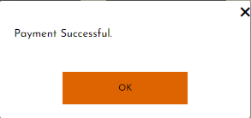

*Created with the Personal Edition of HelpNDoc:* [*Free EBook and documentation generator*](https://www.helpndoc.com)

Supplier Order

*Created with the Personal Edition of HelpNDoc:* [*Generate EPub eBooks with ease*](https://www.helpndoc.com/create-epub-ebooks)

Order Confirm Message

This order confirmation message will appear when a supplier order is being placed and the Place Order button has been clicked. The system will prompt the user to either confirm (YES) or deny (NO) the order placed which is sent to the supplier.

* Clicking the YES button, the order will be confirmed, and the changes will be made to the database. If the order is successful, a successful alert message will be displayed (see Successful Alert Message)
* Clicking the NO button, the order will not be confirmed, and the confirmation message will no longer be displayed.

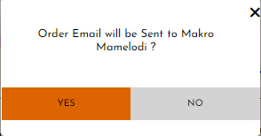

*Created with the Personal Edition of HelpNDoc:* [*Easy CHM and documentation editor*](https://www.helpndoc.com)

Successful Alert Message

This successful alert message will appear when the supplier order email has been successfully sent. The system displays this successful alert message with an OK button.

* Clicking the OK button, the screen will redirect to the List of supplier orders.

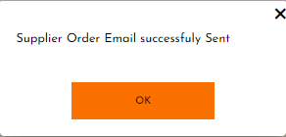

*Created with the Personal Edition of HelpNDoc:* [*Easily create PDF Help documents*](https://www.helpndoc.com/feature-tour)

Cancel Order Confirmation Message

This cancel order confirmation will appear when supplier order is being cancelled and the Cancel Order button has been clicked. The system will prompt the user to either confirm (YES) or deny (NO) the cancellation.

* Clicking the YES button, the cancellation will be confirmed, and the system will redirect the user the Customer Details screen.
* Clicking the NO button, the cancellation will not be confirmed, and the confirmation message will no longer be displayed.

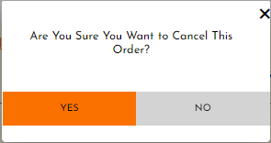

*Created with the Personal Edition of HelpNDoc:* [*Free CHM Help documentation generator*](https://www.helpndoc.com)

Cancel Order Successful Alert Message

This cancel order successful alert message will appear when the supplier order has been successfully cancelled. The system displays this cancel order successful alert message with an OK button.

* Clicking the OK button, the screen will redirect to the Supplier Order Management screen.

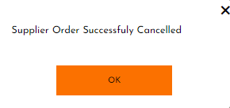

*Created with the Personal Edition of HelpNDoc:* [*Easily create EPub books*](https://www.helpndoc.com/feature-tour)

Order Details Saved Successful Alert Message

This order details saved successful alert message will appear when the supplier order has been saved successfully and the Complete Order Button has been clicked. The system displays this order details saved successful alert message with an OK button.

* Clicking the OK button, the screen will redirect to the Supplier Order Management screen.

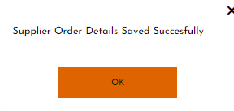

*Created with the Personal Edition of HelpNDoc:* [*Free PDF documentation generator*](https://www.helpndoc.com)

Back Order Confirm Message

This back order confirmation message will appear when a back order is being placed and the Place Back Order button has been clicked. The system will prompt the user to either confirm (YES) or deny (NO) the back order placed which is sent to the supplier.

* Clicking the YES button, the back order will be confirmed, and the changes will be made to the database. If the order is successful, a back order successful alert message will be displayed (see Back Order Successful Alert Message)
* Clicking the NO button, the back order will not be confirmed, and the confirmation message will no longer be displayed.

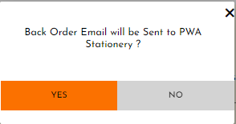

*Created with the Personal Edition of HelpNDoc:* [*Easy to use tool to create HTML Help files and Help web sites*](https://www.helpndoc.com/help-authoring-tool)

Back Order Successful Alert Message

This back order successful alert message will appear when the supplier order email has been successfully sent. The system displays this successful alert message with an OK button.

* Clicking the OK button, the screen will redirect to the Supplier Order Management screen.

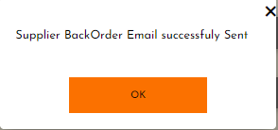

*Created with the Personal Edition of HelpNDoc:* [*Free Kindle producer*](https://www.helpndoc.com/feature-tour/create-ebooks-for-amazon-kindle)

Creditor

*Created with the Personal Edition of HelpNDoc:* [*Benefits of a Help Authoring Tool*](https://www.helpauthoringsoftware.com)

Addition Confirm Message

This addition confirmation message will appear when a new creditor is being added to the system and the Save button has been clicked. The system will prompt the user to either confirm (YES) or deny (NO) the addition of the new creditor details.

* Clicking the YES button, the addition will be confirmed, and the changes will be made to the database. If the addition is successful, a successful alert message will be displayed (see Successful Alert Message)
* Clicking the NO button, the addition will not be confirmed, and the confirmation message will no longer be displayed.

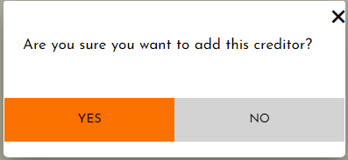

*Created with the Personal Edition of HelpNDoc:* [*Easy EBook and documentation generator*](https://www.helpndoc.com)

Successful Alert Message

This successful alert message will appear when the creditor has been successfully added to the system. The system displays this successful alert message with an OK button.

* Clicking the OK button, the screen will redirect to the Creditor Management screen.

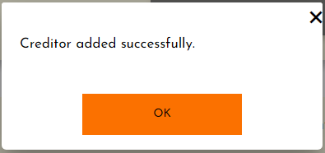

*Created with the Personal Edition of HelpNDoc:* [*Produce online help for Qt applications*](https://www.helpndoc.com/feature-tour/create-help-files-for-the-qt-help-framework)

Update Confirmation Message

This update confirmation will appear when a creditor details is being updated and the Save button has been clicked. The system will prompt the user to either confirm (YES) or deny (NO) the creditor update.

* Clicking the YES button, the update will be confirmed, and the changes will be made to the database. If the update is successful, an update successful alert message will be displayed (see Update Successful Alert Message)
* Clicking the NO button, the update will not be confirmed, and the confirmation message will no longer be displayed.

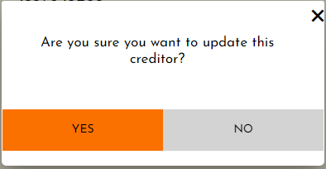

*Created with the Personal Edition of HelpNDoc:* [*Full-featured EBook editor*](https://www.helpndoc.com/create-epub-ebooks)

Update Successful Alert Message

This update successful alert message will appear when the creditor has been successfully updated on the system. The system displays this update successful alert message with an OK button.

* Clicking the OK button, the screen will redirect to the Creditor Management screen.

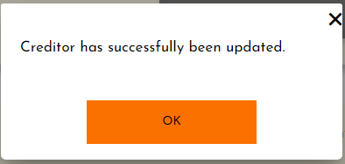

*Created with the Personal Edition of HelpNDoc:* [*Generate EPub eBooks with ease*](https://www.helpndoc.com/create-epub-ebooks)

Cancel Confirmation Message

This cancel confirmation will appear when a Creditor details is being updated and the Cancel button has been clicked. The system will prompt the user to either confirm (YES) or deny (NO) the cancellation.

* Clicking the YES button, the cancellation will be confirmed, and the system will redirect the user the Creditor Management screen.
* Clicking the NO button, the cancellation will not be confirmed, and the cancel confirmation message will no longer be displayed.



*Created with the Personal Edition of HelpNDoc:* [*Easily create Web Help sites*](https://www.helpndoc.com/feature-tour)

Deletion Confirm Message

This deletion confirmation message will appear when a Creditor is being removed from the system and the Delete button has been clicked. The system will prompt the user to either confirm (YES) or deny (NO) the deletion of the Creditor.

* Clicking the YES button, the deletion will be confirmed, and the changes will be made to the database. If the deletion is successful, a delete successful alert message will be displayed (see Delete Successful Alert Message)
* Clicking the NO button, the deletion will not be confirmed, and the confirmation message will no longer be displayed.

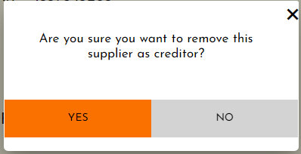

*Created with the Personal Edition of HelpNDoc:* [*Create help files for the Qt Help Framework*](https://www.helpndoc.com/feature-tour/create-help-files-for-the-qt-help-framework)

Delete Successful Alert Message

This delete successful alert message will appear when the Creditor has been successfully deleted from the system. The system displays this delete successful alert message with an OK button.

* Clicking the OK button, the screen will redirect to the Creditor Management screen.

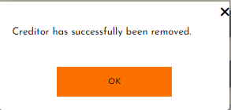

*Created with the Personal Edition of HelpNDoc:* [*Create HTML Help, DOC, PDF and print manuals from 1 single source*](https://www.helpndoc.com/help-authoring-tool)

Creditor Payment

*Created with the Personal Edition of HelpNDoc:* [*Produce Kindle eBooks easily*](https://www.helpndoc.com/feature-tour/create-ebooks-for-amazon-kindle)

Addition Confirm Message

This addition confirmation message will appear when a creditor payment is being added to the system and the Add Creditor Payment button has been clicked. The system will prompt the user to either confirm (YES) or deny (NO) the addition of the creditor payment.

* Clicking the YES button, the addition will be confirmed, and the changes will be made to the database. If the addition is successful, a successful alert message will be displayed (see Successful Alert Message)
* Clicking the NO button, the addition will not be confirmed, and the confirmation message will no longer be displayed.

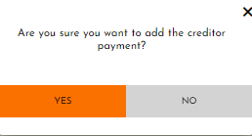

*Created with the Personal Edition of HelpNDoc:* [*Full-featured multi-format Help generator*](https://www.helpndoc.com/help-authoring-tool)

Successful Alert Message

This successful alert message will appear when the creditor payment has been successfully added to the system. The system displays this successful alert message with an OK button.

* Clicking the OK button, the screen will redirect to the Creditor Management screen.

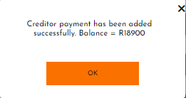

*Created with the Personal Edition of HelpNDoc:* [*Benefits of a Help Authoring Tool*](https://www.helpauthoringsoftware.com)

Payment Greater Alert Message

This payment greater alert message will appear when the creditor payment is greater than the creditors actual balance. The system displays this payment greater alert message with an OK button.

* Clicking the OK button, the screen will redirect to the Creditor Management screen.

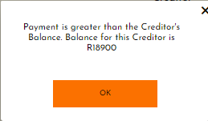

*Created with the Personal Edition of HelpNDoc:* [*Full-featured Help generator*](https://www.helpndoc.com/feature-tour)

Payment Not Added Alert Message

This payment not added alert message will appear when the creditor payment is made but the supplier selected is not a creditor for ORDRA. The system displays this payment not added alert message with an OK button.

* Clicking the OK button, the screen will redirect to the Creditor Management screen.

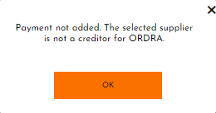

*Created with the Personal Edition of HelpNDoc:* [*Easily create Web Help sites*](https://www.helpndoc.com/feature-tour)

Province

*Created with the Personal Edition of HelpNDoc:* [*Free EPub producer*](https://www.helpndoc.com/create-epub-ebooks)

Addition Confirm Message

This addition confirmation message will appear when a new province is being added to the system and the Save button has been clicked. The system will prompt the user to either confirm (YES) or deny (NO) the addition of the new container details.

* Clicking the YES button, the addition will be confirmed, and the changes will be made to the database. If the addition is successful, a successful alert message will be displayed (see Successful Alert Message)
* Clicking the NO button, the addition will not be confirmed, and the confirmation message will no longer be displayed.

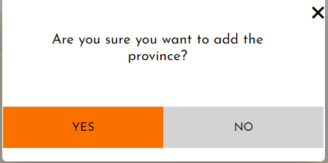

*Created with the Personal Edition of HelpNDoc:* [*Easily create HTML Help documents*](https://www.helpndoc.com/feature-tour)

Successful Alert Message

This successful alert message will appear when the province has been successfully added to the system. The system displays this successful alert message with an OK button.

* Clicking the OK button, the screen will redirect to the GPS Management screen.

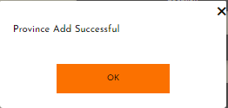

*Created with the Personal Edition of HelpNDoc:* [*Easily create EBooks*](https://www.helpndoc.com/feature-tour)

Update Confirmation Message

This update confirmation will appear when the province details are being updated and the Save button has been clicked. The system will prompt the user to either confirm (YES) or deny (NO) the province update.

* Clicking the YES button, the update will be confirmed, and the changes will be made to the database. If the update is successful, an update successful alert message will be displayed (see Update Successful Alert Message)
* Clicking the NO button, the update will not be confirmed, and the confirmation message will no longer be displayed.

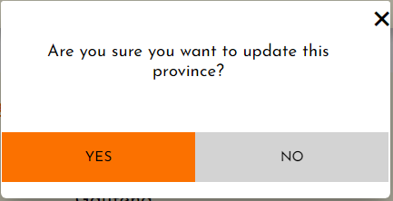

*Created with the Personal Edition of HelpNDoc:* [*Free EBook and documentation generator*](https://www.helpndoc.com)

Update Successful Alert Message

This update successful alert message will appear when the province has been successfully updated on the system. The system displays this update successful alert message with an OK button.

* Clicking the OK button, the screen will redirect to the GPS Management screen.

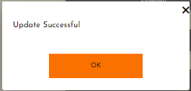

*Created with the Personal Edition of HelpNDoc:* [*Easily create Help documents*](https://www.helpndoc.com/feature-tour)

Cancel Confirmation Message

This cancel confirmation will appear when a province details is being updated and the Cancel button has been clicked. The system will prompt the user to either confirm (YES) or deny (NO) the cancellation.

* Clicking the YES button, the cancellation will be confirmed, and the system will redirect the user the GPS Management screen.
* Clicking the NO button, the cancellation will not be confirmed, and the system will redirect the user the GPS Management screen.



*Created with the Personal Edition of HelpNDoc:* [*Full-featured EBook editor*](https://www.helpndoc.com/create-epub-ebooks)

Deletion Confirm Message

This deletion confirmation message will appear when a province is being removed from the system and the Delete button has been clicked. The system will prompt the user to either confirm (YES) or deny (NO) the deletion of the container.

* Clicking the YES button, the deletion will be confirmed, and the changes will be made to the database. If the deletion is successful, a delete successful alert message will be displayed (see Delete Successful Alert Message)
* Clicking the NO button, the deletion will not be confirmed, and the confirmation message will no longer be displayed.

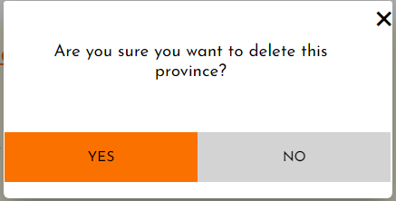

*Created with the Personal Edition of HelpNDoc:* [*Full-featured EPub generator*](https://www.helpndoc.com/create-epub-ebooks)

Delete Successful Alert Message

This delete successful alert message will appear when the province has been successfully deleted from the system. The system displays this delete successful alert message with an OK button.

* Clicking the OK button, the screen will redirect to the GPS Management screen.

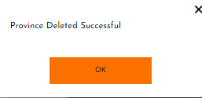

*Created with the Personal Edition of HelpNDoc:* [*Produce electronic books easily*](https://www.helpndoc.com/create-epub-ebooks)

Area

*Created with the Personal Edition of HelpNDoc:* [*News and information about help authoring tools and software*](https://www.helpauthoringsoftware.com)

Addition Confirm Message

This addition confirmation message will appear when a new area is being added to the system and the Add Area button has been clicked. The system will prompt the user to either confirm (YES) or deny (NO) the addition of the new area details.

* Clicking the YES button, the addition will be confirmed, and the changes will be made to the database. If the addition is successful, a successful alert message will be displayed (see Successful Alert Message)
* Clicking the NO button, the addition will not be confirmed, and the confirmation message will no longer be displayed.

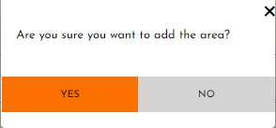

*Created with the Personal Edition of HelpNDoc:* [*Generate EPub eBooks with ease*](https://www.helpndoc.com/create-epub-ebooks)

Successful Alert Message

This successful alert message will appear when the area has been successfully added to the system. The system displays this successful alert message with an OK button.

* Clicking the OK button, the screen will redirect to the GPS Management screen.

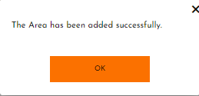

*Created with the Personal Edition of HelpNDoc:* [*Write eBooks for the Kindle*](https://www.helpndoc.com/feature-tour/create-ebooks-for-amazon-kindle)

Update Confirmation Message

This update confirmation will appear when a area details is being updated and the Update button has been clicked. The system will prompt the user to either confirm (YES) or deny (NO) the area update.

* Clicking the YES button, the update will be confirmed, and the changes will be made to the database. If the update is successful, an update successful alert message will be displayed (see Update Successful Alert Message)
* Clicking the NO button, the update will not be confirmed, and the confirmation message will no longer be displayed.

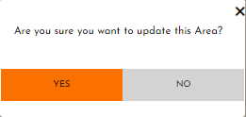

*Created with the Personal Edition of HelpNDoc:* [*Free Qt Help documentation generator*](https://www.helpndoc.com)

Update Successful Alert Message

This update successful alert message will appear when the area has been successfully updated on the system. The system displays this update successful alert message with an OK button.

* Clicking the OK button, the screen will redirect to the GPS Management screen.

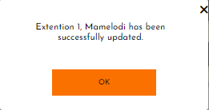

*Created with the Personal Edition of HelpNDoc:* [*Easy EBook and documentation generator*](https://www.helpndoc.com)

Deletion Confirm Message

This deletion confirmation message will appear when an area is being removed from the system and the Delete button has been clicked. The system will prompt the user to either confirm (YES) or deny (NO) the deletion of the area.

* Clicking the YES button, the deletion will be confirmed, and the changes will be made to the database. If the deletion is successful, a delete successful alert message will be displayed (see Delete Successful Alert Message)
* Clicking the NO button, the deletion will not be confirmed, and the confirmation message will no longer be displayed.

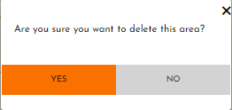

*Created with the Personal Edition of HelpNDoc:* [*Free help authoring tool*](https://www.helpndoc.com/help-authoring-tool)

Delete Successful Alert Message

This delete successful alert message will appear when the area has been successfully deleted from the system. The system displays this delete successful alert message with an OK button.

* Clicking the OK button, the screen will redirect to the GPS Management screen.

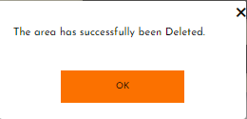

*Created with the Personal Edition of HelpNDoc:* [*Easily create Help documents*](https://www.helpndoc.com/feature-tour)

Location

*Created with the Personal Edition of HelpNDoc:* [*iPhone web sites made easy*](https://www.helpndoc.com/feature-tour/iphone-website-generation)

Addition Confirm Message

This addition confirmation message will appear when a new location is being added to the system and the Save button has been clicked. The system will prompt the user to either confirm (YES) or deny (NO) the addition of the new location details.

* Clicking the YES button, the addition will be confirmed, and the changes will be made to the database. If the addition is successful, a successful alert message will be displayed (see Successful Alert Message)
* Clicking the NO button, the addition will not be confirmed, and the confirmation message will no longer be displayed.

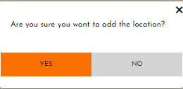

*Created with the Personal Edition of HelpNDoc:* [*Free iPhone documentation generator*](https://www.helpndoc.com/feature-tour/iphone-website-generation)

Successful Alert Message

This successful alert message will appear when the location has been successfully added to the system. The system displays this successful alert message with an OK button.

* Clicking the OK button, the screen will redirect to the GPS Management screen.

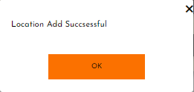

*Created with the Personal Edition of HelpNDoc:* [*Create HTML Help, DOC, PDF and print manuals from 1 single source*](https://www.helpndoc.com/help-authoring-tool)

Update Confirmation Message

This update confirmation will appear when a location details is being updated and the Update button has been clicked. The system will prompt the user to either confirm (YES) or deny (NO) the location update.

* Clicking the YES button, the update will be confirmed, and the changes will be made to the database. If the update is successful, an update successful alert message will be displayed (see Update Successful Alert Message)
* Clicking the NO button, the update will not be confirmed, and the confirmation message will no longer be displayed.

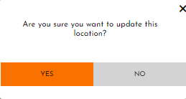

*Created with the Personal Edition of HelpNDoc:* [*Full-featured EBook editor*](https://www.helpndoc.com/create-epub-ebooks)

Update Successful Alert Message

This update successful alert message will appear when the location has been successfully updated on the system. The system displays this update successful alert message with an OK button.

* Clicking the OK button, the screen will redirect to the GPS Management screen.

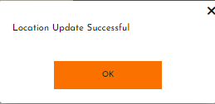

*Created with the Personal Edition of HelpNDoc:* [*Full-featured Documentation generator*](https://www.helpndoc.com)

Donation Recipient

*Created with the Personal Edition of HelpNDoc:* [*Full-featured EPub generator*](https://www.helpndoc.com/create-epub-ebooks)

Addition Confirm Message

This addition confirmation message will appear when a new donation recipient is being added to the system and the Save button has been clicked. The system will prompt the user to either confirm (YES) or deny (NO) the addition of the new donation recipient details.

* Clicking the YES button, the addition will be confirmed, and the changes will be made to the database. If the addition is successful, a successful alert message will be displayed (see Successful Alert Message)
* Clicking the NO button, the addition will not be confirmed, and the confirmation message will no longer be displayed.

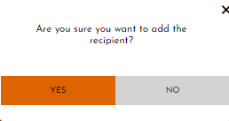

*Created with the Personal Edition of HelpNDoc:* [*Create help files for the Qt Help Framework*](https://www.helpndoc.com/feature-tour/create-help-files-for-the-qt-help-framework)

Successful Alert Message

This successful alert message will appear when the container has been successfully added to the system. The system displays this successful alert message with an OK button.

* Clicking the OK button, the screen will redirect to the Donation Management screen.

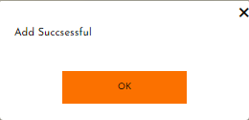

*Created with the Personal Edition of HelpNDoc:* [*Easily create PDF Help documents*](https://www.helpndoc.com/feature-tour)

Update Confirmation Message

This update confirmation will appear when a donation recipient details is being updated and the Save button has been clicked. The system will prompt the user to either confirm (YES) or deny (NO) the recipient update.

* Clicking the YES button, the update will be confirmed, and the changes will be made to the database. If the update is successful, an update successful alert message will be displayed (see Update Successful Alert Message)
* Clicking the NO button, the update will not be confirmed, and the confirmation message will no longer be displayed.

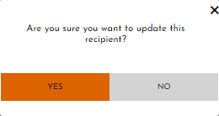

*Created with the Personal Edition of HelpNDoc:* [*Full-featured Documentation generator*](https://www.helpndoc.com)

Update Successful Alert Message

This update successful alert message will appear when the donation recipient has been successfully updated on the system. The system displays this update successful alert message with an OK button.

* Clicking the OK button, the screen will redirect to the Donation Management screen.

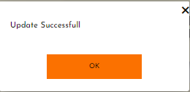

*Created with the Personal Edition of HelpNDoc:* [*iPhone web sites made easy*](https://www.helpndoc.com/feature-tour/iphone-website-generation)

Cancel Confirmation Message

This cancel confirmation will appear when a donation recipient details is being updated and the Cancel button has been clicked. The system will prompt the user to either confirm (YES) or deny (NO) the cancellation.

* Clicking the YES button, the cancellation will be confirmed, and the system will redirect the user the Search Donation Recipient screen.
* Clicking the NO button, the cancellation will not be confirmed, and the system will redirect the user the Search Donation Recipient screen.



*Created with the Personal Edition of HelpNDoc:* [*Create help files for the Qt Help Framework*](https://www.helpndoc.com/feature-tour/create-help-files-for-the-qt-help-framework)

Deletion Confirm Message

This deletion confirmation message will appear when a donation recipient is being removed from the system and the Delete button has been clicked. The system will prompt the user to either confirm (YES) or deny (NO) the deletion of the recipient.

* Clicking the YES button, the deletion will be confirmed, and the changes will be made to the database. If the deletion is successful, a delete successful alert message will be displayed (see Delete Successful Alert Message)
* Clicking the NO button, the deletion will not be confirmed, and the confirmation message will no longer be displayed.

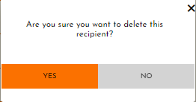

*Created with the Personal Edition of HelpNDoc:* [*Create help files for the Qt Help Framework*](https://www.helpndoc.com/feature-tour/create-help-files-for-the-qt-help-framework)

Delete Successful Alert Message

This delete successful alert message will appear when the recipient has been successfully deleted from the system. The system displays this delete successful alert message with an OK button.

* Clicking the OK button, the screen will redirect to the Donation Management screen.

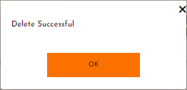

*Created with the Personal Edition of HelpNDoc:* [*Easy to use tool to create HTML Help files and Help web sites*](https://www.helpndoc.com/help-authoring-tool)

Donations

*Created with the Personal Edition of HelpNDoc:* [*Easy EPub and documentation editor*](https://www.helpndoc.com)

Addition Confirm Message

This addition confirmation message will appear when a new donation is being added to the system and the Save button has been clicked. The system will prompt the user to either confirm (YES) or deny (NO) the addition of the new donation details.

* Clicking the YES button, the addition will be confirmed, and the changes will be made to the database. If the addition is successful, a successful alert message will be displayed (see Successful Alert Message)
* Clicking the NO button, the addition will not be confirmed, and the confirmation message will no longer be displayed.

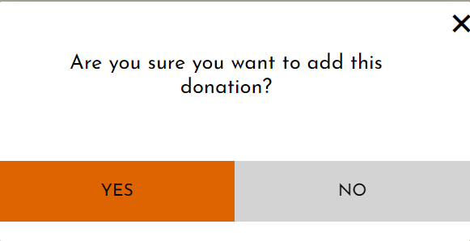

*Created with the Personal Edition of HelpNDoc:* [*Easily create Help documents*](https://www.helpndoc.com/feature-tour)

Successful Alert Message

This successful alert message will appear when the donation has been successfully added to the system. The system displays this successful alert message with an OK button.

* Clicking the OK button, the screen will redirect to the Donation Management screen.

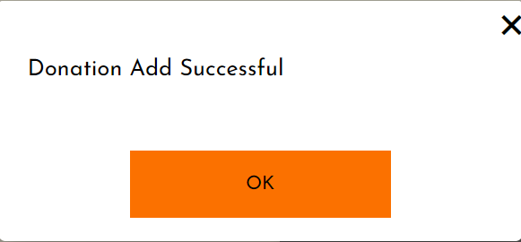

*Created with the Personal Edition of HelpNDoc:* [*Full-featured Documentation generator*](https://www.helpndoc.com)

Update Confirmation Message

This update confirmation will appear when a donation details is being updated and the Save button has been clicked. The system will prompt the user to either confirm (YES) or deny (NO) the donation update.

* Clicking the YES button, the update will be confirmed, and the changes will be made to the database. If the update is successful, an update successful alert message will be displayed (see Update Successful Alert Message)
* Clicking the NO button, the update will not be confirmed, and the confirmation message will no longer be displayed.

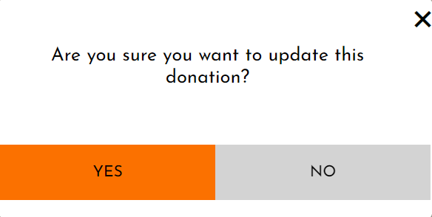

*Created with the Personal Edition of HelpNDoc:* [*Produce electronic books easily*](https://www.helpndoc.com/create-epub-ebooks)

Update Successful Alert Message

This update successful alert message will appear when the donation has been successfully updated on the system. The system displays this update successful alert message with an OK button.

* Clicking the OK button, the screen will redirect to the Donation Management screen.

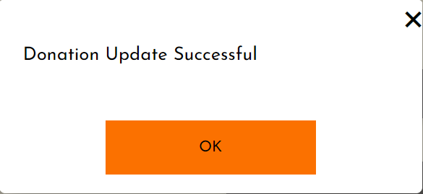

*Created with the Personal Edition of HelpNDoc:* [*Free help authoring environment*](https://www.helpndoc.com/help-authoring-tool)

Cancel Confirmation Message

This cancel confirmation will appear when a donation details is being updated and the Cancel button has been clicked. The system will prompt the user to either confirm (YES) or deny (NO) the cancellation.

* Clicking the YES button, the cancellation will be confirmed, and the system will redirect the user the Search Donation screen.
* Clicking the NO button, the cancellation will not be confirmed, and the system will redirect the user the Search Donation screen.



*Created with the Personal Edition of HelpNDoc:* [*Easy to use tool to create HTML Help files and Help web sites*](https://www.helpndoc.com/help-authoring-tool)

Reporting

There are no confirmation and alert messages that are displayed.

*Created with the Personal Edition of HelpNDoc:* [*Free EPub and documentation generator*](https://www.helpndoc.com)

Administration

*Created with the Personal Edition of HelpNDoc:* [*Free help authoring tool*](https://www.helpndoc.com/help-authoring-tool)

Access Changes Saved Alert Message

This access changes saved alert message will appear when the user type access changes has been successfully saved to the system. The system displays this successful alert message with an OK button.

* Clicking the OK button, the screen will redirect to the Administration screen.

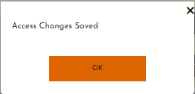

*Created with the Personal Edition of HelpNDoc:* [*Easy EPub and documentation editor*](https://www.helpndoc.com)

**Error Messages**

*Created with the Personal Edition of HelpNDoc:* [*Easily create CHM Help documents*](https://www.helpndoc.com/feature-tour)

Validation Error Message: Subsystems

This error message will be displayed when the data has been entered in the incorrect format or if any of the required fields have been left empty. When the error message is displayed no data will be saved and no confirmation message will be shown until the error has been fixed and the save button is clicked again.

*Created with the Personal Edition of HelpNDoc:* [*Produce electronic books easily*](https://www.helpndoc.com/create-epub-ebooks)

Login

|  |  |
| --- | --- |
| Name required error |  |
| Surname required error |  |
| Cell required error |  |
| Email required error |  |
| Cell length error |  |
| Cell input field only number allowed error |  |
| Email validity error |  |
| Password do not match error |  |
| Invalid username or password |  |
| Select container error |  |

*Created with the Personal Edition of HelpNDoc:* [*Free PDF documentation generator*](https://www.helpndoc.com)

Employee

|  |  |
| --- | --- |
| Name required error |  |
| Surname required error |  |
| Name length error |  |
| Surname length error |  |
| Cell number length error |  |
| Input field only allows characters error |  |
| Input field only allows numbers error |  |
| Work start date required error |  |
| Shifts completed required error |  |
| Record not found message |  |

*Created with the Personal Edition of HelpNDoc:* [*Generate EPub eBooks with ease*](https://www.helpndoc.com/create-epub-ebooks)

Manager

|  |  |
| --- | --- |
| Qualification required error |  |
| Nationality required error |  |
| ID Number required error |  |
| Name required error |  |
| Cell number required error |  |
| Surname required error |  |
| Qualification length error |  |
| Nationality length error |  |
| Input field only allows characters error |  |
| Input field only allows numbers error |  |
| ID number length error |  |
| Name length error |  |
| Cell length error |  |
| Surname length error |  |
| User not found message |  |
| Manager Profile not found message |  |

*Created with the Personal Edition of HelpNDoc:* [*Easily create EBooks*](https://www.helpndoc.com/feature-tour)

Container

|  |  |
| --- | --- |
| Empty fields error |  |
| Name required error |  |
| Description required error |  |
| Name length error |  |
| Description length error |  |
| Empty search field error |  |
| Record not found message |  |
| Delete restrict message |  |

*Created with the Personal Edition of HelpNDoc:* [*Free help authoring tool*](https://www.helpndoc.com/help-authoring-tool)

Product Category

|  |  |
| --- | --- |
| Empty fields error |  |
| Name required error |  |
| Description required error |  |
| Name length error |  |
| Description length error |  |
| Input field only allow text characters error |  |
| Empty search field error |  |
| Record not found message |  |
| Delete restrict message |  |

*Created with the Personal Edition of HelpNDoc:* [*Easily create Qt Help files*](https://www.helpndoc.com/feature-tour)

Supplier

|  |  |
| --- | --- |
| Name required error |  |
| Cell required error |  |
| Email required error |  |
| Street No required error |  |
| Street required error |  |
| Postal Code required error |  |
| Suburb required error |  |
| Input field only allows characters error |  |
| Input field only allows numbers error |  |
| Cell length error |  |
| Valid email error |  |
| Postal Code length error |  |
| Add unsuccessful message |  |
| Empty search field message / Record not found message |  |
| Delete restrict message |  |

*Created with the Personal Edition of HelpNDoc:* [*Free iPhone documentation generator*](https://www.helpndoc.com/feature-tour/iphone-website-generation)

Product

|  |  |
| --- | --- |
| Select Product Category required error |  |
| Select Supplier required error |  |
| Name required error |  |
| Description required error |  |
| Reorder level required error |  |
| Cost price required error |  |
| Unit price required error |  |
| Barcode required error |  |
| Name length error |  |
| Description length error |  |
| Input field only allows characters error |  |
| Select Product required error |  |
| Container required error |  |
| Barcode length error |  |
| Quantity required error |  |
| Save product count |  |

*Created with the Personal Edition of HelpNDoc:* [*What is a Help Authoring tool?*](https://www.helpauthoringsoftware.com)

Customer

|  |  |
| --- | --- |
| Name required error |  |
| Surname required error |  |
| Cell required error |  |
| Email required error |  |
| Street No required error |  |
| Street required error |  |
| Postal Code required error |  |
| Suburb required error |  |
| Input field only allows characters error |  |
| Input field only allows numbers error |  |
| Cell length error |  |
| Valid email error |  |
| Street No length error |  |
| Postal Code length error |  |
| Customer already exists message |  |
| Empty search field message / Record not found message |  |
| Delete restrict message |  |

*Created with the Personal Edition of HelpNDoc:* [*Free help authoring environment*](https://www.helpndoc.com/help-authoring-tool)

Sales

|  |  |
| --- | --- |
| Barcode required error |  |
| Date required error |  |
| Empty search field error |  |
| Product not in stock message |  |

*Created with the Personal Edition of HelpNDoc:* [*Free CHM Help documentation generator*](https://www.helpndoc.com)

Customer Order

|  |  |
| --- | --- |
| Empty input field error |  |
| Name required error |  |
| Surname required error |  |
| Product not selected error |  |
| Quantity not entered error |  |
| Order number required error |  |
| Input field only allows number error |  |
| Cell required error |  |
| Empty search field message / Record not found message |  |
| Order not found message |  |
| Order not paid message |  |
| Order isn’t eligible for payment message |  |
| Fulfilled customer orders message |  |

*Created with the Personal Edition of HelpNDoc:* [*Free help authoring tool*](https://www.helpndoc.com/help-authoring-tool)

Supplier Order

|  |  |
| --- | --- |
| Product is added to an order |  |
| Container selection required error |  |
| Container’s Product Quantity Updated |  |

*Created with the Personal Edition of HelpNDoc:* [*Create iPhone web-based documentation*](https://www.helpndoc.com/feature-tour/iphone-website-generation)

Creditor

|  |  |
| --- | --- |
| Supplier required error |  |
| Bank required error |  |
| Branch required error |  |
| Account number required error |  |
| Account Type required error |  |
| Account Balance required error |  |
| Account Number length error |  |
| Input field only allows numbers/digits error |  |
| Creditor name required error |  |
| Empty search field message / Record not found message |  |
| Delete restrict message |  |

*Created with the Personal Edition of HelpNDoc:* [*Full-featured Documentation generator*](https://www.helpndoc.com)

Creditor Payment

|  |  |
| --- | --- |
| Creditor required error |  |
| Date required error |  |
| Input field only allows numbers/digits error |  |

*Created with the Personal Edition of HelpNDoc:* [*Full-featured Help generator*](https://www.helpndoc.com/feature-tour)

Province

|  |  |
| --- | --- |
| Name required error |  |
| Name length error |  |
| Input field only allows text characters error |  |
| Duplicated province message |  |
| Record not found message |  |
| Delete restrict message |  |

*Created with the Personal Edition of HelpNDoc:* [*Easy EBook and documentation generator*](https://www.helpndoc.com)

Area

|  |  |
| --- | --- |
| Area name required error |  |
| Postal code required error |  |
| Area status required error |  |
| Province required error |  |
| Input field only allows characters error |  |
| Area name length error |  |
| Postal code length error |  |
| Empty search field message / Record not found message |  |
| Delete restrict message |  |

*Created with the Personal Edition of HelpNDoc:* [*Full-featured multi-format Help generator*](https://www.helpndoc.com/help-authoring-tool)

Location

|  |  |
| --- | --- |
| Location name required error |  |
| Area required error |  |
| Container required error |  |
| Location Status required error |  |
| Input field only allows characters error |  |
| Location name length error |  |
| Record not found message |  |

*Created with the Personal Edition of HelpNDoc:* [*Write EPub books for the iPad*](https://www.helpndoc.com/create-epub-ebooks)

Donation Recipient

|  |  |
| --- | --- |
| Empty fields error |  |
| Name required error |  |
| Surname required error |  |
| Cell number required error |  |
| Email is required error |  |
| Street No. required error |  |
| Street required error |  |
| Postal code required error |  |
| Area required error |  |
| Name length error |  |
| Surname length error |  |
| Cell number length error |  |
| Valid email error |  |
| Street No. length error |  |
| Street length error |  |
| Postal code length error |  |
| Area length error |  |
| Input field only allows characters error |  |
| Input field only allows numbers error |  |
| Record not found message |  |
| Delete restrict message |  |

*Created with the Personal Edition of HelpNDoc:* [*Full-featured Kindle eBooks generator*](https://www.helpndoc.com/feature-tour/create-ebooks-for-amazon-kindle)

Donations

|  |  |
| --- | --- |
| Name required error |  |
| Surname required error |  |
| Cell number required error |  |
| Name length error |  |
| Surname length error |  |
| Cell number length error |  |
| Input field only allows characters error |  |
| Input field only allows numbers error |  |
| Status required error |  |
| Donation date required error |  |
| Donated amount in R required error |  |
| Description required error |  |
| Description length error |  |
| Record not found message |  |

*Created with the Personal Edition of HelpNDoc:* [*Easily create Web Help sites*](https://www.helpndoc.com/feature-tour)

Reporting

|  |  |
| --- | --- |
| Option not selected error |  |

*Created with the Personal Edition of HelpNDoc:* [*Easy EBook and documentation generator*](https://www.helpndoc.com)

Administration

|  |  |
| --- | --- |
| User Type Access is Added |  |
| User Type Access is removed |  |

*Created with the Personal Edition of HelpNDoc:* [*Qt Help documentation made easy*](https://www.helpndoc.com/feature-tour/create-help-files-for-the-qt-help-framework)

**Error and Confirmation Messages: Desktop Application**

*Created with the Personal Edition of HelpNDoc:* [*Easily create EPub books*](https://www.helpndoc.com/feature-tour)

**Confirmation and Alert Messages: Subsystem**

*Created with the Personal Edition of HelpNDoc:* [*iPhone web sites made easy*](https://www.helpndoc.com/feature-tour/iphone-website-generation)

Login

*Created with the Personal Edition of HelpNDoc:* [*Easily create HTML Help documents*](https://www.helpndoc.com/feature-tour)

Successful Registration Alert Message

This successful registration alert message will appear when the user has been successfully registered to the system and the Register button has been clicked. The system displays this successful registration alert message with an OK button.

* Clicking the OK button, the screen will redirect to the Login screen.



*Created with the Personal Edition of HelpNDoc:* [*Easily create iPhone documentation*](https://www.helpndoc.com/feature-tour/iphone-website-generation)

Mail Sent Alert Message

This mail sent alert message will appear when a user wants to reset their password and enters their email for a one time pin to be sent as well as clicked the Send One Time Pin button. The system displays this mail sent alert message with an OK button.

* Clicking the OK button, the screen will redirect to the Login screen.



*Created with the Personal Edition of HelpNDoc:* [*What is a Help Authoring tool?*](https://www.helpauthoringsoftware.com)

Verified Successful Alert Message

This verified successful alert message will appear when the user has entered the one time pin that was sent to the, via email and has clicked the Verify One Time Pin. The system displays this verified successful alert message with an OK button.

* Clicking the OK button, the screen will redirect to the Reset Password screen.



*Created with the Personal Edition of HelpNDoc:* [*Free Web Help generator*](https://www.helpndoc.com)

Update Successful Alert Message

This update successful alert message will appear when the password has been successfully reset on the system and the Reset Password button has been clicked. The system displays this update successful alert message with an OK button.

* Clicking the OK button, the screen will redirect to the Login screen.



*Created with the Personal Edition of HelpNDoc:* [*Easily create CHM Help documents*](https://www.helpndoc.com/feature-tour)

Employee

*Created with the Personal Edition of HelpNDoc:* [*Easily create CHM Help documents*](https://www.helpndoc.com/feature-tour)

Addition Confirm Message

This addition confirmation message will appear when a new employee profile is being added to the system and the Save button has been clicked. The system will prompt the user to either confirm (YES) or deny (NO) the addition of the new employee profile details.

* Clicking the YES button, the addition will be confirmed, and the changes will be made to the database. If the addition is successful, a successful alert message will be displayed (see Successful Alert Message)
* Clicking the NO button, the addition will not be confirmed, and the confirmation message will no longer be displayed.



*Created with the Personal Edition of HelpNDoc:* [*Produce Kindle eBooks easily*](https://www.helpndoc.com/feature-tour/create-ebooks-for-amazon-kindle)

Successful Alert Message

This successful alert message will appear when the container has been successfully added to the system. The system displays this successful alert message with an OK button.

* Clicking the OK button, the screen will redirect to the Employee Management screen.



*Created with the Personal Edition of HelpNDoc:* [*Free EPub and documentation generator*](https://www.helpndoc.com)

Update Confirmation Message

This update confirmation will appear when a employee profile details is being updated and the Save button has been clicked. The system will prompt the user to either confirm (YES) or deny (NO) the recipient update.

* Clicking the YES button, the update will be confirmed, and the changes will be made to the database. If the update is successful, an update successful alert message will be displayed (see Update Successful Alert Message)
* Clicking the NO button, the update will not be confirmed, and the confirmation message will no longer be displayed.



*Created with the Personal Edition of HelpNDoc:* [*Free Kindle producer*](https://www.helpndoc.com/feature-tour/create-ebooks-for-amazon-kindle)

Update Successful Alert Message

This update successful alert message will appear when the employee profile has been successfully updated on the system. The system displays this update successful alert message with an OK button.

* Clicking the OK button, the screen will redirect to the Employee Management screen.



*Created with the Personal Edition of HelpNDoc:* [*Easy to use tool to create HTML Help files and Help web sites*](https://www.helpndoc.com/help-authoring-tool)

Cancel Confirmation Message

This cancel confirmation will appear when a employee profile details is being updated and the Cancel button has been clicked. The system will prompt the user to either confirm (YES) or deny (NO) the cancellation.

* Clicking the YES button, the cancellation will be confirmed, and the system will redirect the user the Search Employee profile screen.
* Clicking the NO button, the cancellation will not be confirmed, and the system will redirect the user the Search Employee profile screen.



*Created with the Personal Edition of HelpNDoc:* [*Write EPub books for the iPad*](https://www.helpndoc.com/create-epub-ebooks)

Deletion Confirm Message

This deletion confirmation message will appear when an employee profile is being removed from the system and the Delete button has been clicked. The system will prompt the user to either confirm (YES) or deny (NO) the deletion of the recipient.

* Clicking the YES button, the deletion will be confirmed, and the changes will be made to the database. If the deletion is successful, a delete successful alert message will be displayed (see Delete Successful Alert Message)
* Clicking the NO button, the deletion will not be confirmed, and the confirmation message will no longer be displayed.



*Created with the Personal Edition of HelpNDoc:* [*Write eBooks for the Kindle*](https://www.helpndoc.com/feature-tour/create-ebooks-for-amazon-kindle)

Delete Successful Alert Message

This delete successful alert message will appear when the employee profile has been successfully deleted from the system. The system displays this delete successful alert message with an OK button.

* Clicking the OK button, the screen will redirect to the Employee Management screen.



*Created with the Personal Edition of HelpNDoc:* [*Free help authoring tool*](https://www.helpndoc.com/help-authoring-tool)

Customer

*Created with the Personal Edition of HelpNDoc:* [*Free EPub producer*](https://www.helpndoc.com/create-epub-ebooks)

Addition Confirm Message

This addition confirmation message will appear when a new customer is being added to the system and the Save button has been clicked. The system will prompt the user to either confirm (YES) or deny (NO) the addition of the new customer details.

* Clicking the YES button, the addition will be confirmed, and the changes will be made to the database. If the addition is successful, a successful alert message will be displayed (see Successful Alert Message)
* Clicking the NO button, the addition will not be confirmed, and the confirmation message will no longer be displayed.



*Created with the Personal Edition of HelpNDoc:* [*Write eBooks for the Kindle*](https://www.helpndoc.com/feature-tour/create-ebooks-for-amazon-kindle)

Successful Alert Message

This successful alert message will appear when the customer has been successfully added to the system. The system displays this successful alert message with an OK button.

* Clicking the OK button, the screen will redirect to the Customer Management screen.



*Created with the Personal Edition of HelpNDoc:* [*Free Kindle producer*](https://www.helpndoc.com/feature-tour/create-ebooks-for-amazon-kindle)

Update Confirmation Message

This update confirmation will appear when a customer details is being updated and the Save button has been clicked. The system will prompt the user to either confirm (YES) or deny (NO) the customer update.

* Clicking the YES button, the update will be confirmed, and the changes will be made to the database. If the update is successful, an update successful alert message will be displayed (see Update Successful Alert Message)
* Clicking the NO button, the update will not be confirmed, and the confirmation message will no longer be displayed.



*Created with the Personal Edition of HelpNDoc:* [*Create cross-platform Qt Help files*](https://www.helpndoc.com/feature-tour/create-help-files-for-the-qt-help-framework)

Update Successful Alert Message

This update successful alert message will appear when the customer has been successfully updated on the system. The system displays this update successful alert message with an OK button.

* Clicking the OK button, the screen will redirect to the Customer Management screen.



*Created with the Personal Edition of HelpNDoc:* [*Free help authoring environment*](https://www.helpndoc.com/help-authoring-tool)

Cancel Confirmation Message

This cancel confirmation will appear when a customer details is being updated and the Cancel button has been clicked. The system will prompt the user to either confirm (YES) or deny (NO) the cancellation.

* Clicking the YES button, the cancellation will be confirmed, and the system will redirect the user the Customer Details screen.
* Clicking the NO button, the cancellation will not be confirmed, and the system will redirect the user the Customer Details screen.



*Created with the Personal Edition of HelpNDoc:* [*Write eBooks for the Kindle*](https://www.helpndoc.com/feature-tour/create-ebooks-for-amazon-kindle)

Deletion Confirm Message

This deletion confirmation message will appear when a customer is being removed from the system and the Delete button has been clicked. The system will prompt the user to either confirm (YES) or deny (NO) the deletion of the customer.

* Clicking the YES button, the deletion will be confirmed, and the changes will be made to the database. If the deletion is successful, a delete successful alert message will be displayed (see Delete Successful Alert Message)
* Clicking the NO button, the deletion will not be confirmed, and the confirmation message will no longer be displayed.



*Created with the Personal Edition of HelpNDoc:* [*Easily create iPhone documentation*](https://www.helpndoc.com/feature-tour/iphone-website-generation)

Delete Successful Alert Message

This delete successful alert message will appear when the customer has been successfully deleted from the system. The system displays this delete successful alert message with an OK button.

* Clicking the OK button, the screen will redirect to the Customer Management screen.



*Created with the Personal Edition of HelpNDoc:* [*Free PDF documentation generator*](https://www.helpndoc.com)

Product

*Created with the Personal Edition of HelpNDoc:* [*Easily create Web Help sites*](https://www.helpndoc.com/feature-tour)

Addition Confirm Message

This addition confirmation message will appear when a new product is being added to the system and the Save button has been clicked. The system will prompt the user to either confirm (YES) or deny (NO) the addition of the new product details.

* Clicking the YES button, the addition will be confirmed, and the changes will be made to the database. If the addition is successful, a successful alert message will be displayed (see Successful Alert Message)
* Clicking the NO button, the addition will not be confirmed, and the confirmation message will no longer be displayed.



*Created with the Personal Edition of HelpNDoc:* [*Create HTML Help, DOC, PDF and print manuals from 1 single source*](https://www.helpndoc.com/help-authoring-tool)

Successful Alert Message

This successful alert message will appear when the product has been successfully added to the system. The system displays this successful alert message with an OK button.

* Clicking the OK button, the screen will redirect to the Product Management screen.



*Created with the Personal Edition of HelpNDoc:* [*What is a Help Authoring tool?*](https://www.helpauthoringsoftware.com)

Add Product To Container Alert Message

This add product to container alert message will appear when the product has been successfully added to a container. The system displays this add product to container alert message with an OK button.

* Clicking the OK button, the screen will redirect to the Product Management screen.



*Created with the Personal Edition of HelpNDoc:* [*Easily create PDF Help documents*](https://www.helpndoc.com/feature-tour)

Product Removed From Container Alert Message

This product removed from container alert message will appear when the product has been successfully removed from a container. The system displays this product removed from container alert message with an OK button.

* Clicking the OK button, the screen will redirect to the Product Management screen.



*Created with the Personal Edition of HelpNDoc:* [*Create help files for the Qt Help Framework*](https://www.helpndoc.com/feature-tour/create-help-files-for-the-qt-help-framework)

Update Confirmation Message

This update confirmation will appear when a product details is being updated and the Save button has been clicked. The system will prompt the user to either confirm (YES) or deny (NO) the product update.

* Clicking the YES button, the update will be confirmed, and the changes will be made to the database. If the update is successful, an update successful alert message will be displayed (see Update Successful Alert Message)
* Clicking the NO button, the update will not be confirmed, and the confirmation message will no longer be displayed.



*Created with the Personal Edition of HelpNDoc:* [*Free EPub and documentation generator*](https://www.helpndoc.com)

Update Successful Alert Message

This update successful alert message will appear when the product has been successfully updated on the system. The system displays this update successful alert message with an OK button.

* Clicking the OK button, the screen will redirect to the Product Management screen.



*Created with the Personal Edition of HelpNDoc:* [*Easily create EBooks*](https://www.helpndoc.com/feature-tour)

Movement Alert Message

This movement alert message will appear when the product has been successfully moved the selected container and the Move button has been clicked. The system displays this movement alert message with an OK button.

* Clicking the OK button, the screen will redirect to the display the searched product results card and the alert message will no longer be displayed.



*Created with the Personal Edition of HelpNDoc:* [*Easily create Help documents*](https://www.helpndoc.com/feature-tour)

Price Added Alert Message

This price added alert message will appear when the new price has been successfully added and the Save button has been clicked. The system displays this price added alert message with an OK button.

* Clicking the OK button, the screen will redirect to the display the searched product results card and the alert message will no longer be displayed.



*Created with the Personal Edition of HelpNDoc:* [*Full-featured Kindle eBooks generator*](https://www.helpndoc.com/feature-tour/create-ebooks-for-amazon-kindle)

Saved Stock Form Alert Message

This saved stock form alert message will appear when the stock form has been successfully saved and the Done button has been clicked. The system displays this saved stock form alert message with an OK button.

* Clicking the OK button, the screen will redirect to the display the Stock Management screen and the alert message will no longer be displayed.



*Created with the Personal Edition of HelpNDoc:* [*Free help authoring tool*](https://www.helpndoc.com/help-authoring-tool)

Stock Take Completed Alert Message

This stock take completed alert message will appear when the stock take has been completed successfully and the Complete button has been clicked. The system displays this stock take completed alert message with an OK button.

* Clicking the OK button, the screen will redirect to the display the Stock Management screen and the alert message will no longer be displayed.



*Created with the Personal Edition of HelpNDoc:* [*Free Web Help generator*](https://www.helpndoc.com)

Add To Backlog Alert Message

This add to backlog alert message will appear when the product low in stock has successfully added to the backlog and the Add button has been clicked. The system displays this add to backlog alert message with an OK button.

* Clicking the OK button, the alert message will no longer be displayed.



*Created with the Personal Edition of HelpNDoc:* [*Free PDF documentation generator*](https://www.helpndoc.com)

Add VAT Successful Alert Message

This add vat successful alert message will appear when the vat has been successfully added to the system and the Add VAT button has been clicked. The system displays this add vat successful alert message with an OK button.

* Clicking the OK button, the screen will redirect to the Product Management screen.



*Created with the Personal Edition of HelpNDoc:* [*Free Web Help generator*](https://www.helpndoc.com)

Update VAT Successful Alert Message

This update vat successful alert message will appear when the vat has been successfully updated and the Save button has been clicked. The system displays this update vat successful alert message with an OK button.

* Clicking the OK button, the screen will redirect to the Product Management screen.



*Created with the Personal Edition of HelpNDoc:* [*Create help files for the Qt Help Framework*](https://www.helpndoc.com/feature-tour/create-help-files-for-the-qt-help-framework)

Delete Successful Alert Message

This delete successful alert message will appear when the product has been successfully deleted from the system and the Delete Button has been clicked. The system displays this delete successful alert message with an OK button.

* Clicking the OK button, the screen will redirect to the Product Management screen.



*Created with the Personal Edition of HelpNDoc:* [*Easily create PDF Help documents*](https://www.helpndoc.com/feature-tour)

Sales

*Created with the Personal Edition of HelpNDoc:* [*Create help files for the Qt Help Framework*](https://www.helpndoc.com/feature-tour/create-help-files-for-the-qt-help-framework)

Sale Incomplete Alert Message

This sale incomplete alert message will appear when the Complete Sale button is clicked and there is an outstanding amount. The system displays this sale incomplete alert message with an OK button.

* Clicking the OK button, the screen will remain on the Make Sale screen.



*Created with the Personal Edition of HelpNDoc:* [*Free Qt Help documentation generator*](https://www.helpndoc.com)

Sale Completed Alert Message

This sale completed alert message will appear when the Complete Sale button is clicked, and the sale made was successful. The system displays this sale completed alert message with an OK button.

* Clicking the OK button, the screen will redirect to the Sale Management screen.



*Created with the Personal Edition of HelpNDoc:* [*Easy EPub and documentation editor*](https://www.helpndoc.com)

Low Stock Alert Message

This low stock alert message will appear when the Complete Sale button is clicked, and the product in the container are equal to or below the reorder level. The system displays this low stock alert message with an OK button.

* Clicking the OK button, the screen will redirect to the Low Stock Notification screen.



*Created with the Personal Edition of HelpNDoc:* [*Free Qt Help documentation generator*](https://www.helpndoc.com)

Sale Cancelled Alert Message

This sale cancelled alert message will appear when the Cancel Sale button is clicked. The system displays this sale cancelled alert message with an OK button.

* Clicking the OK button, the screen will redirect to the Sale Management screen.



*Created with the Personal Edition of HelpNDoc:* [*News and information about help authoring tools and software*](https://www.helpauthoringsoftware.com)

Customer Order

*Created with the Personal Edition of HelpNDoc:* [*Free help authoring environment*](https://www.helpndoc.com/help-authoring-tool)

Order Successful Alert Message

This order successful alert message will appear when the customers order has been placed successfully to the system and the Place Order button has been clicked. The system displays this order successful alert message with an OK button.

* Clicking the OK button, the screen will redirect to the Customer Order Management screen.



*Created with the Personal Edition of HelpNDoc:* [*Full-featured Kindle eBooks generator*](https://www.helpndoc.com/feature-tour/create-ebooks-for-amazon-kindle)

Cancel Confirmation Message

This cancel confirmation will appear when a customer order is being placed and the Cancel button has been clicked. The system will prompt the user to either confirm (YES) or deny (NO) the cancellation.

* Clicking the YES button, the cancellation will be confirmed, and the system will redirect the user the Customer Order Management screen.
* Clicking the NO button, the cancellation will not be confirmed, and the cancel confirmation message will no longer be displayed.



*Created with the Personal Edition of HelpNDoc:* [*Write eBooks for the Kindle*](https://www.helpndoc.com/feature-tour/create-ebooks-for-amazon-kindle)

Cancelled Alert Message

This cancelled alert message will appear when the customer order has been cancelled. The system displays this cancelled alert message with an OK button.

* Clicking the OK button, the screen will redirect to the Customer Order Management screen.



*Created with the Personal Edition of HelpNDoc:* [*Easily create iPhone documentation*](https://www.helpndoc.com/feature-tour/iphone-website-generation)

Email Confirmation Message

This email confirmation will appear when customer order is ready for collection and the Send Notification button has been clicked. The system will prompt the user to either confirm (YES) or deny (NO) sending the customer an email.

* Clicking the YES button, the send email will be confirmed, and the system will redirect the user the Customer Order Management screen.
* Clicking the NO button, the send email will not be confirmed, and the email confirmation message will no longer be displayed.



*Created with the Personal Edition of HelpNDoc:* [*News and information about help authoring tools and software*](https://www.helpauthoringsoftware.com)

Email Alert Message

This email alert message will appear when the email was successfully sent to the customer. The system displays this email alert message with an OK button.

* Clicking the OK button, the email alert message will no longer be displayed.



*Created with the Personal Edition of HelpNDoc:* [*Create cross-platform Qt Help files*](https://www.helpndoc.com/feature-tour/create-help-files-for-the-qt-help-framework)

Collection Confirmation Message

This collection confirmation will appear when customer order is being collected and the Collect Order button has been clicked. The system will prompt the user to either confirm (YES) or deny (NO) to confirm the collection.

* Clicking the YES button, the collection will be confirmed, and the system will redirect the user the Customer Order Management screen.
* Clicking the NO button, the collection will not be confirmed, and the collection confirmation message will no longer be displayed.



*Created with the Personal Edition of HelpNDoc:* [*Free PDF documentation generator*](https://www.helpndoc.com)

Payment Successful Alert Message

This payment successful alert message will appear when the payment was successful made and the Make Payment button has been clicked. The system displays this payment successful alert message with an OK button.

* Clicking the OK button, the payment successful l alert message will no longer be displayed.



*Created with the Personal Edition of HelpNDoc:* [*Free iPhone documentation generator*](https://www.helpndoc.com/feature-tour/iphone-website-generation)

**Error Messages**

*Created with the Personal Edition of HelpNDoc:* [*Full-featured EPub generator*](https://www.helpndoc.com/create-epub-ebooks)

Validation Error Message: Subsystems

This error message will be displayed when the data has been entered in the incorrect format or if any of the required fields have been left empty. When the error message is displayed no data will be saved and no confirmation message will be shown until the error has been fixed and the save button is clicked again.

*Created with the Personal Edition of HelpNDoc:* [*Easy EBook and documentation generator*](https://www.helpndoc.com)

Login

|  |  |
| --- | --- |
| Name required error |  |
| Surname required error |  |
| Cell required error |  |
| Email required error |  |
| Cell length error |  |
| Cell input field only number allowed error |  |
| Email validity error |  |
| Password do not match error |  |
| Invalid username or password |  |
| Select container error |  |

*Created with the Personal Edition of HelpNDoc:* [*Easy to use tool to create HTML Help files and Help web sites*](https://www.helpndoc.com/help-authoring-tool)

Employee

|  |  |
| --- | --- |
| Name required error |  |
| Surname required error |  |
| Name length error |  |
| Surname length error |  |
| Cell number length error |  |
| Input field only allows characters error |  |
| Input field only allows numbers error |  |
| Work start date required error |  |
| Shifts completed required error |  |
| Record not found message |  |

*Created with the Personal Edition of HelpNDoc:* [*Easy CHM and documentation editor*](https://www.helpndoc.com)

Customer

|  |  |
| --- | --- |
| Name required error |  |
| Surname required error |  |
| Cell required error |  |
| Email required error |  |
| Street No required error |  |
| Street required error |  |
| Postal Code required error |  |
| Suburb required error |  |
| Input field only allows characters error |  |
| Input field only allows numbers error |  |
| Cell length error |  |
| Valid email error |  |
| Street No length error |  |
| Postal Code length error |  |
| Customer already exists message |  |
| Empty search field message / Record not found message |  |
| Delete restrict message |  |

*Created with the Personal Edition of HelpNDoc:* [*News and information about help authoring tools and software*](https://www.helpauthoringsoftware.com)

Product

|  |  |
| --- | --- |
| Select Product Category required error |  |
| Select Supplier required error |  |
| Name required error |  |
| Description required error |  |
| Reorder level required error |  |
| Cost price required error |  |
| Unit price required error |  |
| Barcode required error |  |
| Name length error |  |
| Description length error |  |
| Input field only allows characters error |  |
| Select Product required error |  |
| Container required error |  |
| Barcode length error |  |
| Quantity required error |  |
| Save product count |  |

*Created with the Personal Edition of HelpNDoc:* [*Easy to use tool to create HTML Help files and Help web sites*](https://www.helpndoc.com/help-authoring-tool)

Sales

|  |  |
| --- | --- |
| Barcode required error |  |
| Date required error |  |
| Empty search field error |  |
| Product not in stock message |  |

*Created with the Personal Edition of HelpNDoc:* [*Create iPhone web-based documentation*](https://www.helpndoc.com/feature-tour/iphone-website-generation)

Customer Order

|  |  |
| --- | --- |
| Empty input field error |  |
| Name required error |  |
| Surname required error |  |
| Product not selected error |  |
| Quantity not entered error |  |
| Order number required error |  |
| Input field only allows number error |  |
| Cell required error |  |
| Empty search field message / Record not found message |  |
| Order not found message |  |
| Order not paid message |  |
| Order isn’t eligible for payment message |  |
| Fulfilled customer orders message |  |

*Created with the Personal Edition of HelpNDoc:* [*Free PDF documentation generator*](https://www.helpndoc.com)

**Conclusion**

This section contained all the possible confirmation and error message that are used in the web, desktop and mobile application.

*Created with the Personal Edition of HelpNDoc:* [*Free EPub producer*](https://www.helpndoc.com/create-epub-ebooks)

**Glossary**

*Created with the Personal Edition of HelpNDoc:* [*Free HTML Help documentation generator*](https://www.helpndoc.com)

**Introduction**

The glossary contains the most important terms in the use of the system and web applications.

*Created with the Personal Edition of HelpNDoc:* [*Easily create CHM Help documents*](https://www.helpndoc.com/feature-tour)

**Glossary**

|  |  |  |  |
| --- | --- | --- | --- |
|  | Term | Description | Page Reference |
| B | Backlog Products | Shows a list of all the products that are equal to or below the products reorder level. | 127 |
| C | Container | This is where the products are being sold from (business operation). | 45-49 |
|  | Creditor | Where the business still needs to pay their supplier for the products. | 139-143 |
|  | Customer | A person who buys goods or  services from a shop or business | 97-102, 213-217 |
|  | Customer Order | An order made by a customer which is captured onto the system | 109-122, 206-273 |
| D | Dashboard | View the revenue of the sales made. | 195 |
|  | Donation | Something given to charity. | 173-180 |
|  | Donation Recipient | A person who a donation is made to. | 166-171 |
| E | Employee | A person employed for wages or salary, especially at non-executive level. | 24-32, 203-211, |
| H | Home Screen | A screen that is set at the default screen when the user login | 193, 277 |
| M | Manager | A person responsible for controlling or administering an organization or group of staff | 34-41 |
| P | Product | These are the items the are being sold or are going to be sold. | 61-79, 219-237 |
|  | Product Category | Various categories to place the different products. | 50-54 |
| R | Receive Stock | The stock receive from the suppliers. | 137 |
| S | Sales | This is where product have be sold | 103-108, 254-259 |
|  | Stock Take | This is where stock is taken on a daily basis. | 88, 245 |
|  | Supplier | A person or organization that  provides something needed such  as a product or service. | 56-60 |
|  | Supplier Order | An order place to the supplier due to the product quantity being low. | 126-133 |
|  | User Types | The different types of users | 196 |
| V | VAT | Taxation consequence of qualifying products. | 95-96, 252-253 |

*Created with the Personal Edition of HelpNDoc:* [*Generate Kindle eBooks with ease*](https://www.helpndoc.com/feature-tour/create-ebooks-for-amazon-kindle)

**Conclusion**

The glossary contained the most important terms in the use of the system and web applications.

*Created with the Personal Edition of HelpNDoc:* [*Produce online help for Qt applications*](https://www.helpndoc.com/feature-tour/create-help-files-for-the-qt-help-framework)

**Conclusion**

The User Manual contained the controls which are used in the system, the help functionality, system procedure implementation, installation procedure, user functionality for the web and desktop application as well as the possible confirmation and error messages and the glossary.

*Created with the Personal Edition of HelpNDoc:* [*Easily create Help documents*](https://www.helpndoc.com/feature-tour)